**NAME……………………………………………………….. INDEX NO…………………/…….**

**SCHOOL……………………………………………………… DATE………………………**

**CANDIDATE’S SIGNATURE……………………**

**312/2**

**GEOGRAPHY**

**Paper 2**

**Time: 2 ¾ HOURS**

**CHUGU BOYS SECONDARY SCHOOL**

**Kenya certificate of secondary education (K.C.S.E)**

## INSTRUCTIONS TO CANDIDATES

* **This paper contains Two sections: A and B**
* **Answer ALL the question in section A.**
* **In section B answer question 6 and any other two questions from Section B**
* **Answers to be written in the answer booklet provided**

***This paper consists of 4 printed pages. Candidates should check the question paper to ensure that all pages are printed and no questions are missing.***

**SECTION A**

**INSTRUCTIONS: Answer all the questions in this section**

1. (a) State ***Three*** ways in which minerals occur **(3 Marks)**

(b) Name any ***Two*** types of underground mining **(2 Marks)**

1. (a) What is **a forest** **(1 Mark)**

(b) State any ***Two*** characteristics of the tropical hardwood forests. **(2 Marks)**

(c) State ***Two*** main species of softwood trees mainly grown in Canada. **(2 Marks)**

1. (a) State ***One*** major characteristics of non-renewable energy sources. **(1Mark)**

(b) Name any ***Two*** non-renewable energy sources. **(2Marks)**

(c) State any ***Two*** effects of charcoal burning in the environment. **(2Marks)**

1. (a) What is a trading bloc? **(2Marks)**

(b) State any ***Three*** factors influencing trade. **(3Marks)**

1. (a) Name any ***Two*** pre- historic sites that are popular with tourists in Kenya. **(2Marks)**

(b) State the ***Three*** agencies set up by the three governments of East Africa countries to manage the game parks and take care of the wildlife. **(3Marks)**

**SECTION B**

**Answer question (6) compulsory and any other two questions.**

1. The table below shows the population for the three district of Trans–Nzoia County.

|  |  |  |  |  |
| --- | --- | --- | --- | --- |
| **DISTRICT** | **2008** | **2009** | **2010** | **2011** |
| **TRANS-NZOIA WEST** | **150** | **175** | **180** | **200**  Note  Population in  ‘000’people |
| **TRANS-NZOIA EAST** | **25** | **30** | **25** | **28** |
| **KWANZA** | **10** | **20** | **30** | **32** |

1. (i) U sing the above information, construct a compound bar graph. Use a scale of 1cm Represent 25,000 people use the graph paper provided. **(9Marks)**

(ii) Draw any ***Two*** conclusions from the bar graph you have constructed **(2Marks)**

1. Explain ***Three*** factors causing internal migration in Kenya. **(6Marks)**
2. (i) Explain ***Three*** factors leading to slow population growth in some parts of East Africa. **(6Marks)**

(ii) State any ***Two*** importance of a high population in a country. **(2Marks)**

1. (a) (i) Name ***Two*** major towns found in the oil palm growing areas in Nigeria. **(2Marks)**

(ii) Explain ***Four*** physical features favouring oil palm growing in Nigeria. **(8Marks)**

(b) Describe the steps involved in the processing of oil palm from the time is harvested. **(8Marks)**

(c) (i) State ***Four*** problems facing oil palm farmers in Nigeria. **(4Marks)**

(ii) List ***Three*** uses of oil palm. **(3Marks)**

1. (a) (i) What are pelagic fish **(1Mark)**

(ii) Give ***Two*** examples of pelagic fish **(2Marks)**

(b) The map below shows fishing grounds in East Africa. Use it to answer the questions that Follows

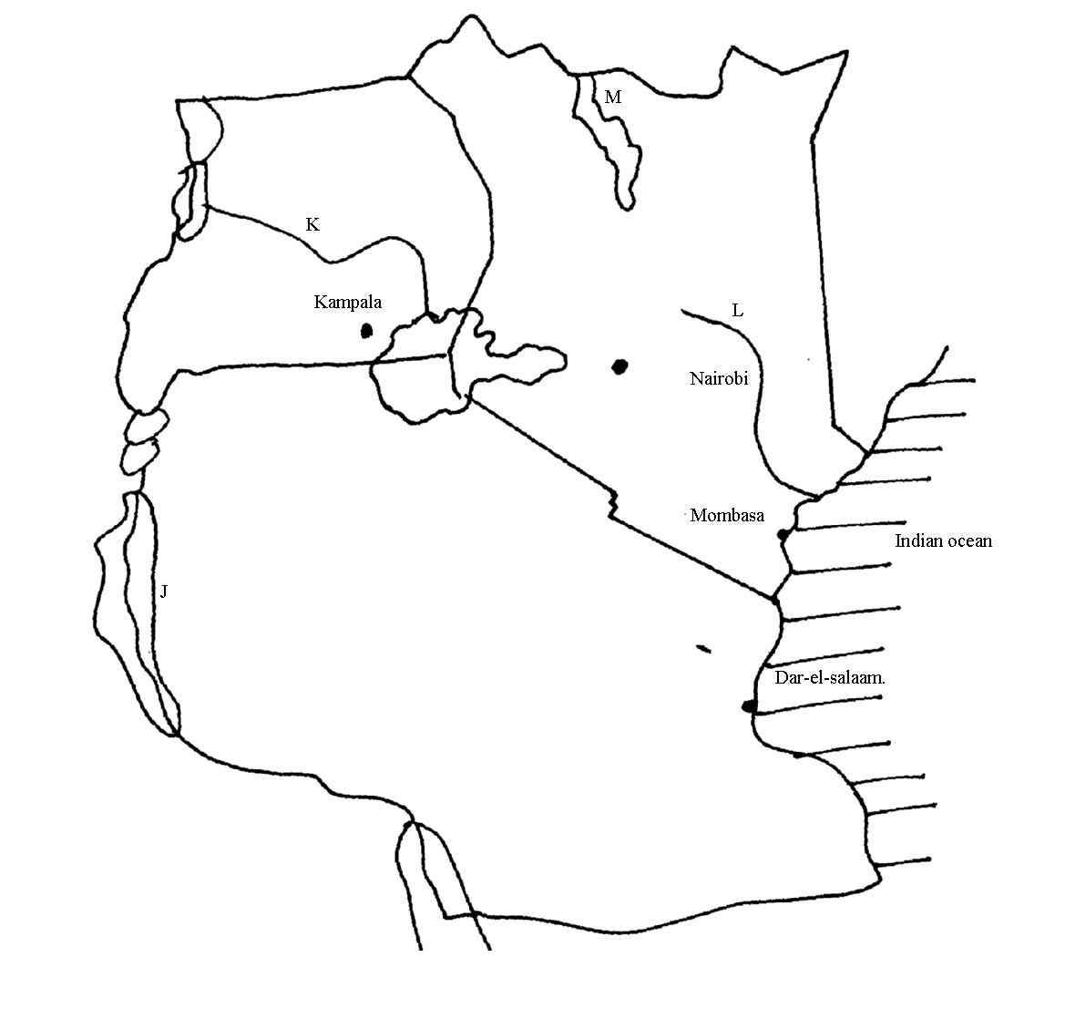

1. Name the fishing grounds marked J, K, L and M. **(4Marks)**
2. Explain the solutions to any ***Four*** problems facing Inland fishing in East Africa. **(8Marks)**

(c) Explain three factors why the Namibian Coast fishing ground is not well developed like other major fishing grounds in the world. **(6Marks)**

(d) Compare fishing in Kenya and Japan under the following sub- headings.

1. Market. **(2Marks)**
2. Nature of landscape. **(2Marks)**
3. (a) (i) Define land Rehabilitation **(2Marks)**

(ii) State ***Four*** benefits of land Rehabilitation in Kenya **(4Marks)**

(b) (i) Explain **Four** factors that led to the successful establishment of Pekerra irrigation scheme **(8Marks)**

(ii) State ***Three*** problems facing Pekerra irrigation scheme **(3Marks)**

(iii) List ***Four*** main crops grown in Pekerra irrigation scheme **(4Marks)**

1. State ***Four*** advantages of irrigation farming to the economy of Kenya. **(4Marks)**
2. (a) i) Differentiate between **market gardening** and **floriculture**. **(2Marks)**

(ii) State ***Four*** features of horticulture. **(4Marks)**

1. State ***Three*** physical factors that favour development of horticulture in Kenya. **(3Marks)**

ii) Explain why horticulture is more developed in Netherlands than in Kenya. **(8Marks)**

c) State and explain ***Four*** contributions of horticulture to the economy of Kenya. **(8Marks)**