**School**: ________________________________________________

**Student Name**: __________________________________________ Adm**. No ___________**

**Stream:** ___________________ **Signature**: ______________________

**312/1**

**GEOGRAPHY**

**Paper 1**

**Term 2 2024**

**Time: 2 3/4 Hours**



**NYAHOKAKIRA CLUSTER II**

***Kenya Certificate of Secondary Education (KCSE)***

**Geography**

**Paper 1**

***Instructions to candidates***

*1. This paper has two sections A and B.*

*2. Answer ALL the questions in section A. In section B answer questions 6 and any other TWO questions.*

*3. All answers to be written on the answer booklet provided.*

*4. Candidates should check the question papers to ascertain that all the pages (6) are printed as indicated and that no questions are missing.*

**FOR EXAMINERS USE ONLY**

|  |  |  |  |
| --- | --- | --- | --- |
| **SECTION** | **QUESTION** | **CANDIDATE’S**  **SCORE** | **MAXIMUM**  **SCORE** |
| **A** | **1-5** |  | **25** |
| **B** | **6** |  | **25** |
|  |  | **25** |
|  |  | **25** |
|  | **TOTAL**  **MARKS** |  | **100** |

**SECTION A:**

**ANSWER ALL QUESTIONS**

1. a) Name **three** divisions of physical geography. (3 marks)

b) Explain the relationship between Geography and Mathematics. (2 marks)

2.(a) Define the term Eclipse. (2 marks)

b) calculate the longitude whose local time is 6:00pm when the local time at longitude 0⁰ is 10:00 pm. (3mks)

3. Describe how lake Victoria was formed (5 marks)

4. a) Differentiate between weathering and mass wasting (2marks)

b) Apart from exfoliation, name three processes of mechanical weathering. (3marks)

5. a) Differentiate between an ice caps ice bergs (2marks)

b) Name thee ways through which glacier moves (3marks)

6.a) (i) Give the information contained in the sheet title. (1mark)

ii) Give two methods used in representing relief the map extract. (2 marks)

iii) convert the scale on the map to linear sale

iv) Measure the bearing of the air photo principal in grid square 5333 form that in grid square 6030. (2 marks)

(v) Identify **two** human made features found in grid square 6541 (2 marks)

b) On the graph paper provided, reduce the area bounded by eastings 50 and 52 and Northings 38 and 44 by a scale factor of 2.(2mks)

On it mark and label

1. All weather road loose surface (1mk)
2. Administrative boundary (provincial) (1mk)
3. Bumala Dam (1mark)
4. C) Calculate the new scale (2marks)

c) Describe the distribution of natural vegetation in the area covered by the map.

(4 marks)

d) Citing evidence from the map, explain two factors that favour trading in the area covered by the map. (4 marks)

7. a) (i) State **two** causes of earth movements. (2 marks)

(ii) Give **three** effects of movement of tectonic plates. (3 marks)

(iii) State **two** reasons why it is necessary to study the plate tectonics theory. (2 marks)

b) The diagram below represents types of folds. Use it to answer questions that follow.

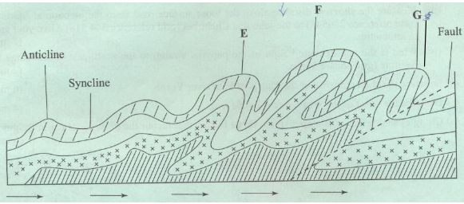

(i) Name the type of fold marked

E (1 mark)

G (1 mark)

c) Describe the formation of Fold Mountains using the contraction theory. (5 marks)

d) Form four students from your school carried out a field study on the area that

has undergone folding.

i) Give two reasons why a map of the area was necessary. (2 marks)

ii) Give three sources of secondary data they may have used. (3 marks)

e) Apart from Fold Mountains give three other features resulting from folding that they may have observed. (3 marks)

8. a) Draw sketch map of Kenya on it, mark and name the (3 marks)

(i) Lake Turkana (1mark)

(ii) River Athi (1mark)

(iii) Mount Kenya (1mark)

(iv) The equator (1mark)

b) Describe the climatic conditions experienced in the Kenya highlands. (6 marks)

c) Explain four ways in which vegetation in the Nyika region of Kenya has adapted to the climate conditions experienced in the area. (8 marks)

d) Explain how the presence of a cold ocean current influences the climate of the adjacent coastlands. (4 marks)

9.a)(i)Distinguish between an ocean and a sea (2marks)

ii) State ***four*** factors that influence ocean salinity (4marks)

b) With the aid of well labelled diagrams, explain how the following wave erosional features are formed (10marks)

(i) Cliff

(ii) Geo

c) You are planning to carry out a field study on the depositional features along the coast of Kenya

(I) Give ***three*** types of submerged highland coasts you identified (3marks)

ii) State ***three*** objectives you would formulate for the study(3mks)

iii) Give ***three*** methods you would use to record the information collected (3marks)

10. (a) (i) Define a spring (2marks)

(ii) State four conditions necessary for the formation of a spring (4marks)

(ii) The diagram below shows an artesian basin. Use it answer the questions that follow;

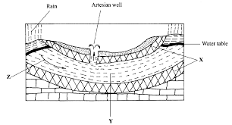

ii) Identify the pats labeled X and Y (2 marks)

(iii) Give three conditions favoring development of an artesian basin. (3 marks)

(iv) State three reasons why there are few settlements in karst regions. (3 marks)

(c) (i) Name two land forms due to chemical weathering. (2marks)

(ii) Describe the formation of the following features;

* Stalagmite (3marks)
* Doline. (3marks)
* Drumlin (3marks)