

**312/2 -** GEOGRAPHY  **- Paper 2**



***Kenya Certificate of Secondary Education (K.C.S.E)***

***GEOGRAPHY PAPER 2***

***2 ¾ HRS***

**Name ……………………………………………… Index Number ………………………... Class…………………………………... Candidates Signature…………………………….**

**Date ……………………………………**

**2022 TRIAL 2 JULY INTERNAL EXAMINATION**

***(Kenya Certificate of Secondary Education)***

**INSTRUCTIONS TO CANDIDATES**

(a) *This paper has two sections A and B*

*(b) Answer ALL the questions in section A*

*(c) Answer question 6 and any other two questions from section B*

*(d) All answers must be written in the answer sheets provided*.

|  |  |  |
| --- | --- | --- |
| **SECTION** | **QUESTIONS** | **CANDIDATES SCORE** |
| **A** | **1-5** |  |
| **B** | **6** |  |
| **7** |  |
| **8** |  |
| **9** |  |
| **10** |  |
|  | **TOTAL SCORE** |  |

***This paper consists of 5 printed pages. Candidates should check the question paper to ascertain that all pages are printed as indicated and that no questions are missing***

**SECTION A**

**ATTEMPT ALL THE QUESTIONS FROM THUS SECTION**

1.a) Identify two methods used to reclaim land in Kenya. 2mks

b) i) State two methods that were used to reclaim the Yala swamp. 2mks

ii) Identify the main crop grown in each of the following irrigation schemes. 3mks

2. a) State three reasons why Tanzania produces more fish than Kenya. 2mks

b) Identify three reasons why fish farming should be encouraged in Kenya. 3mks

3. a) Define the term dereliction. 2mks

b) Suggest three measures that can be used to combat dereliction and its dangers in Kenya.3mks

4. a) State two problems facing small scale farming in Kenya. 2mks

b) Identify three importance’s of market gardening to the economy of Kenya. 3mks

5. state three roles of domestic tourism. 3mks

***6. Use the data below to answer the questions that follow.***

Destruction of forest covers in Kenya between 2017 – 2019 in ‘000’ tones.

|  |  |  |  |
| --- | --- | --- | --- |
| **TYPE OF FOREST** | **2017** | **2018** | **2019** |
| Indigenous | 14000 | 1200 | 900 |
| Exotic | 1280 | 1050 | 800 |
| Planted | 1800 | 1750 | 1500 |
| Coniferous | 1600 | 1400 | 1300 |
| montane | 500 | 450 | 420 |
| **TOTAL** | **6580** | **5850** | **4920** |

a.i) Using a scale of 1cm to represent 500 tonnes present the above data using a compound bar graph. 6mks

a.ii) Identify any three forest reserves in Kenya. 3mks

b.i) State two advantages of presenting data using compound bar graphs. 2mks

ii) Distinguish between a forest and forestry. 2mks

c) Give the differences between softwood forests in Kenya and Canada under the following sub- headings.

i) Tree harvesting. 2mks

ii) Marketing 2mks

d) Describe the steps taken by the Kenyan government to realize effective management of forests. 4mks

e) Explain four problems facing forest exploitation in Canada. 4mks

7.a.i) Define dairy farming. 2mks

ii) Name three major dairy breeds in Kenya. 3mks

b.i) Identify three features of nomadic pastoralist. 3mks

ii) State three measures the government has taken to improve livestock rearing among the pastoralists. 3mks

c.i) Name two areas in Kenya where dairy farming is practiced. 2mks

ii) Highlight four characteristics of dairy breeds. 4mks

d) Explain four reasons why dairy farming is mainly located in the Kenyan highlands. 8mks

8.a.i) Identify three formations in which minerals may occur. 3mks

ii) State three health hazards associated with mining. 3mks

b) Explain five effects of mining on the economy of South Africa. 10mks

c) Use the map below to identify the minerals labeled; 3mks

A,B,C,D

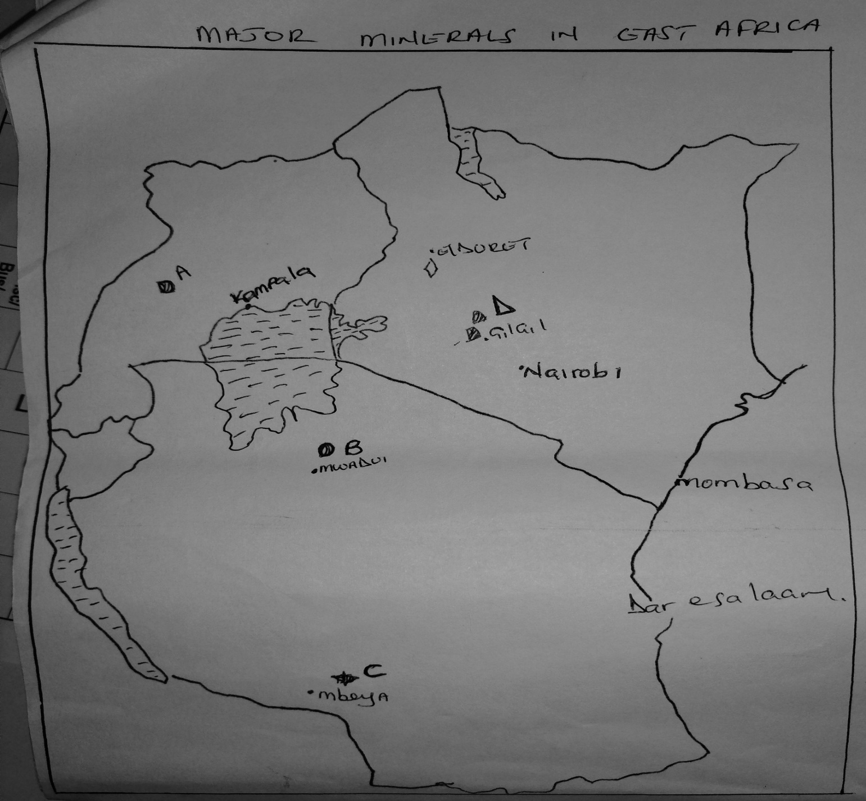

d) Your geography teacher has organized a field study trip to Lake Magadi in the southern part of the Rift Valley of Kenya.

i) Name the mineral mined in this lakes. 1mk

ii) Identify two methods you will use to collect information. 3mks

iii) State two problems you are likely to encounter during your study. 2mks

9. a. i) Define fish farming. 1mk

ii) Identify three fishing methods used by the local fishermen in Kenya. 3mks

b. i) Give five reasons why fish farming should be encouraged in Kenya. 5mks

ii) Highlight five factors that have promoted fishing in Japan. 5mks

c) Name three major fishing grounds of the world. 3mks

d) Explain four physical factors that influence the distribution of world fishing grounds. 8mks

10, a. i) Name two areas where swamps have been drained in Kenya. 2mks

ii) Highlight four problems facing Mwea Tebere irrigation scheme in Kenya. 4mks

b. i) Name two main reclaimed projects in Netherlands. 2mks

ii) Describe how a polder is reclaimed. 10mks

c) Your class carried out a field study to a polder in Netherlands

i) Name two main crops you identified grown in the polder. 2mks

ii) Identify three benefits that people of Netherlands experiences as a result of reclaiming a polder. 3mks

iii) Highlight two follow up activities. 2mks