GAS LAWS
1. (a) State Boyle’s law
(b) A column of air 5cm is trapped by mercury thread of 10cm as shown in the figure below.
If the tube is laid horizontally as shown in (b), calculate the new length of trapped air
(atmospheric pressure =75.0cmHg and density of mercury = 13600kgm⁻³)
Mercury
5cm
10cm
Air
L
10cm

`

(c) Explain why:
(i) It is difficult to remove the lid from a preserving jar which was closed when the
(ii) A force pump must be used instead of a lift pump to raise water from a deep well over 10m
2. The figure below shows a simple set up for pressure law apparatus:-
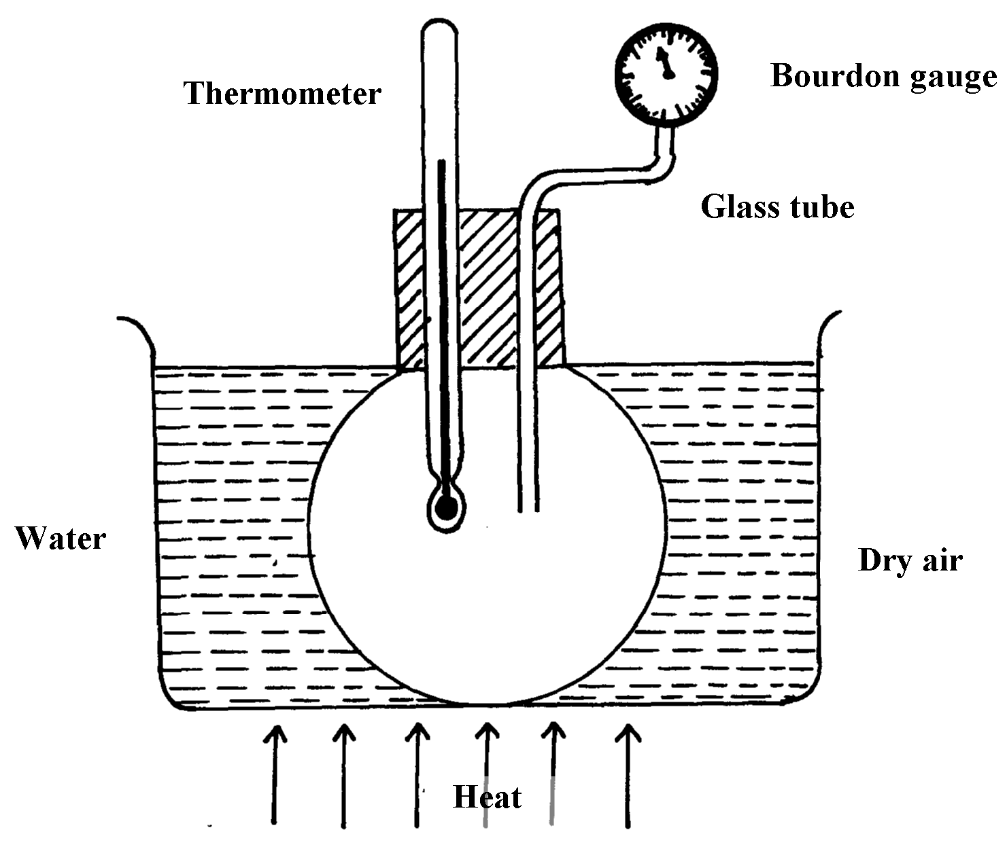

a) Describe how the apparatus may be used to verify pressure law
b) The graph in the figure below shows the relationship between the pressure and temperature
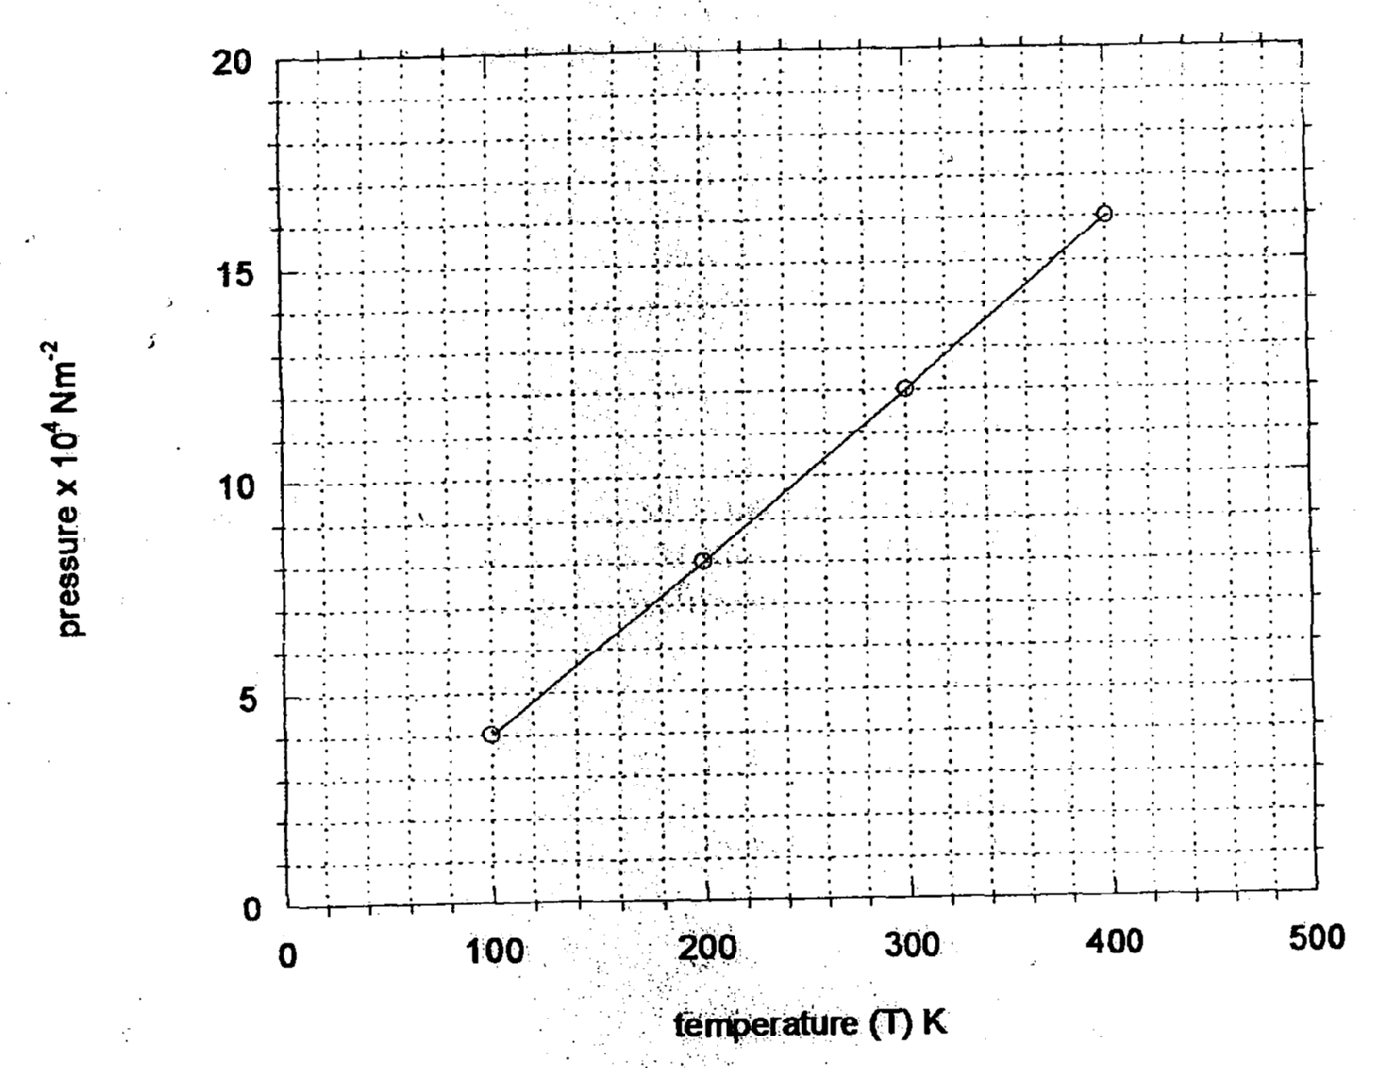
for a fixed mass of an ideal gas at constant volume

i) Given that the relationship between pressure, P and temperature, T in Kelvin is of the form
P = kT + C
Where k and C are constants, determine from the graph, values of k and C
ii) Why would it be possible for pressure of the gas to be reduced to zero in practice?
c) A gas is put into a container of fixed volume at a pressure of 2.1 x 10⁵. Nm⁻² and
temperature 27°C. The gas is then heated to a temperature of 327°C. Determine the
new pressure

3. (a) State Boyle’s law
(b) The volume of a bubble at the base of a container of water is 3cm³. The depth of water
is 30cm. The bubble rises up the column until the surface ;
(i) Explain what happens to the bubble as it rises up the water column
(ii) Determine the volume of the bubble at a point 5cm below the water surface
(c) A faulty thermometer records 11ºC instead of 0ºC and 98ºC instead of 100ºC. Determine
the reading on the thermometer when dipped in liquid at a temperature of 56ºC

4. (a) State Boyles law
Some students carried out an experiment to verify Boyle’s law and recorded their results as
shown in the table below:-
Pressure ^{KN}/ _{M2} | 400 | 320 | 160 | 180
Volume (m³) | 2.0 | 2.5 | 5.0 | 10.0
¹/_{V} (mm⁻³)
(i) Complete the table
(ii) Plot a graph of pressure against ¹/_{volume}
(c) Determine the gradient for the graph and state its units
(d) A sample of gas has a pressure of 1.0 x 10⁵Pa when its temperature is 10ºC. What
will be its pressure if its temperature is raised to 100ºC and its volume doubled

5. (a) State: (i) Boyle’s Law
(ii) Charles’ Law.
(b) A form three student carried out an experiment on one of the gas law. She obtained the
following results.
Temperature (⁰c) | 10 | 35 | 60 | 80 | 90 | 110
Volume V(cm³) | 5 | 5.8 | 6.4 | 7.0 | 7.2 | 7.8
(i) Plot a graph of volume V against temperature.
(ii) From the graph, determine the volume of the gas at 0ºc.
(iii) Determine the slope of the graph.
(iv) The equation of the line obtained is of the form V = kT + c. What is the value of k and c?

6. (a) State Charles’ law
(b) A mass of gas occupies a volume of 150cm³ at a temperature of -73°C and a pressure of
1 atmosphere. Determine the 1.5 atmospheres and the temperature 227 °C

7. In an experiment to verity Boyle’s law, two quantities were advised to be kept constant
(a). State the quantities.
(b). the results of experiment to verify Boyle’s law were recorded in the table below.
Pressure(atmospheres) | 1.0 | 1.2 | 1.4 | 1.6 | 1.8
Volume (litres) | 0.62 | 0.521 | 0.450 | 0.391 | 0.351
Plot a suitable graph to verify the law.
(c). Determine the volume of the gas when the pressure is two atmospheres.
GAS LAWS
1. (a) It states that the pressure of a fixed mass of gas is inversely proportional to its volume
provided temperature is kept constant (PV = K)
(b) P₁L₁ = P₂L₂
86 x 5 = 75 x L₂
= 5.73cm

(c) (i) When steam condenses, the pressure inside the container will be lower than the
atmospheric pressure on the outside. The excess atmospheric pressure acting on the lid
exerts a force on the lid thus making it difficult to open the lid.
(ii) The lift pump depends only on atmospheric pressure which can only support a column
of water 10m long. The force pump uses force and therefore can lift water to the length
greater than 10m.

2. a) Describe how the apparatus may be used to verify pressure law
Plotting pressure against absolute temp we get a straight line graph
P
Pas
T (k)
Conclusion
Pressure of infixed mass of a gas indirectly proportional to its absolute to temperature if volume is kept constant

b) i) Given that the relationship between pressure, P and temperature, T in Kelvin is of the form
P = kT + C
Where k and C are constants, determine from the graph, values of k and C
K = gradient
= (8-0) X 10⁴ NM ⁻²
200 - 0
K = 400N m⁻² K⁻¹
C = O
ii) Why would it be possible for pressure of the gas to be reduced to zero in practice?
- The gas liquefies at low temperature before reaching zero Kelvin
c) A gas is put into a container of fixed volume at a constant volume at a pressure of 2.1 x 10⁵.
Nm⁻² and temperature 27°C. The gas is then heated to a temperature of 327°C. Determine
the new pressure

P₁ = P₂ T₂ =273 + 327
T₁ T₂ = 600K
P₁ = 2.1 X 105 Nm⁻² P₂ = P₁ T₂
P₂ = ? T₁ ₂
T₁= 27+ 273 = (2.1 X 600) X 10⁵NM ⁻² = 4.2 X10⁵NM⁻²
= 300K 300
3. a) The volume of a fixed mass of gas is inversely proportional to its pressure provided
temperature is kept constant.
(b) (i) The bubble expands as it comes up finally bursts when at the surface
(ii) p₁V₁ = P2V₂
(76 + 30) x 3 = (76 + 5) V₂
106 x3 = 81 X V₂
V₂ = 106 x 3
81
= 3.93cm³

(c) 100ºC - 0ºC = 98 -11
1 division = 87
100
Reading = 8 x 56
1000
= 48.72ºC

4. a) The volume of a fixed mass of a gas is inversely proportional to the pressure provided
that temperature is kept constant √ 1

¹/_{v} (mm⁻³) | 0.5 | 0.4 | 0.2 | 0.1

b) Labeling the axes
Scale
Plotting (3,4) pts
2 points
Below 2 points
Smooth curve / straight line

c) Gradient = Δy
Δ x
= 400 – 160
(0.5 – 0.2) X 10⁻⁹ √ 1
= 340
0.3 X 10⁻⁹
= 1133.33 X 10⁻⁹
= 1.1333 X 10⁻⁶ KNM

d) P₁V₁ = P₂V₂
T₁ T₂ √ 1
1 X 10⁵ X V₁ = P₂2_{V1} √ 1
285 373
P2 = 6.95 X 10⁴ Pa √ 1

5. a) Boyles Law: States:-
(i) - The pressure of a fixed mass of a gas is inversely proportional to its volume, provided the temperature is kept constant. 1
(ii) Charles Law states:
- The volume of a fixed mass of a gas is directly proportional to its absolute temperature at constant pressure. 1

b) (i)
(ii) at 0⁰c, v = 4.7 cm³ + 0.1 1
(iii) Slope = DV
DT
= (6.4. – 50)cm³ 1= 0.028 cm³/⁰c + 0.002 1
(60 – 10)⁰c
(iv) V = KT + C.
K = Slope = 0.028cm³/⁰c + 0.002 1
C = V intercept when T = 0 and 1
= 4.7. cm³ + 0.1

