**KENYA JUNIOR SCHOOL EDUCATION ASSESSMENT**

**TERM 1 2025**

**G9 – PRETECHNICAL STUDIES.**

**Time: 2 Hours.**

NAME: ______________________________________________________________________

SCHOOL: ____________________________________________________________________

STREAM: ____________________________ DATE: __________________

**INSTRUCTIONS**

Write your name, school, stream and the date in the spaces provided.

Answer all the questions in the booklet using the spaces provided after every question.

All questions are answered I n English.

All answers must be given according to the guidelines of each question.

**ASSESSMENT RUBRICS.**

**RANGE** **LEVEL**

|  |  |
| --- | --- |
| **80% to 100%** | Exceeding Expectations. |
|  |  |
| **60% to 79%** | Meeting Expectations. |
|  |  |
| **40% to 59%** | Approaching Expectations. |
|  |  |
| **0% to 39%** | Below Expectations |

**LEARNER’S SCORE**

**OUT OF 50 MARKS**

*Score*

*% Score*

1

|  |  |  |  |
| --- | --- | --- | --- |
|  |  |  |  |
|  |  |  |  |
| 1. |  |  |  |
| a.) Name the following raised platforms. | |  | **(4mks)** |
| **A** | **B** | **C** | **D** |

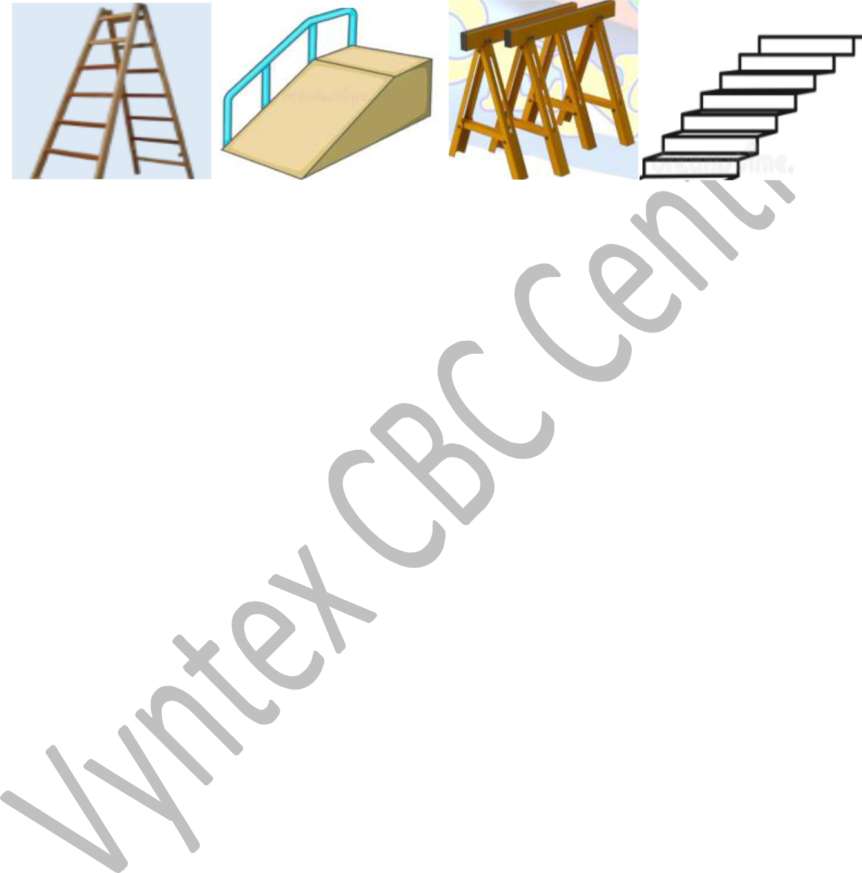

1. ________________________________________________________________________
2. ________________________________________________________________________
3. ________________________________________________________________________
4. ________________________________________________________________________

b.) State **three** safety measures to observe when using the raised platforms above. **(3mks)**

__________________________________________________________________________

__________________________________________________________________________

__________________________________________________________________________

__________________________________________________________________________

c.) Give **two** importance of observing safety when using raised platforms. **(2mks)**

_____________________________________________________________________________

_____________________________________________________________________________

_____________________________________________________________________________

2.

a.) Give **three** characteristics of computers. **(3mks)**

_____________________________________________________________________________

_____________________________________________________________________________

_____________________________________________________________________________

b.) State **three** ways one can use to secure data in an electronic device. **(3mks)**

_____________________________________________________________________________

_____________________________________________________________________________

_____________________________________________________________________________

2

|  |  |
| --- | --- |
|  |  |
|  |  |
| 3. |  |
| a.) Name **four** drawing instruments. | **(4mks)** |

_____________________________________________________________________________

_____________________________________________________________________________

_____________________________________________________________________________

_____________________________________________________________________________

b.) Define the term dimensioning. **(2mk)**

_____________________________________________________________________________

_____________________________________________________________________________

c.) State the **three** types of dimensioning. **(3mks)**

_____________________________________________________________________________

_____________________________________________________________________________

_____________________________________________________________________________

4.

a.) What is free hand sketching? **(2mks)**

_____________________________________________________________________________

_____________________________________________________________________________

b.) List down any **four** instruments used in free hand sketching. **(4mks)**

_____________________________________________________________________________

_____________________________________________________________________________

_____________________________________________________________________________

_____________________________________________________________________________

c.) Grade 7 learners were practicing different freehand drawing techniques. Name the **two**

techniques shown by the pictures they drew below. **(2mks)**

**Technique H** **Technique P**

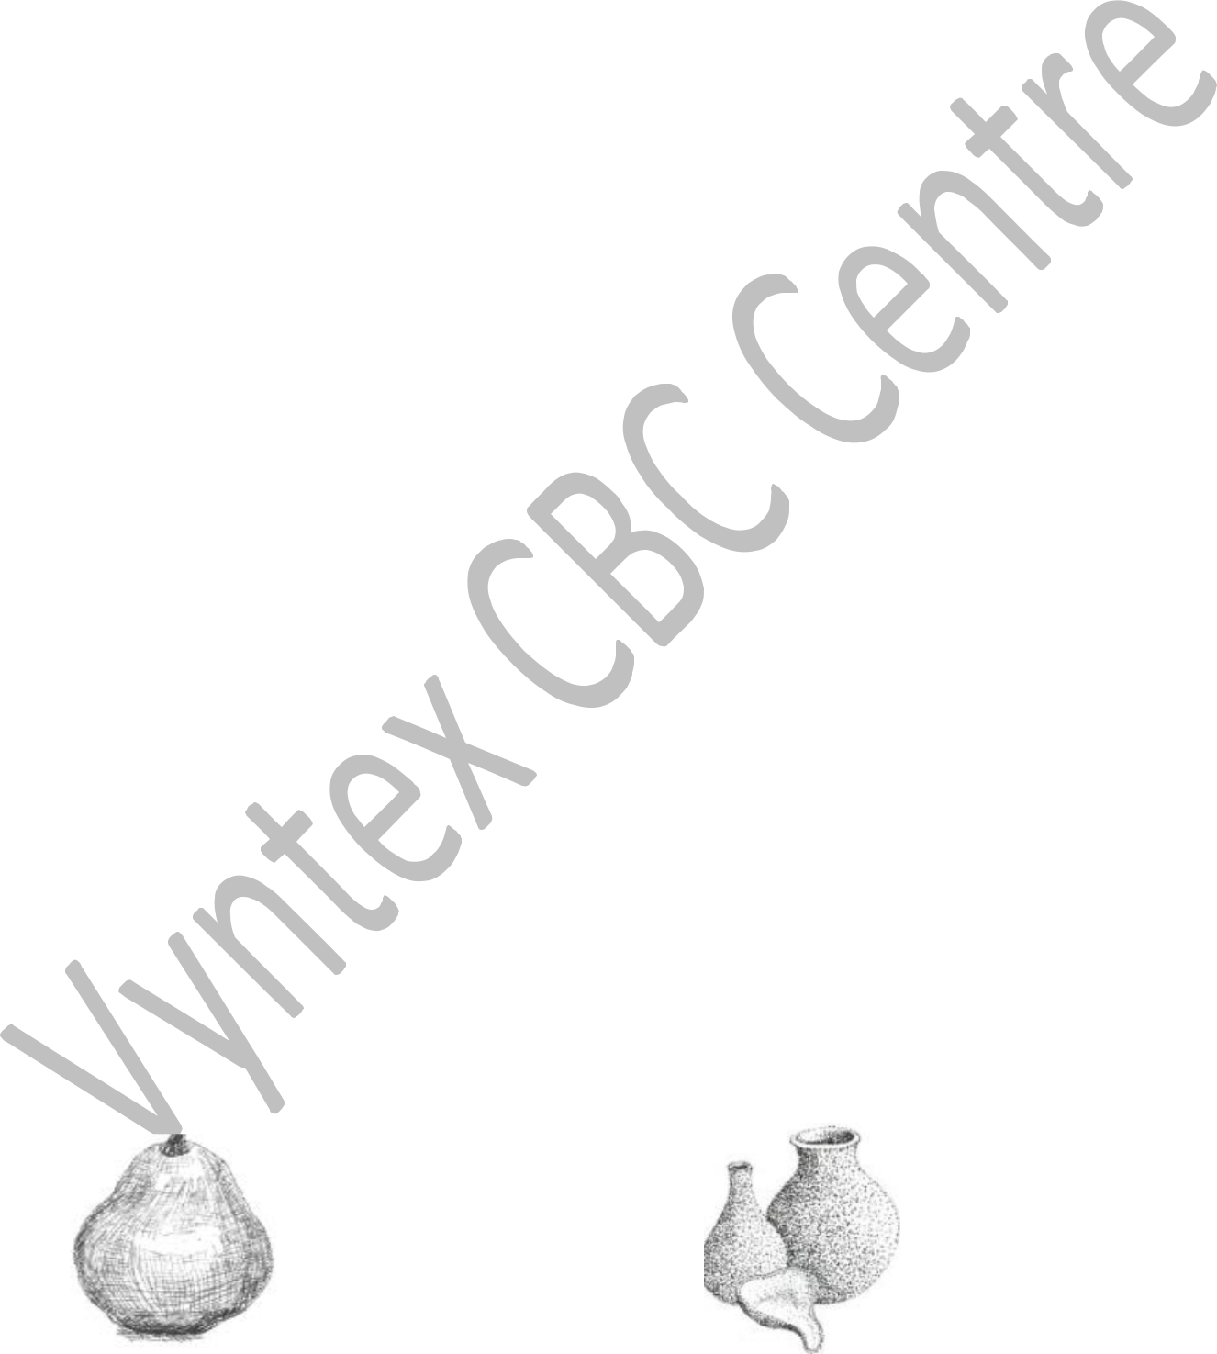

__________________ ____________________



3

|  |  |
| --- | --- |
|  |  |
|  |  |
| 5. Give **three** ways we can sustainably use economic resources. | **(3mks)** |

_____________________________________________________________________________

_____________________________________________________________________________

_____________________________________________________________________________

_____________________________________________________________________________

6. Giving **one** example in each, State the **two** categories of computer output devices. **(4mks)**

_____________________________________________________________________________

_____________________________________________________________________________

7. Name **three** examples of visual programming applications. **(3mks)**

_____________________________________________________________________________

_____________________________________________________________________________

_____________________________________________________________________________

8.

a.) Define the term entrepreneur. **(2mks)**

_____________________________________________________________________________

_____________________________________________________________________________

b.) Give **four** ICT tools used in marketing of good and services. **(4mks)**

_____________________________________________________________________________

_____________________________________________________________________________

_____________________________________________________________________________

_____________________________________________________________________________

c.) What is impulsive buying? **(2mks)**

_____________________________________________________________________________

_____________________________________________________________________________

**THIS IS THE LAST PRINTED PAGE**

4