JUNIOR SCHOOL EDUCATION ASSESSMENT
GRADE 9
TERM ONE 2025 OPENER
NAME: ……………………………………………………………………..
SCHOOL: ………………………………………………………………….
ASSESSMENT NUMBER: ……………………………………………….
SIGNATURE: ……………………………….DATE:……………………..
PRETECHNICAL STUDIES
ASSESSMENT RUBRICS

Learning | Performance | Exceeds | Meets | Approaching | Below
area |  | Expectations (4) | Expectations (3) | Expectations (2) | Expectations (1)
Pre-Technical
Studies

- Kingi, a firefighter, visited grade 8 learners to discuss fire safety. Highlight three measures to prevent fire

outbreaks at home he likely mentioned. (3 marks)

...............................................................................................................................................

...............................................................................................................................................

...............................................................................................................................................

2. Name two common firefighting methods in a work environment. (2 marks)

...............................................................................................................................................

...............................................................................................................................................

3. Njomo owns a publishing company. He carries out different transactions in order to run his business.

What are the main classifications of business transactions in entrepreneurship? (2 marks)

...............................................................................................................................................

...............................................................................................................................................

4. | What do you understand by the term bookkeeping? |  | (2 marks)
 | ...............................................................................................................................................
 | ...............................................................................................................................................
5. | The diagrams below show different cutting tools. Name the cutting tools shown and state their uses.
 |  |  | (6 marks)
 | Cutting tool | Name | Use
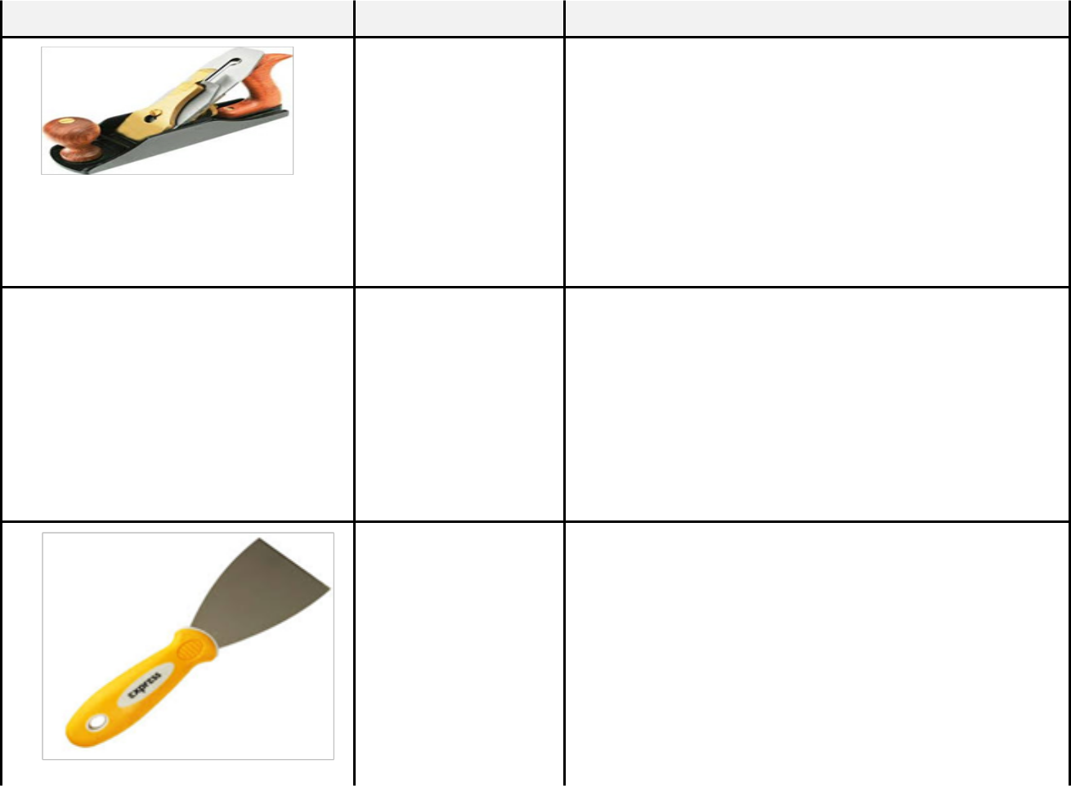

(a)

(b)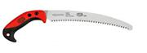

 | (c)
6. | Adesh sells different types of saws in his hardware. Mention two common types of saws. |  | (2 marks)
 | ...............................................................................................................................................
 | ...............................................................................................................................................
7. | Grade eight learners were asked to bring ceramic materials during a practical lesson. Mention two
 | common ceramic materials found in the locality. |  | (2 marks)
 | ...............................................................................................................................................
 | ...............................................................................................................................................
8. | The table below shows different output devices. Complete the table to show the functions of the output
 | devices. |  | (6 marks)
 | Output device | Function

- Plotter

- Monitor

- Projector

- Fixed storage devices such as internal hard drives (HDDs), solid-state drives (SSDs) and other built-in

storage media offer several advantages. Outline two of these advantages. (2 marks)

...............................................................................................................................................

...............................................................................................................................................

10. Name the four categories of computer hardware. (4 marks)

...............................................................................................................................................

...............................................................................................................................................

...............................................................................................................................................

...............................................................................................................................................

11. Bimmas Holdings is a tech company that deals with large volumes of information. Name two storage

devices they likely use. (2 marks) ............................................................................................................................................... ...............................................................................................................................................
- The CPU (Central Processing Unit) is often referred to as the “brain” of the computer and plays a critical role in determining the overall speed and performance of a computer system. State two

components of the CPU in a computer. (2 marks) ............................................................................................................................................... ...............................................................................................................................................
- Audio-visual communication channels enhance audience engagement by combining auditory and visual elements for more impactful interactions. A video conference like the one below is one such example.



Outline three other examples of Audio-Visual communication channels. |  | (3 marks)
...............................................................................................................................................
...............................................................................................................................................
...............................................................................................................................................
14. Mention two common visual programming applications. |  | (2 marks)
...............................................................................................................................................
...............................................................................................................................................

15. State three factors to consider when selecting input devices for use in a computer in your school.

(3 marks)

...............................................................................................................................................

...............................................................................................................................................

...............................................................................................................................................

16. Consumer protection measures are often established by the law.


State two importance of consumer protection. |  |  | (2 marks)
...............................................................................................................................................
...............................................................................................................................................
17. Name three composite materials found in the locality. |  |  | (3 marks)
...............................................................................................................................................
...............................................................................................................................................
...............................................................................................................................................
18. The diagram below shows a secateur.
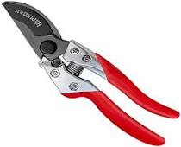

What purpose does it serve? (2 marks)

...............................................................................................................................................

...............................................................................................................................................

