

**KENYA JUNIOR SCHOOL EDUCATION ASSESSMENT**

**KEJSEA ENDTERM ONE 2025**

**GRADE 9**

**903- MATHEMATICS**

**Name: ____________________________________________________________.**

**School: ___________________________________________________________.**

**Signature: _________________________ Date: ________________________.**

**Duration:** 2 Hours  
**Total Marks:** 70 marks

**FOR FACILITATOR’S USE ONLY**

|  |  |  |  |  |
| --- | --- | --- | --- | --- |
| SCORE RANGE | 60-69 | 50-59 | 26-49 | 0-25 |
| LEVEL | EXCEEDING EXPECTATION | MEETING EXPECTATION | APPROACHING EXPECTATION | BELOW EXPECTATION |
| LEARNER’S SCORE |  |  |  |  |
| TICK LEVEL |  |  |  |  |

**General Instructions:**

1. **Read all questions carefully** before answering.
2. **Write your answers in the space provided** for each question.
3. **Use clear and concise language** in your responses.
4. **Answer all questions** to the best of your ability.
5. **Write legibly**. Unreadable answers may not be awarded marks.
6. **You are allowed to use a calculator** for mathematical questions.
7. Show all workings for full marks.
8. Calculators may be used.

**SECTION A (20 marks)**

1. Simplify: 3 $x+5x-7$

A) 8x−7

B) 3x−7

C) 5x+7

D) 8x+7

1. Solve for x: $5x-3=17$

A) x=3

B) x=4

C) x=5

D) x=6

1. What is the LCM of 15 and 25?

A) 30

B) 45

C) 75

D) 100

1. Simplify: $2(x+3)+4(x-1)$

A) 6x+2

B) 6x+2−4

C) 6x+2

D) 6x−2

1. The ratio of boys to girls in a class is 4:5. If there are 80 boys, how many girls are there?

A) 100

B) 120

C) 160

D) 200

1. Solve for x: $\frac{4}{5}=\frac{x}{15}$

A) x=10

B) x=12

C) x=8

D) x=20

1. A car travels 180 km in 6 hours. What is the speed of the car in km/h?

A) 30 km/h

B) 36 km/h

C) 40 km/h

D) 45 km/h

1. A shirt originally costs Ksh 1,500. After a 10% discount, what is the final price of the shirt?

A) Ksh 1,350

B) Ksh 1,400

C) Ksh 1,500

D) Ksh 1,600

1. What is 25% of 320?
   * A) 60
   * B) 80
   * C) 90
   * D) 100
2. The population of a town increases by 10% every year. If the current population is 50,000, what will the population be after 2 years?

A) 55,000

B) 60,000

C) 61,000

D) 62,100

1. What is the area of a rectangle with length 10 cm and width 6 cm?

A) 30 cm²

B) 40 cm²

C) 60 cm²

D) 100 cm²

1. The volume of a sphere is calculated using the formula V= πr3. If the radius of a sphere is 3 cm, what is its volume? (Use π=3.14)

A) 84.78 cm³

B) 113.04 cm³

C) 27 cm³

D) 15.4 cm³

1. What is the surface area of a cube with side length 4 cm?

A) 48 cm²

B) 64 cm²

C) 96 cm²

D) 128 cm²

1. The marks obtained by a student in five subjects are: 70, 80, 90, 75, and 85. What is the median of the marks?

A) 75

B) 80

C) 85

D) 90

1. If the mode of a data set is 12, which of the following could be the data set?

A) 10, 12, 14, 16

B) 5, 7, 12, 12, 12, 13

C) 5, 5, 8, 8, 12, 13

D) 6, 7, 8, 10, 12, 15

1. If the equation of a line is y=2x+1, what is the y-intercept?

A) 0

B) 1

C) 2

D) 3

1. What is the slope of the line passing through the points (0, 2) and (3, 8)?

A) $\frac{3}{5}$

B) $\frac{5}{3}$

C) 2

D) $\frac{6}{3}$

1. The points (2, 3) and (4, 7) lie on a straight line. What is the slope of the line?

A) $\frac{4}{2}$ B) $\frac{7}{3}$ C) $\frac{1}{2}$ D) 2

1. What is the name of the figure below?
2. Trapezium
3. Rhombus
4. Square
5. Rectangle
6. Calculate the area of the circle below that has a radius of 12.5cm rounded off to the nearest whole number.

**12.5 cm**

1. 600cm2  B.409cm2 C. 125 cm2  D.491cm2

**SECTION B: 80 MARKS**

**Number Operations and Algebra (20 Marks)**

1. Simplify the following expressions:  
   a) 5a−3b+2a−7b

b) 3x(x+2)−4(x+2)

1. Solve for x in the equation:  
   2x+3=11
2. Find the LCM and HCF of 18 and 24.

**Ratios and Proportions (15 Marks)**

1. A school has 120 boys and 80 girls. Find the ratio of boys to girls in its simplest form.
2. Solve for x in the following proportion: $$\frac{3}{4}=\frac{x}{12}$$
3. A car travels 120 km in 3 hours. How far will it travel in 5 hours at the same speed?

**Percentages (15 Marks)**

1. A laptop originally costs Ksh 30,000. After a 15% discount, what is the price of the laptop?
2. A population of a town increases by 12% annually. If the current population is 50,000, what will be the population after 2 years?
3. Calculate the simple interest on a loan of Ksh 20,000 at 8% per annum for 3 years.

**Measurement (20 Marks)**

1. Find the area of a triangle with a base of 10 cm and a height of 6 cm.
2. Calculate the volume of a cylinder with a radius of 7 cm and height of 14 cm. Use π= $\frac{22}{7}$
3. Find the surface area of a cube with a side length of 5 cm.

**Data handling (15 Marks)**

1. The marks obtained by a student in five subjects are: 70, 85, 90, 65, and 75.
   1. Find the mean, median, and mode of the marks.

b) Construct a bar graph to represent these marks.

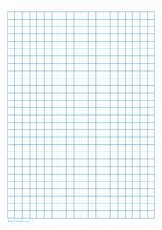

**Linear Graphs (15 Marks)**

1. 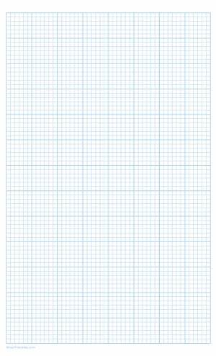Plot the following points on a graph:  
   A(0, 2), B(2, 4), C(4, 6), D(6, 8).

a) Draw the line that passes through these points.

b) Find the gradient of the line.

**THIS IS THE LAST PRINTED PAGE**

**COMPREHENSIVE MARKING SCHEME**

**SECTIONA: 20 MARKS**

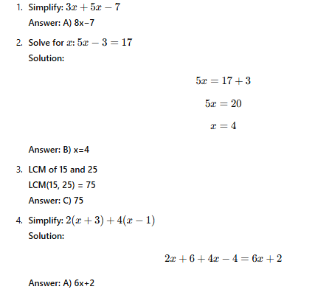

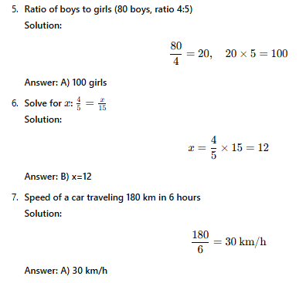 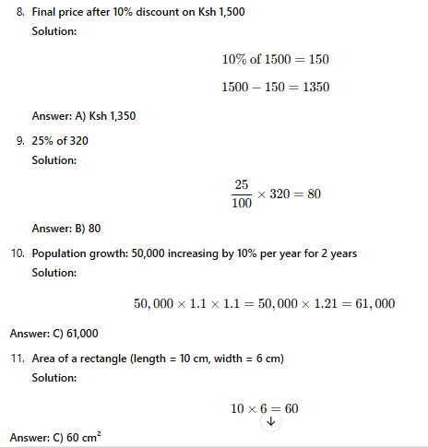

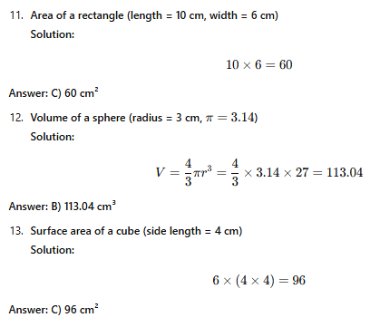 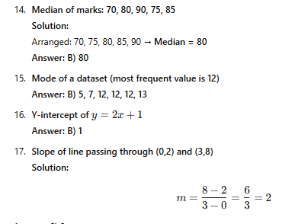 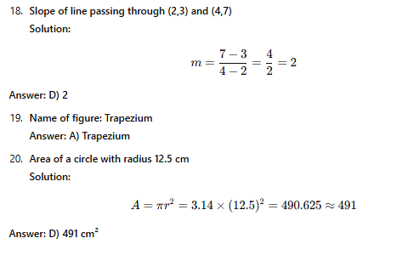

SECTION B: 80 MARKS

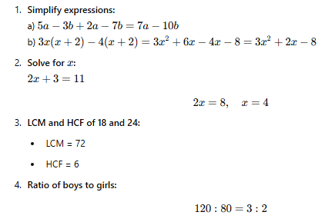 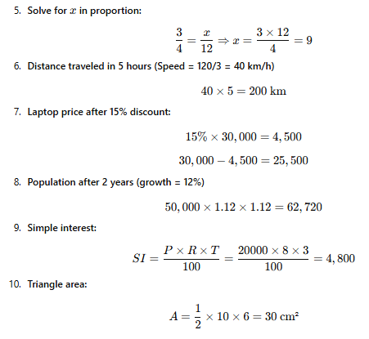 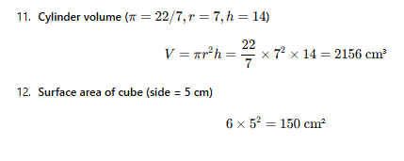

13.

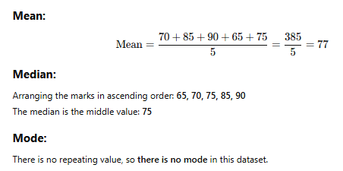

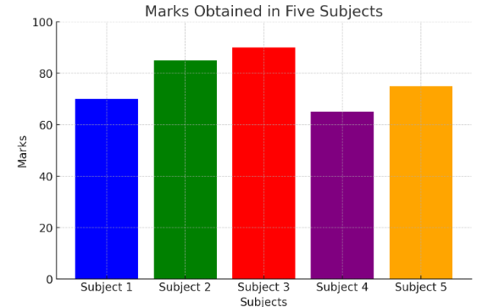

1. **Plot the following points on a graph:**  
   