**KENYA JUNIOR SCHOOL EDUCATION ASSESSMENT**

**GRADE 9**  
**903: MATHEMATICS**  
**Time: 2 HOURS**

**NAME:** _______________________________________________________________________  
**SIGN:** ________________________________________________________________________  
**DATE:** _______________________________________________________________________  
**CANDIDATE'S ASSESSMENT NUMBER:** ________________________________________  
**SCHOOL:** ____________________________________________________________________  
**SCHOOL CODE:** ______________________________________________________________

**INSTRUCTIONS TO CANDIDATES**

1. Write your name and assessment number in the spaces provided above.
2. Write the name and code of your school in the spaces provided above.
3. Sign and write the date of the assessment in the spaces provided above.
4. This question paper consists of TWO sections: A and B.
5. Answer ALL the questions in Section A on the separate ANSWER SHEET provided.
6. Answer ALL the questions in Section B in the spaces provided in this QUESTION PAPER.
7. Show all the workings in Section B in the spaces provided.
8. Non-programmable calculators may be used, except where stated otherwise.
9. Give non-exact numerical answers correct to **three significant figures** and **one decimal place for angles in degrees**, unless specified otherwise.

**SECTION A: (20 Marks)**

**Choose the correct answer**

1. A farmer harvested **5,678,912** maize cobs. What is the place value of **7** in this number?  
   A) Seventy thousand  
   B) Seven hundred thousand  
   C) Seven million  
   D) Seven hundred
2. A company recorded **4,230,567** shillings in revenue. Write this number in words.  
   A) Four million, two hundred thirty thousand, five hundred sixty-seven  
   B) Four million, twenty-three thousand, five hundred sixty-seven  
   C) Forty-two million, three hundred fifty-six thousand, seven hundred  
   D) Four billion, two hundred thirty million, five hundred sixty-seven thousand
3. A recipe requires **3/4** kg of sugar. Convert this fraction to a decimal.  
   A) 0.75 B) 0.8  
   C) 0.7 D) 0.85
4. Jane spent **2/5** of her salary on rent and **1/4** on food. What fraction of her salary did she spend altogether?  
   A) 3/9 B) 13/20 C) 9/20 D) 8/20
5. A car travels **360 km** in **6 hours**. What is its speed?  
   A) 30 km/h B) 40 km/h  
   C) 50 km/h D) 60 km/h
6. A cyclist moves at **20 km/h** for **2.5 hours**. What distance does he cover?  
   A) 40 km B) 50 km  
   C) 55 km D) 60 km
7. The area of a circular garden with a radius of **14 m** is:  
   A) 154 m² B) 616 m²  
   C) 44 m² D) 98 m²
8. A builder cuts a **3.5 m** metal rod into pieces of **0.25 m** each. How many pieces does he get?  
   A) 12 B) 14 C) 16 D) 18
9. A bag contains **5 red**, **3 green**, and **2 yellow** balls. What is the probability of picking a green ball?  
   A) $\frac{3}{10}$ B) $\frac{2}{10}$ C) $\frac{5}{10}$ D) $\frac{8}{10}$
10. The mean of the numbers **12, 18, 24, 30, and 36** is:  
    A) 18 B) 22 C) 24 D) 30
11. What is **50,678** rounded to the nearest thousand?

A) 50,000 B) 50,700

C) 51,000 D) 50,680

1. The least common multiple (LCM) of **12 and 18** is:

A) 6 B) 36

C) 24 D) 48

1. Convert **0.375** into a fraction in its simplest form.

A) $\frac{3}{5}$ B) $\frac{3}{8}$

C) $\frac{5}{8}$ D) $\frac{7}{10}$

1. A car travels **540 km in 6 hours**. What is its average speed?

A) 60 km/h B) 90 km/h

C) 45 km/h D) 80 km/h

1. A trader buys a bicycle for **Ksh 4,000** and sells it at **Ksh 5,200**. What is the percentage profit?

A) 25% B) 30%

C) 20% D) 40%

1. Solve for **x**:  
   2x+5=172x + 5 = 172x+5=17

A) 5

B) 6

C) 7

D) 8

1. The perimeter of a rectangle is **42 cm**. If the length is **12 cm**, what is the width?

A) 9 cm B) 8 cm

C) 7 cm D) 6 cm

1. What is the mode of the numbers **4, 7, 5, 7, 9, 7, 10**?

A) 7

B) 9

C) 5

D) 10

1. A bag contains **3 red, 5 green, and 7 yellow balls**. What is the probability of picking a **green ball**?

A) $\frac{5}{12}$ B) $\frac{5}{15}$

C) $\frac{5}{10}$ D) $\frac{5}{13}$

1. Find the area of a triangle with base **10 cm** and height **6 cm**.

A) 30 cm²

B) 40 cm²

C) 50 cm²

D) 60 cm²

**SECTION B: (80 Marks)**

Show your working

**1. Numbers and Operations (10 marks)**

(a) Write **9,602,345** in words. (2 marks)

(b) Find the LCM and GCD of **15** and **20**. (4 marks)

(c) A school bus carries **42** students per trip. How many trips are needed to transport **378** students? (2 marks)

(d) Round **568,349** to the nearest **hundred thousand**. (2 marks)

**2. Algebra (10 marks)**

(a) Solve for **x**: **4x - 7 = 2x + 5**. (3 marks)

(b) Factorize: **x² - 10x + 24**. (3 marks)

(c) Solve the inequality: **5x + 8 ≤ 23**. (2 marks)

(d) A fruit vendor sells **mangoes at Ksh 20 each**. Write an equation for the total cost **C** when buying **n** mangoes. (2 marks)

**3. Matrices and Determinants (10 marks)**

(a) Find the determinant of **M =** 3 2 (3 marks)

4 5

(b) Find the inverse of **M**. (4 marks)

(c) Given **A =**

2 1 and **B =** 1 0​​

3 4 2 3

Compute **AB**. (3 marks)

**4. Geometry and Measurement (10 marks)**

(a) The perimeter of a rectangular field is **84 m**. If its width is **18 m**, find its length. (3 marks)

(b) Convert **750 litres** into cubic meters. (3 marks)

(c) A triangle has sides **7 cm, 24 cm, and 25 cm**. Prove it is a right-angled triangle. (4 marks)

**5. Probability and Data Handling (10 marks)**

(a) Find the median of **5, 8, 12, 15, 20**. (2 marks)

(b) A school has **400 students**. A survey shows **35%** like football, **25%** like basketball, **20%** like swimming, and the rest prefer athletics. Find the angle representing athletics in a pie chart. (2 marks)

(c) A die is rolled. What is the probability of getting an even number? (2 marks)

(d) A basket contains **10 apples, 8 oranges, and 7 bananas**. What is the probability of picking a banana? (2 marks)

(e) A shopkeeper buys an item for **Ksh 3,000** and sells it for **Ksh 4,200**. Find the percentage profit. (2 marks)

### ****6. Question (5 Marks):****

Given a line segment **AB = 10 cm**, construct its **perpendicular bisector** and label the midpoint as **M**.

1. **Draw line segment AB = 10 cm** using a ruler.
2. **Set the compass width to more than half** of AB (approximately 6 cm).
3. **Place the compass needle at point A** and draw an arc above and below the line.
4. **Without changing the compass width, place the needle at point B** and draw another arc above and below the line to intersect the first arcs.
5. **Mark the intersection points of the arcs** above and below AB.
6. **Draw a straight line connecting these intersection points**. This is the **perpendicular bisector** of AB.
7. **Label the midpoint of AB as M**, where the bisector crosses AB.

**THIS IS THE LAST PRINTED PAGE**

ANSWERS

**SECTION A: (20 Marks)**

1. **B) Seven hundred thousand**
2. **A) Four million, two hundred thirty thousand, five hundred sixty-seven**
3. **A) 0.75**
4. **B) 13/20**
5. **D) 60 km/h**

Speed = Distance ÷ Time = 360 km ÷ 6 h = **60 km/h**

1. **B) 50 km**

Distance = Speed × Time = 20 km/h × 2.5 h = **50 km**

1. **B) 616 m²**

Area = πr² = 3.142 × 14² = **616 m²**

1. **C) 16**

Number of pieces = 3.5 ÷ 0.25 = **14**

1. **A) 3/10**

Probability = Favorable outcomes / Total outcomes = 3/(5+3+2) = **3/10**

1. **C) 24**

Mean = (12+18+24+30+36) ÷ 5 = **24**

1. **C) 51,000**
2. **B) 36**
3. **C) 3/8**
4. **B) 90 km/h** Speed=Distance/Time
5. **C) 30%**
6. **B) 6** 2x+5=172x=12x=62x + 5 = 17 2x = 12 x = 62x+5=172x=12x=6
7. **C) 7 cm** 2L+2W=422(12)+2W=4224+2W=422W=18W=92L + 2W = 42 2(12) + 2W = 42 24 + 2W = 42 2W = 18 W = 92L+2W=422(12)+2W=4224+2W=422W=18W=9
8. **A) 7** (Appears most frequently)
9. **B) $\frac{5}{15}$**  •
10. **A) 30 cm²** Area=12×Base×Height=12×10×6=30 cm2

**SECTION B: (80 Marks)**

**21. Numbers and Operations (10 Marks)**

(a) **9,602,345** in words:  
**Nine million, six hundred two thousand, three hundred forty-five.** (2 marks)

(b) **LCM and GCD of 15 and 20:**

* **Factors of 15**: {1, 3, 5, 15}
* **Factors of 20**: {1, 2, 4, 5, 10, 20}
* **GCD = 5**, **LCM = 60**. (4 marks)

(c) **Trips needed for 378 students:**

* Trips = 378 ÷ 42 = **9 trips**. (2 marks)

(d) **Round 568,349 to the nearest 100,000:**

* Answer: **600,000**. (2 marks)

**22. Algebra (10 Marks)**

(a) Solve **4x - 7 = 2x + 5**:

* 4x - 2x = 5 + 7
* 2x = 12
* x = **6**. (3 marks)

(b) Factorize **x² - 10x + 24**:

* (x - 4)(x - 6) = 0. (3 marks)

(c) Solve **5x + 8 ≤ 23**:

* 5x ≤ 15
* x ≤ **3**. (2 marks)

(d) Equation for cost **C** when buying **n** mangoes at **Ksh 20** each:

* **C = 20n**. (2 marks)

**23. Matrices and Determinants (10 Marks)**

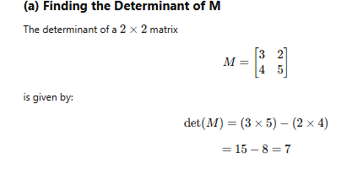

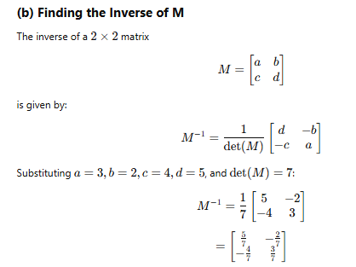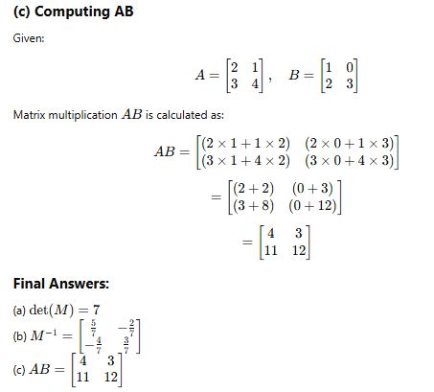

**24. Geometry and Measurement (10 Marks)**

(a) Perimeter of a rectangle is **84 m**, width = **18 m**, find length:

* **P = 2(L + W)**
* 84 = 2(L + 18)
* 42 = L + 18
* **L = 24 m**. (3 marks)

(b) Convert **750 L** to cubic meters:

* 1 cubic meter = 1000 L
* 750 L = **0.75 m³**. (3 marks)

(c) Prove **7 cm, 24 cm, 25 cm** is a right-angled triangle:

* Check if **a² + b² = c²**
* **7² + 24² = 25²**
* **49 + 576 = 625**
* **625 = 625** Right-angled! (4 marks)

**25. Probability and Data Handling (10 Marks)**

(a) Median of **5, 8, 12, 15, 20**:

* Middle value = **12**. (2 marks)

(b) Find angle for athletics in a pie chart:

* Total students = **100%**
* Other sports = **35% + 25% + 20% = 80%**
* Athletics = **20%**
* Angle = (20/100) × 360° = **72°**. (2 marks)

(c) Probability of rolling an even number:

* Even numbers on a die = {2, 4, 6}
* Probability = 3/6 = **1/2**. (2 marks)

(d) Probability of picking a banana:

* Total fruits = **10 + 8 + 7 = 25**
* Probability = **7/25**. (2 marks)

(e) Percentage profit:

* **Profit = Selling Price - Cost Price = 4200 - 3000 = 1200**
* **% Profit = (1200/3000) × 100 = 40%**. (2 marks)
  1. The perpendicular bisector of **AB = 10 cm** is a vertical line that divides AB into two equal halves (each 5 cm), with midpoint **M**.