**COMPETENCE BASED ASSESSMENT**

**GRADE NINE**

**EXTRA-ACTIVITY ASSESSMENT**

**INTEGRATED SCIENCE**

**NAME: ____________________________________________________**

**SCHOOL: ___________________________________________________**

**DATE: _____________________________________________________**

|  |  |
| --- | --- |
| 1. Calcium has an atomic number = 20. Determine: |  |
| a.) The number of electrons in calcium. | **(1mk)** |

_____________________________________________________________________________

b.) Its electronic arrangement. **(2mks)**

_____________________________________________________________________________

c.) Its electronic structure. **(3mks)**

2. Define the term compressibility. **(2mks)**

_____________________________________________________________________________

_____________________________________________________________________________

_____________________________________________________________________________

1. Mwalimu Moses brought a chart shown below in grade 7. He asked the learners to name the parts labeled by the letter as shown in the chart.

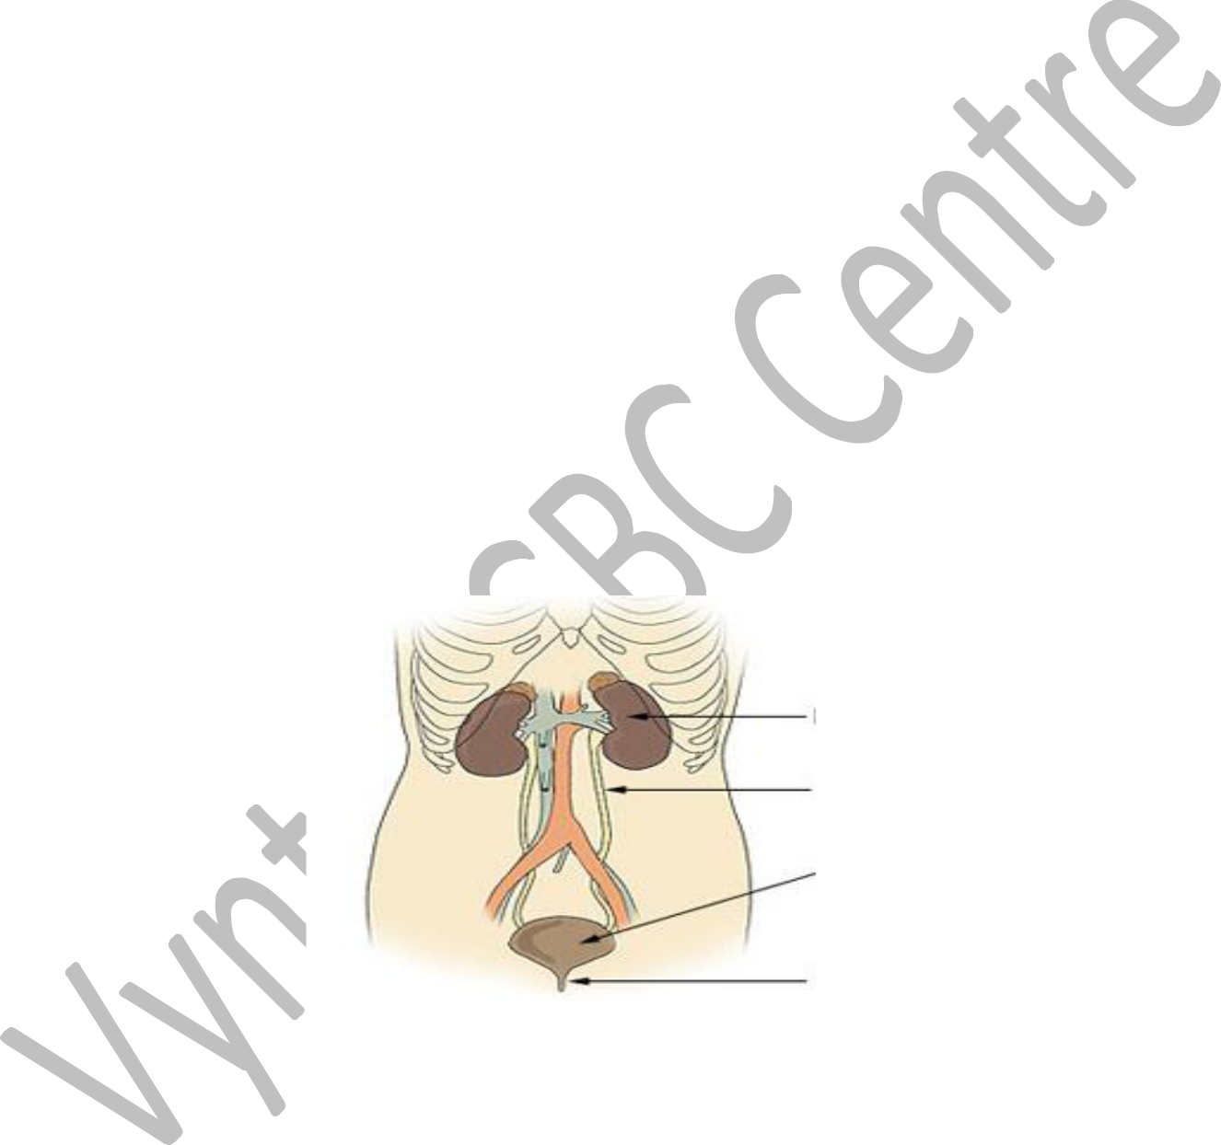

**A**

**B**

**C**

**D**

a.) Name the parts labeled A, B, C and D. **(4mks)**

1. ___________________________________________________________________________
2. ___________________________________________________________________________
3. ___________________________________________________________________________
4. ___________________________________________________________________________

b.) Write down four healthy lifestyle practices that keeps part A healthy. **(4mks)**

_____________________________________________________________________________

_____________________________________________________________________________

_____________________________________________________________________________

|  |  |
| --- | --- |
| c.) Which part: |  |
| i. Temporarily stores urine. | **(1mk)** |

_____________________________________________________________________________

ii. Carry urine form the kidney to the bladder. **(1mk)**

_____________________________________________________________________________

|  |  |  |
| --- | --- | --- |
| d.) State four excretory waste products required to be eliminated from the body. | | **(4mks)** |
| ___________________________________ | _____________________________________ | |
| ___________________________________ | _____________________________________ | |
| e.) Name any three disorders that affects part labeled A. | | **(2mks)** |

_____________________________________________________________________________

_____________________________________________________________________________

1. Grade 8 learners from a certain school set an experiment using a peeled potato as shown below. Use it to answer the questions that follow.

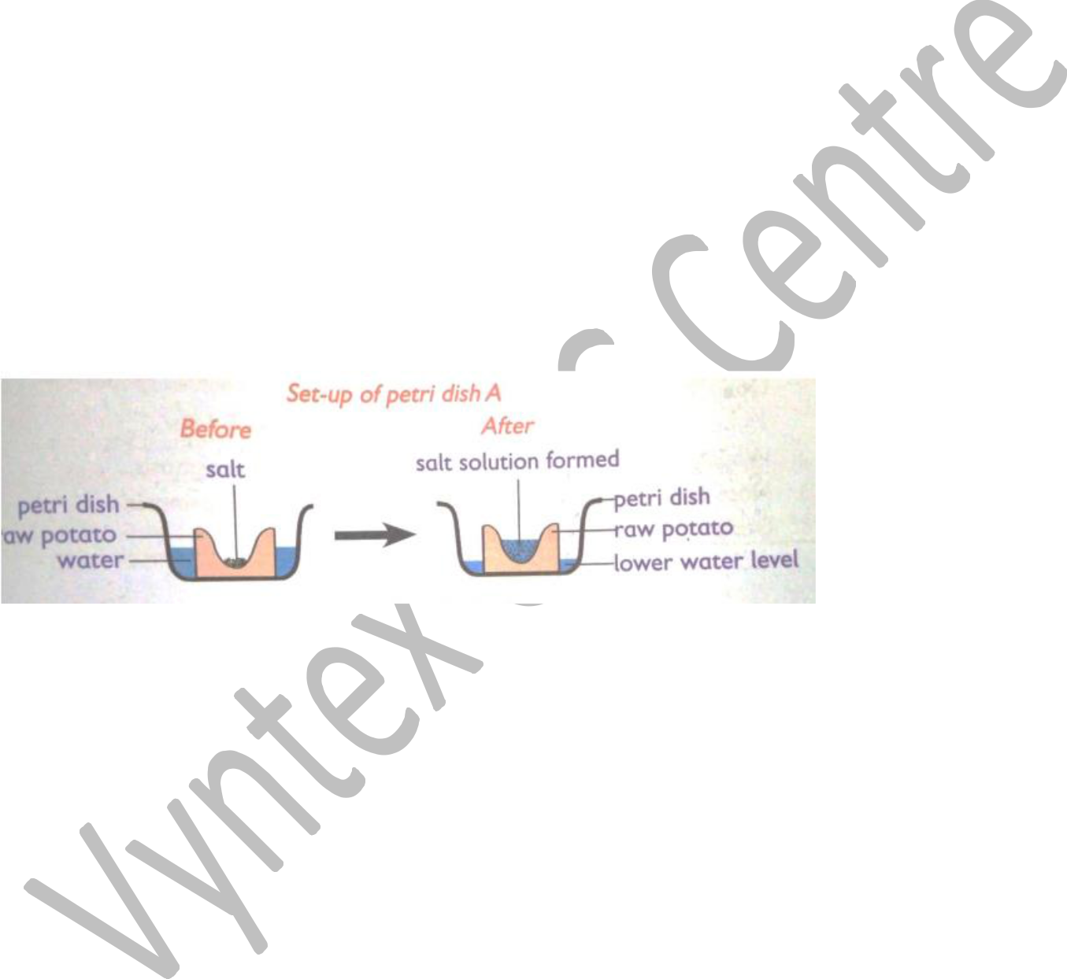

a.) Name the process being investigated through the set up above. **(1mk)**

_____________________________________________________________________________

b.) Why was it necessary to peel off the potato before using it in the experiment. **(2mks)**

_____________________________________________________________________________

_____________________________________________________________________________

c.) State the two observations after the experiment was set up. **(2mks)**

_____________________________________________________________________________

_____________________________________________________________________________

_____________________________________________________________________________

c.) Explain the observations in (b) above. **(2mks)**

_____________________________________________________________________________

_____________________________________________________________________________

e.) Explain the results in case the learners used a boiled potato. **(2mks)**

_____________________________________________________________________________

_____________________________________________________________________________

6.

a.) What are metalloids? **(2mks)**

_____________________________________________________________________________

_____________________________________________________________________________

b.) Name two examples of metalloid. _________________________________

**(2mks)**

____________________________________

7.

a.) Give two main reasons for making metal alloys. **(2mks)**

_____________________________________________________________________________

_____________________________________________________________________________

b.) Give one common use of the following metals. **(2mks)**

1. Aluminium ________________________________________________________________
2. Copper ____________________________________________________________________

8.

a.) For rusting to occur, there must be _________________ and __________________ **(2mks)**

b.) State four ways used to prevent rusting. _____________________________________ _____________________________________

**(4mks)**

_____________________________________

_____________________________________

9. Use the picture below to answer the questions that follow.

M

|  |  |  |  |  |  |
| --- | --- | --- | --- | --- | --- |
|  |  | N |  |  |  |
| a.) Name the parts labelled **M** and **N**. |  |  |  | **(2mks)** |  |
|  |  |  |  |
| M_________________________ | N __________________________ | | |  |  |
| c.) Identify the process that takes place when the two parts meet. | | | | **(1mk)** |  |

_____________________________________________________________________________

**THIS IS THE LAST PRINTED PAGE.**

**MARKING SCHEME**

**1. Calcium has an atomic number = 20. Determine:**

a.) **The number of electrons in calcium.**  
**Answer:** 20 electrons

b.) **Its electronic arrangement.**  
**Answer:** 2, 8, 8, 2

c.) **Its electronic structure.**  
**Answer:**

markdown

CopyEdit

2e⁻

8e⁻

8e⁻

2e⁻

**2. Define the term compressibility.**

**Answer:**  
Compressibility is the ability of a substance to decrease in volume when subjected to pressure.

**3. Mwalimu Moses brought a chart shown below in Grade 7. He asked the learners to name the parts labeled by the letter as shown in the chart.**

a.) **Name the parts labeled A, B, C, and D.**

* **A:** Kidney
* **B:** Ureter
* **C:** Bladder
* **D:** Urethra

b.) **Four healthy lifestyle practices that keep part A (Kidney) healthy.**

* Drinking enough water
* Eating a balanced diet
* Avoiding excessive salt and alcohol intake
* Regular exercise

c.) **Which part:**  
i. **Temporarily stores urine?**

* **Bladder**

ii. **Carries urine from the kidney to the bladder?**

* **Ureter**

d.) **Four excretory waste products required to be eliminated from the body.**

* Urea
* Carbon dioxide
* Excess water
* Salts

e.) **Three disorders that affect the kidney.**

* Kidney stones
* Kidney failure
* Urinary tract infection (UTI)

**5. Grade 8 learners from a certain school set an experiment using a peeled potato as shown below. Use it to answer the questions that follow.**

a.) **Name the process being investigated through the setup above.**

* Osmosis

b.) **Why was it necessary to peel off the potato before using it in the experiment?**

* To remove the outer skin and expose the cells to the external solution for effective osmosis.

c.) **Two observations after the experiment was set up.**

* Water collects inside the potato cavity.
* The level of water inside the potato increases.

d.) **Explain the observations in (c) above.**

* Water moves from the surrounding solution into the potato by osmosis since the potato cells contain a more concentrated solution.

e.) **Explain the results in case the learners used a boiled potato.**

* No water movement would be observed because boiling kills the potato cells, making them lose their semi-permeability, preventing osmosis.

**6.**

a.) **What are metalloids?**

* Metalloids are elements that have properties of both metals and non-metals.

b.) **Two examples of metalloids.**

* Silicon
* Boron

**7.**

a.) **Two main reasons for making metal alloys.**

* To improve strength and durability
* To enhance resistance to corrosion

b.) **One common use of the following metals:**  
i. **Aluminium:** Used in making airplane bodies due to its lightweight and strength.  
ii. **Copper:** Used in electrical wiring because of its high conductivity.

**8.**

a.) **For rusting to occur, there must be:**

* **Oxygen**
* **Water**

b.) **Four ways used to prevent rusting.**

* Painting metal surfaces
* Galvanization (coating with zinc)
* Oiling or greasing
* Using stainless steel (alloying with chromium)

**9.**

a.) **Name the parts labeled M and N.**

* **M:** Sperm cell
* **N:** Egg cell (Ovum)

b.) **Identify the process that takes place when the two parts meet.**

* Fertilization