JUNIOR SCHOOL EDUCATION ASSESSMENT
GRADE 9
TERM ONE 2025 OPENER
NAME: ……………………………………………………………………..
SCHOOL: ………………………………………………………………….
ASSESSMENT NUMBER: ……………………………………………….
SIGNATURE: ……………………………….DATE:……………………..
INTEGRATED SCIENCE

ASSESSMENT RUBRICS

Learning Performance | Exceeds | Meets | Approaching | Below
area | Expectations (4) | Expectations (3) | Expectations (2) | Expectations (1)
Integrated
Science

- During a practical lesson, a group of grade 8 learners were shown by their teacher the change when zinc (II) oxide is heated.

(a) What observations did the learners make at the end of the lesson?
(1 mark)

.................................................................................................................................................

(b) Identify the type of change that was demonstrated.

(1 mark)

.................................................................................................................................................

(c) State three characteristics of the type of change stated in (a) above.

(2 marks)

.................................................................................................................................................

.................................................................................................................................................

- The diagram below shows the heating curve of a pure substance. Study it carefully then answer the questions that follow.
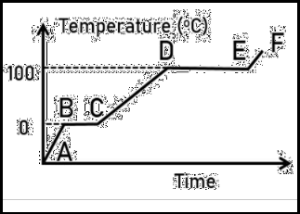

(a) Using the kinetic theory of matter, explain what happens to the substances between points A and B.

................................................................................................................................................................................................................................................................................ | (2 marks)
(b) What happens to the temperature between points B and C? | (1 mark)
.......................................................................................................................................
(c) What would happen to the melting point of this substance if it were contaminated with
sodium chloride?................................................................................................................. | (1 mark)
- Gloria and Patrick carried out a practical activity on an onion epidermal cell in the science laboratory. The following are the steps they followed.
Place it on a microscope slide. Put a coverslip over it.

Peel a very thin layer of onion skin off.

Add a few drops of iodine solution. Draw what you see.

Place it under a microscope to view it.

The steps are not in the correct order. Help gloria and Patrick rearrange the steps in the

correct order. (4 marks)

.................................................................................................................................................

.................................................................................................................................................

.................................................................................................................................................

.................................................................................................................................................

.................................................................................................................................................

.................................................................................................................................................

- In investigating a certain physiological process, a group of grade 8 learners set up the apparatus as shown below and made the observations after 30 minutes.
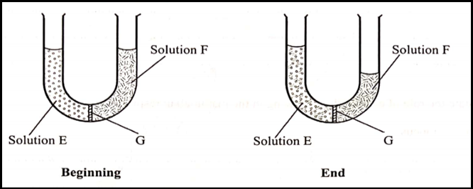

(a) Name the physiological process being investigated. (1 mark)

.................................................................................................................................................

(b) Account for the observations made at the end of the experiment. (2 marks)

.................................................................................................................................................

.................................................................................................................................................
(c) State the likely identity of G. (1 mark)
.................................................................................................................................................
5. A Grade 8 learner was using a light microscope to view onion cells. If the eye piece lens magnification
was × 10 while the objective lens he used was × 40, calculate the total magnification. (3 marks)
.................................................................................................................................................
.................................................................................................................................................
.................................................................................................................................................

- A group of learners were tasked by their teacher to classify the following changes as either chemical or physical. Souring of milk, heating glass until it melts, adding common salt to water, rusting of rooftops, striking a matchstick and heating hydrated copper (II) sulphate.

Classify the changes as either physical or chemical. (3 marks)

Physical changes

Chemical change

- A Grade 8 learner was tasked by his teacher to draw a fire triangle. The figure below shows what the learner drew.
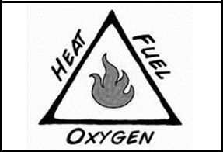

(a) What mistake did the learner made? (1 mark)

.................................................................................................................................................

(b) Draw the correct fire triangle. (2 marks)

.................................................................................................................................................

.................................................................................................................................................

- The diagram below shows a specialised plant cell. Study it carefully and then answer the questions that follow.
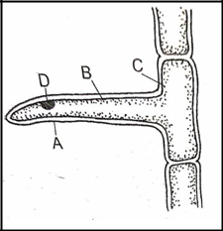

(a) Name the cell. .................................................................... (1 mark)
(b) Name the parts labelled A, B, C and D. (2 marks)
.................................................................................................................................................
.................................................................................................................................................
(c) State the function of the part labelled D. (1 mark)
.................................................................................................................................................

- Mutie came across the following specialised cell when carrying out his research using print media resources. Study it carefully and then answer the questions that follow.
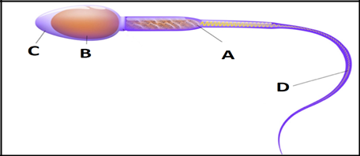

(a) Identify the parts labelled A, B, C and D. (2 marks)
.................................................................................................................................................
.................................................................................................................................................
(b) State the importance of the part labelled A in the above cell. (1 mark)
.................................................................................................................................................
(c) How is the cell illustrated above involved in the process of fertilisation? (1 marks)
.................................................................................................................................................

10. The illustration below shows a summary of the main phases of the human

menstrual cycle.



(a) Name the process that takes place around the 14th day. (1 mark)

.................................................................................................................................................

(b) Under which two conditions would the cycle be interrupted? (2 marks)

.................................................................................................................................................

.................................................................................................................................................

(c) Apart from pain and irregular periods, name one other challenge related to the menstrual cycle.

................................................................................................................................................. (1 mark)

- Halima and Rashid saw their mother lighting a jiko as shown in the picture below.

  - Write two-word equations of the reaction likely to take place at the regions labelled A and B.
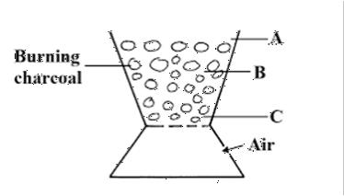

................................................................................................................................................. (2 marks)

(b) Identify the type of change that takes place when burning charcoal. ................................... (1 mark)

- Three learners in Grade 8 were discussing the symbol of different elements. They wrote the following in their notebooks.
Lead – Au Iron – Fe Gold – Ag Copper - Co Sodium – Na

Aluminium - Ai

(a) Which of the above elements were their symbols wrongly written? (2 marks)

.................................................................................................................................................

.................................................................................................................................................

(b) Write the symbols in (a) above correctly. (2 marks)

.................................................................................................................................................

.................................................................................................................................................

- Grade 8 learners used their digital devices connected to the internet to search for information

on symptoms of HIV and AIDS and how it can be prevented. What information are they likely to find?

................................................................................................................................................. (4 marks)

.................................................................................................................................................

.................................................................................................................................................

.................................................................................................................................................

- The photograph below shows the energy transformation in an electrical circuit. Study it and then answer the question that follows.
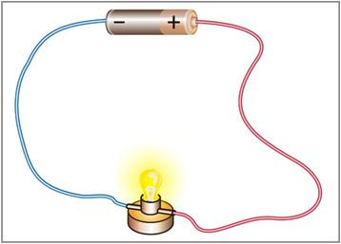

Describe the energy transformation taking place in the picture above. (2 marks)

.................................................................................................................................................

.................................................................................................................................................

