**KENYA JUNIOR SCHOOL EDUCATION ASSESSMENT**

**FORMATIVE ASSESSMENT 2025**  
**GRADE** **9 - 905/1: INTEGRATED SCIENCE (Theory)**

**NAME:** _______________________________________________________________________  
**SCHOOL:** _____________________________________________________________________  
**DATE:** _____________________________________**SIGN:** _____________________________  
**MARKS:** **70**  
**TIME:** **1 Hour 40 Minutes**

| **Section** | **Score** | **Learner’s Score** |
| --- | --- | --- |
| **SECTION A** | 30 |  |
| **SECTION B** | 40 |  |
| **TOTAL** | 70 |  |

**SCORE RANGE AND PERFORMANCE LEVELS**

| **Score Range** | **Performance Level** |
| --- | --- |
| 1-19 | Below Expectation (BE) |
| 20-39 | Approaching Expectation (AE) |
| 40-59 | Meeting Expectation (ME) |
| 60-70 | Exceeding Expectation (EE) |

**INSTRUCTIONS**

1. Read all instructions carefully before attempting the questions.
2. Answer all questions in the spaces provided.
3. Write neatly and clearly using correct spelling and grammar.
4. Do not leave any question unanswered.
5. Explain answers clearly for structured questions.
6. Manage your time well to complete all sections within the allocated time.
7. Ensure your work is clean and legible before submission.
8. Cross-check your answers before handing in your paper.
9. **Do not copy or share answers during the exam.**

**SECTION A: (30 Marks)**

1. Which of the following substances is corrosive?

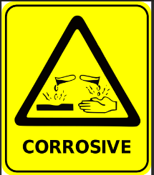

A. Sugar B. Vinegar  
C. Bleach D. Cooking Oil

1. Which of the following is a reason for studying Integrated Science?  
   A. To understand history  
   B. To become a musician  
   C. To understand nature and solve problems  
   D. To memorize facts
2. Identify the correct chemical symbols:  
   A. He, Na, Ca, Br B. Ho, Ne, Mg, Cl  
   C. H, Na, Al, Si D. H, N, Al, Ag
3. Which of the following consists only of compounds?  
   A. Oxygen and Water  
   B. Water and Carbon Dioxide  
   C. Carbon and Oxygen  
   D. Sodium and Hydrogen
4. Which of the following are homogeneous mixtures?  
   A. Sand and Water, Oil and Water  
   B. Sugar and Water, Milk and Water  
   C. Salt and Sand, Flour and Water  
   D. Vinegar and Oil, Flour and Oil
5. Which of the following are metals?  
   A. Calcium and Sodium  
   B. Carbon and Oxygen  
   C. Sulfur and Nitrogen  
   D. Chlorine and Fluorine
6. Which diagram represents the arrangement of particles in air and

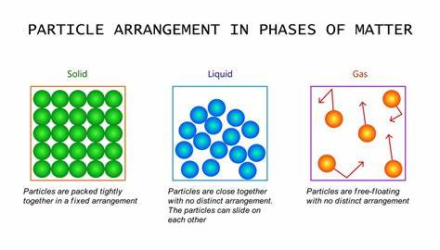A B

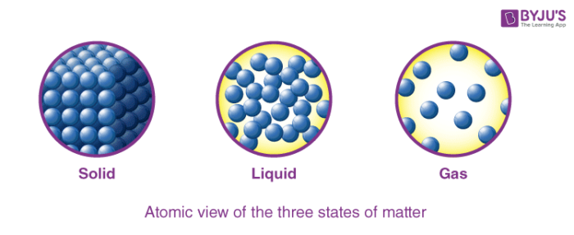

C D

1. Which of the following will not help in controlling fire?  
   A. Turning on the fire alarm  
   B. Using a fire extinguisher  
   C. Removing flammable materials  
   D. Pouring water on a fire
2. Which methods can make hard water lather easily?  
   A. Filtering the water  
   B. Boiling the water and adding washing soda  
   C. Adding salt  
   D. Stirring the water
3. Which of the following are physical changes?  
   A. Burning wood and boiling water  
   B. Rusting iron and melting ice  
   C. Water becoming ice and drying of wet clothes  
   D. Cooking food and dissolving sugar in water
4. Which of the following are applications of bases?  
   A. Vinegar and Baking Powder  
   B. Lemon Juice and Soap  
   C. Toothpaste and Baking Powder  
   D. Vinegar and Washing Soda
5. What is the function of the testes in males?  
   A. Producing hormones and sperms  
   B. Carrying urine out of the body  
   C. Producing eggs  
   D. Holding urine
6. Which of the following is a characteristic change in boys only during puberty?  
   A. Hips widen  
   B. Breasts enlarge  
   C. Voice deepens  
   D. Hair grows under armpits
7. 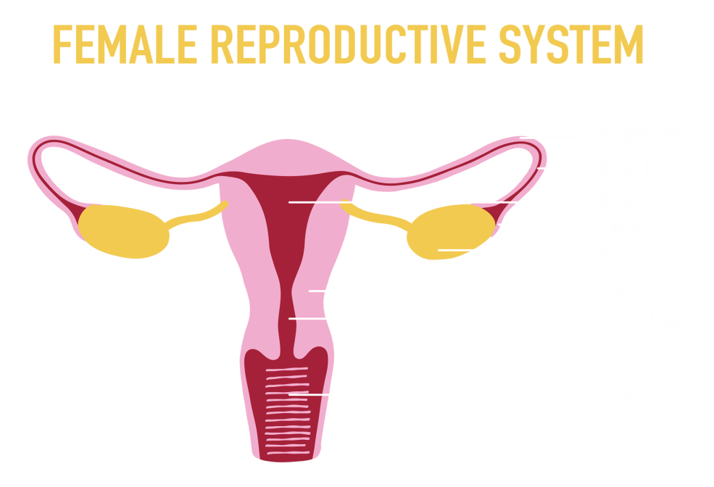Part **N** in the female reproductive system is known as:

**N**

A. Fallopian Tube B. Vagina  
C. Ovary D. Uterus

1. Fertilization occurs in which part of the female reproductive system?  
   A. Oviduct B. Uterus  
   C. Vagina D. Ovary
2. The best way to manage mood swings during adolescence is:  
   A. Isolating yourself  
   B. Watching TV all day  
   C. Doing physical exercises regularly  
   D. Ignoring emotions
3. Which organ temporarily stores urine?  
   A. Kidney B. Ureter  
   C. Bladder D. Urethra
4. The function of the kidney is to:  
   A. Absorb nutrients  
   B. Filter waste from blood  
   C. Store urine  
   D. Remove sweat
5. The part of the skin that produces sweat is:  
   A. Hair follicle B. Fat layer  
   C. Oil gland D. Sweat gland
6. What is the function of the epidermis in the skin?  
   A. Protecting against physical injury  
   B. Storing fat  
   C. Producing sweat  
   D. Storing blood
7. Where is most water absorbed in the digestive system?  
   A. Stomach B. Large intestine  
   C. Small intestine D. Liver
8. Chisel-shaped teeth are used for:  
   A. Tearing food B. Cutting food  
   C. Grinding food D. Chewing food
9. Which of these is an unhealthy habit for kidney health?  
   A. Drinking enough water  
   B. Eating fruits and vegetables  
   C. Exercising regularly  
   D. Eating too much sugary food
10. A freely suspended bar magnet always aligns itself in which direction?  
    A. East-West B. North-South  
    C. Up-Down D. Randomly
11. A magnet can attract which object?  
    A. Wooden block B. Iron nail  
    C. Rubber ball D. Glass sheet
12. Which of the following is a renewable energy source?  
    A. Coal B. Natural gas  
    C. Geothermal D. Petrol
13. 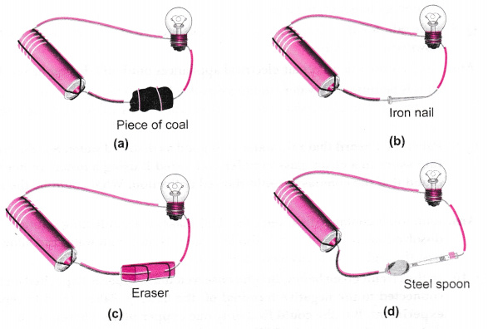In which electric circuit will a bulb not light?

**A B**



**C D**

1. Which of the following is a safe electrical practice?  
   A. Operating appliances with wet hands  
   B. Overloading sockets  
   C. Repairing broken wires yourself  
   D. Switching off appliances when not in use
2. What is the function of the placenta in pregnancy?  
   A. It stores waste  
   B. It protects the baby from injury  
   C. It supplies oxygen and nutrients to the baby  
   D. It helps in fertilization
3. Which of the following causes rusting in iron?  
   A. Heat and electricity  
   B. Oxygen and moisture  
   C. Cold and pressure  
   D. Fire and sunlight

**SECTION B:**

1. (a) Name any one laboratory safety rules. (1 mark)

__________________________________________________________________________________________________________________________________________________________  
 (b) Explain why it is important to wear a lab coat during experiments. (1 mark)

__________________________________________________________________________________________________________________________________________________________

1. (a) Differentiate between a chemical change and a physical change. (2 marks)

__________________________________________________________________________________________________________________________________________________________  
 (b) Give two examples of each. (2 marks)

__________________________________________________________________________________________________________________________________________________________

1. Draw and label a simple electric circuit containing a bulb, battery, and switch. (5 marks)
2. (a) Name one diseases of the urinary system. (1 mark)

_________________________________________________________________________________________________________________________________________________________

1. (a) What is the function of the small intestine in digestion? (2 marks)

__________________________________________________________________________________________________________________________________________________________  
(b) Name one digestive enzyme and state their functions. (1 mark)

__________________________________________________________________________________________________________________________________________________________

1. (a) Name one non-magnetic material. (1 mark)

__________________________________________________________________________________________________________________________________________________________  
(b) State one uses of magnets in everyday life. (1 mark)

__________________________________________________________________________________________________________________________________________________________

1. A student placed a raisin in a beaker of water and left it overnight. The next day, the raisin had swollen.

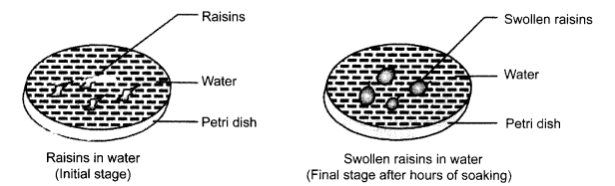

**(a) Name the process that caused the raisin to swell. (1 mark)**

**__________________________________________________________________________________  
(b) Explain how this process occurred. (1 mark)**

**________________________________________________________________________________________________________________________________________________________________________  
(c) What would happen if the raisin were placed in a strong sugar solution instead of water? Explain. (1 mark)**

**________________________________________________________________________________________________________________________________________________________________________**

1. In a perfume shop, a customer sprayed perfume on one side of the room, and within a few seconds, people on the other side could smell it.

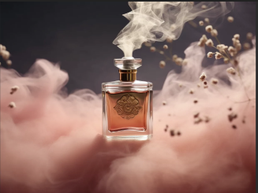

**(a) What process is responsible for the movement of the perfume molecules? (1 mark)**

**__________________________________________________________________________________  
(b) State two factors that affect the rate of this process. (2 marks)**

**________________________________________________________________________________________________________________________________________________________________________  
(c) Why does diffusion occur faster in gases than in liquids? (2 marks)**

**________________________________________________________________________________________________________________________________________________________________________**

1. During a science lesson, a teacher drew a diagram of an atom on the board. The diagram had a nucleus and several particles orbiting it.

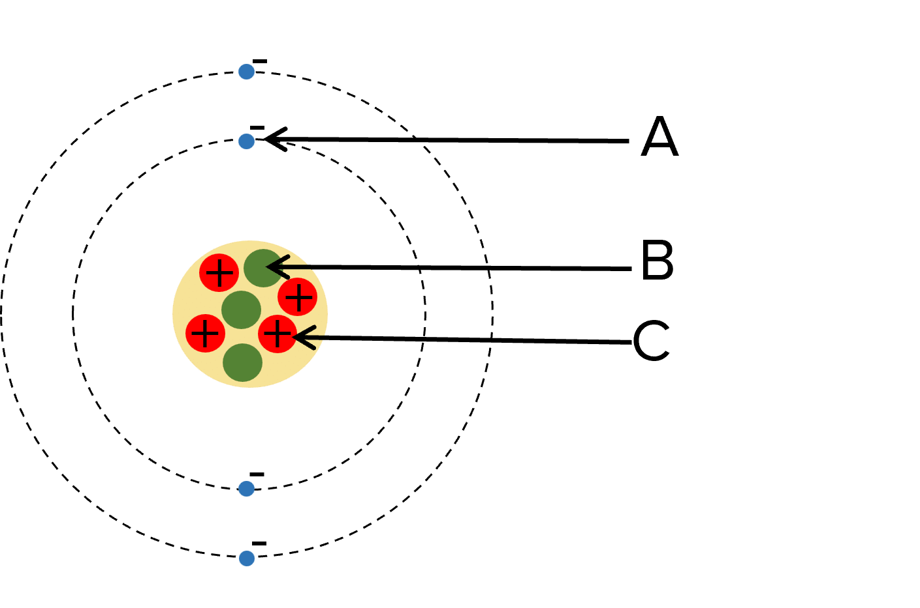

**(a) Name the three subatomic particles of an atom. (3 marks)**

**____________________________________________________________________________________________________________________________________________________________________________________________________________________________________________________________  
(b) Which subatomic particle carries a negative charge? (1 mark)**

**___________________________________________________________________________________  
(c) Where in the atom are protons found? (1 mark)**

_________________________________________________________________________________

1. A scientist examined the electron arrangement of an element with atomic number 12.

**(a) Write the electron configuration of this element. (1 mark)**

**________________________________________________________________________________________________________________________________________________________________________  
(b) Which group in the periodic table does this element belong to? (1 mark)**

**___________________________________________________________________________________  
(c) Why is it classified as a metal? (2 marks)**

**___________________________________________________________________________________  
(d) How many valence electrons does it have? (1 mark)**

_____________________________________________________________________________________________________________________________________________________________________

1. During a nature walk, students collected different types of leaves and observed their internal structure under a microscope.

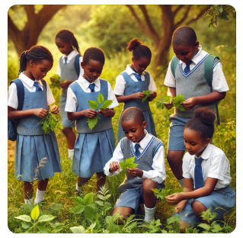

**(a) Which internal structure of the leaf contains chlorophyll? (1 mark)**

**___________________________________________________________________________________  
(b) State two functions of the stomata in a leaf. (2 marks)**

**________________________________________________________________________________________________________________________________________________________________________  
(c) What is the role of the veins in a leaf? (2 marks)**

______________________________________________________________________________________________________________________________________________________________________

### ****THIS IS THE LAST PRINTED PAGE****

### ****MARKING SCHEME****

1. **C**. Bleach
2. **C**. To understand nature and solve problems
3. **A**. He, Na, Ca, Br
4. **B**. Water and Carbon Dioxide
5. **B**. Sugar and Water, Milk and Water
6. **A**. Calcium and Sodium
7. **A**
8. **D**. Pouring water on a fire
9. **B**. Boiling the water and adding washing soda
10. **C**. Water becoming ice and drying of wet clothes
11. **C**. Toothpaste and Baking Powder
12. **A**. Producing hormones and sperms
13. **C**. Voice deepens
14. **D**. Uterus
15. **A**. Oviduct (Fallopian Tube)
16. **C**. Doing physical exercises regularly
17. **C**. Bladder
18. **B**. Filter waste from blood
19. **D**. Sweat gland
20. **A**. Protecting against physical injury
21. **C**. Small intestine
22. **B**. Cutting food
23. **D**. Eating too much sugary food
24. **B**. North-South
25. **B**. Iron nail
26. **C**. Geothermal energy
27. **C-**
28. **D**. Switching off appliances when not in use
29. **C**. It supplies oxygen and nutrients to the baby
30. **B**. Oxygen and moisture

**31. (a) Name any one laboratory safety rule. (1 mark)**

One laboratory safety rule is: **Do not eat or drink in the laboratory.**  
**Explanation:** Eating or drinking in the laboratory can lead to accidental ingestion of harmful chemicals, contamination of food, or interference with experiments.

**(b) Explain why it is important to wear a lab coat during experiments. (1 mark)**

Wearing a lab coat is important because it **protects the body and clothing from chemical spills, harmful substances, and biological materials.**  
**Explanation:** Some chemicals can cause skin burns or irritation. The lab coat acts as a barrier, reducing direct contact with these hazardous substances.

**32. (a) Differentiate between a chemical change and a physical change. (2 marks)**

* **Chemical Change:** A change where new substances with different properties are formed. The change is usually irreversible.  
  **Example:** Burning of wood produces ash and gases, which are different from the original wood.
* **Physical Change:** A change that affects only the form or appearance of a substance without creating a new substance. It is usually reversible.  
  **Example:** Melting of ice into water, as it can be refrozen into ice.

**(b) Give two examples of each. (2 marks)**

* **Examples of Chemical Changes:**
  1. Rusting of iron
  2. Digestion of food
* **Examples of Physical Changes:**
  1. Boiling of water
  2. Cutting a piece of paper

**33. Draw and label a simple electric circuit containing a bulb, battery, and switch. (5 marks)**

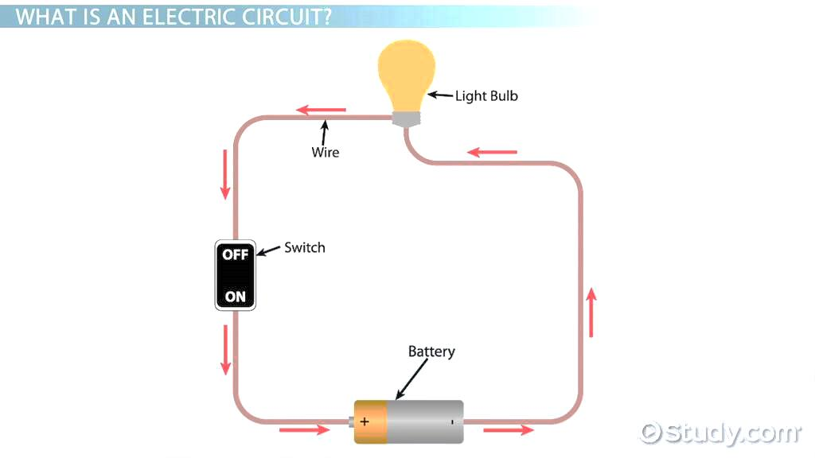

**34. (a) Name one disease of the urinary system. (1 mark)**

One disease of the urinary system is **kidney stones.**  
**Explanation:** Kidney stones are hard mineral deposits that form in the kidneys. They can cause severe pain and difficulty in urination.

**35. (a) What is the function of the small intestine in digestion? (2 marks)**

The small intestine **absorbs nutrients from digested food into the bloodstream.**  
**Explanation:** The walls of the small intestine contain tiny finger-like projections called **villi**, which increase the surface area for absorption. Nutrients such as glucose, amino acids, and fatty acids are absorbed and transported to the rest of the body.

**(b) Name one digestive enzyme and state its function. (1 mark)**

One digestive enzyme is **amylase.**  
**Function:** Amylase breaks down starch into simple sugars like maltose. It is found in saliva and the pancreas.

**36. (a) Name one non-magnetic material. (1 mark)**

One non-magnetic material is **plastic.**  
**Explanation:** Non-magnetic materials do not attract or respond to magnets because they lack magnetic properties.

**(b) State one use of magnets in everyday life. (1 mark)**

**Magnets are used in refrigerator doors to keep them closed.**  
**Explanation:** A magnet strip in the door helps it stay shut, preventing cold air from escaping and keeping food fresh.

**37. (a) Name the process that caused the raisin to swell. (1 mark)**

The process is called **osmosis.**

**(b) Explain how this process occurred. (1 mark)**

**Explanation:** Osmosis is the movement of water molecules from a region of low solute concentration (water in the beaker) to a region of high solute concentration (inside the raisin) through a semi-permeable membrane. Since the raisin has a higher concentration of solutes, water moves into it, making it swell.

**(c) What would happen if the raisin were placed in a strong sugar solution instead of water? Explain. (1 mark)**

The raisin would **shrink** instead of swelling.  
**Explanation:** In a strong sugar solution, water would move out of the raisin into the solution because the sugar solution has a lower water concentration. This causes the raisin to lose water and become smaller.

**38. (a) What process is responsible for the movement of the perfume molecules? (1 mark)**

The process is called **diffusion.**  
**Explanation:** Diffusion is the movement of particles from an area of high concentration to an area of low concentration until they are evenly spread.

**(b) State two factors that affect the rate of this process. (2 marks)**

1. **Temperature:** Higher temperatures increase the movement of molecules, speeding up diffusion.
2. **Concentration gradient:** A higher difference in concentration leads to faster diffusion.

**(c) Why does diffusion occur faster in gases than in liquids? (2 marks)**

**Explanation:** In gases, molecules are further apart and move freely at high speeds, leading to faster diffusion. In liquids, molecules are closer together and move more slowly due to intermolecular forces, making diffusion slower.

**39. (a) Name the three subatomic particles of an atom. (3 marks)**

1. **Electron**
2. **Neutron**
3. **Proton**

**(b) Which subatomic particle carries a negative charge? (1 mark)**

The **electron** carries a negative charge.

**(c) Where in the atom are protons found? (1 mark)**

Protons are found in the **nucleus** of the atom.

**40. (a) Write the electron configuration of an element with atomic number 12. (1 mark)**

The electron configuration is **2, 8, 2.**

**(b) Which group in the periodic table does this element belong to? (1 mark)**

It belongs to **Group 2** (alkaline earth metals).

**(c) Why is it classified as a metal? (2 marks)**

* It **easily loses electrons** to form positive ions (cations).
* It is **a good conductor of electricity and heat.**

**(d) How many valence electrons does it have? (1 mark)**

It has **2 valence electrons** (in the outermost shell).

**41. (a) Which internal structure of the leaf contains chlorophyll? (1 mark)**

The **chloroplasts** contain chlorophyll.  
**Explanation:** Chlorophyll is the green pigment responsible for capturing sunlight for photosynthesis.

**(b) State two functions of the stomata in a leaf. (2 marks)**

1. **Allow gas exchange:** Stomata let in carbon dioxide (CO₂) for photosynthesis and release oxygen (O₂).
2. **Control water loss:** They regulate transpiration by opening and closing to maintain water balance.

**(c) What is the role of the veins in a leaf? (2 marks)**

1. **Transport water and minerals** from the roots to the leaf through the xylem.
2. **Transport food (glucose)** from the leaf to the rest of the plant through the phloem.