**COMPETENCE BASED ASSESSMENT**

**GRADE NINE**

**EXTRA-ACTIVITY ASSESSMENT**

**CREATIVE ARTS AND SPORTS**

**NAME: ____________________________________________________**

**SCHOOL: ___________________________________________________**

**DATE: _____________________________________________________**

.

|  |  |
| --- | --- |
| 1. State **five** careers in creative arts and sports. | **(5mks)** |

_____________________________________________________________________________

_____________________________________________________________________________

_____________________________________________________________________________

_____________________________________________________________________________

2. State the **four** categories of creative arts and sports. **(4mks)**

_____________________________________________________________________________

_____________________________________________________________________________

_____________________________________________________________________________

_____________________________________________________________________________

3. State **five** phases in a javelin throw. **(5mks)**

_____________________________________________________________________________

_____________________________________________________________________________

_____________________________________________________________________________

_____________________________________________________________________________

_____________________________________________________________________________

4. State **five** creative arts forms appreciated through sense of sight. **(5mks)**

_____________________________________________________________________________

_____________________________________________________________________________

_____________________________________________________________________________

_____________________________________________________________________________

_____________________________________________________________________________

5. Explain the meaning of the following elements of play.

a.) Theme

**(4mks)**

_____________________________________________________________________________

_____________________________________________________________________________

b.) Character

_____________________________________________________________________________

_____________________________________________________________________________



c.) Plot

_____________________________________________________________________________

_____________________________________________________________________________

d.) Setting

_____________________________________________________________________________

_____________________________________________________________________________

6.

a.) Name **two** types of passes used in netball. **(2mks)**

_____________________________________________________________________________

_____________________________________________________________________________

b.) Give two types of landing techniques in the game of netball. **(2mks)**

_____________________________________________________________________________

_____________________________________________________________________________

c.) Give three importance of pivoting in the game of netball. **(2mks)**

_____________________________________________________________________________

_____________________________________________________________________________

_____________________________________________________________________________

_____________________________________________________________________________

7. Grade 8 learners designed a dress and decorated with the following decorations techniques.

Identify the techniques illustrated in the pictures below. **(2mks)**

**A** **B**

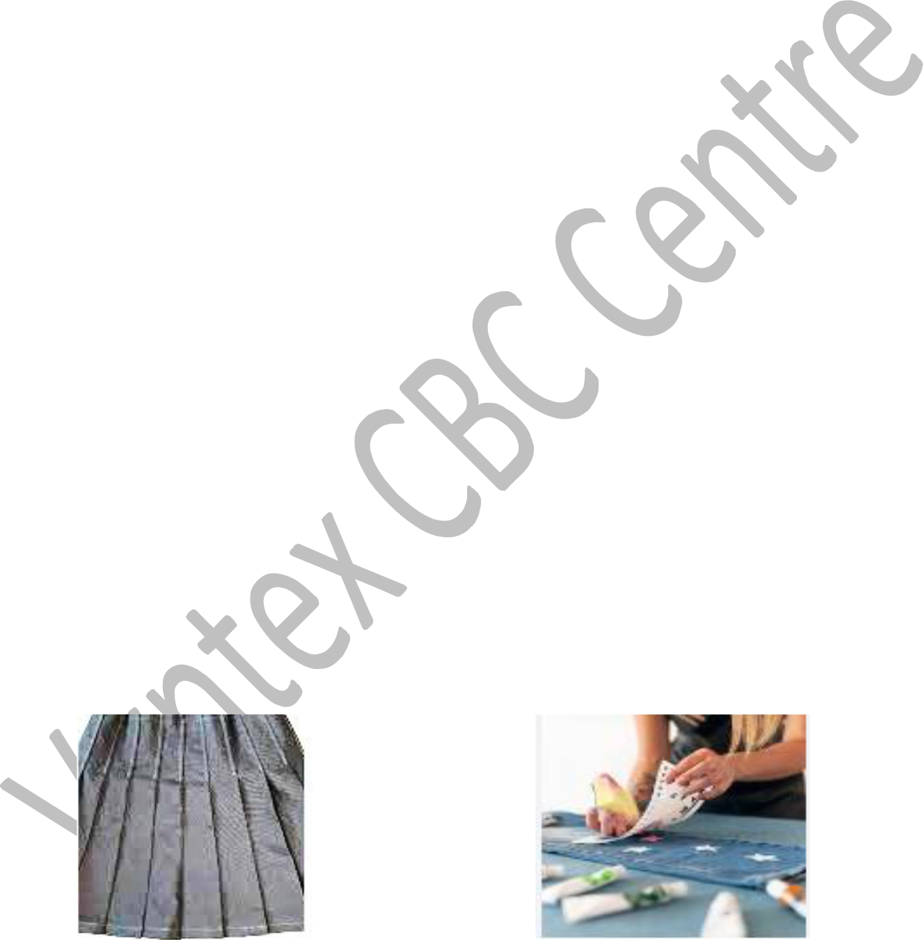

________________________________

_______________________________________

8. Give **four** techniques of playing a descant recorder.

**(4mks)**



_____________________________________________________________________________

_____________________________________________________________________________

_____________________________________________________________________________

_____________________________________________________________________________

9. List three safety measures to observe when performing a high jump. **(3mks)**

_____________________________________________________________________________

_____________________________________________________________________________

_____________________________________________________________________________

_____________________________________________________________________________

10. Identify the following types of music notes as either crotchet, minim, quaver and semi-

quaver. **(4mks)**

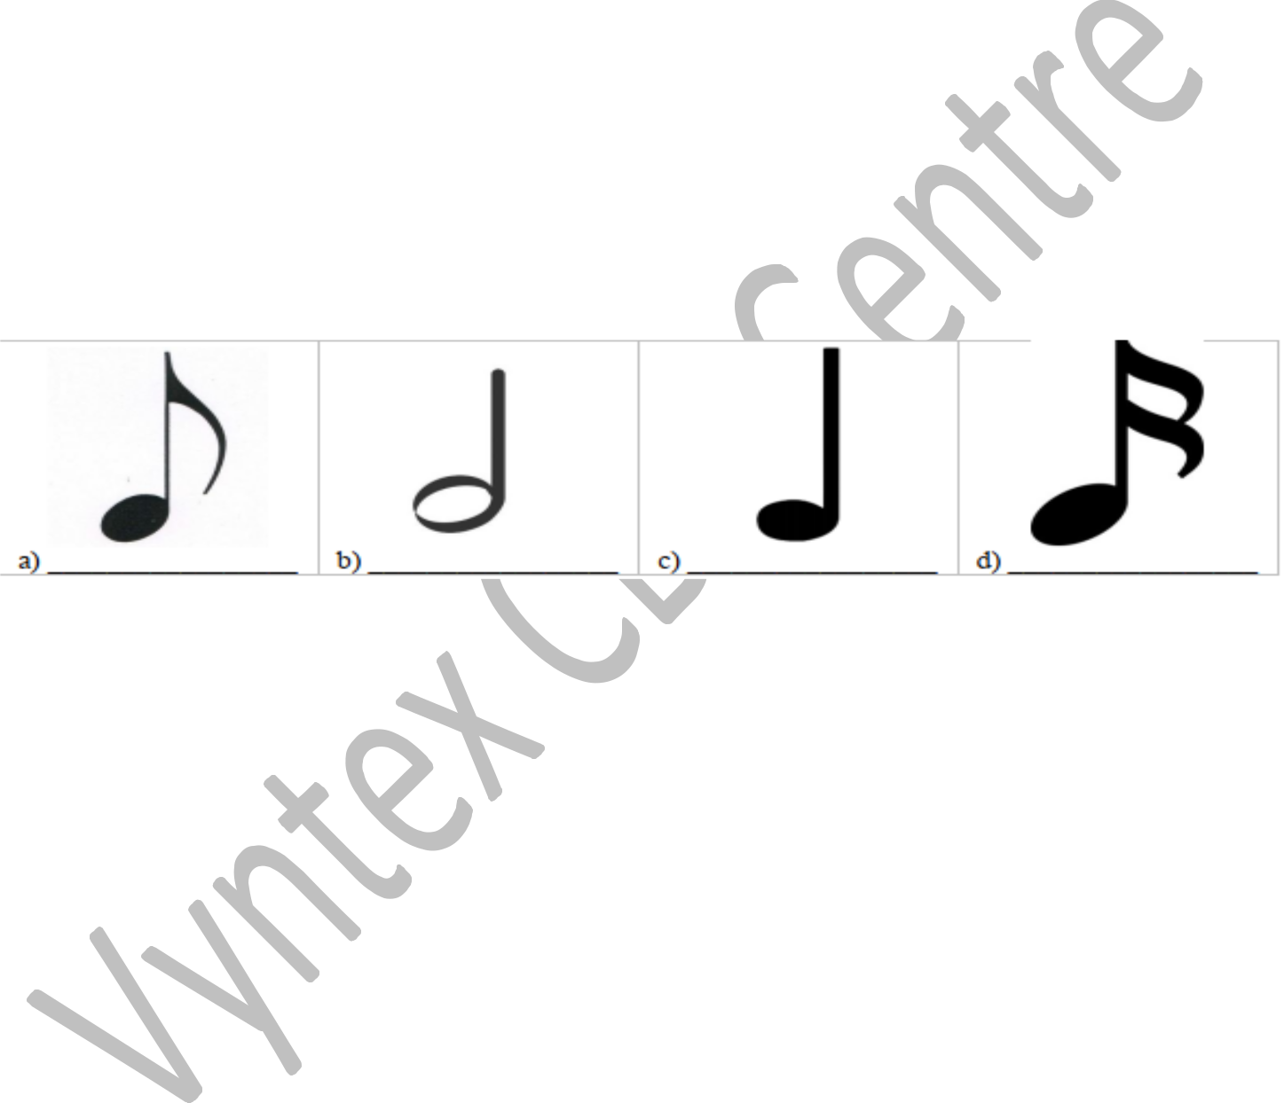

11. Name five different types of beads used in beadworks **(5mks)**

_____________________________________________________________________________

_____________________________________________________________________________

_____________________________________________________________________________

_____________________________________________________________________________

_____________________________________________________________________________

12.

a.) What is physical fitness? **(1mk)**

_____________________________________________________________________________

_____________________________________________________________________________

b.) Name two components of physical fitness. **(2mks)**

___________________________________________________________

___________________________________________________________

**THIS IS THE LAST PRINTED PAGE.**

**ANSWERS**

**1. Five Careers in Creative Arts and Sports (5 marks)**

* Musician
* Actor/Actress
* Graphic Designer
* Professional Athlete
* Choreographer

**2. Four Categories of Creative Arts and Sports (4 marks)**

* Performing Arts
* Visual Arts
* Literary Arts
* Sports and Physical Activities

**3. Five Phases in a Javelin Throw (5 marks)**

* Approach run
* Withdrawal (carrying phase)
* Transition phase
* Delivery phase (throwing phase)
* Recovery

**4. Five Creative Arts Forms Appreciated Through the Sense of Sight (5 marks)**

* Painting
* Sculpture
* Photography
* Architecture
* Fashion Design

**5. Elements of Play and Their Meanings (4 marks each)**

**a.) Theme:**  
The central idea or message in a play that reflects the main subject or moral lesson.

**b.) Character:**  
A person, animal, or figure in a play who carries out the actions and conveys the story.

**c.) Plot:**  
The sequence of events in a play, including the beginning, middle, and end.

**d.) Setting:**  
The time and place where the events of a play take place.

**6. Netball Skills**

**a.) Two Types of Passes Used in Netball** (2 marks)

* Chest pass
* Bounce pass

**b.) Two Types of Landing Techniques in Netball** (2 marks)

* One-foot landing
* Two-foot landing

**c.) Three Importance of Pivoting in Netball** (2 marks)

* Helps in maintaining ball control
* Enables quick passing and shooting
* Helps players avoid stepping violations

**7. Dress Decoration Techniques**

* **A:** Embroidery
* **B:** Beadwork

**8. Four Techniques of Playing a Descant Recorder (4 marks)**

* Proper finger placement
* Correct blowing technique
* Tonguing (articulation)
* Breath control

**9. Three Safety Measures When Performing a High Jump (3 marks)**

* Ensure the landing area is cushioned
* Perform warm-up exercises before jumping
* Use the correct jumping technique to avoid injuries

**10. Identifying Music Notes (4 marks)**

* **Crotchet:** One beat
* **Minim:** Two beats
* **Quaver:** Half a beat
* **Semi-quaver:** Quarter beat

**11. Five Different Types of Beads Used in Beadwork (5 marks)**

* Glass beads
* Wooden beads
* Plastic beads
* Ceramic beads
* Metal beads

**12. Physical Fitness**

**a.) Definition of Physical Fitness** (1 mark)  
The ability of the body to perform physical activities efficiently without excessive fatigue.

**b.) Two Components of Physical Fitness** (2 marks)

* Cardiovascular endurance
* Muscular strength