JUNIOR SCHOOL EDUCATION ASSESSMENT
GRADE 9
TERM ONE 2025 OPENER
NAME: ……………………………………………………………………..
SCHOOL: ………………………………………………………………….
ASSESSMENT NUMBER: ……………………………………………….
SIGNATURE: ……………………………….DATE:……………………..
CREATIVE ARTS AND SPORTS

ASSESSMENT RUBRICS

Learning | Performance | Exceeds |  | Meets | Approaching |  | Below
area |  | Expectations (4) |  | Expectations (3) | Expectations (2) |  | Expectations (1)
Creative
Arts
and Sports
1. A descant recorder is one among the western solo instruments.
(a) Draw and label the three parts of a descant recorder. |  |  |  |  |  |  | (5 marks)

(b) State any three techniques used to play a descant recorder. (3 marks)
.................................................................................................................................................
.................................................................................................................................................
.................................................................................................................................................

JS Assessment 1 Creative Arts & Sports Grade 9

(c) Name other two western solo instruments.
(2 marks)

.................................................................................................................................................

.................................................................................................................................................

- Maryan, a Grade 9 learner composed a rhythm during a Creative Arts and Sports lesson. Below is part of the rhythm she composed.
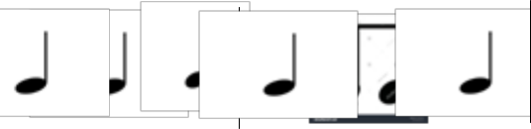

Identify the time signature for the rhythmic pattern.

(1 mark)

.................................................................................................................................................

- Martin is in Grade 9 and intends to pursue sports in senior school, an idea his father is opposed to. State any two economic importance of sports that Martin can explain to his farther to convince him.
................................................................................................................................................. (2 marks)

.................................................................................................................................................

- During a drama festival, the audience gave the performers a standing ovation to show that they were satisfied with their performance. State any other three ways the audience could show their satisfaction

for the performance.

(3 marks)

.................................................................................................................................................

.................................................................................................................................................

.................................................................................................................................................

- Hafsa included the note below in a musical rhythmic composition during a Creative Arts and Sports lesson.
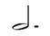

(a) Write the note represented by the dot................................................ (1 mark)

(b) Write the total number of counts represented by the notes shown above............................ (2 marks)

6. The diagram was used by a grade 7 teacher to explain the categories of Creative Arts and Sports. What

were the possible categories marked A, B, and C? |  | (3 marks)
 | B
Music and | Creative Arts | A
Dance | and sports | A
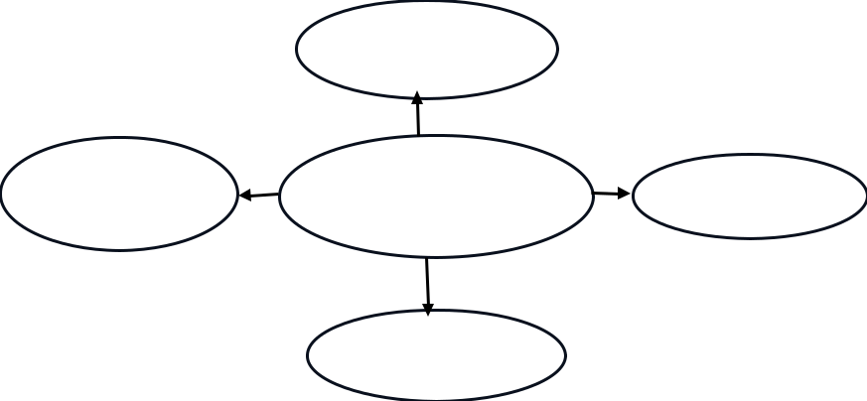

C

JS Assessment 2 Creative Arts & Sports Grade 9

A ....................................................................................

B ....................................................................................

C ....................................................................................

7. Grade 9 learners from Kitise Junior School created the rhythmic pattern below


 |  | *
(a) Write the French rhythm for the above rhythmic pattern. |  |  |  |  | (3 marks)
.................................................................................................................................................
.................................................................................................................................................
.................................................................................................................................................
(b) Draw the rest symbol for the note with asterisk (*). |  |  |  |  | (1 mark)

- In the game of handball, there are different skills that are used. State any three of these skills. (3 marks)

.................................................................................................................................................

.................................................................................................................................................

.................................................................................................................................................

- Below are steps which were followed by Grade 9 learners during a practical lesson to make a storyboard. (4 marks)

  - Displaying the storyboard in the classroom.

  - Pasting the picture cut outs.

  - Collecting the pictures and cutting pictures.

  - Preparing the background by painting.

Arrange the steps in their correct order.

.................................................................................................................................................

JS Assessment 3 Creative Arts & Sports Grade 9

- Mr. Makali, a Grade 9 Creative Arts and Sports teacher used the illustration below to explain plot as an element of a story.

 |  |  |  |  |  |  |  |  |  |  |  |  | C
 |  |  |  |  |  |  |  |  |  |  | B |  |  |  | D
 |  |  | A |  |  |  |  |  |  |  |  |  |  |  |  |  |  |  | E
Briefly explain what happens in the regions marked B, C and E. |  |  |  |  |  |  |  |  |  |  |  |  |  |  |  |  |  |  |  |  |  |  |  |  | (6 marks)
B ......................................................................................................................................................
......................................................................................................................................................
C ........................................................................................................................................................
.........................................................................................................................................................
E ......................................................................................................................................................
.......................................................................................................................................................
11. Below is a keyboard that was drawn by learners during a Creative Arts and Sports lesson. On the
keyboard, show the scale of G major. |  |  |  |  |  |  |  |  |  |  |  |  |  |  |  |  |  |  |  |  |  |  |  |  | (4 marks)
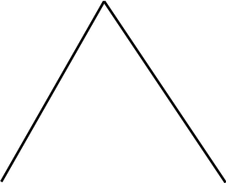

12. During a painting lesson, learners from Bright Star Junior School were asked by their teacher to use complementary colors. Give any two pairs of complementary colors they used. (2 marks) (i) ..................................................................... and ........................................................ (ii) .................................................................. and ..........................................................

13. | Your friend has asked you to advise him on careers related to Creative Arts and Sports. Give three
 | examples of these careers. |  |  | (3 marks)
 | .................................................................................................................................................
 | .................................................................................................................................................
 | .................................................................................................................................................
14. | Outline two similarities between the different categories of Creative Arts and Sports. |  |  | (2 marks)
 | .................................................................................................................................................
 | .................................................................................................................................................
JS Assessment |  | 4 | Creative Arts & Sports Grade 9

