**KENYA JUNIOR SCHOOL EDUCATION ASSESSMENT**

**TERM 1 2025**

**GRADE 9**

**911 -CREATIVE ARTS & SPORTS.**

|  |  |
| --- | --- |
|  | **Time: 2 Hours.** |
| NAME: ______________________________________________________________________ | |
| SCHOOL: ____________________________________________________________________ | |
| STREAM: ____________________________ | DATE: __________________ |

**INSTRUCTIONS**

Write your name, school, stream and the date in the spaces provided.

Answer all the questions in the booklet using the spaces provided after every question.

All questions are answered I n English.

All answers must be given according to the guidelines of each question.

**ASSESSMENT RUBRICS.**

**RANGE** **LEVEL**

|  |  |
| --- | --- |
| **80% to 100%** | Exceeding Expectations. |
|  |  |
| **60% to 79%** | Meeting Expectations. |
|  |  |
| **40% to 59%** | Approaching Expectations. |
|  |  |
| **0% to 39%** | Below Expectations |

**LEARNER’S SCORE**

**OUT OF 50 MARKS**

***Score***

***% Score***

1

|  |  |
| --- | --- |
|  |  |
|  |  |
| 1. State **five** careers in creative arts and sports. | **(5mks)** |

_____________________________________________________________________________

_____________________________________________________________________________

_____________________________________________________________________________

_____________________________________________________________________________

2. State the **four** categories of creative arts and sports. **(4mks)**

_____________________________________________________________________________

_____________________________________________________________________________

_____________________________________________________________________________

_____________________________________________________________________________

3. State **five** phases in a javelin throw. **(5mks)**

_____________________________________________________________________________

_____________________________________________________________________________

_____________________________________________________________________________

_____________________________________________________________________________

_____________________________________________________________________________

4. State **five** creative arts forms appreciated through sense of sight. **(5mks)**

_____________________________________________________________________________

_____________________________________________________________________________

_____________________________________________________________________________

_____________________________________________________________________________

_____________________________________________________________________________

5. Explain the meaning of the following elements of play.

a.) Theme

**(4mks)**

_____________________________________________________________________________

_____________________________________________________________________________

b.) Character

_____________________________________________________________________________

_____________________________________________________________________________



2



c.) Plot

_____________________________________________________________________________

_____________________________________________________________________________

d.) Setting

_____________________________________________________________________________

_____________________________________________________________________________

6.

a.) Name **two** types of passes used in netball. **(2mks)**

_____________________________________________________________________________

_____________________________________________________________________________

b.) Give two types of landing techniques in the game of netball. **(2mks)**

_____________________________________________________________________________

_____________________________________________________________________________

c.) Give three importance of pivoting in the game of netball. **(2mks)**

_____________________________________________________________________________

_____________________________________________________________________________

_____________________________________________________________________________

_____________________________________________________________________________

7. Grade 8 learners designed a dress and decorated with the following decorations techniques.

Identify the techniques illustrated in the pictures below. **(2mks)**

**A** **B**

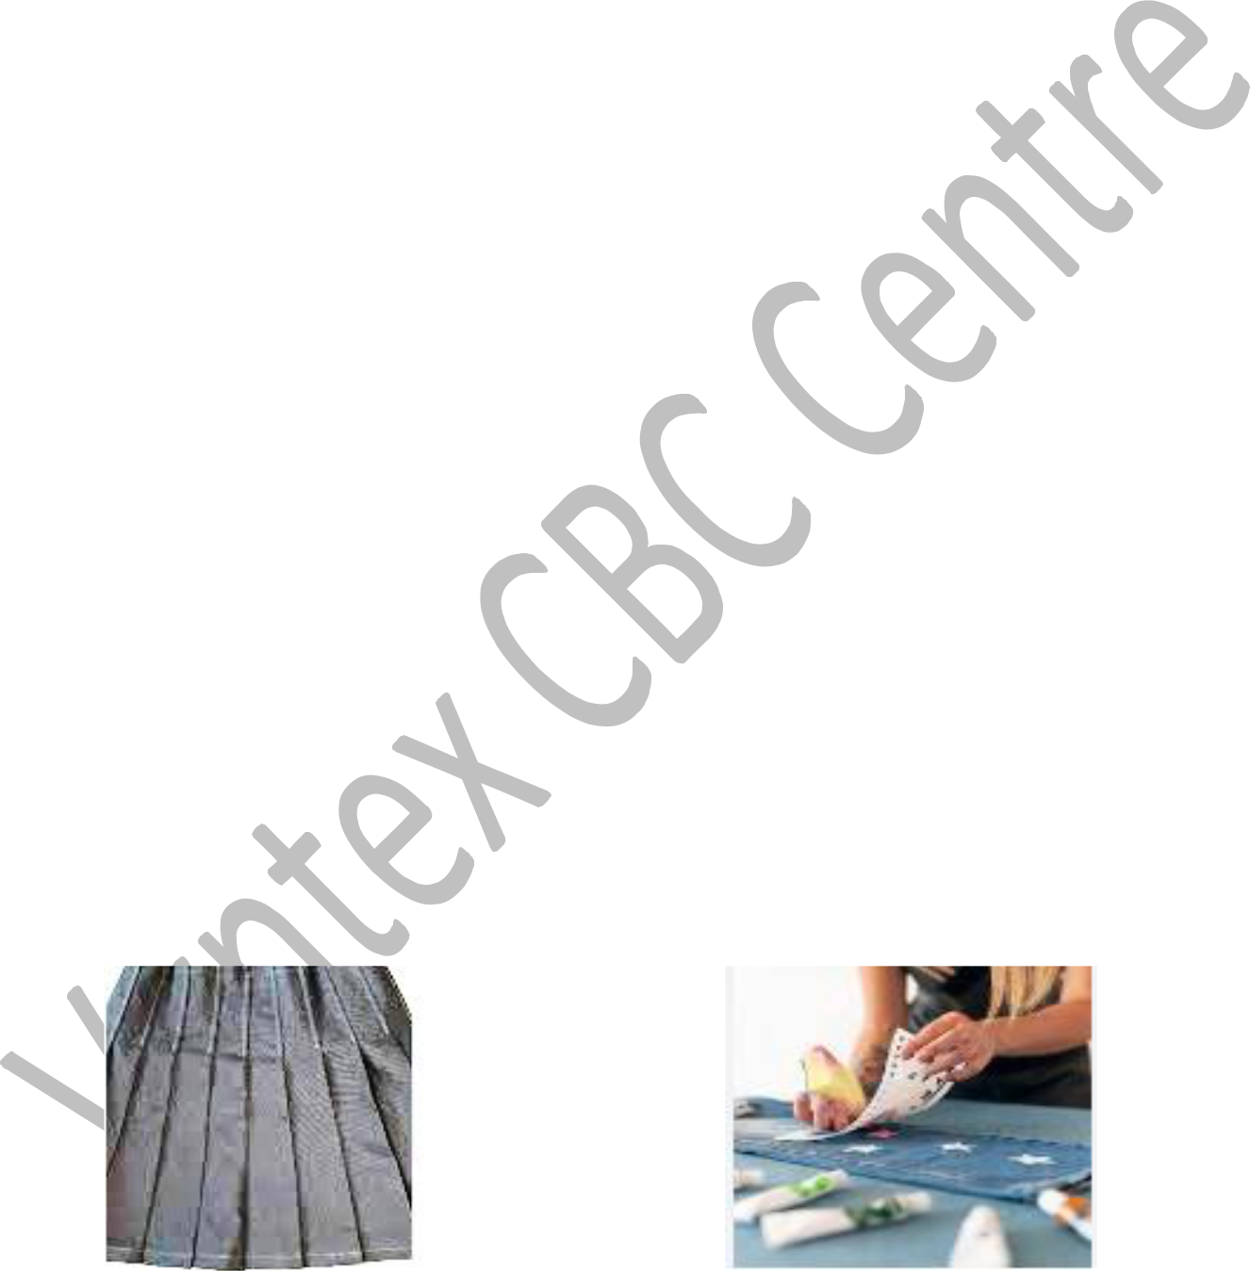

________________________________

_______________________________________

8. Give

**four** techniques of playing a descant recorder.



**(4mks)**

3



_____________________________________________________________________________

_____________________________________________________________________________

_____________________________________________________________________________

_____________________________________________________________________________

9. List three safety measures to observe when performing a high jump. **(3mks)**

_____________________________________________________________________________

_____________________________________________________________________________

_____________________________________________________________________________

_____________________________________________________________________________

10. Identify the following types of music notes as either crotchet, minim, quaver and semi-

quaver. **(4mks)**

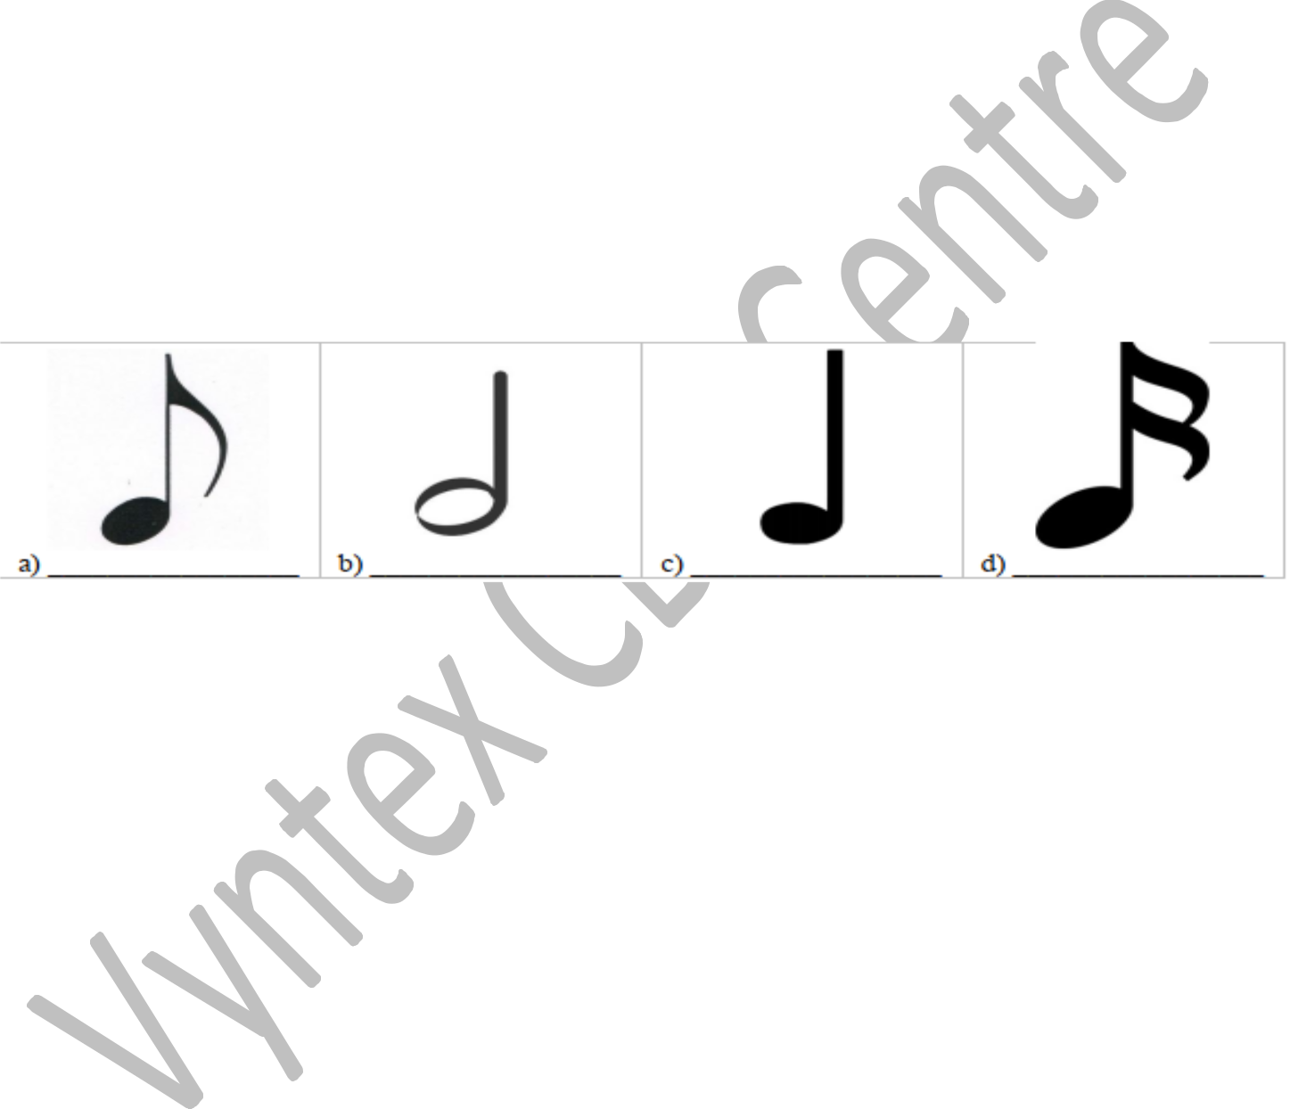

11. Name five different types of beads used in beadworks **(5mks)**

_____________________________________________________________________________

_____________________________________________________________________________

_____________________________________________________________________________

_____________________________________________________________________________

_____________________________________________________________________________

12.

a.) What is physical fitness? **(1mk)**

_____________________________________________________________________________

_____________________________________________________________________________

b.) Name two components of physical fitness. **(2mks)**

___________________________________________________________

___________________________________________________________

**THIS IS THE LAST PRINTED PAGE**

4