JUNIOR SCHOOL EDUCATION ASSESSMENT
GRADE 9
TERM ONE 2025 OPENER
NAME: ……………………………………………………………………..
SCHOOL: ………………………………………………………………….
ASSESSMENT NUMBER: ……………………………………………….
SIGNATURE: ……………………………….DATE:……………………..
AGRICULTURE AND NUTRITION

ASSESSMENT RUBRICS

Learning | Performance | Exceeds | Meets | Approaching | Below
area |  | Expectations (4) | Expectations (3) | Expectations (2) | Expectations (1)
Agriculture

- The picture below shows a method of soil conservation where channels are constructed and used for the safe disposal of excess runoff from the crop lands to some safe outlet like rivers, streams or reservoirs.
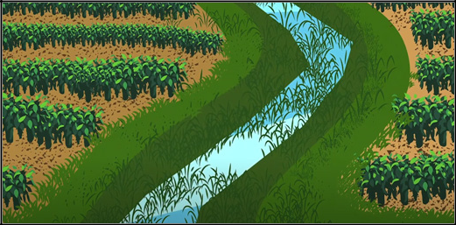

(a) Identify the method of soil conservation shown in the picture above. (1 mark)

..............................................................................................................................................

(b) Apart from the method in (a), name three other soil conservation methods in an agricultural

environment. (3 marks)

..............................................................................................................................................

..............................................................................................................................................

..............................................................................................................................................

2. The Grade 8 Agriculture and Nutrition teacher explained to her learners that by carrying out soil conservation measures, water can penetrate and stay in the soil to allow crops to access and use the

water for growth. Outline three other importance of soil conservation. (3 marks)

..............................................................................................................................................

..............................................................................................................................................

..............................................................................................................................................

- Banda has constructed an underground tank for harvesting and storing water as shown in the picture below.
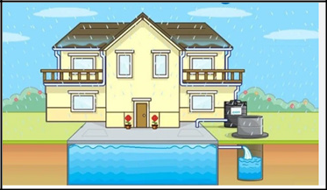

(a) Apart from reservoir tanks and containers, name two other structures that can be used for storing

harvesting water. (2 marks)

..............................................................................................................................................

..............................................................................................................................................

(b) Give two reasons why water harvesting is important. (2 marks)

..............................................................................................................................................

..............................................................................................................................................

- The picture below shows Hamisi and his wife cultivating and carrying out management practices in their backyard garden.
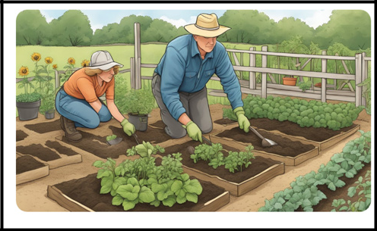

Highlight three benefits they will get from the established backyard garden. (3 marks)

..............................................................................................................................................

..............................................................................................................................................

..............................................................................................................................................

5. Grade 8 learners harvested the following vegetables they had established in their school kitchen garden.

Identify and name each of them. (3 marks)
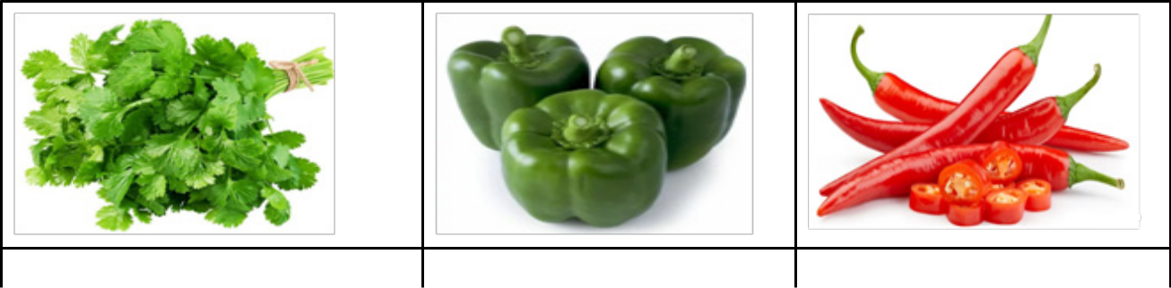

(a)

(b)

(c)

JS Assessment 2 Agriculture Grade 9

6. Rashid and his group members collected the following materials to make soap locally. Perfumes, Dyes, Disinfectants, Builders. Complete the following table by stating the role of each of the substances in

soap making. | (4 marks)
Substance | Role

- Perfumes

- Dyes

- Disinfectants

  - Builders

- The picture below shows a fold unit used for rearing poultry.

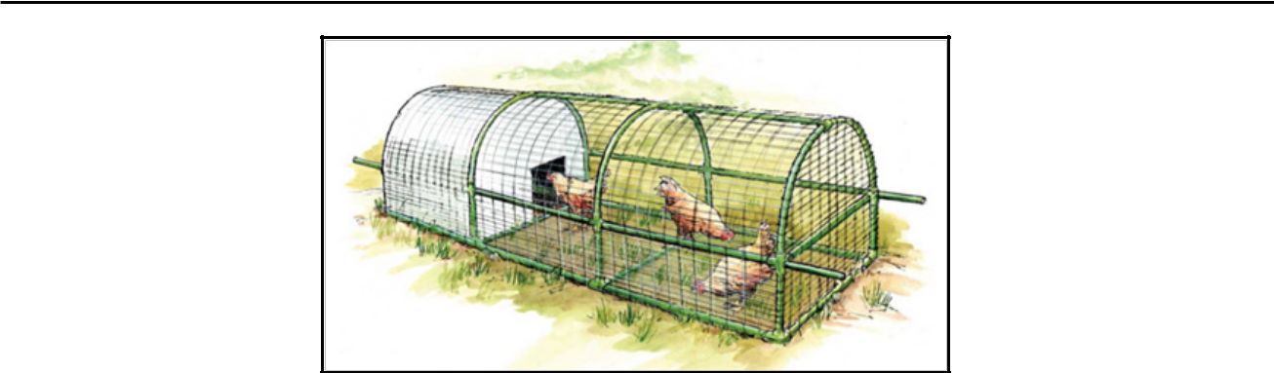

(a) What do you understand by the term fold in poultry rearing? |  | (1 mark)
..............................................................................................................................................
..............................................................................................................................................
(b) Name two locally available materials that can be used to construct the poultry fold. |  | (2 marks)
..............................................................................................................................................
..............................................................................................................................................
(c) One of the management practices in a fold is moving it from one place to another. What is the
importance of this? |  | (1 mark)
..............................................................................................................................................
(d) Outline two other management practices in poultry rearing. | (2 marks)
..............................................................................................................................................

..............................................................................................................................................

..............................................................................................................................................

8. During a field activity, Wendo took the picture below of crops under pest attack.
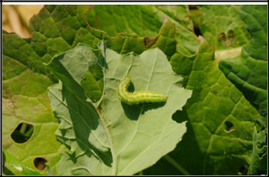

(a) What observable characteristic shows that the crops have been attacked by pests? (1 mark)

..............................................................................................................................................

(b) State two other characteristics of crops attacked by pests. (2 marks)

..............................................................................................................................................

..............................................................................................................................................

(c) Apart from leaves, name two other parts of crops that are commonly attacked by pests. (2 marks)
..............................................................................................................................................

..............................................................................................................................................

- Mention two reasons why it is important to control pests and diseases in agricultural production.

 | .............................................................................................................................................. |  | (2 marks)
..............................................................................................................................................
JS Assessment |  | 3 | Agriculture Grade 9

10. Fish preparation involves various processes.

(a) What does each of the following processes in fish preparation involve?

(i) Gutting (1 mark)

..............................................................................................................................................

(ii) Scaling (1 mark)

..............................................................................................................................................

(b) State the importance of each of the processes in (a) above. (2 marks)

..............................................................................................................................................

..............................................................................................................................................

11. Asha saw meat being smoked in a nearby household as shown in the picture below.
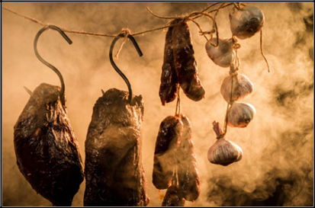

(a) State the importance of smoking meat as shown in the picture. (1 mark)

..............................................................................................................................................

(b) Apart from smoking, name two other methods of preserving meat in households. (2 marks)

..............................................................................................................................................

..............................................................................................................................................

- Vera lives with her parents, siblings as well as her grandparents. One evening, she prepared a balanced meal for her family, considering that some family members are allergic to some foods.

(a) What do you understand by a balanced meal? (2 marks)

..............................................................................................................................................

..............................................................................................................................................

(b) Apart from health status, outline two other factors to consider when preparing a balanced meal.

 | ............................................................................................................................................................................................................................................................................................ |  |  | (2 marks)
13. | Chebet decided to grow tomatoes in her suspended garden because tomatoes mature fast and are not
 | large in size. Which two other factors could she have considered to make her choice? |  |  | (2 marks)
………………………………………………………………………………………………..
………………………………………………………………………………………………..
14. | Study the picture below showing value addition to a crop produce.
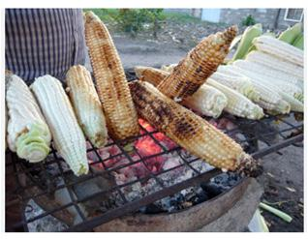

 | (a) How is value addition being done to the crop in the picture? |  | (1 mark)
..............................................................................................................................................
 | (b) Give two other ways value addition can be done to the crop in the picture. |  | (2 marks)
..............................................................................................................................................
..............................................................................................................................................
 | JS Assessment | 4 | Agriculture Grade 9

