**KENYA JUNIOR SCHOOL EDUCATION ASSESSMENT.**

**TERM 1 2025**

**GRADE 9**

**906/1-AGRICULTURE & NUTRITION.**

|  |  |
| --- | --- |
|  | **Time: 2 Hours.** |
| NAME: ______________________________________________________________________ | |
| SCHOOL: ____________________________________________________________________ | |
| STREAM: ____________________________ | DATE: __________________ |

**INSTRUCTIONS**

Write your name, school, stream and the date in the spaces provided.

Answer all the questions in the booklet using the spaces provided after every question.

All questions are answered I n English.

All answers must be given according to the guidelines of each question.

**ASSESSMENT RUBRICS.**

**RANGE** **LEVEL**

|  |  |
| --- | --- |
| **80% to 100%** | Exceeding Expectations. |
|  |  |
| **60% to 79%** | Meeting Expectations. |
|  |  |
| **40% to 59%** | Approaching Expectations. |
|  |  |
| **0% to 39%** | Below Expectations |

**LEARNER’S SCORE**

**OUT OF 50 MARKS**

*Score*

*% Score*

1



1. Grade 8 learners used different ICT tools to obtain information about inputs in agriculture.

State any **two** inputs they may have seen. **(2mks)**

_____________________________________________________________________________

_____________________________________________________________________________

1. State **three** challenges associated with use of innovative waterers in the community. **(3mks)**

_____________________________________________________________________________

_____________________________________________________________________________

_____________________________________________________________________________

_____________________________________________________________________________

1. Grade 9 prepared the following during conservation of forage. Use the picture to answer the questions that follow.

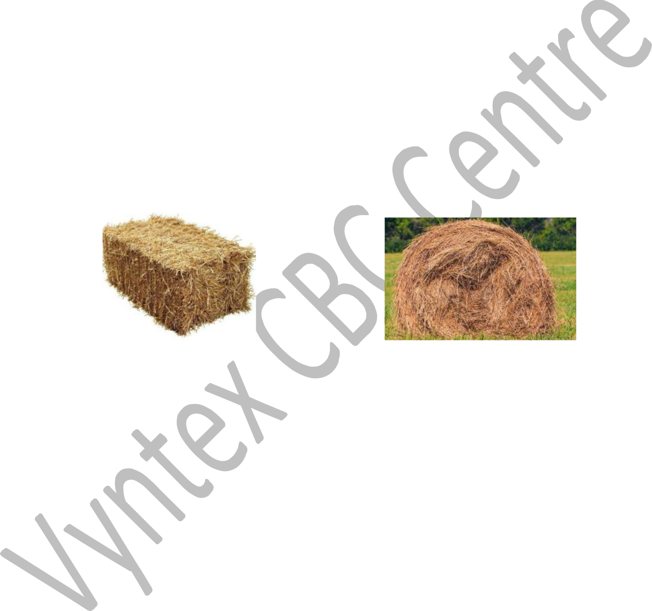**A** **B**



a.) Name the **two** methods of conserving hay above. **(2mks)** Method A ____________________________________________________________________

Method B ____________________________________________________________________

b.) State **three** advantages of conserving hay using method **A** compared to method **B**. **(3mks)**

_____________________________________________________________________________

_____________________________________________________________________________

_____________________________________________________________________________

c.) List down **four** materials required when making hay using method **A**. **(4mks)**

_____________________________________________________________________________

_____________________________________________________________________________

_____________________________________________________________________________

_____________________________________________________________________________

2

|  |  |
| --- | --- |
|  |  |
|  |  |
| d.) Give **three** factors to consider when selecting the methods of conserving forage. | **(3mks)** |

_____________________________________________________________________________

_____________________________________________________________________________

_____________________________________________________________________________

4. Grade 7 learners from a certain school took pictures while planting trees as shown below.

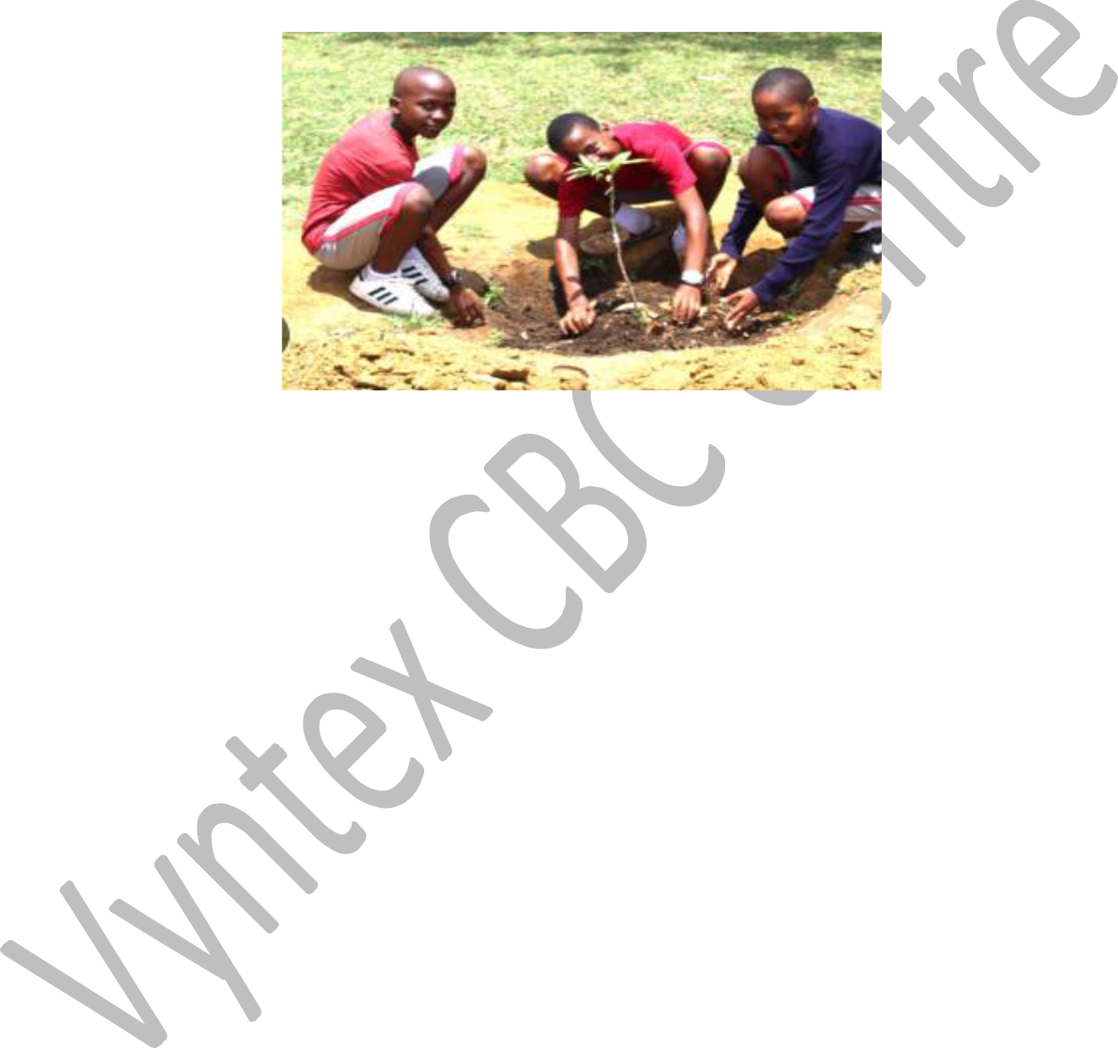

a.) Give **two** ways the learners used to avoid soil pollution during the exercise above. **(2mks)**

_____________________________________________________________________________

_____________________________________________________________________________

b.) State **three** practices the learners might have used to take care of the trees planted. **(3mks)**

_____________________________________________________________________________

_____________________________________________________________________________

_____________________________________________________________________________

_____________________________________________________________________________

c.) Give **three** roles played by trees in soil and water conservation. **(3mks)**

_____________________________________________________________________________

_____________________________________________________________________________

_____________________________________________________________________________

_____________________________________________________________________________

5. Name **three** crops in which earthing up is required. **(3mks)**

_____________________________________________________________________________

_____________________________________________________________________________

_____________________________________________________________________________



3



1. The diagram below shows a certain poultry structure. Use it to answer the questions that follow.

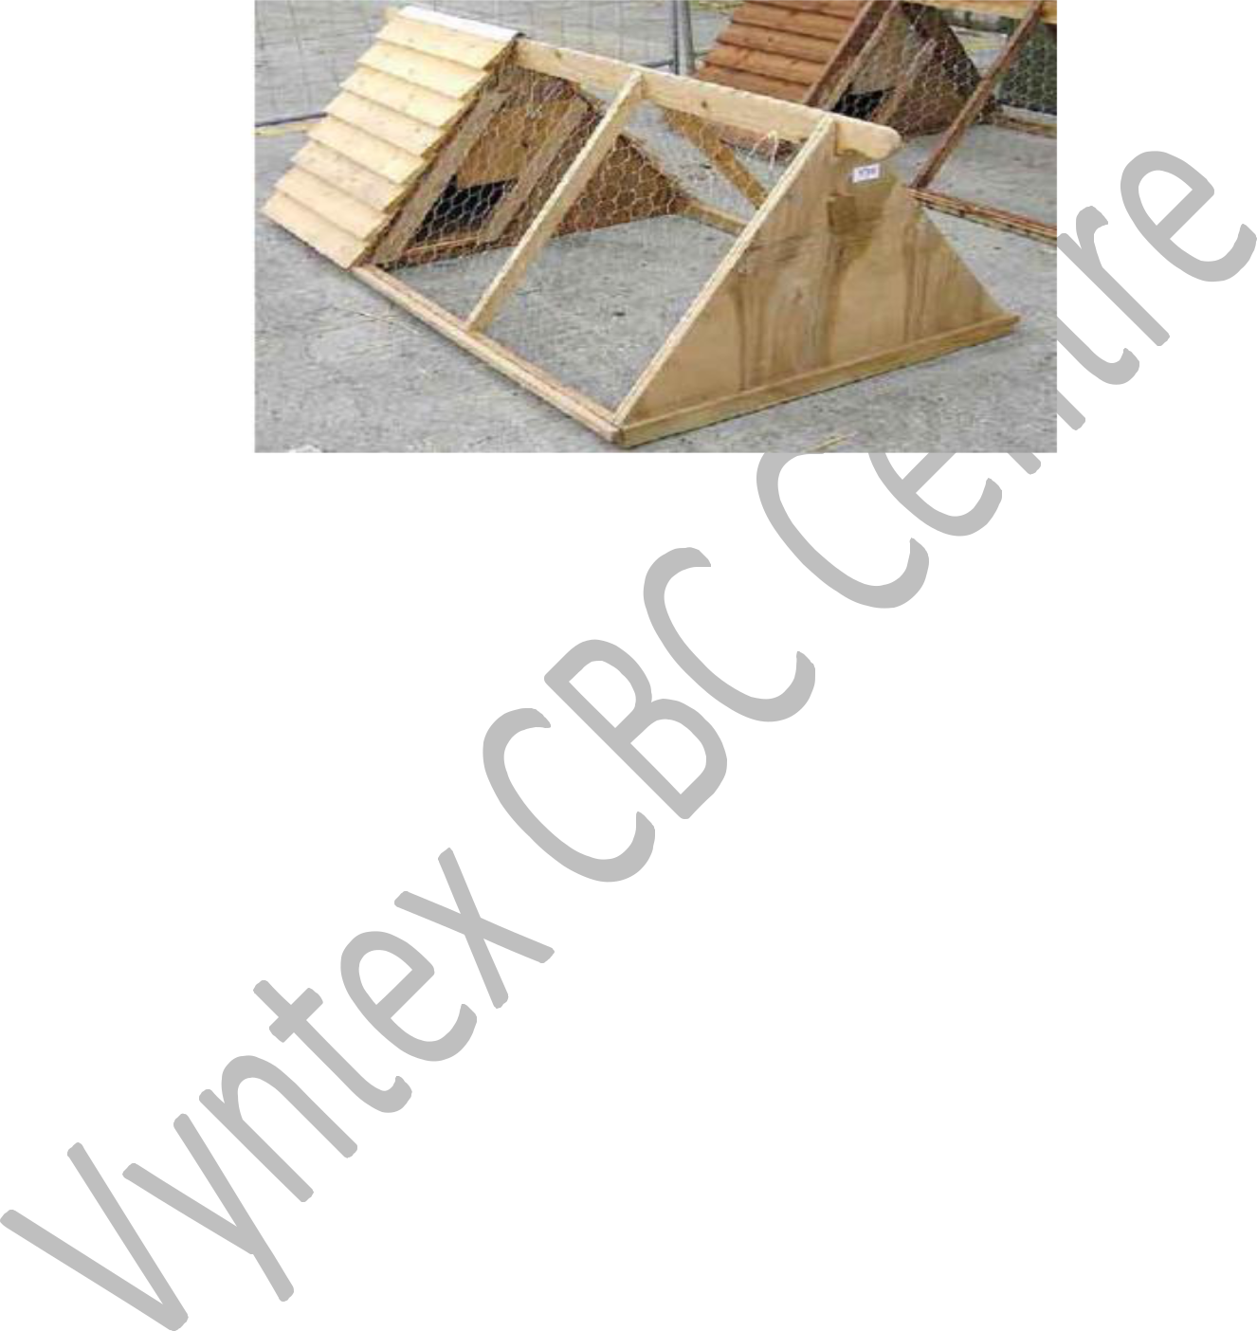

a.) Identify the structure above. **(1mk)**

_____________________________________________________________________________

b.) State any four locally available materials that can be used when constructing the structure. **(4mks)**

_____________________________________________________________________________

_____________________________________________________________________________

_____________________________________________________________________________

_____________________________________________________________________________

c.) Grade 8 learners have been asked by their teacher to locate a suitable site where the structure above can be located. State **three** factors the learners should consider when siting the structure.

**(3mks)**

_____________________________________________________________________________

_____________________________________________________________________________

_____________________________________________________________________________

d.) Give **three** routine management practices required when using the structure above in rearing

poultry. **(3mks)**

_____________________________________________________________________________

_____________________________________________________________________________

_____________________________________________________________________________

_____________________________________________________________________________



4



1. The pictures below shows two different types of innovative kitchen gardens used by learners from Horizon Junior secondary school.

**Garden A** **Garden B**

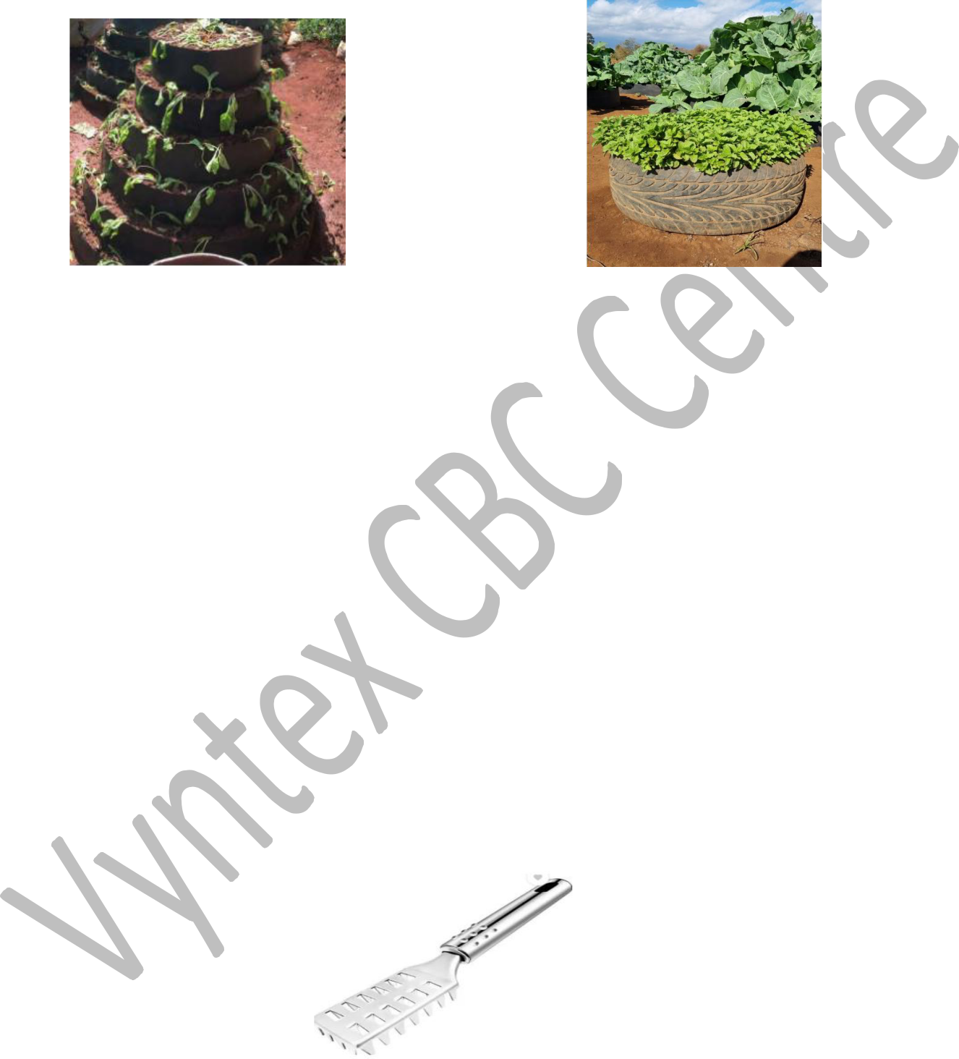

a.) Identify the **two** types of innovative kitchen gardens in pictures above. **(2mks)**

1. ___________________________________________________________________________
2. ___________________________________________________________________________

b.) State **three** roles played by the innovative kitchen gardens above. **(3mks)**

_____________________________________________________________________________

_____________________________________________________________________________

_____________________________________________________________________________

_____________________________________________________________________________

c.) State **three** indications learners can use to know the vegetables planted in the kitchen

gardens are attacked by pests. **(3mks)**

_____________________________________________________________________________

_____________________________________________________________________________

_____________________________________________________________________________



8

This is a ______________ used for _____________________ during ______________ **(3mks)**

**THIS IS THE LAST PRINTED PAGE**

5