G8
COMPETENCE BASED CURRICULUM
ENDTERM ONE ASSESSMENT

KENYA JUNIOR SCHOOL EDUCATION ASSESSMENT
LEARNER’S NAME: _______________________________.
SCHOOL: _______________________________________.
DATE: ________________SIGNATURE:_______________.
SOCIAL STUDIES TIME: 1 HOUR 30 MINUTES

INSTRUCTIONS TO LEARNER

- Write your name, name of your school and assessment number in the spaces provided.

- Answer ALL the questions in the spaces provided.

- Answer all questions in section A and sections B.

Time: 1 hour

FOR OFFICIAL USE ONLY
SCORE GRID
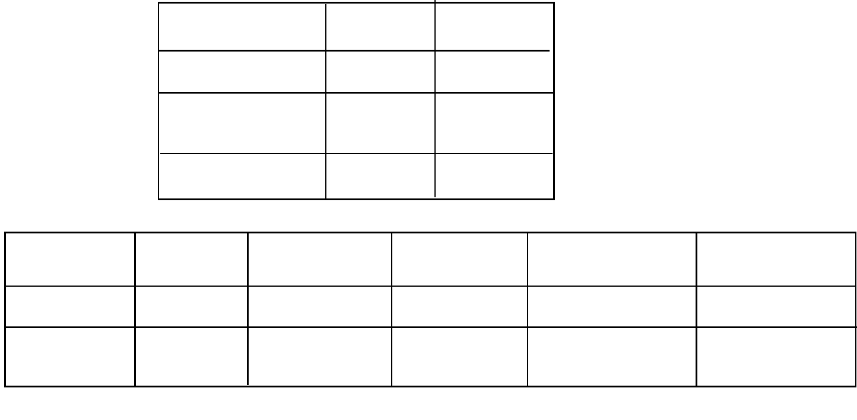

Sections Maximum Candidates

Score Score

Social Studies 50

No. of

Questions 16

Total Score | 50
 | ASSESSMENT RUBRICS
Learning area Performance | Exceeds | Meets | Approaching | Below
Expectations(4) |  | expectations(3) | Expectations(2) | Expectations(1)

Social

Studies

Religious

Education

This paper consists of 4 printed pages.

The learner should check the question paper to ascertain that all the pages are printed as indicated and that no questions are missing.

SECTION A: (38 marks)

SOCIAL STUDIES

Answer all the following questions

- A grade 8 learner wrote some careers related to studying Social Studies on a manila paper. Write two careers he likely had on the manila paper? (2mks)

...................................................................................................................................................

...................................................................................................................................................

- After watching a video clip about the earth, a learner realized that the earth rotates. List two effects of rotation of the earth. (2mks)

...................................................................................................................................................

...................................................................................................................................................

- A teacher brought the weather instrument below in class.


What is the function of the instrument? (1mk)

...............................................................................................................................................................

- State three factors that make Africa to be considered the cradle of humankind. (3mks)

...................................................................................................................................................

...................................................................................................................................................

.....................................................................................................................................................

- Some countries in the world are led by an emperor. State three features of an empire. (3mks)

...................................................................................................................................................

...................................................................................................................................................

...................................................................................................................................................

- Highlight three common things learnt about the Ogiek people? (3mks)

...................................................................................................................................................

...................................................................................................................................................

...................................................................................................................................................

- Kiama listed some personalities that differentiate people. Briefly describe them. (3mks)

  - Authentic ..............................................................................................................................................

  - Diligence ..............................................................................................................................................

  - Empathy ................................................................................................................................................

- Many countries in the world are looking forward to have peace. State three importance of peace in a nation? (3mks)

...................................................................................................................................................

...................................................................................................................................................

...................................................................................................................................................

- State four factors that led to development of the Indian Ocean Slave Trade in the 15th Century. (4mks)

...................................................................................................................................................

...................................................................................................................................................

...................................................................................................................................................

...................................................................................................................................................

- Some areas in Africa are over populated and others have scarce population. State four factors influencing population distribution in Africa. (4mks)

...................................................................................................................................................

...................................................................................................................................................

...................................................................................................................................................

...................................................................................................................................................

- Angela was tasked to collect data about people living in poverty in her community and record. State four methods of data recording she will use. (4mks)

...................................................................................................................................................

...................................................................................................................................................

...................................................................................................................................................

...................................................................................................................................................

- Highlight four contributions of the Nile valley agriculture to world civilization. (4mks)

...................................................................................................................................................

...................................................................................................................................................

...................................................................................................................................................

...................................................................................................................................................

- Zulu is one of the famous communities in Africa. State four economic activities carried out by the Zulu. (4mks)

...................................................................................................................................................

...................................................................................................................................................

...................................................................................................................................................

...................................................................................................................................................

- Kenya has the 2010 constitution. List three national values as enriched in the constitution of Kenya. (3mks)

...................................................................................................................................................

...................................................................................................................................................

...................................................................................................................................................

- Many Kenyans have travelled abroad in search of jobs. State three roles of diasporas in promotion of African unity. (3mks)

...................................................................................................................................................

...................................................................................................................................................

...................................................................................................................................................

- State four achievements of AU. (4mks)

...................................................................................................................................................

...................................................................................................................................................

...................................................................................................................................................

...................................................................................................................................................

