THE KENYA JUNIOR SCHOOL EDUCATION ASSESSMENT.

GRADE 8.

INTEGRATED SCIENCE.
JULY-AUGUST

Time: 1¹/2 Hours.

JUNIOR SCHOOL ASSESSMENT
HOMEWORK ENGAGEMENT

INTEGRATED SCIENCE.

Learner’s Name:______________________________________________________________

Assessment No:_____________________________ Grade:___________________________

Date:________________________________________________________________________

FOR EXAMINERS USE ONLY.
Score Range | Performance Level | Tick
80-100 | Exceeding Expectation
60-79 | Meeting Expectations
40-59 | Approaching Expectations
Below 40 | Below Expectations

Instructions to Learners.

OUT OF |  | 50 MARKS
Learners
Score.
Learners

%

- Write your name, stream and register in the spaces provided above.

- Sign and write the date of examination in the space provided above.

- Answer all questions in this question paper.

- All your answers must be written in the spaces provided below each question.

- This paper consists of printed pages. Learners should check the questions in each paper to ascertain that all the papers are printed as indicated and that there is no question missing.

- Answer all the questions in English.

QUESTIONS.

1. Give two safety measures to observe when using a power extension cable. (2mks)

_____________________________________________________________________________

_____________________________________________________________________________

. pg. 1

- The ability of a substance to be reduced in volume or size by applying force or pressure on it is referred to as _________________________________________________________ (2mks)

3. Give the information one gets when they see the following signs. (4mks)
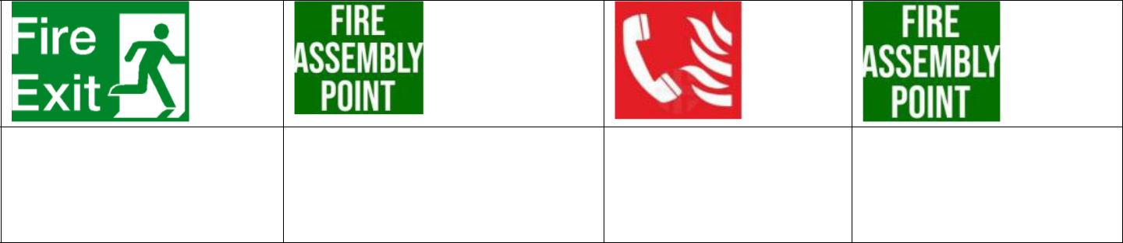

4. State the difference between animal and plant cells considering the following aspects. (6mks)

Aspect | Animal cell | Plant cell.
Shape
Size
Presence of
Cell wall and
cell
membrane
5. Name the parts of a cell that: |  | (3mks)

a.) Helps in photosynthesis. ______________________________________________________

b.) Controls all the activities of the cell. ____________________________________________

c.) Found both in animal and plant cells. ____________________________________________

6. Name the two gases that are exchanged in the alveoli. (2mks)

_____________________________________________________________________________

_____________________________________________________________________________

7. Study the set up below and use it to answer the questions that follow.
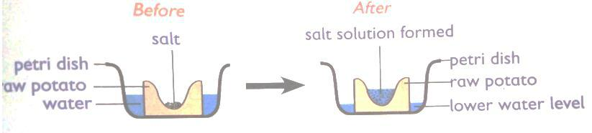

pg. 2
a.) Name the process taking place in the diagram above. (1mk)

_____________________________________________________________________________

b.) Name two observation show in the set up after the experiment was done. (2mks)

_____________________________________________________________________________

_____________________________________________________________________________

c.) If the experiment is done using a boiled potato, state the observation that. (2mks)

_____________________________________________________________________________

_____________________________________________________________________________

d.) Name two occasions when the process above is applied in living organisms. (2mks)

_____________________________________________________________________________

_____________________________________________________________________________

8. Give four challenges related to human menstrual cycle. (4mks)

_____________________________________________________________________________

_____________________________________________________________________________

_____________________________________________________________________________

_____________________________________________________________________________

9. Differentiate between fertilization and implantation. (2mks)

_____________________________________________________________________________

_____________________________________________________________________________

_____________________________________________________________________________

_____________________________________________________________________________

10. Name two waste products excrete through the skin. (2mks)

_____________________________________________________________________________

_____________________________________________________________________________

11. Differentiate between heterogeneous and homogeneous mixtures. (2mks)

_____________________________________________________________________________

_____________________________________________________________________________

pg. 3
12. Name two instruments used to enlarge the image of a specimen when viewing. (2mks)

_____________________________________________________________________________

_____________________________________________________________________________

13. Write the five basic scientific skills. (5mks)

_____________________________________________________________________________

_____________________________________________________________________________

_____________________________________________________________________________

_____________________________________________________________________________

14. Name three items to put on while using the laboratory chemicals. (3mks)

_____________________________________________________________________________

_____________________________________________________________________________

_____________________________________________________________________________

15. In case of a fire outbreak, write down three items you will use to put off fire. (3mks)

_____________________________________________________________________________

_____________________________________________________________________________

_____________________________________________________________________________

_____________________________________________________________________________

16. Draw a sign you will print and stick on a flammable materials. (1mk)

THIS IS THE LAST PRINTED PAGE.

pg. 4

