***KENYA JUNIOR SCHOOL EDUCATION ASSESSMENT.***

**GRADE 8**

**INTEGRATED SCIENCE- (Theory)**

**Time: 11/2 Hours.**

**September 2024.**

**Learner’s Name:______________________________________________________________**

**Assessment No:_____________________________ Grade:___________________________**

**Date:________________________________________________________________________**

**FOR EXAMINERS USE ONLY.**

|  |  |  |
| --- | --- | --- |
| **Score Range** | **Performance Level** | **Tick** |
| ***80-100*** | **Exceeding Expectation** |  |
| ***60-79*** | **Meeting Expectations** |  |
| ***40-59*** | **Approaching Expectations** |  |
| ***Below 40*** | **Below Expectations** |  |

|  |  |
| --- | --- |
| **OUT OF** | **50 MARKS** |
| **Learners Score.** |  |
| **Learners %** |  |

**Instructions to Learners.**

1. Write your name, Assessment Number, Grade/Stream and the Date in the spaces provided above.
2. Answer all questions in this question paper.
3. All your answers must be written in the spaces provided below each question.
4. This paper consists of printed pages. Learners should check the questions in each paper to ascertain that all the papers are printed as indicated and that there is no question missing.
5. Answer all the questions in English.

**QUESTIONS.**

1. Stephen wants to determine the exact volume of liquid reagents in the laboratory. Give five apparatus he can use to do so **(5mks)**

_________________________________________________________________________________________________________________________________________________________________________________________________________________________________________________________________________________________________________________________________________________________________________________________________

2. Draw the following laboratory apparatus in the space provided below. **(6mks)**

|  |  |  |
| --- | --- | --- |
| Conical flask | Beaker | Volumetric flack. |
|  |  |  |

3. Give three common methods we can using to separate solid-solid mixtures. **(3mks)**

_______________________________________________________________________________________________________________________________________________________________________________________________________________________________________

4. Write down three derived quantities and their correct SI units. **(6mks)**

____________________________________________________________________________________________________________________________________________________________________________________________________________________________________________________________________________________________________________________

5. List down any four parts of a cell. **(4mks)**

____________________________________________________________________________________________________________________________________________________________________________________________________________________________________________________________________________________________________________________

6. Name five substances that can be used in a fire extinguisher to put off fire. **(5mks)**

_________________________________________________________________________________________________________________________________________________________________________________________________________________________________________________________________________________________________________________________________________________________________________________________________

7.

a.) The total magnification of a microscope is determined by: **(2mks)**

__________________________________________________________________________________________________________________________________________________________

b.) Use the table below to determine the magnifications correctly. **(4mks)**

|  |  |  |
| --- | --- | --- |
| **Objective lens magnification** | **Eyepiece lens magnification** | **Total magnification** |
| X6 | X8 |  |
|  | X7 | X35 |
| X5 |  | X20 |
| X7 | X4 |  |

8. Describe solids as a state of mater under the following properties. **(4mks)**

a.) Volume ___________________________________________________________________

b.) Shape _____________________________________________________________________

c.) Ability to flow ______________________________________________________________

d.) Compressibility _____________________________________________________________

part A Part B

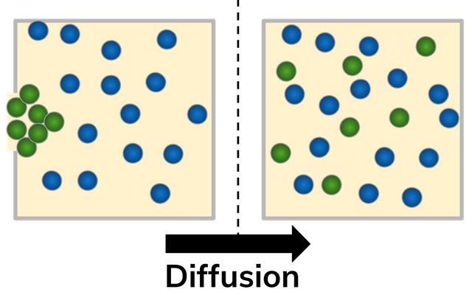

9. The diagram above shows different particles released together in part A. After sometime the particles could mix up as shown in part B.

a.) Name the process illustrated above. **(2mks)**

_____________________________________________________________________________

b.) Explain why particles end up mixing as shown in part B. **(2mks)**

_______________________________________________________________________________________________________________________________________________________________________________________________________________________________________

10. List down four forms of energy in nature. **(4mks)**

____________________________________________________________________________________________________________________________________________________________________________________________________________________________________________________________________________________________________________________

11. Amina is adding a solute into a solvent. After sometime she notices that the solute no longer dissolves in the solvent even when stirring. A point where the solvent does not dissolve any more solute is described as _________________________________________ **(2mk)**

12. Magnets can move, pull or push magnetic objects without touching them. This invisible force is known as ________________________________________________________ **(1mk)**

**THIS IS THE LAST PRINTED PAGE.**