COMPETENCE BASED CURRICULUM
JUNIOR SCHOOL
MID TERM ASSESSMENT
TERM 1 2025
CREATIVE ARTS AND SPORTS

NAME:________________________________________________.
SCHOOL:______________________________________________.
ASSESSMENT NUMBER: ________________________________.
DATE:____________________ SIGNATURE:________________.

FOR OFFICIAL USE ONLY

ASSESSMENT RUBRIC
TASK | Exceeding Expectation | Meeting Expectation | Approaching Expectation | Below Expectation
LEVEL
SCORE

INSTRUCTIONS TO LEARNER

1. Write your name, name of your school and assessment number and sign in the spaces provided.

2. Answer ALL the questions in the spaces provided.

Time: 2HOURS

- List two ways in which a Grade seven learner can perceive the visual arts. (2 marks)

  - ..................................................................................................

  - ..................................................................................................

- What is the importance of doing research on the categories of art. (3marks)

...............................................................................................................................................................

...............................................................................................................................................................

- Highlight career pathways related to Arts. (3marks)

  - ..................................................................................................

  - ..................................................................................................

  - ..................................................................................................

- Define the following terms as used in visual Arts. (2marks)

  - Architecture ......................................................................................................................................

  - Education ......................................................................................................................................

- Identify three things to consider when preparing and making a presentation on the categories of the arts. (3marks)

  - ..................................................................................................

  - ..................................................................................................

  - ..................................................................................................

- Differentiate between the terms photography and film making. (2marks)

...............................................................................................................................................................

...............................................................................................................................................................

- Explore and classify samples of 2D and 3D artworks. (2marks)

...............................................................................................................................................................

...............................................................................................................................................................

- Explain the 2 major characteristics of colours as used in the colour wheel. (2marks)

  - Hue ................................................................................................................................

(ii)Value ...............................................................................................................................

- Set up a still –life composition of cuboid forms. (4marks)

- Explain how one colour complements another. (2marks)

...............................................................................................................................................................

...............................................................................................................................................................

- Define the term accidental as used in music. (2marks)

..................................................................................................................................................

..................................................................................................................................................

- Explain the meaning of the following terms as used in a skit. (4marks)

  - Millstone ................................................................................................................................................

  - Plot .......................................................................................................................................................

- State two issues that can be addressed in a narrative. (2marks)

  - ............................................................................................................................

  - ............................................................................................................................

- Outline three voice techniques used when reciting a verse. (3marks)

  - ............................................................................................................................

  - ............................................................................................................................

  - ............................................................................................................................

- Define the term theme. (1mark)

.................................................................................................................................................................

................................................................................................................................................................

- Name 3 parts of a descant recorder. (3marks)

  - ............................................................................................................................

  - ............................................................................................................................

  - ............................................................................................................................

- Write the function of the following participants in a folk dance. (2marks)

  - ............................................................................................................................

  - ............................................................................................................................

- Write down 3 elements of music. (3marks)

  - ............................................................................................................................

  - ............................................................................................................................

  - ............................................................................................................................

- Explain what you understand by the following criteria for evaluating a verse. (5marks)

    - Body ....................................................................................................................................................

(b)Voice ....................................................................................................................................................

(c)Movement ............................................................................................................................................

    - Theme ..................................................................................................................................................

    - Poetic language .....................................................................................................................................

- During an inter-class athletic competition, Wafula asked his learners to identify three ways of starting a race. What three ways can you start a race? (3mks)

  - ....................................................................................................................

  - ....................................................................................................................

  - ....................................................................................................................

- During a jumping technique in a long jump, a jumper can use different techniques in the flight phase. Name two such techniques. (2 marks)

  - ....................................................................................................................

  - ....................................................................................................................

- When playing a hockey game, Wanyoike asked his learners to observe safety. Which three safety measures were the learners likely to observe? (3 mks)

  - ....................................................................................................................

  - ....................................................................................................................

  - ....................................................................................................................

- A grade five teacher asked his learners to identify any two defensive positions in a kabaddi game. State two positions the learners were likely to give. (2 mks)

  - ................................................................................

  - ..............................................................................

- During a swimming lesson, a learner was seen swimming in water using the technique shown below.
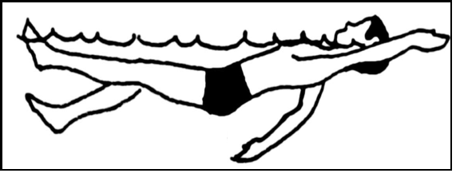

What is the name of the technique shown? (2 mks)

......................................................................................

- When playing a game of handball, Mogaka was seen dribbling a ball. Why did the player dribble the ball? (2mks)

....................................................................................................................

- When playing a hockey game, leraners can pass the ball to their team mates using different techniques. Name two techniques. (4 mks)

  - ....................................................................................................................

  - ....................................................................................................................

- Njuguna encourages his learners to always perform cool down activities immediately after performing any game. Give three reasons why this is necessary. (3mks)

  - ....................................................................................................................

  - ....................................................................................................................

  - ....................................................................................................................

28. You have been appointed as your school kabaddi captain. Name two types of tackles you will advice your

defenders to use while playing. (2mks)

(i) ....................................................................................................................

(ii) ....................................................................................................................

29. The figure below shows a hockey stick used while playing a game of hockey. Name the parts marked X, Y and Z.

(3 mks)
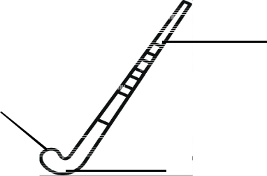
Z X ..............................................
_{X} Y ...............................................

Z ................................................
Y

- A teacher wrote the following statements on a manilla paper and asked learners to complete the statements using a term related to health and fitness. Complete the statements. (4 mks)

  - Ability of a joint to move through a range of motion without feeling pain. .....................................................

  - Ability to use two or more body parts together efficiently at the same time to achieve a given goal.

..........................................................

- Passing a ball in handball involves delivering a ball to a teammate during play. Which three types of passes can you

use? (3 mks)

(i) ...................................................... (ii) .....................................................

(iii) ....................................................................................................................

32. A boy finished a 100M athletics event as shown below. (2 mks)
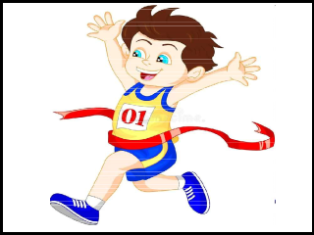

The technique shown above is known as

...........................................

- Mokua advised his learners to practise a single feign dodge back at home. How is a single feign dodge performed. (2 mks) ..................................................................................................

- Brian a grade 7 boy was seen practising a healh related skill using a sit and reach test. What component of physical health was he likely to be evaluating? (2 mks) ....................................................................................................
- When swimming, one should observe pool safety measures. Give three safety measures you should observe. (3mks)

  - ....................................................................................................................

  - ....................................................................................................................

  - ....................................................................................................................

- Your friend wants to study a sport related career at university level. Which three career opportunities will you advice him to take? (3 mks)

(i) ........................................ (ii) ....................................... (iii) .......................................

37. The diagram below shows a learner performing a skill in basketball. (2 mks)
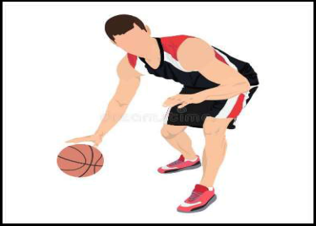

What skill is shown alongside?

..........................................................................

- When playing a game of Netball, one should grip the ball properly. How is the correct grip made? (2 mks) ..................................................................................................................
- A grade 7 teacher asked his learners to practice a ropework technique which involved skipping with the toes touching and heels apart, then heels touching and toes apart. The technique learners practised was known as (1 mk) .................................................................................

