***KENYA JUNIOR SCHOOL EDUCATION ASSESSMENT.***

**GRADE 8**

**CREATIVE ARTS & SPORTS**

**Time: 11/2 Hours.**

**Learner’s Name:______________________________________________________________**

**Assessment No:_____________________________ Grade:___________________________**

**Date:________________________________________________________________________**

**FOR EXAMINERS USE ONLY.**

|  |  |  |
| --- | --- | --- |
| **Score Range** | **Performance Level** | **Tick** |
| ***80-100*** | **Exceeding Expectation** |  |
| ***60-79*** | **Meeting Expectations** |  |
| ***40-59*** | **Approaching Expectations** |  |
| ***Below 40*** | **Below Expectations** |  |

|  |  |
| --- | --- |
| **OUT OF** | **50 MARKS** |
| **Learners Score.** |  |
| **Learners %** |  |

**Instructions to Learners.**

1. Write your name, Assessment Number, Grade/Stream and the Date in the spaces provided above.
2. Answer all questions in this question paper.
3. All your answers must be written in the spaces provided below each question.
4. This paper consists of printed pages. Learners should check the questions in each paper to ascertain that all the papers are printed as indicated and that there is no question missing.
5. Answer all the questions in English.

**QUESTIONS.**

1. State three components of creative arts and sports. **(3mks)**

_______________________________________________________________________________________________________________________________________________________________________________________________________________________________________

2. What is the meaning of Photomontage? **(2mks)**

__________________________________________________________________________________________________________________________________________________________

3. Give two main elements of Music in creative arts and sports. **(2mks)**

__________________________________________________________________________________________________________________________________________________________

4. Differentiate between fitness and agility as used in creative arts and sports. **(4mks)**

____________________________________________________________________________________________________________________________________________________________________________________________________________________________________________________________________________________________________________________

5. Write the following notes using a tie. **(3mks)**

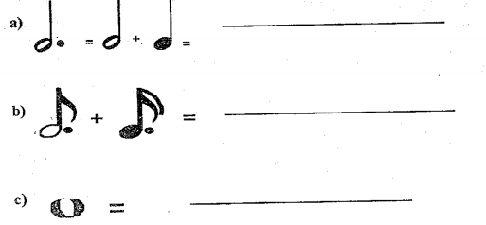

6. State two examples of middle-distance race 2m. **(2mks)**

__________________________________________________________________________________________________________________________________________________________

7. State any three safety measures to observe when performing middle-distance running**. (3mks)**

____________________________________________________________________________________________________________________________________________________________________________________________________________________________________________________________________________________________________________________

8. In the spaces provided below, draw a dotted quaver and semi quaver together and also write its French rhythm. **(3mks)**

9. Write the rhythm name for the following notes. **(3mks)**

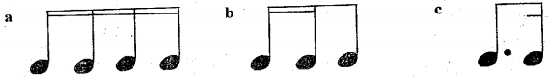

10. Define the term rhythm as used in creative arts. **(2mks)**

__________________________________________________________________________________________________________________________________________________________

11. State two types of dodging techniques used in the game of netball. **(2mks)**

__________________________________________________________________________________________________________________________________________________________

12. State one cultural preservation role of creative arts and sports in the society. **(1mk)**

__________________________________________________________________________________________________________________________________________________________

13. Define the term marking as used in netball game. **(2mks)**

__________________________________________________________________________________________________________________________________________________________

14. List down five types of beads used in beads used in beadwork. **(5mks)**

_________________________________________________________________________________________________________________________________________________________________________________________________________________________________________________________________________________________________________________________________________________________________________________________________

15. Give any two roles of creative arts and sports in the society. **(2mks)**

____________________________________________________________________________________________________________________________________________________________________________________________________________________________________________________________________________________________________________________

16. Use the diagram below to answer the questions that follow.

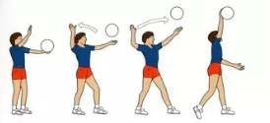

a.) Identify the sports above. **(1mk)**

_____________________________________________________________________________

b.) Give the type of serve illustrated. **(1mk)**

_____________________________________________________________________________

17. Give three societal issues that can be addressed through a verse. **(3mks)**

____________________________________________________________________________________________________________________________________________________________________________________________________________________________________________________________________________________________________________________

18. Name two types of passes in netball. **(2mks)**

__________________________________________________________________________________________________________________________________________________________

19. Write done four professions that can arise from creative arts and sports. **(4mks)**

**____________________________________________________________________________________________________________________________________________________________________________________________________________________________________________________________________________________________________________________**

**THIS IS THE LAST PRINTED PAGE.**