COMPETENCE BASED CURRICULUM
G8
ENDTERM ONE ASSESSMENT
KENYA JUNIOR SCHOOL EDUCATION ASSESSMENT
LEARNER’S NAME: _______________________________.
SCHOOL: _______________________________________.
DATE: ________________SIGNATURE:_______________.
ASSESSMENT NUMBER: _____________________________.
CREATIVE ARTS AND SPORTS TIME: 1HOUR 30MINUTES

INSTRUCTIONS TO LEARNER

- Write your name, name of your school and assessment number in the spaces provided.

- Answer ALL the questions in the spaces provided.

- Answer all questions in the part you have prepared for.

Time: 2 hours

FOR OFFICIAL USE ONLY
SCORE GRID
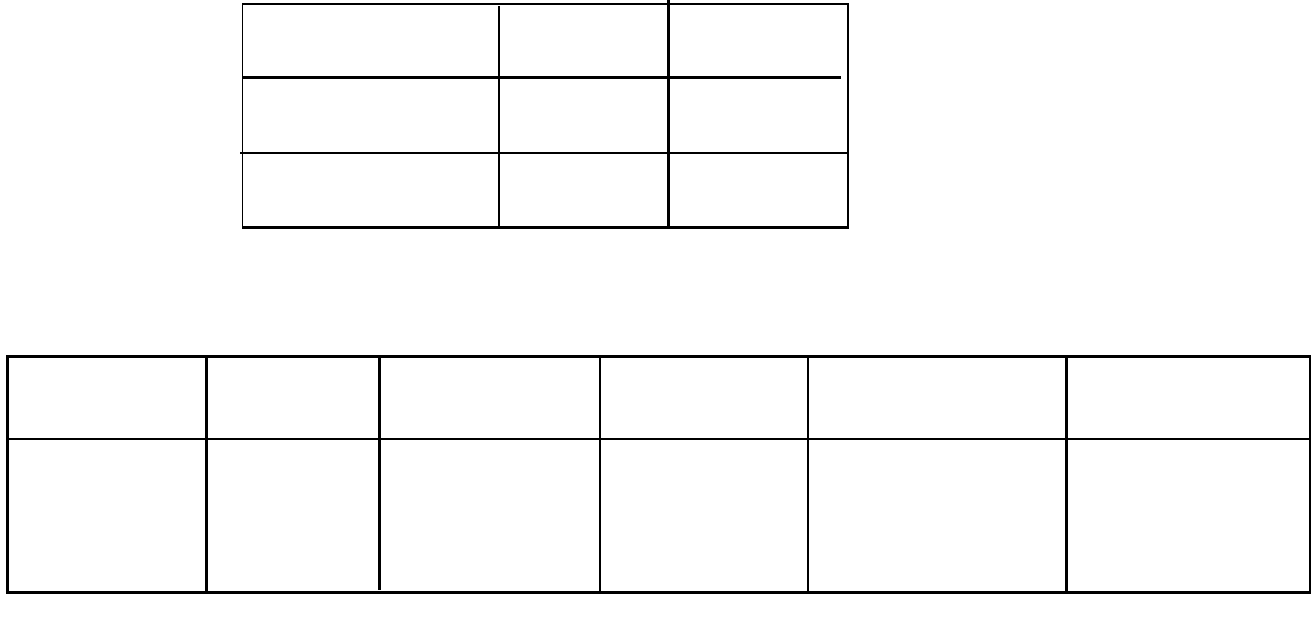

Sections Maximum Candidates

Score Score

Creative and sports 50

Total Score 50

 |  | ASSESSMENT RUBRICS
Learning | area Performance | Exceeds | Meets | Approaching | Below
 | Expectations(4) |  | expectations(3) | Expectations(2) | Expectations(1)
Creative
And Sports

This paper consists of 4 printed pages.

The learner should check the question paper to ascertain that all the pages are printed as indicated and that no questions are missing.

Answer all the following questions.

- During a handball game, players should take precautions to avoid accidents. Give four precautions that should be observed.(4mks)

...................................................................................................................................................

...................................................................................................................................................

...................................................................................................................................................

...................................................................................................................................................

- During a PE lesson, grade eight learners were asked by their teacher to demonstrate how throwing of a javelin is done. State 7 steps one should follow in the correct order. (7mks)
...................................................................................................................................................

...................................................................................................................................................

...................................................................................................................................................

...................................................................................................................................................

...................................................................................................................................................

...................................................................................................................................................

...................................................................................................................................................

- Story telling calls upon one to be creative through applying of different styles. Identify five uses of a flip book in story telling. (5mks)

...................................................................................................................................................

...................................................................................................................................................

...................................................................................................................................................

...................................................................................................................................................

..................................................................................................................................................

- One of the techniques that are employed in football is trapping. What are two benefits of this technique? (2mks)

...................................................................................................................................................

...................................................................................................................................................

- During a music practical lesson, grade eight learners noticed that some wind instruments are capable of playing both melody, harmony and rhythm simultaneously. Give one example of an
instrument that can carry out these functions. (1mk)

...................................................................................................................................................

- Mwalili, a grade 8 learner was asked by her teacher to give components of fitness. State five components he was likely to give. (5mks)

...................................................................................................................................................

...................................................................................................................................................

...................................................................................................................................................

...................................................................................................................................................

..................................................................................................................................................

- When making a javelin, there are some final techniques that are carried out to enhance a final finishing. What are the three techniques that are to be employed? (3mks)
...................................................................................................................................................

...................................................................................................................................................

...................................................................................................................................................

- Mr. Jesse drew the illustration below on the board.
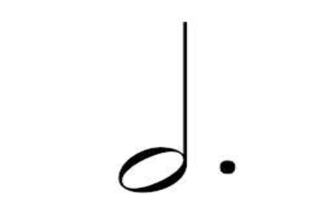

What is the term given to the illustration above? (1mk)

...................................................................................................................................................

- During an AGM at Zuri school, some police officers were seen on the movement below.
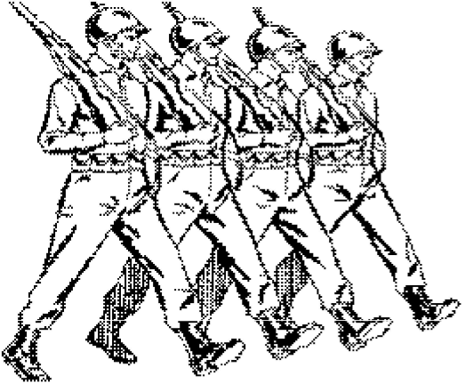

Identify the technique diplayed above and give two of its importance. (3mks)

...................................................................................................................................................

...................................................................................................................................................

...................................................................................................................................................

- Lucy, a grade 8 learner was asked by her teacher to give five importance of learning Creative Arts and Sports. State the correct responss that she gave. (5mks)
...................................................................................................................................................

...................................................................................................................................................

...................................................................................................................................................

...................................................................................................................................................

...................................................................................................................................................

- During the presentation of a play at the National theatre, the adjudicator emphasized to the participants on the importanc of familiarizing themselves with the aspects. What are the four aspects of a play? (4mks)

...................................................................................................................................................

...................................................................................................................................................

...................................................................................................................................................

...................................................................................................................................................

- Leah, a grade seven learner was asked by her teacher to define the term dynamics as used in music. What was her answer? (2mks)

...................................................................................................................................................

...................................................................................................................................................

- Swimming skills are considered to be a life saver. Briefly explain this statement. (1mk)

...................................................................................................................................................

...................................................................................................................................................

- In music, there are different methods of extending a melody with an aim of improving the quality of the song. What are the two ways of achieving this? (3mks)

...................................................................................................................................................

...................................................................................................................................................

...................................................................................................................................................

- Agnes, a grade eight learner was asked by her fellow learners to teach them the skills on dancing. What are the four skills needed mainly for dancing? (4mks)

...................................................................................................................................................

...................................................................................................................................................

...................................................................................................................................................

...................................................................................................................................................

