JUNIOR SCHOOL EDUCATION ASSESSMENT
GRADE 8
TERM ONE 2025 OPENER
NAME: ……………………………………………………………………..
SCHOOL: ………………………………………………………………….
ASSESSMENT NUMBER: ……………………………………………….
SIGNATURE: ……………………………….DATE:……………………..
CREATIVE ARTS AND SPORTS

ASSESSMENT RUBRICS

Learning | Performance | Exceeds | Meets | Approaching | Below
area |  | Expectations (4) | Expectations (3) | Expectations (2) | Expectations (1)
Creative
Arts
and Sports

- During a painting lesson, a teacher instructed his learners to paint an imaginative seascape using either cool or warm colours. Give an example of each category of colours.
(a) Warm colour ............................................................................................................ (1 mark)

(b) Cool colour ............................................................................................................... (1 mark)

2. Grade 7 learners were practicing javelin throw during one of their practical lessons. List any three safety
measures they should observe during the practice. (3 marks)

3. Explain the meaning of the following terms as used in music. (2 marks)

- Dynamics

.....................................................................................................................................................

.....................................................................................................................................................

- Tempo

.....................................................................................................................................................

.....................................................................................................................................................

- Teacher Maundu, a grade 7 Creative Arts and Sports teacher invited a resource person for a story telling session.

(a) List any three storytelling techniques the resource person could use. (3 marks)

.....................................................................................................................................................

.....................................................................................................................................................

.....................................................................................................................................................

(b) Name any three pertinent and contemporary issues in the society for storytelling. (3 marks)

.....................................................................................................................................................

.....................................................................................................................................................

.....................................................................................................................................................

5. In the game of handball, passing is a very important skill.

(a) Justify this statement by giving two importance of passing. (2 marks)

.....................................................................................................................................................

.....................................................................................................................................................

(b) List any two qualities of a good pass. (2 marks)

.....................................................................................................................................................

.....................................................................................................................................................

- The diagram below shows a staff that was drawn by a grade 7 learner during a Creative Arts and Sports lesson.
(iv)

(iii)
_{(i)} (ii)

(a) On the staff, draw a G-clef. | (2 marks)
(b) Name the pitches labelled i, ii, iii and iv. | (4 marks)

(i) ..................................................................

(ii) .................................................................

(iii) ...............................................................

(iv) .............................................................

7. In preparation for a carving in sculptor lesson, learners were asked by their teacher to collect what they

would use. Name any two materials they could use to carve. | (2
marks)
.....................................................................................................................................................
8. Explain the meaning of the term time signature as used when creating rhythmic patterns. | (1 mark)

.....................................................................................................................................................

.....................................................................................................................................................

9. Below is a piano keyboard which was used by grade 7 learners to practice playing the scale of G major.

 |  |  |  |  | (ii) |  |  |  |  | (iii)
(i)
Name the keys labelled i, ii and iii. |  |  |  |  |  |  |  |  |  |  |  |  | (3 marks)
(i) ..................................................................
(ii) ...............................................................
(iii) ...............................................................
10. Name and explain any three phases of a plot as an element of a story. |  |  |  |  |  |  |  |  |  |  |  |  | (6 marks)
.....................................................................................................................................................
.....................................................................................................................................................
.....................................................................................................................................................
.....................................................................................................................................................
.....................................................................................................................................................
.....................................................................................................................................................

- Complete the diagram below by filling the boxes labelled a, b and c with correct music note symbols.

(3 marks)
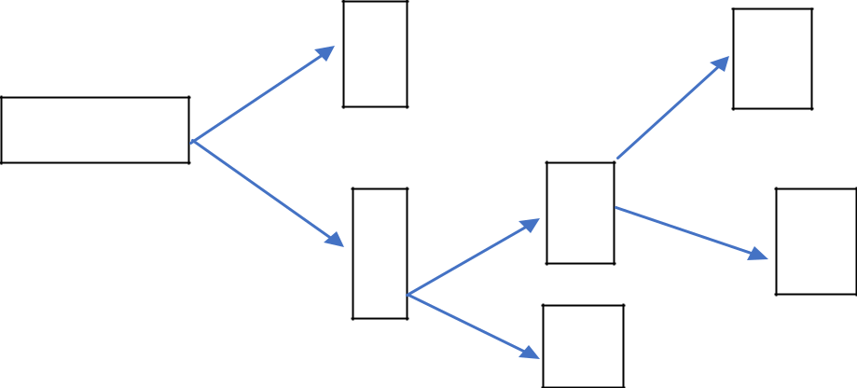

a

Minim

b

c

12. Mutoko, a grade 7 learner composed the rhythmic pattern below.
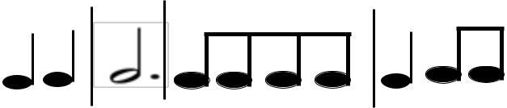

(a) Insert the time signature in front of the rhythmic pattern. (1 mark)

.....................................................................................................................................................

(b) Write the French rhythm for the pattern above. (4 marks)

.....................................................................................................................................................

.....................................................................................................................................................

.....................................................................................................................................................

.....................................................................................................................................................

- Creative Arts and Sports plays important roles in the society. Explain any two of these roles. (4 marks)

.....................................................................................................................................................

.....................................................................................................................................................

.....................................................................................................................................................

.....................................................................................................................................................

14. (a) Explain the meaning of collage as used in picture making. (1 mark)

.....................................................................................................................................................

.....................................................................................................................................................

(b) State any two materials that can be used in collage making. (2 marks)

.....................................................................................................................................................

.....................................................................................................................................................

