COMPETENCE BASED CURRICULUM
G8
ENDTERM ONE ASSESSMENT
KENYA JUNIOR SCHOOL EDUCATION ASSESSMENT
LEARNER’S NAME: _______________________________.
SCHOOL: _______________________________________.
DATE: ________________SIGNATURE:_______________.
ASSESSMENT NUMBER:_____________________________.
AGRICULTURE AND NUTRITION TIME: 1HOUR 30MINUTES

INSTRUCTIONS TO LEARNER

- Write your name, name of your school and assessment number in the spaces provided.

- Answer ALL the questions in the spaces provided.

- Answer all questions in the paper..

Time: 2 hours

FOR OFFICIAL USE ONLY
SCORE GRID

 | Sections | Maximum Candidates
 |  | Score | Score
 | Agriculture and
 |  | 50
 | Nutrition
 | Total Score | 50
 |  | ASSESSMENT RUBRICS
Learning | area Performance | Exceeds | Meets |  | Approaching | Below
 | Expectations(4) |  | expectations(3) |  | Expectations(2) | Expectations(1)
Agriculture
and Nutrition

This paper consists of 4 printed pages.

The learner should check the question paper to ascertain that all the pages are printed as indicated and that no questions are missing.

Answer all the following questions.

- Merrika, a grade 8 learner came across the practice below.
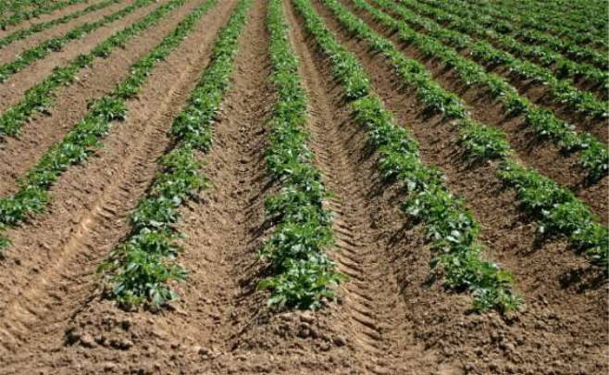

- What is the name of the practice shown above? (1mk)

......................................................................................................................................

- Give three importance of the practice demonstrated above. (3mks)

......................................................................................................................................

- Grade 8 learners prepared a meal as shown below.
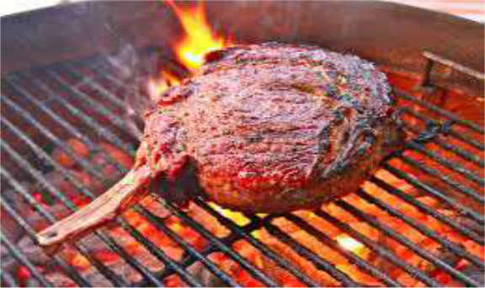

Mercy was told to give four importances of preparing the food using the method illustrated above.What importance was she likely to give? (4mks)

..........................................................................................................................................................

..........................................................................................................................................................

..........................................................................................................................................................

..........................................................................................................................................................

- After harvesting honey, grade 8 learners had to remove the honey from the combs as shown below.
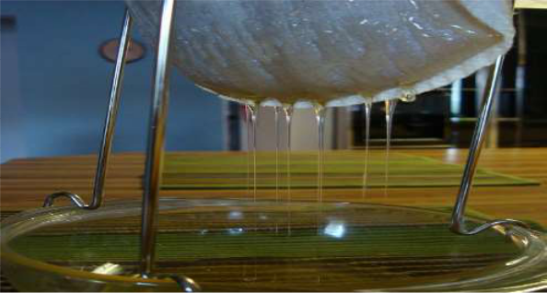

What are four importance of using this method of honey extraction? (4mks)

..........................................................................................................................................................

..........................................................................................................................................................

..........................................................................................................................................................

..........................................................................................................................................................

- Gein was asked by her teacher to identify causes soil pollution and how it can be prevented. Identify four methods of controlling soil pollution. (4mks)

..........................................................................................................................................................

..........................................................................................................................................................

..........................................................................................................................................................

..........................................................................................................................................................

- Trees play an important role in the conservation of the environment as well as in agriculture. Name four importance of trees in conservation of the environment. (4mks)

..........................................................................................................................................................

..........................................................................................................................................................

..........................................................................................................................................................

..........................................................................................................................................................

- There are different ways of making items from fibre. Identify four techniques used when knitting with an aim of producing different designs. (4mks)

..........................................................................................................................................................

..........................................................................................................................................................

..........................................................................................................................................................

..........................................................................................................................................................

- In farm activities, different technologies have been introduced that have enhanced agriculture. Basing on the framed suspended gardens, name four of it’s advantages. (4mks)
..........................................................................................................................................................

..........................................................................................................................................................

..........................................................................................................................................................

..........................................................................................................................................................

- During cleaning in our homes, we use different types of soap to obtain the cleanliness. What are the four examples of soap used at home? (4mks)

..........................................................................................................................................................

..........................................................................................................................................................

..........................................................................................................................................................

..........................................................................................................................................................

- Pollution has many disadvantages to the surrounding. Give four causes of soil pollution in the soil. (4mks)

..........................................................................................................................................................

..........................................................................................................................................................

..........................................................................................................................................................

..........................................................................................................................................................

- Maimuna made her piece of land to the tilth illustrated below.

What are the four advantages of the type of tilth shown above? (4mks)

..........................................................................................................................................................

..........................................................................................................................................................

..........................................................................................................................................................

..........................................................................................................................................................

- Different animal products are prepared differently. Give two ways that are used in preparation of beef meat. (2mks)

..........................................................................................................................................................

..........................................................................................................................................................

..........................................................................................................................................................

..........................................................................................................................................................

- In egg production, there are some practices that are supposed to be done so that the eggs are certified for marketing. Give two of the practices. (2mks)

..........................................................................................................................................................

..........................................................................................................................................................

- Hygiene is important in our kitchen. Give two types of cleaning that are carried out in our kitchens to keep them clean. (2mks)

..........................................................................................................................................................

..........................................................................................................................................................

- Grade 8 learners were asked by their teacher to carry some items for teeth cleaning. Explain why cleaning of teeth is important for our health. (2mks)

..........................................................................................................................................................

..........................................................................................................................................................

- Personal hygiene is important and this needs one to be keen in managing our hygiene. Give two practices that will help one manage sweat as a way of maintaining hygiene. (2mks)
..........................................................................................................................................................

..........................................................................................................................................................
