COMPETENCE BASED CURRICULUM
JUNIOR SCHOOL
MID TERM ASSESSMENT
TERM 1 2025
AGRICULTURE AND NUTRITION

NAME:________________________________________________.
SCHOOL:______________________________________________.
ASSESSMENT NUMBER: ________________________________.
DATE:____________________ SIGNATURE:________________.

FOR OFFICIAL USE ONLY

ASSESSMENT RUBRIC
TASK | Exceeding Expectation | Meeting Expectation | Approaching Expectation | Below Expectation
LEVEL
SCORE

INSTRUCTIONS TO LEARNER

1. Write your name, name of your school and assessment number and sign in the spaces provided.

2. Answer ALL the questions in the spaces provided.

Time: 2HOURS

- The practice of maintaining a healthy environment that sustains plants, water, land and air in good condition is referred to as ………………………………… (2 mks)

- Identify 2 biotic major components of the environment. (2 mks)
(a)………………………..................................................
(b)...........................................……………………………..

- Identify 2 main causes of soil pollution. (2 mks)
(a)………………………..................................................
(b)...........................................……………………………..
(c)……………………….....................................................

- The level of coarseness or fineness of a planting site is known as …………….............……... (1 mk)

- Identify the 3 main types of soil tilths. (3 mks)
(a)………………………..................................................
(b)...........................................……………………………..
(c)……………………….....................................................

- Identify 2 main ways of reusing plastic waste in the farm. (2 mks)
(a)………………………..................................................
(b)...........................................……………………………..

- Identify the structure below used to control surface runoff . (2 mks)
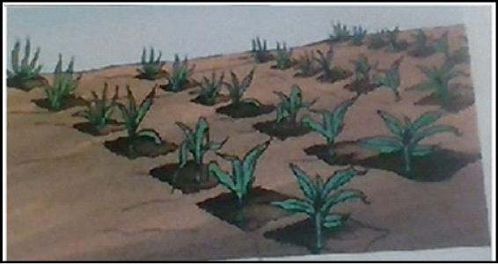

……………………………………………
- The farming practice where disturbance of the soil is kept at the minimum is known as
………………………………… (2 mks)

- Identify 2 main crop production practices in a farm.(2 mks)
(a)………………………..................................................
(b)...........................................……………………………..
- Identify the planting materials in the pictures below. (4 mks)
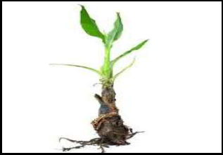
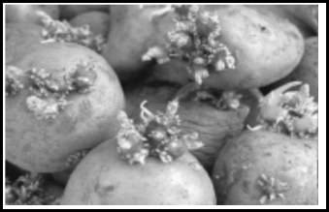

..................................... .....................................

- Identify the 3 components in an agroforestry farm. (3 mks)
(a)………………………....................................................
(b)...........................................……………………………..
(c)……………………….....................................................

- Identify 3 crop management practices on established crops. (3 mks)
(a)………………………....................................................
(b)...........................................……………………………..
(c)……………………….....................................................

- What makes it impossible to use herbicides in a farm where maize and beans have bean planted together? (2 mks)

……………………………………………………………………………
……………………………………………………………………………

- Highlight 3 ways of handling animals humanely. (3 mks)
  - ………………………............................................................
  - ……………………….............................................................
  - ……………………….............................................................

- Identify 2 ways you can communicate with animals (2 mks)
  - ………………………............................................................
  - ……………………….............................................................

- The farming practice where the farmer grows crops during dry period is referred to as
………………………………………………… (1mk)

- Identify 3 advantages of off season cropping. (3mks)
  - ………………………............................................................
  - ……………………….............................................................
  - ……………………….............................................................

- Discuss 3 materials used in container gardening. (3 mks)
  - ………………………............................................................
  - ……………………….............................................................
  - ……………………….............................................................

- Identify 2 ways of preparing animal products. (2 mks)
  - ………………………............................................................
  - ……………………….............................................................

- Identify 2 factors to consider when grading eggs. (2 mks)
  - ………………………............................................................
  - ……………………….............................................................

- The range of activities done to improve quality of crop produce and attract high market value is known as

………………………………………………………… (2 mks)

- Discuss how drying is identified as value addition to some crops. (2 mks)
  - ………………………............................................................
  - ……………………….............................................................

- List down two safety measures while chrotcheting. (2mks)
  - ………………………............................................................
  - ……………………….............................................................

- Identify two factors to consider while buying small kitchen tools and equipment. (2mks)

  - ………………………............................................................
  - ……………………….............................................................

- State two career opportunities associated with Homescience. (2mks)
  - ………………………............................................
  - ...................................……………………………..

- State two ways of preparing clothes before washing. (2mks)
  - ………………………............................................................
  - ……………………….............................................................

- State 3 kitchen tools that can be improvised. (3mk)
(a)………………………..................................................
(b)...........................................…………………………….
(c)……………………….....................................................

- Identify two methods of preserving meat. (2mks)
  - ………………………............................................................
  - ……………………….............................................................

- Name three foods that can be preserved by drying. (3mks)
(a)………………………..................................................
(b)...........................................……………………………..
(c)……………………….....................................................

- State two desirable properties of silk. (2 mks)
(a)………………………………………………………..
  - ……………………………………………………….

- Eric went to a shop to buy a silk shirt. Which physical identification test can be used to identify silk garments? (3mk)
………………………………………………………..

- State two factors to consider when choosing seams in cloth making. (2mks)
(a)………………………………………………………..
  - ……………………………………………………….

- Name three parts of a sewing machine. (3mks)
(a)………………………..................................................
(b)...........................................……………………………..
(c)……………………….....................................................

- State two factors to consider when buying a sewing machine. (4mks)
(a)………………………..................................................
(b)...........................................……………………………..

- State three methods of cooking different types of food. (3mks)
(a)………………………..................................................
(b)...........................................……………………………..
(c)……………………….....................................................

- Peter has just harvested green maize. Describe how he can grill the green maize for his family. (2mks)

  - ………………………………………………………..
  - ……………………………………………………….

- Grade 7 learners were asked to prepare charts on safety precautions to take when cooking.Write the safety precautions they should include in the chart for each of the following methods of cooking. (6mks)

- Grilling - ............................................................................................................................................

- Roasting - ........................................................................................................................................

- Steaming - ...................................................................................................................................

- State three special treatment in laundry work. (3 mks)
  - ………………………………………………………..
  - ……………………………………………………….
(c) .....................................................................................

- Write two agents required for special treatment in laundry work. (2mks)
  - ………………………............................................................
  - ……………………….............................................................

- Outline two guidelines for nutrient conservation during cooking of food. (4mks)
  - ………………………………………………………..
  - ……………………………………………………….

