COMPETENCE BASED CURRICULUM
GRADE 7 TERM 1
KJSEA OPENER EXAMS 2025
SOCIAL STUDIES ACTIVITIES
NAME:……………………………………………………………………………………………………
SCHOOL……………………………………………………………………………………………….
ASSESSMENT NUMBER;……………………………………………………………………
DATE;…………………………………………………………………………………………

- Grade 7 Social Studies teacher asked the learners to identify three branches of Social Studies. Which response did they give?(3mks)
- …………………………………………………………………………….……………
- ………………………………………………………………………………………….
- ………………………………………………………………………………………….

- Name four communities found in Uganda who belong to the Bantu speakers.(4mks)

- …………………………………………………………………………….……………
- ………………………………………………………………………………………….
- ………………………………………………………………………………………….
- …………………………………………………………………………………………

- Identify four elements of weather.(4mks)

- …………………………………………………………………………….……………
- ………………………………………………………………………………………….
- ………………………………………………………………………………………….
- …………………………………………………………………………………………

- Allan, a grade six learner was asked to name three historic built environments in Eastern Africa.Write the historic built environments he named.(3mks)

- Population in Africa is not evenly distributed. This is influenced by various factors. Name three factors that influence this.(3mks)

- A Social Studies teacher asked learners to do research from their grandparents and define the following terms. Which explanation did they come up with?(3mks)
  - A clan

  - Age group

  - Age set

- Identify where the following minerals are mined in Eastern Africa.

  - Gold

  - Limestone

  - Petroleum

  - Soda ash

- Grade six learners were asked to name traditional methods of education. List three methods they gave?(3mks)

9. What is self awareness?(2mks)

- Which roles were performed by the leaders below in the traditional Buganda kingdom.(4mks) a)Kabaka

b)Katikiro

c)Omulamuzi

d)Omwanika

- Differentiate between talent and ability.(2mks)

- Name three countries that first founded East African Community (E.A.C)(3mks)

- Use the map of Africa to answer questions
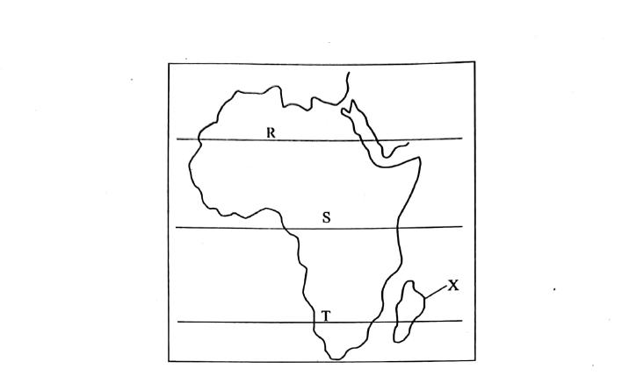

- Name the tropics labelled

- R

- S

- T

b) The country marked X is called

14. Name three careers related to Social Studies.(3mks)

- List four characteristics of a person with high self esteem.(4mks)

- Which is the second largest continent in the world?(1mk)

Answers

- 1. History

  - Citizenship and governance

  - Geography

- 1. Baganda

  - Batoro

  - Bagisu

  - Banyakole

  - Bachiga

- 1. Rainfall

  - Temperature

  - Air pressure

  - Wind

  - Sunshine

  - Humidity

- 1. Francis of Asisi - Eritrea

  - Fort Jesus - Kenya

  - Namugongo Shrine - Uganda

  - Roman Kiosk - Sudan .

- 1. Climate

  - Soil

  - Government police

  - Economic factors e.g. industries, mines, plantation, irrigation schemes

- A clan:

  - Group of people with a common ancestor.

Age group:

1. A group of people born almost at the same time.

Age set

  - A group of people initiated at the same time.

- 1. Gold - Tanzania

  - Limestone - Uganda

  - Petroleum - Turkana, Ugamia,Kenya

  - Soda ash - L. Magadi - Kenya

- 1. Apprenticeship

  - -Use of proverbs

  - Use of songs

  - -Use of stories

  - Use of riddles

- 1. Having an accurate understanding of ourselves.

- 1. Kabaka - King

  - Katikiro - Prime Minister

  - Omulamuzi - Chief Justice

  - Omwanika - Treasurer

- 1. A talent is an inborn ability within a person which make them excel in a certain activity while ability is someone's capacity to do something which is acquired through constant practise and training.

- 1. Kenya

  - Uganda

  - Tanzania

- a)

  - Tropic of Cancer

  - Tropic of Capricorn

  - Equator

b)

  - Madagascar

- 1. Geology

  - Teaching

  - Archaeology

  - Meteorology

  - Law

  - Survey

  - Aviation

  - Climatology

- 1. Believes in his or her own capacities to solve problems.

  - Is able to make choices easily.

  - Is not afraid to express his or her own feelings.

  - Is comfortable with change.

  - Enjoy healthy relationships.

- Africa

