G7
COMPETENCE BASED CURRICULUM
ENDTERM ONE ASSESSMENT

KENYA JUNIOR SCHOOL EDUCATION ASSESSMENT
LEARNER’S NAME: _______________________________.
SCHOOL: _______________________________________.
DATE: ________________SIGNATURE:_______________.
PRETECHNICAL STUDIES TIME: 2 HOURS

INSTRUCTIONS TO LEARNER

- Write your name, name of your school and assessment number in the spaces provided.

- Answer ALL the questions in the spaces provided.

- Answer all questions in the paper..

Time: 1 hour

FOR OFFICIAL USE ONLY
SCORE GRID
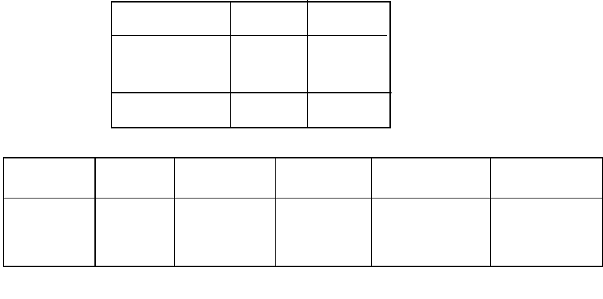

Sections Maximum Candidates
Score Score
Pre-Technical 50
studies

Total Score 50

ASSESSMENT RUBRICS
Learning Performance Exceeds Meets Approaching Below
Expectations(4) Expectations(3) Expectations(2) Expectations(1) area
Pre-technical
studies

This paper consists of 4 printed pages.

The learner should check the question paper to ascertain that all the pages are printed as indicated and that no questions are missing.
Turn over

Answer all the following questions.

- Identify three components of Pre-technical studies as a learning area. (3mks)

.....................................................................................................................................................

.....................................................................................................................................................

.....................................................................................................................................................

- Explain three roles of Pre-technical studies as a learning area. (3mks)

.....................................................................................................................................................

.....................................................................................................................................................

.....................................................................................................................................................

- Learners in Grade seven in Happy school were asked to discuss in groups on some hazards to

personal safety in the work environment. State five hazards they discussed. (5mks)

.....................................................................................................................................................

.....................................................................................................................................................

.....................................................................................................................................................

.....................................................................................................................................................

.....................................................................................................................................................

- Grade 7 learners were asked by their teachers to write the meaning of the following terms as used in computer concepts. (6mks)

  - Computer

.....................................................................................................................................................

.....................................................................................................................................................

  - Data

.....................................................................................................................................................

.....................................................................................................................................................

  - Information

.....................................................................................................................................................

.....................................................................................................................................................

- Pre-technical teacher in Grace School placed learners in groups to brainstorm and discuss the safety rules and regulations in a work environment. Highlight four measures to take to stay safe and avoid common hazards in the locality that were likely to be discussed and presented in class. (4mk)
.....................................................................................................................................................

.....................................................................................................................................................

.....................................................................................................................................................

.....................................................................................................................................................

- Joy received a notification that her account was logged in, three days after visiting a cybercafe.

  - Identify the possible online threat that Joy encountered. (2mks)

.....................................................................................................................................................

.....................................................................................................................................................

  - What might have led to Joy’s account being logged into by a different person? (2mks)

.....................................................................................................................................................

.....................................................................................................................................................

.....................................................................................................................................................

  - Name the possible online safety measure that Joy should observe in order to avoid experiencing this online threat. (3mks)

.....................................................................................................................................................

.....................................................................................................................................................

.....................................................................................................................................................

- Computers have different characteristics which identify their functionality. State the characteristics of computers described below. (4mks)

  - Computers perform more than one task at a time.

.....................................................................................................................................................

.....................................................................................................................................................

  - Computers lacks its own intelligence to process some tasks unless programmed.

.....................................................................................................................................................

  - Computers give out information without errors according to the data entered.

.....................................................................................................................................................

  - A computer performs tasks at high speed compared to humans.

.....................................................................................................................................................

- Samuel wants to start a small business at home. He needs a computer to save her stock records, make shopping list and calculate his sales. He has little money to spend because her budget is fixed. Advise her on the best type of computer he can buy. (2mks)

.....................................................................................................................................................

.....................................................................................................................................................

- During a computer lesson, Melanie and her friend Prudence entered the computer room with her water bottle and packed lunch. She wanted to complete an assignment. Prudence ran over the cable with her dusty shoes in an attempt to secure herself a cool spot. She tripped and fell hitting a stool that was having the keyboard. The keyboard fell and broke.
  - List what Melanie did wrong in the computer room .(1mk)

.....................................................................................................................................................

  - What was Prudence’s mistake? (2mks)

.....................................................................................................................................................

  - List the safety measures that the two girls were supposed to observe. (4mks)

.....................................................................................................................................................

.....................................................................................................................................................

.....................................................................................................................................................

.....................................................................................................................................................

- Gacheru has been receiving links that want him to register and win money in an online gaming application. What advice would you give Gacheru? (1mk)

.....................................................................................................................................................

- Abigael posted video shots on TikTok and Instagram dancing to the trending amapiano song. Her social media friend commented on the videos meanly. She felt embarrassed and depressed.
  - What online threat did Abigael experience? (1mk)

.....................................................................................................................................................

  - List the online safety measures that Abigael should observe in future. (2mks)

.....................................................................................................................................................

- Nelius received 40 friend requests and 5 messages on her Facebook account. She did not know any of the people sending the friend requests and messages.

  - What would you advise Nelius to do? (1mk)

.....................................................................................................................................................

  - Give reasons for your answer in (a) (2mks)

.....................................................................................................................................................

.....................................................................................................................................................

- You have noticed your computer is taking long to start up and open programs. It is always displaying error messages. It keeps crashing and has problems restarting and shutting down.
  - Identify the possible threat in your computer. (1mk)

.....................................................................................................................................................

  - List the most appropriate ways you will use to protect your personal data in a computer. (2mks)

.....................................................................................................................................................

- Berea Supermarket found a way of minimising errors at their checkout point of sale terminals. The cashiers do not enter the prices of items manually. They use a computer hardware that captures the data of items directly. What type of computer is this? (2mks)

.....................................................................................................................................................

.....................................................................................................................................................

- What are you supposed to do when you are creating a word document in the computer room? (1mk)

.....................................................................................................................................................

.....................................................................................................................................................

