COMPETENCE BASED CURRICULUM
GRADE 7 TERM 1
KJSEA OPENER EXAMS 2025
PRETECHNICAL STUDIES ACTIVITIES
NAME:……………………………………………………………………………………………………
SCHOOL……………………………………………………………………………………………….
ASSESSMENT NUMBER;……………………………………………………………………
DATE;…………………………………………………………………………………………

- Grade 7 learners were having a debate on the role of Pre-Technical studies in day –to-day life. List three roles that they should have included.(3mks)

- Keith is a newly employed human resource officer. He works using an online system. He feels that his work environment is threatened.
  - Which two types of threats are likely to face his work environment?(2Marks)

  - Give two examples of each type of threat you have identified(4 marks)

  - After consulting with his superiors, he was advised to observe some safety regulations. List 4 way he would protect his personal information online.(4Marks)

- During a Pre-Technical lesson, learners gave definitions of the following terms; computer, data and information. What was the correct meaning of those terms?(3 marks)
  - Computer

  - Data

  - Information

- Mrs. Edith was having a discussion with her learners about characteristics of a computer. State any 5 characteristics that they discussed.(5 marks)

- The ministry of ICT is planning to procure different types of computers. Which three parameters can they use to classify the computers?(3 marks)

Answers

- 1. It prepares the learner for technical and engineering and career technology studies

  - It equips the learner with foundational knowledge, skills, attitudes and values needed in technical learning areas such as metal work, wood work, electricity, culinary arts, hair dressing and beauty therapy, aviation technology, building construction, power mechanics, leather work, marine and fisheries, manufacturing and media technology
- It equips the learner with exploration, imagination, creativity, innovation and hands on skills through projects and practical activities.
- It provides the learner with unique experience in career exploration

2. a)

- Physical Threats

- Online Threats

b)
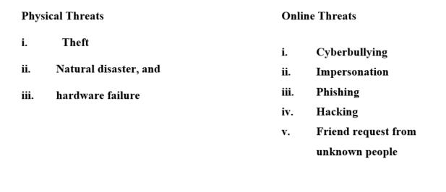

c)

- Creating a strong password

- Avoid oversharing on social media

- Use free Wi-Fi with caution

- Watch out for links and attachments

- Check to see if the site is secure

- Consider additional protection e.g. anti-virus, hacking insurance, etc.

3. a)

1. A computer is an electronic device that converts data to information.

b)

- Data refers to raw facts such as numbers symbols, images and letters that have no meaning to the user

c)

  - Information refers to processed data that is meaningful to the user

- 1. Speed

  - Accuracy

  - Versatility

  - Storage

  - Consistent
- 1. Functionality

  - Purpose

  - size

