COMPETENCE BASED CURRICULUM
GRADE 7 TERM 1
KJSEA OPENER EXAMS 2025
MATHEMATICS ACTIVITIES
NAME:……………………………………………………………………………………………………
SCHOOL……………………………………………………………………………………………….
ASSESSMENT NUMBER;……………………………………………………………………
DATE;…………………………………………………………………………………………

- The number of learners who joined grade 1 in the year 2023 was two million two hundred and two thousand two hundred and two. What is this number in symbols?(2mks)

- What is the difference between the largest and the smallest numbers that can be formed using these digits 4, 7, 3, 0 and 8?(2mks)

- A farmer subdivided his farm into equal square plots. The area of each plot was 1024m². What is the length of each plot of land?(2mks)

- In a school, 0.45 of the learners are boys while the rest are girls. What is the percentage of the girls in the school?

- Work out the value of: 140+90 - 30 x 24 + 6

- What is the reciprocal of 18?

- What is the smallest number that can be divided by 6, 16 and 28 without a remainder?(2marks)

- A motorist covered a distance of 54.1586km. Round off the distance he covered to three decimal places.(2marks)

- What is the sum of the prime numbers between 20 and 30?(2mks)

- The county government of Nairobi distributed 43 bags of rice to each of the 546 schools in the county.How many bags were distributed altogether?(2mks)

- The length of a spoon is 22cm 5mm. What is the total length of 10 such spoons in mm?(2mks)

- Find the total area of the field drawn below in square metres (2mks)
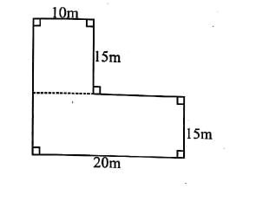

13. Find the area of the shaded part in the figure below( 2marks )
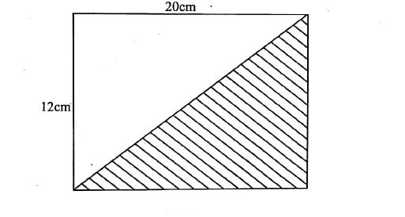

- A butcher had 15 kilograms of meat, he sold kilograms. How many kilograms of meat was he left with? (2marks)

- Find the size of the angle marked x (2marks)
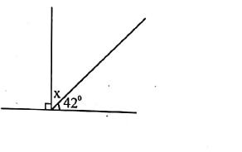

16. In the equation below,solve the value of y(2mks)

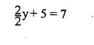

- Ahmed sold a radio for sh. 2450. He made a loss of sh. 550. How much had he bought the radio?

- A shop keeper had 2 tonnes of sugar. He packed the sugar into 5kg packets. How many packets did he obtain?(2mks)

- Find the circumference of the circular field drawn below.(2marks)

- What is 12:10am written in 24 hour clock system?(1mk)

- Grace bought the following items from the shop:

2 loaves of bread at sh. 65

3 packets of milk for sh. 165

1 match box @ sh.5.

If she paid for the items using a 500 shilling note. How much balance did she get?

- A rectangular container measures 13cm long, 10 cm wide and 14 cm high. Calculate the amount of water it can hold in cubic centimetres.(2marks)

- A family used 45 litres of water in one week. What is the capacity of water used by the family in 3 weeks in millilitres?(2marks)

- The diagram below shows a 3-D shape. What is the sum of its faces, vertices and edges?(3mks)
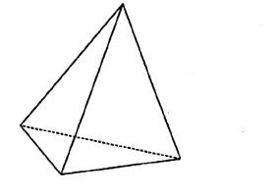

25. The graph below shows the number of learners who were present in a school in one week. (2 marks)

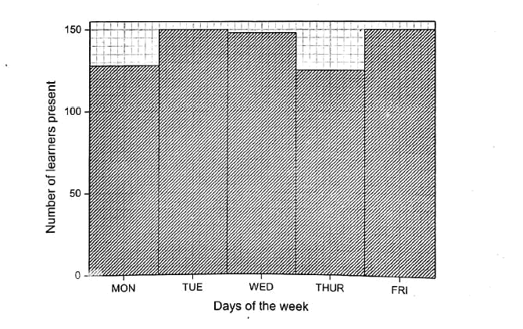

what was the total number of learners present the whole week?

Answers
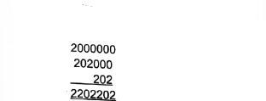

1.
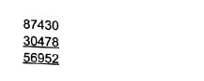

2.
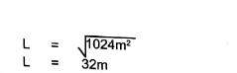

3.
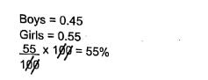

4.

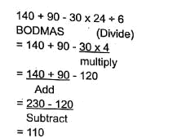

5.
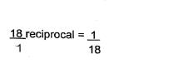

6.
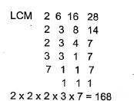

7.
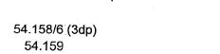

8.

- 23+29=52

- 5.46 x 43bags = 23478 bags
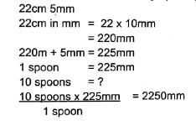

11.
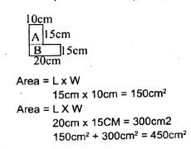

12.

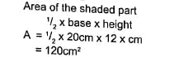
13.
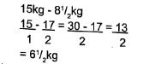

14.
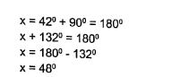

15.
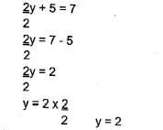

16.
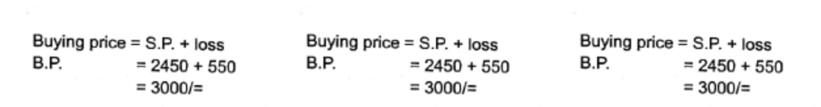

17.
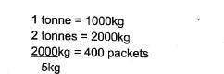

18.
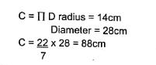

19.

20. 0010hrs
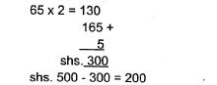

21.

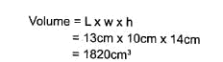
22.
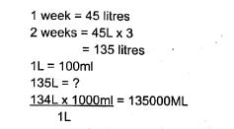

23.

24. 4 faces + 6 edges + 4 vertices = 14
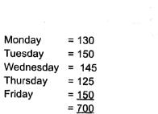

25.

