COMPETENCE BASED CURRICULUM
GRADE 7 TERM 1
KJSEA OPENER EXAMS 2025
CREATIVE ARTS AND SPORTS ACTIVITIES
NAME:……………………………………………………………………………………………………
SCHOOL……………………………………………………………………………………………….
ASSESSMENT NUMBER;……………………………………………………………………
DATE;…………………………………………………………………………………………

- Mary and Caro were demonstrating a pass used in the game of netball as shown below
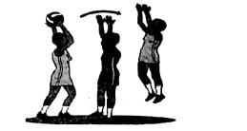

Identify the type of pass they executed(1mk)

- Bridget and Stacy improvised a football ball. List three readily available materials they used. (3mks)

- In a class discussion, Esther, a learner in grade seven, mentioned the three finishing techniques in sprints. Write down the correct techniques she mentioned. (3mks)

- Name the following parts of a javelin(4mks)
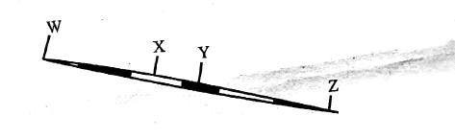

- You have been asked to name four phases of long jump. Write them down. (4mks)

- In a physical education and health the learner practised the jump rope skill shown below.
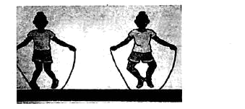

Identify the of jump rope skill________________(4mk)

- ______________players per team are allowed in the field of play during the start of kabaddi game.(1mk)

- List three swimming pool rules that need to be observed. (3mks)

- When playing the game of kabaddi, a player entered the opposing team's side while chanting "kabaddi".What is the name of the player?(1mk)

- During the interclass handball competition, the coach asked a player to dribble the ball. Write down the three reasons the coach would request learners to use that skill. (3mks)

- During a 100m race start, an athlete was in a position as shown in the diagram.
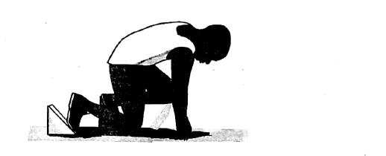

What are the commands given during the start of this race on the above position? (3mks)

- In a physical education lesson, the teacher defined the following terms. Write the correct meaning she gave (2mks)

Speed Coordination

- Name one type of bandage used in first aid.(4mks)

- List FOUR ways of experiencing arts. (4 marks)
- Define entrepreneurship. (1 mark)

- Differentiate between visual arts and written arts. (2marks)

- List TWO examples of each of the following categories of arts. (4 Marks)

  - Applied arts

  - Visual arts

- Define teamwork as an aspect of preparing for a presentation. (2 marks)

- List TWO roles played by the audience in performing arts. (2 marks).

- Define performing arts. (2 marks)

- Define the following terms as used in performing arts. (4 marks)

  - Artiste

b)Audience

c).Dialogue '

d)Performance

- List five disciplines of performing arts. (5 marks)

- Differentiate between drama and film. (2marks)

- List TWO reasons why it is important to study performing arts. (2marks)

Answers

- Overhead pass

- 1. Plastic bag - This could be used to create a makeshift ball shape or as stuffing inside the ball.

  - Rubber bands - These could be used to hold the plastic bag together or to give the ball structure.

  - Duct tape - This could be used to bind the materials together and give the ball a more solid form

- 1. Lean Forward - This technique involves leaning the upper body slightly forward towards the finish line to help drive momentum and reach the line faster.

  - Drive the Arms - Sprinting with strong arm movements helps to propel the body forward, especially in the final strides of the race.

  - Maintain a Strong Posture - Ensuring the body remains upright with relaxed shoulders and a focused head position as the runner approaches the finish line helps prevent loss of speed.

- W - metal grip
X - cord grip

Y - shaft

Z - tail

- 1. Approach - This is the initial phase where the athlete runs towards the takeoff board, building up speed.

  - Takeoff - The athlete leaps off the takeoff board, pushing off with one foot to achieve maximum height and distance.

  - Flight - During this phase, the athlete is airborne, and they work on positioning their body to maintain balance and control.

  - Landing - The final phase where the athlete lands on the sandpit, aiming to land with their feet ahead of their takeoff point to achieve the longest possible jump.

- Wounded duck

- Seven

- 1. No running - To prevent slipping and accidents around the pool area.

  - Shower before entering the pool - To maintain cleanliness and hygiene in the pool.

  - No diving in shallow areas - To avoid injury by ensuring proper depth for safe diving.

- 1. Raider

- 1. To Maintain Possession - Dribbling helps the player keep control of the ball while moving, preventing the opposing team from stealing it.

  - To Advance the Ball - Dribbling allows the player to move the ball forward and create opportunities for a pass or shot on goal.

  - To Avoid Defenders - Dribbling enables the player to maneuver around defenders, creating space and making it harder for opponents to block or intercept the ball.

- On your marks and set

- a)

  - The ability to move quickly or cover a distance in the shortest amount of time possible.

b)

  - The ability to use different parts of the body together smoothly and efficiently, especially when performing complex movements
- 1. roller bandage

- 1. Viewing Art - Observing visual art forms such as paintings, sculptures, and photography in galleries or museums.

  - Listening to Music - Enjoying various genres of music, whether live or recorded, to experience rhythm, melody, and emotion.

  - Watching Performances - Attending theater plays, dance performances, or live shows to experience the performing arts.

  - Engaging in Creative Expression - Participating in art-making activities like painting, drawing, acting, or crafting to create personal artistic expressions.

- 1. is the process of starting and operating a new business, taking on financial risks in the hope of making a profit, and often involving innovation and the development of new products or services.

- Visual arts

  - involve the creation of artworks that are primarily appreciated through sight, such as painting, sculpture, photography, and drawing. These forms focus on visual expression and can be viewed or experienced in person or through images.
Written arts

- refer to the creation of works that are expressed through written language, such as poetry, literature, essays, and stories. These forms focus on verbal expression and communication through the written word

- a)

- Graphic design - The creation of visual content to communicate messages, often seen in advertising and branding.

- Fashion design - The art of designing clothing and accessories, combining creativity with functionality.

b)

  - Painting - The practice of applying pigments to a surface, such as canvas or paper, to create a work of art.

  - Sculpture - The art of shaping materials like clay, wood, or metal into three-dimensional forms.

- 1. as an aspect of preparing for a presentation refers to the collaborative effort of a group of individuals working together to plan, organize, and deliver the presentation. It involves sharing tasks, communicating effectively, supporting each other’s strengths, and ensuring that all parts of the presentation come together cohesively for a successful delivery.

- 1. Engagement - The audience responds to the performance through reactions such as applause, laughter, or silence, which can influence the energy and flow of the performance.

  - Interpretation - The audience interprets the meaning and emotions conveyed through the performance, adding personal understanding and perspective to the artistic experience

- 1. refer to forms of art in which artists use their body, voice, or presence to convey artistic expression. This includes disciplines such as dance, theater, music, and circus arts, where the performance is typically live and experienced by an audience.

- a)

  - An individual who is skilled in one or more forms of performing arts, such as acting, singing, dancing, or playing a musical instrument, and performs for an audience.

b)

- The group of people who watch and listen to a performance, providing feedback through reactions such as applause or silence.

c)

- The spoken conversation or exchange of words between characters in a play, film, or other performance, helping to advance the story and develop characters.

d)

  - The act of presenting a work of art, such as a play, dance, or musical concert, in front of an audience, where the artists showcase their skills and interpret the material
- 1. Dance - The art of movement, often performed to music, expressing emotions, stories, or themes.

  - Theater (Drama) - The art of acting and performing plays or dramatic works in front of an audience.

  - Music - The art of creating sound through vocal or instrumental performance, often to convey emotions or tell a story.

  - Opera - A form of theater that combines singing, orchestral music, acting, and sometimes dancing.

  - Circus Arts - Performance involving acrobatics, juggling, clowning, and other physical feats, typically in a circus setting
23.

  - Drama refers to a performance of a story or play, typically presented live on stage in front of an audience, where actors perform in real time with minimal or no technological effects.
  - Film, on the other hand, refers to a motion picture or movie that is recorded and edited, typically shown on a screen, and can include special effects, sound design, and editing to enhance the story. Films are not performed live and can be reproduced and viewed multiple times.

- Enhances Creativity - Performing arts encourage creative expression, helping individuals to think imaginatively and explore new ways of communicating ideas.
Improves Communication Skills - It fosters effective verbal and non-verbal communication, as individuals learn to express emotions, ideas, and stories through acting, music, and movement

