JUNIOR SCHOOL ASSESSMENT

Learner’s Name:

.............................................

Grade:

.............................................

School Name:

............................................

Assessment No:

.............................................

GRADE 7 AGRICULTURE

Instructions for Learners:

1. Write down your name, name of your school and assessment number in the spaces provided.

- This paper consists of 17 questions.

- Ensure you check the question paper to ascertain that all the pages are printed and that no questions are missing.

- Answer all the questions in the answer booklet provided.

TIME: 1 hr 30 min

SCORE GRID

Question | Score | Question | Score
1. |  | 10.
2. |  | 11.
3. |  | 12.
4. |  | 13.
5. |  | 14.
6. |  | 15.
7. |  | 16.
8. |  | 17.
9.
 | Total Score
 | Assessed out of |  | 50

ASSESSMENT RUBRICS

Learning | Performance | Exceeds | Meets | Approaching | Below
area |  | Expectations (4) | Expectations (3) | Expectations (2) | Expectations (1)
Agriculture
and
Nutrition

1. Hidaya took the following photograph of maize growing in their farm.
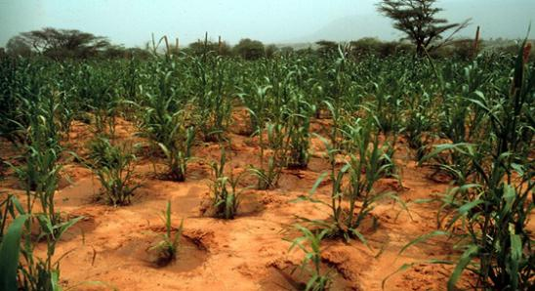

(a) Identify the structures in which the maize plants have been planted. (1 mark)
……………………………………………………………………………............................
(b) Explain how the structures in (a) helps to conserve water. (1 marks)
……………………………………………………………………………............................
……………………………………………………………………………............................

 | (c) State two ways in which water retention structures are important. | (2 marks)
 | ……………………………………………………………………………............................
 | ……………………………………………………………………………............................
2. | Why is it not advisable to throw plastic wastes in the farm? | (2 marks)
 | ……………………………………………………………………………..................................
 | ……………………………………………………………………………..................................
3. | Rapudo wanted to remove weeds from his farm with minimum disturbance to the soil. Name two
 | practices you would advise him to carry out. | (2 marks)
 | ……………………………………………………………………………..................................
 | ……………………………………………………………………………..................................
4. | The picture below shows a Grade 7 learner using a peeler to thinly peel the potatoes.
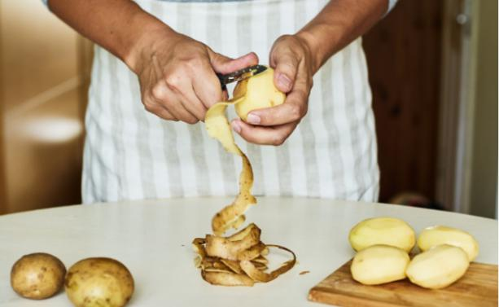

What is the importance of peeling the potatoes thinly? (1 mark)

……………………………………………………………………………..................................

5. Different vegetative materials are suitable for planting in different soil tilths. Complete the table below

by stating the correct tilth for the following planting materials. |  | (3 marks)
Planting material | Type of soil tilth
Sesame seeds
Maize seeds
Stem cutting

6. The picture below shows one of the farming practices that can help in preventing soil pollution.
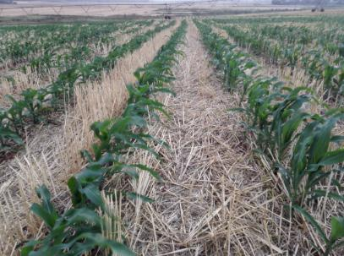

(a) Identify the farming practice. (1 mark)

……………………………………………………………………………............................

(b) Name two other farming practices that can help prevent soil pollution. (2 marks)

……………………………………………………………………………............................

……………………………………………………………………………............................

7. Mkulima harvests his honey and stores them in bottles with airtight lids as shown below.
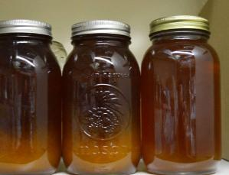

What is the importance of storing the honey in bottles with airtight lids? (2 marks)

……………………………………………………………………………..................................

……………………………………………………………………………..................................

8. Kendi used her tablet to search for the importance of water conservation. Write four points she is likely

to write down in her findings. (3 marks)

……………………………………………………………………………..................................

……………………………………………………………………………..................................

……………………………………………………………………………..................................

……………………………………………………………………………..................................

9. Atyang wishes to sensitise the farmers in her region to embrace agroforestry in order to conserve the

environment. Which two methods would you advise her to use? (2 marks)

……………………………………………………………………………..................................

……………………………………………………………………………..................................

10. (a) Identify the methods of weed removal shown in the pictures below. (2 marks)

(i)

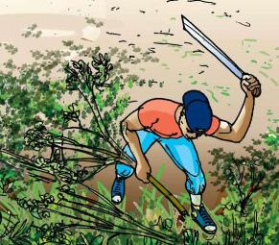

(ii)

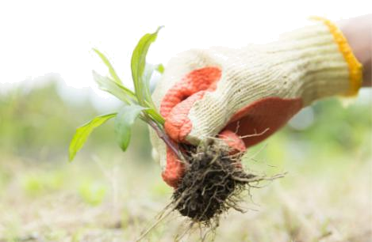

______________________

______________________

(b) Which of the methods of weed removal in (a) above is the most effective? Give a reason. (2 marks)

……………………………………………………………………………............................

……………………………………………………………………………............................

(c) Give a reason why it is important to put on protective clothing when weeding. (1 mark)

……………………………………………………………………………............................

- Honey processing involves two main steps; crushing and straining. Briefly describe what happens in each of the processes.

(a) Crushing (2 marks)

……………………………………………………………………………............................

……………………………………………………………………………............................

(b) Straining (2 marks)

……………………………………………………………………………............................

……………………………………………………………………………............................

12. Give two reasons why it is important to process honey before sale. (2 marks)

……………………………………………………………………………..................................

……………………………………………………………………………..................................

13. | Hanifa has graded the eggs in her shop using their sizes. Apart from size, outline three factors that can be
 | considered when grading eggs. | (3 marks)
 | ……………………………………………………………………………..................................
 | ……………………………………………………………………………..................................
 | ……………………………………………………………………………..................................
14. | The picture below shows value addition in maize.
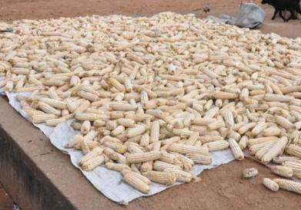

(a) Identify the value addition technique shown in the picture. (1 mark)

……………………………………………………………………………............................

(b) Name two other crops that can be done value addition using the technique shown above. (1 mark)

……………………………………………………………………………............................

(c) Apart from the technique in (a), how else can value be added to maize? (2 marks)

……………………………………………………………………………............................

……………………………………………………………………………............................

15. Special treatment in laundry is treating or cleaning clothes differently from just normal washing.

(a) What do you understand by the term bleaching as a type of special treatment in laundry? (1 mark)

………………………………………………………………………………

………………………………………………………………………………

(b) Apart from bleaching, outline two other types of special treatments in laundry. (2 marks)

………………………………………………………………………………

………………………………………………………………………………

16. What is the difference between roasting and grilling as methods of cooking? (2 marks)

……………………………………………………………………………..................................

……………………………………………………………………………..................................

……………………………………………………………………………..................................

17. The picture below shows a routine practice carried out on small domestic animals.
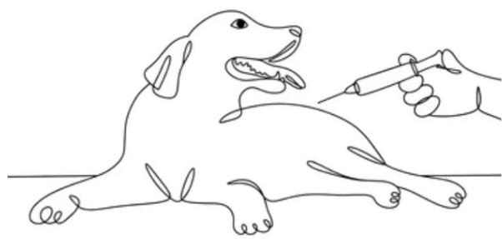

 | (a) Identify the practice shown in the picture. |  | (1 mark)
 | ……………………………………………………………………………............................
 | (b) What is the importance of the above practice to small domestic animals? |  | (1 mark)
 | ……………………………………………………………………………............................
 | (c) State three other routine practiced that are practices on small domestic animals. |  | (3 marks)
 | ……………………………………………………………………………............................
 | ……………………………………………………………………………............................
 | ……………………………………………………………………………............................

