G7
COMPETENCE BASED CURRICULUM
ENDTERM ONE ASSESSMENT

KENYA JUNIOR SCHOOL EDUCATION ASSESSMENT
LEARNER’S NAME: _______________________________.
SCHOOL: _______________________________________.
DATE: ________________SIGNATURE:_______________.
AGRICULTURE AND NUTRITION TIME:1HOUR 30MINUTES

INSTRUCTIONS TO LEARNER

- Write your name, name of your school and assessment number in the spaces provided.

- Answer ALL the questions in the spaces provided.

- Answer all questions in the paper..

Time: 2 hours

FOR OFFICIAL USE ONLY
SCORE GRID

Sections Maximum Candidates
Score Score
Agriculture and 100
Nutrition

Total Score 100

ASSESSMENT RUBRICS
Learningarea Performance Exceeds Meets Approaching Below
Expectations(4) expectations(3) Expectations(2) Expectations(1)
Agriculture
and Nutrition

This paper consists of 4 printed pages.

The learner should check the question paper to ascertain that all the pages are printed as indicated and that no questions are missing.

Answer all the following questions.

- Define the term soil pollution. (2mks)

..................................................................................................................................................

..................................................................................................................................................

- You visited a dumping site near your school. List four measures of controlling soil pollution that can be put in place to solve the problem. (4mks)

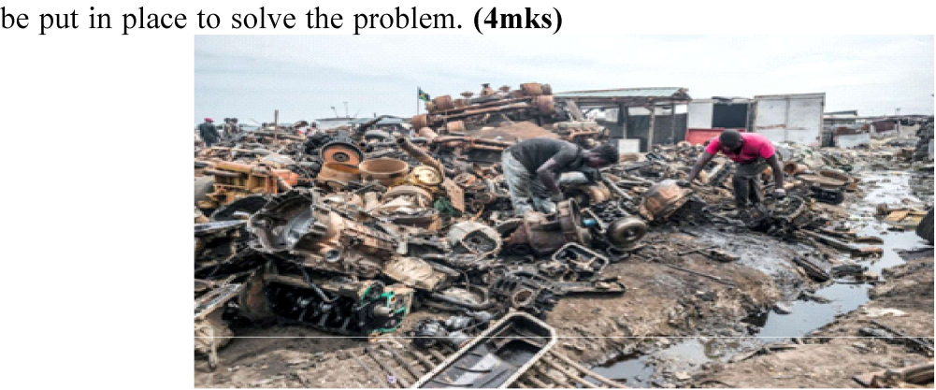

..................................................................................................................................................

..................................................................................................................................................

..................................................................................................................................................

..................................................................................................................................................

- Grade 7 learners visited a nearby farm. The farmer was preparing organic manure in preference to artificial fertilizers. Explain how using artificial fertilizer and chemicals pollute the soil. (2mks)
..................................................................................................................................................

..................................................................................................................................................

- Grade seven learners of Selah Academy visited a plantation and observed some structures used for conserving surface runoff. Give three structures they were likely to observe. (3mks)
..................................................................................................................................................

..................................................................................................................................................

..................................................................................................................................................

- Name two methods of preserving milk at home. (2mks)

..................................................................................................................................................

..................................................................................................................................................

- Mr. Peter told his Grade 6 learners to name any three diseases that are prevented by washing hands. Which diseases did they give? (3mks)

..................................................................................................................................................

..................................................................................................................................................

- Muso’s mother has a bakery. Write two foods that can be prepared through baking. (2mks)

..................................................................................................................................................

..................................................................................................................................................

- Mwanahamisi is a Grade six girl who stays with her family in Wajir. They have plenty of goat meat for family use. Name the cheapest preservation methods that Mwanahamisi is likely to suggest to the family. (1mk) ..................................................................................................................................................

- Grade six learners were discussing reasons why meals should be planned at home. Write three reasons the learners gave. (3mks)

..................................................................................................................................................

..................................................................................................................................................

..................................................................................................................................................

- Faith, a Grade 7 learner wants to teach her community about soil erosion. Help her explain the mean-ing of the term soil erosion (1mk)

..................................................................................................................................................

- During the rainy season, farms in Kiambu county experience surface runoff of water. What is surface runoff? (2mks)

..................................................................................................................................................

..................................................................................................................................................

- Lilian has installed a system of irrigation where water is supplied drop by drop near the root plants. This system is known as (1mk)

.........................................................................................................................................................

- A nutritional deficiency disorder has the following characteristics.

  - Swollen and bleeding gum.

  - Loose teeth.

  - Wounds that take long to heal.

Which disorder is described above?.................................................................... (2mks)

- Emily wanted to prepare and cook kales. How would she conserve nutrients during preparation? (4mks)

..................................................................................................................................................

..................................................................................................................................................

..................................................................................................................................................

..................................................................................................................................................

- Kimani bought raw vegetables and fruits in the locality. Describe ways of nutrients conservation that can be used when cooking the vegetables. (4mks)

..................................................................................................................................................

..................................................................................................................................................

..................................................................................................................................................

..................................................................................................................................................

- State three physical methods of controlling weeds. (3mks)

..................................................................................................................................................

..................................................................................................................................................

..................................................................................................................................................

- Dylan is in Grade 7. His favorite learning area is Agriculture and Nutrition. He browsed on the internet and found different career opportunities related to Agriculture and Nutrition. List the pos-sible career opportunities he found. (2mks)

..................................................................................................................................................

..................................................................................................................................................

18. Grade six learners of Peniel Primary School visited Mr. Wanyama’s shamba. They observed different seedbeds that conserve soil that Mr. Wanyama was using on his farm. Name any two types of seed-beds you think Mr. Wanyama was using. (2mks)

..................................................................................................................................................

..................................................................................................................................................

- Hope was watching types of soil erosion on YouTube. She came across a video showing soil being carried away by wind. What type of soil erosion was taking place? (1mk)
..................................................................................................................................................

- Rosalind, a Grade six girl lives with her parents, younger sister and grandmother. What factors should she consider when planning the family meal? (3mks)
..................................................................................................................................................

..................................................................................................................................................

..................................................................................................................................................

- Musa took his old t-shirt which he no longer uses and cut a piece of cloth from it. Which cleaning material was he improvising? (1mk)

..................................................................................................................................................

- Patricia is a vegetarian who does not eat animal products due to health reasons. Which food will you advise him to eat so as to get iron? (1mk)

..................................................................................................................................................

- Alyssah chopped his meat into small pieces. He mixed salt with water then dipped the meat in the salt solution and allowed it to stay for some time. Which preservation methods was she carrying out? (1mk)

..................................................................................................................................................

