COMPETENCE BASED ASSESSMENT


KENYA PRIMARY SCHOOL EDUCATION ASSESSMENT
GRADE 6
SOCIAL STUDIES
MIDTERM 2 2024
LEARNER’S NAME:_________________________________________________________________________________ SIGN:_______________.
ASSESSMENT NUMBER: _____________________________________________________________DATE________________________________.
FOR EXAMINERS USE ONLY.
OUT OF | 30 MARKS
Learners Score.
Learners %
Score Range | Performance Level | Tick
80-100 | Exceeding Expectation
60-79 | Meeting Expectations
40-59 | Approaching Expectations
Below 40 | Below Expectations
Instructions to Learners.
Answer all the Questions.

LEARNERS INSTRUCTIONS

- Write your name and assessment number in the spaces provided above

- Answer all the questions in this paper.

- All your answers must be written in the spaces provided in the question paper.

- Learners should check the question paper to ascertain that all the pages are printed as indicated and that no questions are missing.

- Learners must answer the questions in English
(4 Marks)
1. Below are ways of communication. Name them.
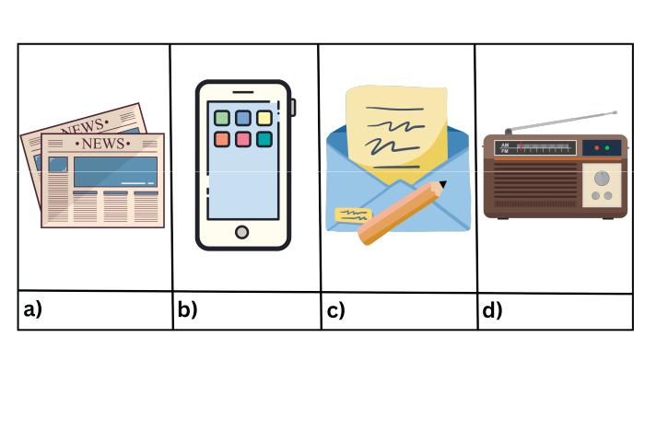

(4 Marks)
2. Write in the basket the qualities of a bad leader.
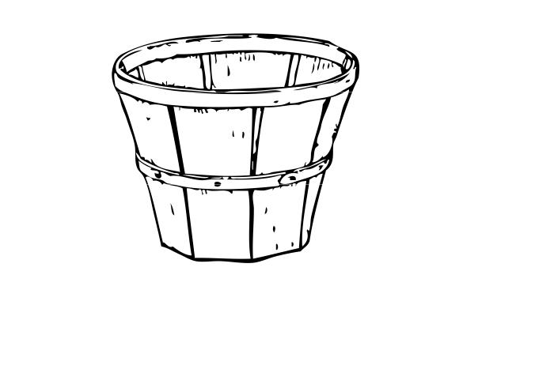

(4 Marks)
3. Name the following traditional foods.
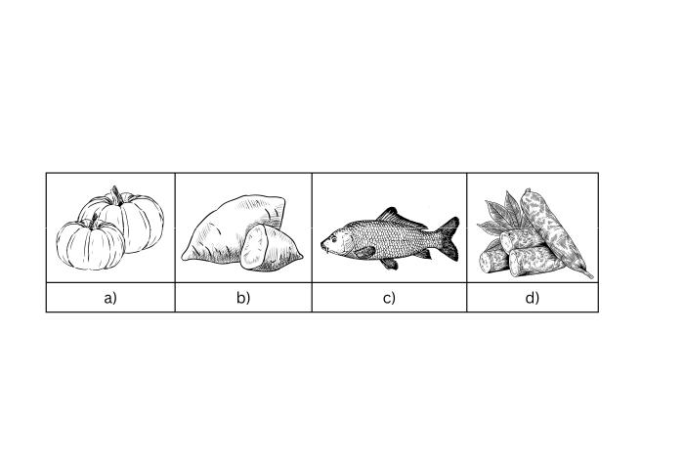

(2 Marks)
4. The dots below show population distribution. Describe the population.
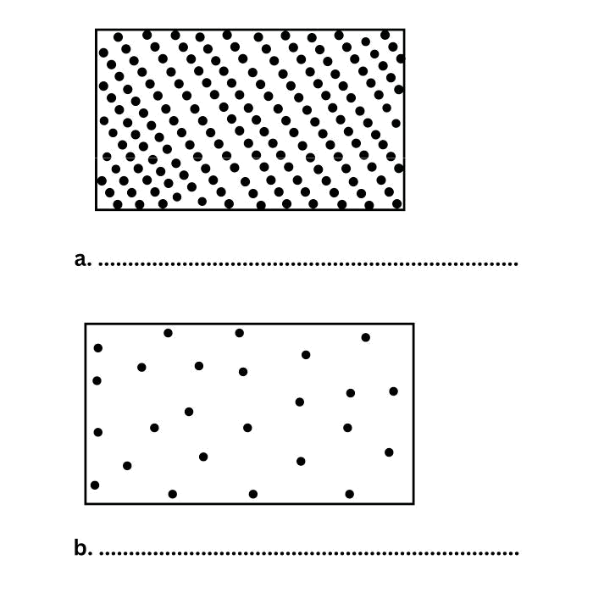

(10 Marks)
5. Study the map and answer the following questions.

A. The forest is to the ...................................................................... of the hospital.

B. Kaka Market is to the ......................................................................of the church.

C. Which direction is Pevo Market? ......................................................................

D. Which direction does River Bulima flow from? ........................................................

E. Scrub vegetation is to the ...................................................................... of the map.
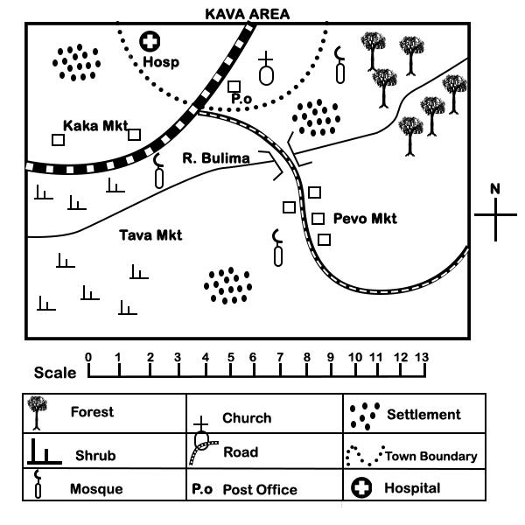

(2 Marks)
6. Name these artefacts.
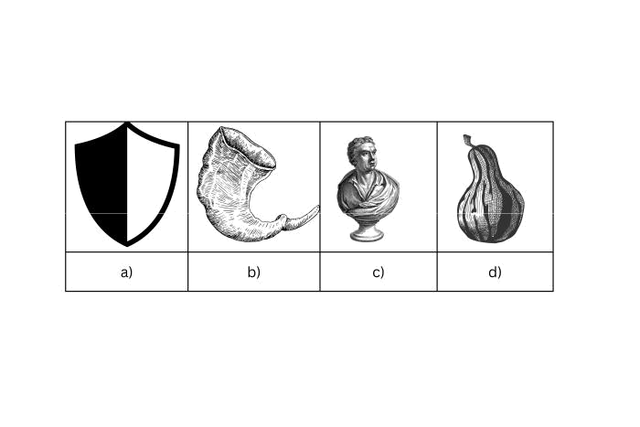

(1 Marks)
7. Which country in Eastern Africa is known for its rapid population growth?

Rwanda

Uganda

Ethiopia

Kenya

(1 Marks)
- What is the direction of Somalia from Kenya?

  - East.

  - West.

  - South

  - North

- Which of the following statements about the position of some East African countries is false?(2 Marks)

    - Kenya lies south of Ethiopia.

    - Djibouti borders Somalia to the south.

    - Uganda is located east of Kenya.

    - Eritrea does not border Kenya to any side.

(1 Marks)
- The Ethiopian Highlands are known for their extensive coffee plantations. What does this indicate about its natural vegetation?

- All the following are effects of high population distribution in East Africa. Which one is not? (2 Marks)

  - Scarcity of land.

  - Availability of cheap labour.

  - Unutilized resources.

  - Availability of market for goods produced.

12. What is the primary purpose of beef farming? (2 Marks)

- Grade 4 learners were asked by their socia! studies teacher to give the main reason why they (1 Marks) started an entrepreneurship project in their school, who among them gave the correct answer?

  - Amina- To make use of locally available resources.

  - Peter - To help the school in buying land.

  - Margaret - To help them raise income.

  - William - To help them create employment in school
14. | A person who belongs to a certain country is known as | (2 Marks)
 | A. patriot
 | B. resident
 | C. citizen
 | D. foreigner
15. | In which country is the Selous Game Reserve located? | (1 Marks)
16. | What is the primary source of government revenue in Kenya? | (2 Marks)
17. | Why should tourists avoid feeding wild animals in Eastern Africa? | (2 Marks)
18. | Which of the following is not a feature associated with the Great Rift Valley? | (1 Marks)
 | Volcanoes
 | Glaciers
 | Escarpments
 | Lakes
19. | How do water transport routes benefit Eastern Africa's economy? | (2 Marks)
 | A. By limiting trade
 | B. By providing routes for international trade
 | C. Water routes are only for leisure activities
 | D. They have no impact on the economy
20. | The climate in the Rwenzori Mountains can be classified as: | (1 Marks)
 | Alpine
 | Temperate
 | Tropical savanna
 | Semi-arid
21. | How does HIV/AIDS influence population distribution? | (2 Marks)
 | A. It increases population in a given area.
 | B. It lowers population in a given area.
 | C. It reduces dependence ratio.
 | D. It increases fertility rate.
22. | What is the Great Migration in Eastern Africa? | (1 Marks)
 | A. People moving to cities
 | B. Birds flying south for the winter
 | C. Large herds of wildebeest and zebras migrating
 | D. Fish swimming upstream
23. | Among the Maasai, who defended the community? | (2 Marks)

- Oloibon

- Young children

- Old men

- Morans
24. What role does beef farming play in the economy of Eastern African countries? (1 Marks)

A. It contributes to food security and employment

B. It is mainly for entertainment purposes

C. It has no role in the economy

D. It is only for educational purposes

(1 Marks)
- The following are facts about a country in Eastern Africa:

  - It is found north of the equator.

  - It is landlocked

  - It was not colonized.

  - It hosts the headquarters of an international organisation. The county described above is

A. Ethiopia. B. Eritrea. C. Sudan.
D. South Sudan

(1 Marks)
26. What is the major river found in Somalia?

The Juba River

The Shabelle River

The Nile River

The Omo River

(2 Marks)
- The original homeland of the Cushites was?

  - Horn of Africa

  - Congo forest

  - Sudan

  - Cameroon

28. Which of the following borders Kenya to the South East? (2 Marks)

- Somalia

- South Sudan

- Indian Ocean

- Lake Victoria

(1 Marks)
29. Which language is widely spoken in Kenya and Tanzania?

English

Oromo

Swahili

Amharic

30. What is the most common mode of transportation in many Eastern African cities? (2 Marks)

- Bicycles

- Cars

- Matatus (minibuses)

- Trains
31. What is a challenge for internet connectivity in many parts of Eastern Africa? (1 Marks)

A. Too many service providers

B. High-speed connections everywhere

C. Limited infrastructure

D. Internet is banned

32. Why are customs duties important for Kenya's government revenue? (2 Marks)

A. They make imported goods more expensive

B. They are charged on exports

C. They are a source of income on imported goods

D. They apply to goods that children buy

33. Why is it important for citizens to respect the rights of others? (1 Marks)

A. To create a fair and peaceful society

B. To win a medal

C. Because it's a fun game

D. To become famous

(1 Marks)
- The Ruwenzori Range, also known as the Mountains of the Moon, is located on the border between which two countries?

Kenya and Uganda

Uganda and Congo

Tanzania and Kenya

Rwanda and Burundi

(1 Marks)
35. | Which crop is significant in Eastern African agriculture and culture?
 | Potatoes
 | Corn (Maize)
 | Rice
 | Wheat
36. | Most of the people are allowed by the government to settle around the game parks and | (2 Marks)
 | airports.
37. | Which country has the smallest population in Eastern Africa? | (1 Marks)
 | Seychelles
 | Eritrea
 | Djibouti
 | Burundi
38. | What is the largest island in Africa, located off the southeastern coast of the continent? | (1 Marks)

Zanzibar

Madagascar

Seychelles

Mauritius
(1 Marks)
39. Which language is commonly used in the education system in Kenya?

Luo

Kikuyu

English

Swahili

(1 Marks)
40. Madagascar's primary language, Malagasy, belongs to which language family?

Afro-Asiatic

Austronesian

Niger-Congo

Nilo-Saharan

(1 Marks)
41. Which of the following countries is entirely surrounded by South Africa?

Lesotho

Swaziland

Mozambique

Namibia

42. Which of these is a popular news source in Eastern Africa? (1 Marks)

A. Social media

- Radio

- Newspapers

- All of the above

(1 Marks)
43. What is the capital city of Uganda?

Kampala

Kigali

Nairobi

Dodoma

(2 Marks)
- Which feature is formed at the point where River Tana flows into the Indian Ocean?

  - Tributarys.

  - Valley.

  - Delta.

  - Estuary.

(2 Marks)
- The last Bantu community to migrate into Eastern Africa, were the ___________. They were escaping from the raids by the Zulu of South Africa.

  - Abaluhya

  - Luo

  - Somali

  - Ngoni
46. How does the Kenyan government support the agricultural sector? (2 Marks)

A. By discouraging farming

B. By taxing farmers heavily

C. By providing subsidies and support services

D. By banning agricultural exports

47. Which of the following is a major challenge for transportation in Eastern Africa? (2 Marks)

A. Too many highways

B. Excellent road conditions

C. Traffic congestion

D. Over-reliance on air travel

48. What is the importance of ceremonies in traditional Eastern African governance? (2 Marks)

A. They are just for entertainment

B. Ceremonies mark important decisions and transitions in leadership

C. They have no real purpose

D. They are primarily for tourists

(1 Marks)
49. What is the capital city of Ethiopia?

Nairobi

Addis Ababa

Kampala

Mogadishu

50. What is a common method to identify cattle in beef farms? (1 Marks)

A. Naming them

B. Using ear tags or branding

C. Painting them different colors

D. Teaching them to respond to roll call
(Confidential)

Marking Scheme

1. | a. Newspaper. | (4 Marks)
 | b. Mobile phone.
 | c. Sending letters.
 | d. Radio.
2. | Dishonest, selfish, greedy, jealous, cunning, liar. | (4 Marks)
3. | a. pumpkin. | (4 Marks)
 | b. Sweet potatoes.
 | c. fish.
 | d. Cassava.
4. | a. Dense Population | (2 Marks)
 | b. Evenly distributed population
5. | A. East. | (10 Marks)
 | B. South West.
 | C. South East.
 | D. North East.
 | E. South West.
6. | a. Shield | (2 Marks)
 | b. Horn
 | c. Sculpture
 | d. Calabash
7. | B | (1 Marks)
8. | A | (1 Marks)
9. | B | (2 Marks)
10. | The region supports lush, dense forests conducive to coffee growing. | (1 Marks)
11. | C | (2 Marks)
12. | To raise cattle for meat production. | (2 Marks)

13. | C | (1 Marks)
14. | C | (2 Marks)
15. | Tanzania. | (1 Marks)
16. | Taxes. | (2 Marks)
17. | It can disrupt their natural behavior and diet. | (2 Marks)
18. | B | (1 Marks)
19. | B | (2 Marks)
20. | A | (1 Marks)
21. | A | (2 Marks)
22. | C | (1 Marks)
23. | D | (2 Marks)
24. | A | (1 Marks)
25. | A | (1 Marks)
26. | A | (1 Marks)
27. | A | (2 Marks)
28. | C | (2 Marks)
29. | C | (1 Marks)
30. | C | (2 Marks)
31. | C | (1 Marks)
32. | C | (2 Marks)
33. | A | (1 Marks)
34. | B | (1 Marks)
35. | B | (1 Marks)

36. B (2 Marks)

37. | A | (1 Marks)
38. | B | (1 Marks)
39. | C | (1 Marks)
40. | B | (1 Marks)
41. | A | (1 Marks)
42. | D | (1 Marks)
43. | A | (1 Marks)
44. | C | (2 Marks)
45. | D | (2 Marks)
46. | C | (2 Marks)
47. | C | (2 Marks)
48. | B | (2 Marks)
49. | B | (1 Marks)
50. | B | (1 Marks)

