COMPETENCE BASED ASSESSMENT

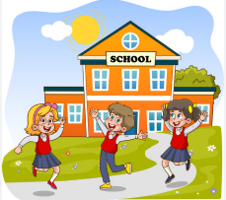
KENYA PRIMARY SCHOOL EDUCATION ASSESSMENT
GRADE 6
SCIENCE AND TECHNOLOGY
ENDTERM 2 2024
LEARNER’S NAME:_________________________________________________________________________________ SIGN:_______________.
ASSESSMENT NUMBER: _____________________________________________________________DATE________________________________.
FOR EXAMINERS USE ONLY.
OUT OF | 50 MARKS
Learners Score.
Learners %
Score Range | Performance Level | Tick
80-100 | Exceeding Expectation
60-79 | Meeting Expectations
40-59 | Approaching Expectations
Below 40 | Below Expectations
Instructions to Learners.
Answer all the Questions.

LEARNERS INSTRUCTIONS

- Write your name and assessment number in the spaces provided above

- Answer all the questions in this paper.

- All your answers must be written in the spaces provided in the question paper.

- Learners should check the question paper to ascertain that all the pages are printed as indicated and that no questions are missing.

- Learners must answer the questions in English
(1 Marks)
- Grade six learners were asked to name the blood component that prevents excessive bleeding. Who gave the correct answer?

  - NJERI - platelets

  - JEMO – white blood cells

  - ALMA - plasma

  - LENCER – red blood cells

2. An example of an echinoderm is: (1 Marks)

- Earthworm

- Starfish

- Beetle

- Squid

3. Describe the body structure of a cnidarian. (2 Marks)

(2 Marks)
- The diagram below shows the parts of the human heart. Name the part of the heart marked W, and Y respectively. W ________________________________

Y _________________________________
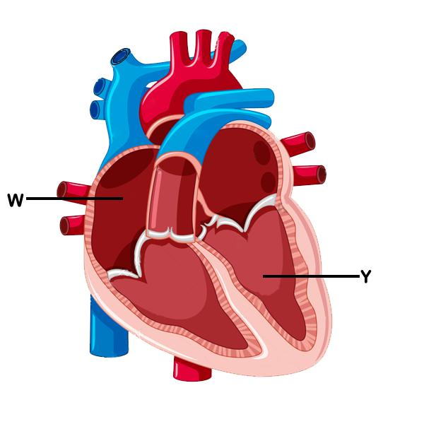

(2 Marks)
- The chart drawn below shows the components of air in the atmosphere. Write two functions of the gas marked Q.

  - ________________________________

  - _______________________________
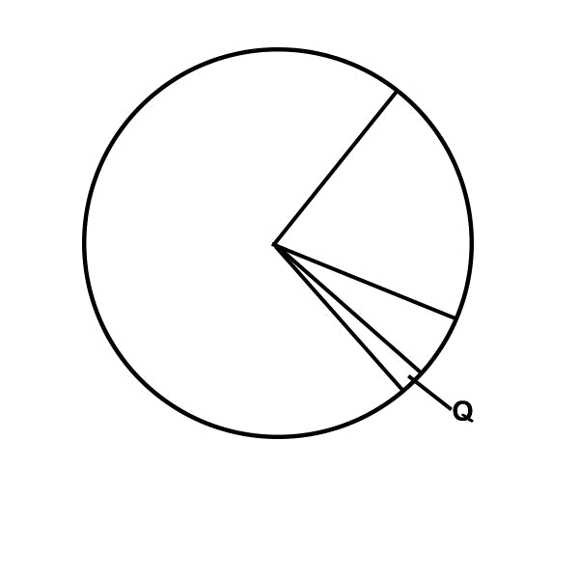

(3 Marks)
- State three examples of animals with the same characteristics as the one shown below

  - _______________________________________

  - _______________________________________

  - _______________________________________
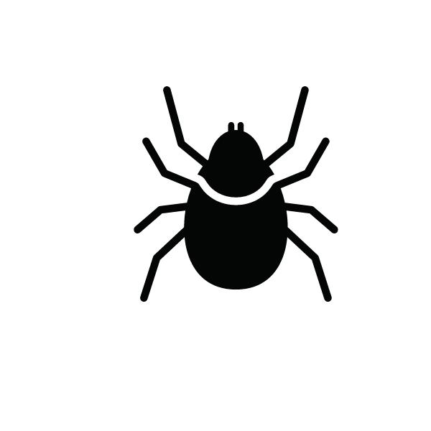

(2 Marks)
7. Which tooth is drawn below
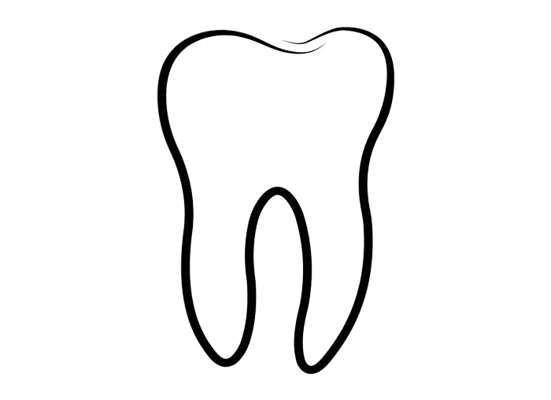

- Molar

- Incisor

- Canine

- pre molar

(2 Marks)
- The diagram below shows parts of the female reproductive system. The part marked C is known as
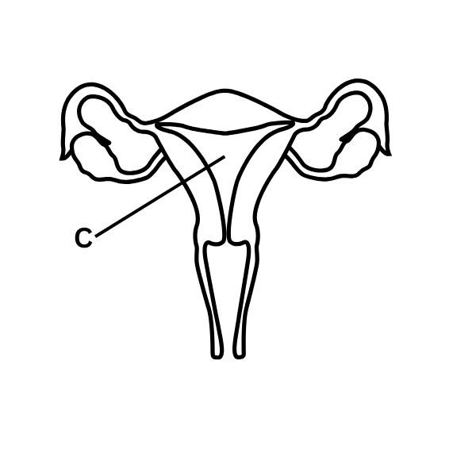

- uterus

- ovary

- oviduct

- birth canaL

(2 Marks)
9. Which digital part of the computer is shown below?
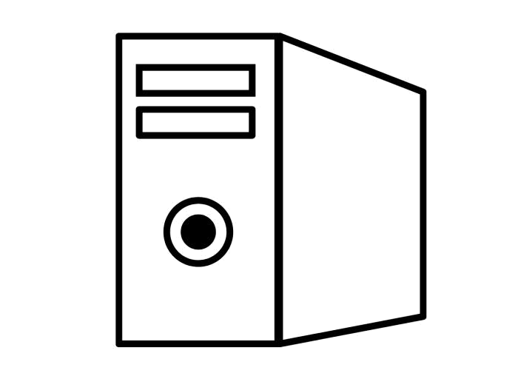

- C.P.U

- Monitor

- Keyboard

- Mouse

(2 Marks)
- Some students uprooted a plant with the type of root drawn below. Name two plants with this type of root.
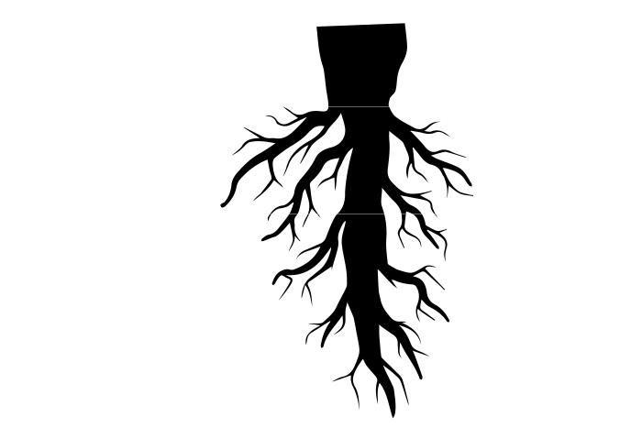

(2 Marks)
- Use the diagram below to answer the question. Digestion of food starts at the part marked:
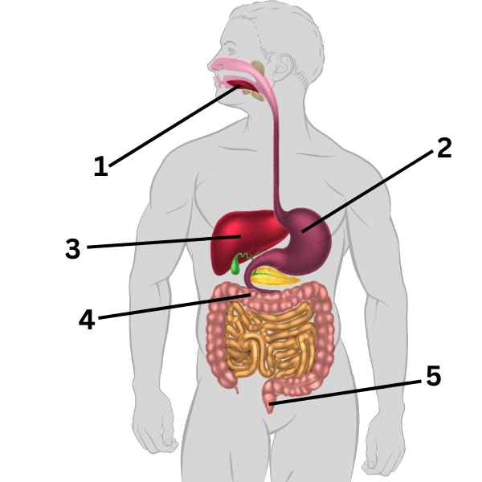

- 1

- 2

- 3

- 4

(1 Marks)
- Most raised buildings have the slope marked X. Which group of people are they mainly meant for?
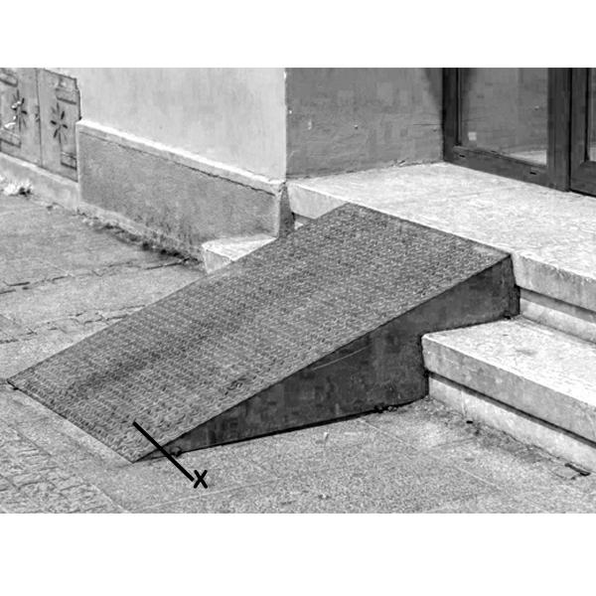

(2 Marks)
13. The following crops have the same type of roots as shown above. Which one does NOT?
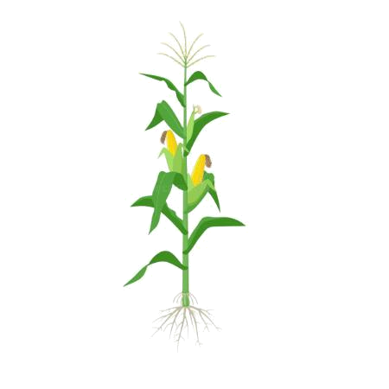

- Maize

- Grass

- Rice

- Beans

(1 Marks)
14. Name one invertebrate that is in the same group as the one shown below.
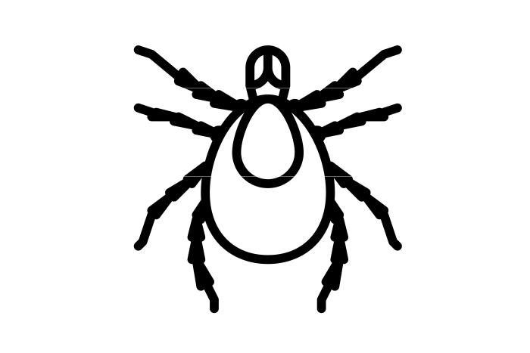

(2 Marks)
15. The part of the leaf marked P is known as:
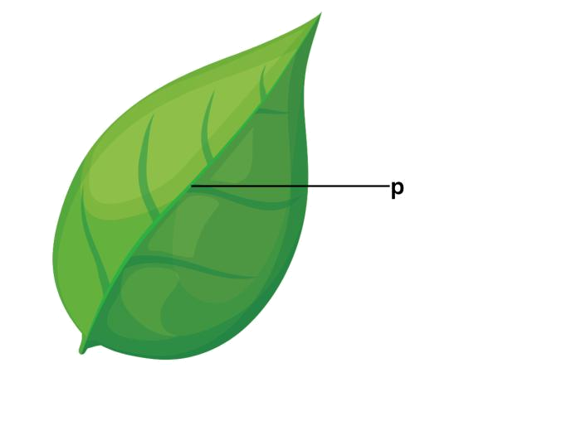

- Vein

- Leaf stalk

- Lamina

- Midrib

(2 Marks)
16. What is the name of invertebrate shown below.
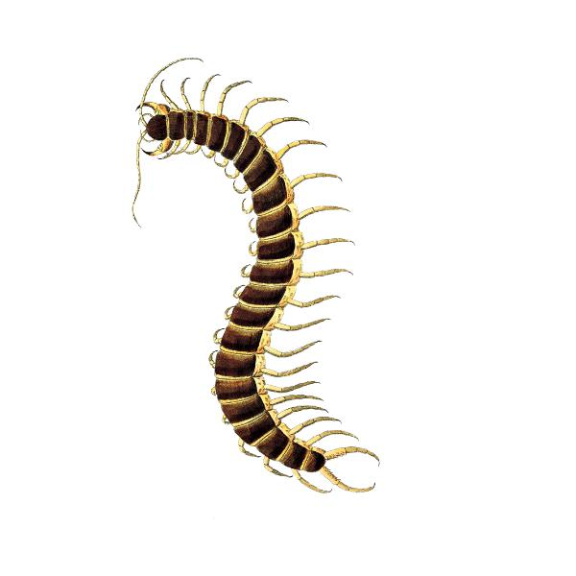

- Millipede

- Centipede

- Snake

- Caterpillar

(2 Marks)
- Some grade 7 pupils carried out the experiment shown below in their school laboratory. a) What observation did they make? (1mk)

b) State their conclusion (1mk)

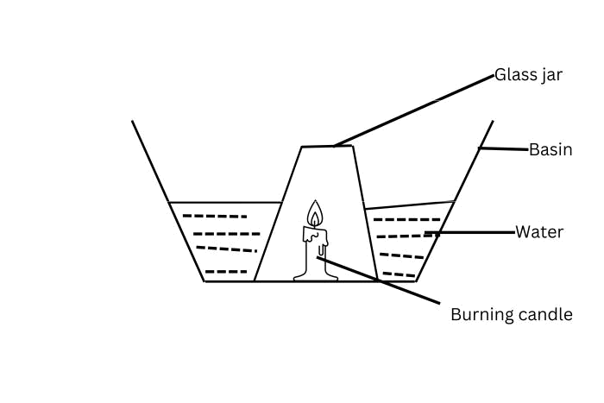

(2 Marks)
- The method of irrigation shown below is called ________

  - basin irrigation

  - drip irrigation

  - pipe irrigation

  - flood irrigation

19. Otoyo educated his friends on the ways of conserving water. Which one of the following is (2 Marks) not a way in which water is conserved?

A. Reusing water.

B. Construction of dams.

C. Harvesting rain water.

D. Building gabions.

20. The following are ways of reducing water wastage. Which one is not? (2 Marks)

A. reparring leaking taps

B. using drip irrigation

C. turning off water taps after use.

D. avoiding use of water

(1 Marks)
- The following are ways of reducing water wastage. Which one is not?

  - Repairing leaking taps.

  - Using drip irrigation.

  - Turning off water taps after use.

  - Avoiding use of water.

22. Treating water that has already been used so that it is safe to be used again is called (2 Marks)

- evaporation

- radiation

- eradicating D.recycling

23. Invertebrates are animals that (1 Marks)

A. Can fly

B. Have a backbone
C. Do not have a backbone

D. Live only in water

24. Which part of the plant conducts photosynthesis to convert sunlight into energy? (1 Marks)

A. The stem

B. The leaf

C. The root

D. The flower

25. We are tiny oval shaped cells. We are found in plasma and help in blood clotting. Who are (2 Marks) we?

A.Red blood cells

- Platelets C.white blood cell D. Plasma

(2 Marks)
- Below is a description of a blood vessel.

  - Carries blood away from the heart.

  - Have thick elastic walls.

  - Have no valves.

  - They carry blood under high pressure. Which blood vessel is it?

    - Veins

    - Arteries

    - Capillaries

    - Aorta

27. Which among the following plants has a different root system? (2 Marks)

- Carrot

- Sugarcane

- Groundnuts

- Pea

28. What is a unique feature of cephalopods within mollusks? (1 Marks)

A. They have segmented bodies

B. They have an exoskeleton

C. They have advanced eyesight

D. They have shells

29. | During a nature walk, learners observed a plant remove gum, and fall its leaves. What | (2 Marks)
 | characteristics of plants did it demonstrated? That plants
 | A. Reproduce
 | B. Remove waste
 | C. Feed
 | D. Grow
30. | What is a common feature of annelids? | (1 Marks)

A. Segmented bodies

- Tentacles

- Wings

- Shells
31. | Corals are part of which invertebrate group? | (1 Marks)
 | A. Annelids
 | B. Arthropods
 | C. Cnidarians
 | D. Echinoderms
32. | What component of the blood is primarily water and transports nutrients, hormones, and | (1 Marks)
 | waste products?

A. Red blood cells

B. White blood cells

- Platelets

- Plasma

33. What adaptation do tuberous roots offer to plants? (1 Marks)

A. They help the plant climb

B. They protect the plant from predators

C. They provide a means of asexual reproduction

D. They store food and nutrients for the plant

34. Which of the following is an example of a crustacean? (2 Marks)

- Earthworm

- Leech

- Crab

- Snail

35. What is the main function of the human circulatory system? (1 Marks)

A. To transport gases

B. To break down food

C. To control body temperature

D. To send nerve signals

36. Three of the following are safety precautions when handling plants. Which one is not?. (1 Marks)

A. wear gloves on your hands.

B. wash hands using soap after handling plants.

C. wear protective gears.

D. any fruits or leaves.
(Confidential)

Marking Scheme

1. | A | (1 Marks)
2. | B | (1 Marks)
3. | 1 mark for stating that cnidarians have a sac-like body with tentacles surrounding a central | (2 Marks)
 | mouth opening. 1 mark for mentioning that they have specialized stinging cells called
 | cnidocytes.

(2 Marks)
- W- Right atrium. Y - Left ventricle

(2 Marks)
5. Gas Q is carbon dioxide.

Used as a fire extinguisher.
Making plant food.
Preservation of soft drinks.

(3 Marks)
6. Spider, Scorpion, tick

(2 Marks)
7. D

(2 Marks)
8. A

(2 Marks)
9. A

(2 Marks)
- Examples of plants with tap root.

legumes - beans, peas, groundnuts, green grams, Mango, acacia, pigweed, cassava, potatoes etc.

(2 Marks)
11. A

(1 Marks)
- The ramp is used in raised buildings and mainly meant for people who are physically challenged.

(2 Marks)
13. D
(1 Marks)
- The diagram shows a tick. It is in the same group with scorpion, spider and mite (eight legs and 2 body parts)

15. | D | (2 Marks)
16. | B | (2 Marks)
17. | a) Observation. | (2 Marks)
 | The candle went off after some time.
 | The level of water in the basin dropped.
 | The water level in the glass jar rose.
 | b) They concluded that part of the air (oxygen).
18. | B | (2 Marks)
19. | D | (2 Marks)
20. | D | (2 Marks)
21. | D | (1 Marks)
22. | D | (2 Marks)
23. | C | (1 Marks)
24. | B | (1 Marks)
25. | B | (2 Marks)
26. | B | (2 Marks)
27. | B | (2 Marks)
28. | C | (1 Marks)
29. | B | (2 Marks)
30. | A | (1 Marks)
31. | C | (1 Marks)
32. | D | (1 Marks)
33. | D | (1 Marks)
34. | C | (2 Marks)
35. | A | (1 Marks)
36. D (1 Marks)

