COMPETENCE BASED CURRICULUM
HOMEWORK ENGAGEMENT PROGRAM
GRADE 6 2024 AUGUST
SCIENCE AND TECHNOLOGY

- Which one of the following shows a cactus plant?

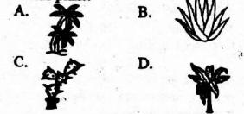

    - A

    - B

    - C

    - D

- Some Grade six learners were asked to name the part of a plant used for absorption of water and mineral salts:

Kamene: Branch

Ngugi: Leaves

Wayua: Stem

Hassan: Roots

Who among them was correct?

    - Kamene

    - Ngugi

    - Hassan

    - Wayua

- Which among the following plants has a different root system?

    - Carrot

    - Sugarcane

    - Groundnuts

    - Pea

- The following are characteristics of a certain small animal:

  - Three body parts.

(ii) Three pairs of legs.

- Presence of compound eyes.

- No backbone.

Which of the following small animal has been described above?

  - Scorpion

  - Butterfly

  - Centipede

  - Spider

- The chart below shows a part of the classification of invertebrates.
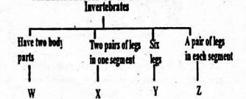

In which category is a mite likely to fall?

  - X

  - Z

  - Y

  - W

- The illustration below shows an importance of invertebrates to man.
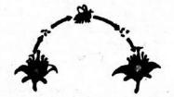

The illustration above shows the importance of invertebrates in

  - nectar collection

  - feeding

  - pollination

  - decoration

- Use the diagram below to answer the following questions.
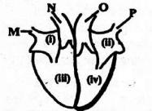

The chamber marked iii is connected to the vessel marked

- O

- M

- P
  - N

- Which of the labelled parts shows the right auricle?

  - iv

  - i

  - ii

  - iii

- The vessel marked O

  - is the main artery

  - carries deoxygenated blood to the lungs

  - carries oxygenated blood to the heart for pumping

  - is the main vein

- Blood plasma transports all the following but not

  - digested food

  - waste materials

  - hormones

  - haemoglobin

- In computing, the part of a computer used for display can also be used

  - for processing data

  - to edit a document

  - to print a document

  - for typing

- Amanda drew a device like the one shown below.
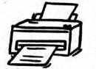

What is the function of the computing gadget Amanda drew?

  - Saving typed documents

  - Printing documents

  - Retrieving lost documents

  - Downloading files

- When creating a Word document, what is the use of a cursor?

  - Correcting spelling errors

  - Showing the beginning of a text

  - Creating spaces between words in a text

  - Showing the end of a text

- A space bar is found on the

  - mouse

  - keyboard

  - CPU

  - monitor

- When handling computing devices, our hands should be
- dry

- smooth

- wet

- visible

Answers

- C

- Hassan

- Sugarcane

- Butterfly

- W

- pollination

- N

- i

- is the main artery

- haemoglobin

- to edit a document

- Printing documents

- Showing the end of a text

- keyboard

- dry

