GRADE 6 - 2025
G6

CBC ASSESSMENT

THIRD TRIAL

ENDTERM

PRIMARY SCHOOL EDUCATION ASSESSMENT

MATHEMATICS
TIME: 2 HOURS

INSTRUCTIONS TO LEARNER’S (Please read these instructions carefully)

- You have been given this question booklet and a separate answer sheet. The question booklet contains 30 questions.

Answer all the questions.

- Do any necessary rough work in this booklet.

- When you have chosen your answer, mark it on the ANSWER SHEET, not in this question booklet.

HOW TO USE THE ANSWER SHEET

- Use ordinary pencil.

- Confirm that the answer sheet that you have been provided with has the following:

YOURASSESSMENT NUMBER YOURNAME

NAME OFYOURSCHOOL NAMEOFSUBJECT
- Do not make any marks outside the boxes.

- Keep the sheet as clean as possible and do not fold it.

- For each of the question 1 - 30, four answers are given. The choices are lettered A, B, C, D. In each case only ONE of the four choices is correct. Choose the correct answer.

- On the answer sheet, show the correct answer by drawing a dark line inside the box in which the letter you have

chosen is written.

Example:

In the question booklet:

11. Work out: 335 x 24

- 8004

- 8400

- 8040

- 80040

The correct answer is C (8040)

On the answer sheet:

In the set of boxes numbered 11, draw a dark line inside the box with letter C printed as indicated below.


  - [A] [B] [C] [D]

- Your dark line MUST be within the box.

- For each question, ONLY ONE box is to be marked in each set of four boxes.

- A tea factory sold 2034865 packets of tea leaves in a year. What is the place value of digit 0 in the number?
  - Millions

  - Hundreds of thousands

  - Tens of thousands

  - Thousands.

- What is four hundred and thirty thousand two hundred and three written in symbols?
  - 43600203

  - 463203

  - 430203

  - 436302

- What is 7997 rounded off to the nearest hundred?

  - 8000

  - 8910

  - 8010

  - 7910

- A company exported 149246 vehicles in 2022 and 248357 vehicles in 2023. How many vehicles were exported in the two years?
  - 397613

  - 397503

  - 397603

  - 397513

4
5. Kipkoech ran 2 ₅ km and then walked

3
1 ₄ km. What distance did he cover?

11
A. 4 ₂₀ km

11
B. 3 ₂₀km

1
C. 1 ₂₀km

1
D. 3 ₂₀km
- A meeting started at 11:30am. It took 4hrs 40minutes. At what time did it end?
  - 4:00pm

  - 3:10pm

  - 4:40pm

  - 4:10pm

- Arrange the following decimals from the smallest to the largest.
0.5, 0.25, 0.75, 0.05

  - 0.05, 0.25, 0.5, 0.75

  - 0.5, 0.75, 0.05, 0.25

  - 0.5, 0.25, 0.75, 0.05

  - 0.75, 0.5, 0.25, 0.05

- A packet of milk costs sh.25 while a loaf of bread costs sh.30. Kanyi was given sh.500 and asked to buy 8 packets of milk and use the balance on bread. How many loaves of bread did he buy?
  - 8

  - 10

  - 5

  - 6

1
9. In Ann’s shop, milk is sold in ₂ litre

packets. Wafula bought 32litres. How

many half litre packets did he buy?

A. 64

B. 16

C. 32

D. 96

10. Juma had four of the notes shown below.
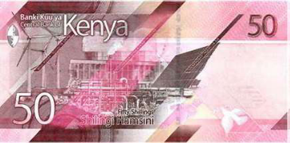

How much money did he have

altogether?

A. Sh. 150

B. Sh. 400

C. Sh. 200

D. Sh. 250

CBC ASSESSMENT 2 ^{MATHS/GR .6}

- Okoth walked round the triangle below three times.
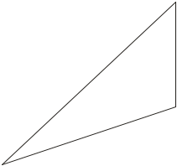

 | m |  | 14m
0
2
 |  |  | m
 |  | 5
 |  | 1
What distance did he cover?

  - 49m

  - 98m

  - 147m

  - 196m

- Work out; 15.46 - 9.08
  - 6.38

  - 6.42

  - 6.52

  - 6.62

- Okello started his journey at

9:30am. He took 4 hours to reach his destination. At what time did he arrive?

  - 7:30pm

  - 3:30pm

  - 2:30pm

  - 1:30pm

- How many days are there in the months of September and November?
  - 62

  - 60

  - 61

  - 58

- Find the sum of LCM and GCD of 24,18 and 12

  - 48

  - 144

- 72 D. 78
- Omollo’s Vegetable garden is square in shape. It has a length of 19m. What is its area?

  - 631m2

  - 361m2

  - 441m2

  - 961m2

4
17. Musyoka bought 5 ₅ kg irish potatoes

1
and 4 ₄ kg of sweat potatoes. What was the total mass of the two items?
10
A. 1 ₂₀ kg

1
B. 10 ₂₀kg

21
C. 9 ₂₀ kg

5
D. 9 ₂₀ kg

- Work out; 24 ÷ 4 x 3 + 15 - 5

  - 28

  - 33

  - 18

  - 38

- James covered 0.84km in a race. What distance did he cover as a percentage?
  - 100%

  - 8.4%

  - 84%

  - 16%

- A tailor used 7cm 5mm of ribbon to decorate a table cloth. What is the length of the ribbon used in millimeters?
  - 750mm

  - 7.5mm

  - 70mm

  - 75mm

CBC ASSESSMENT 3 ^{MATHS/GR .6}

1
21. What is the reciprocal of 1 ₂ ?
16
A. ₃
2
B. ₃

C. 2¹₂
3
D. ₂

22. Which of these objects is a 3D object?
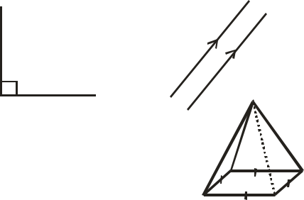

A. B.


C. D.

- Jane was asked to write the next multiple of 8 after 56. Which number did she write?
  - 48

  - 80

  - 64

  - 88

- A pupil was given sh.1000 by his uncle. He used sh.250. How much money did he save?
  - Sh 500

  - Sh. 750

  - Sh. 650

  - Sh. 1000

- Manzo bought the following items from a shop.

- 2kgs of rice for sh.280.

- A packet of milk for sh. 60 - A loaf of bread for sh.120.
- One litre of salad for sh.300 How much balance did she receive if she paid using a one thousand shillings note?

  - Sh. 760

  - Sh. 340

  - Sh. 240

  - Sh. 140

- In a coffee plantation there are 560 workers. If there are 112 women, how many men are there?
  - 540

  - 448

  - 122

  - 336

- Kola made the box below using metal sheets.
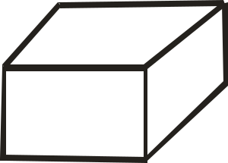

3m

6m

4m

What is the volume of the box?

A. 48m3 | B. 72m3
C. 63m3 | D. 84m3

- Which is the next number in the series below? 5, 9, 13, 17 ____

  - 16

  - 15

  - 21

  - 14

- A teacher drew the angle below on the board.
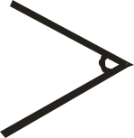

What type of angle is this?

A. Right angle.

B. Obtuse angle.

C. Reflex angle.

D. Acute angle.

- A green grocer had t kgs of tomatoes. He bought y kgs of potatoes and 36kgs of onions. How many kilograms did he have altogether?
  - (t + y + 36) kg

  - 36 ty kg

  - (t + 36y) kg

  - (y + 36t) kg

CBC ASSESSMENT 4 ^{MATHS/GR .6}

