COMPETENCE BASED CURRICULUM
HOMEWORK ENGAGEMENT PROGRAM
GRADE 6 2024 AUGUST
MATHEMATICS

- Mkombozi village had a total of 43 261 children. Out of these, only one hundred and ninety three were not vaccinated against polio. How many children were vaccinated?
  - Forty three thousand, one hundred and sixty eight

  - Forty three thousand and sixty eight

  - Forty two thousand and sixty eight

  - Forty two thousand one hundred and sixty eight

- An agricultural show was attended by 1 610 men, 1 266 women and 966 children. What is the total number of adults who attended the show rounded off to the nearest thousand?
  - 3842

  - 2876

  - 4000

  - 3000

- In a class of 33 pupils, each pupil had 33 beads for an Art and Craft lesson. How many beads were there altogether?

  - 66

  - 1189

  - 1089

  - 1098

- A Grade six teacher asked each learner to bring a number of seeds equal to the total number of pupils in the class. If a total of 1 156 seeds were brought, how many pupils were in that class?
  - 47

  - 39

  - 34

  - 27

- During a Homescience lesson, Grade six learners mixed 3¹/₅ litres of milk with 6²/₃ litres of water to prepare tea. What was the total mixture?

  - 9³/₅

  - 9¹³/₁₅

  - 10³/₅

  - 10¹³/₁₅

- During a heavy downpour, a tank became 95% full of water. What is this capacity as a fraction?

  - ⁹⁵/₁₀₀

  - 1¹/₂₀

  - ⁹/₂₀

  - ¹⁹/₂₀
- In a matatu carrying 20 passengers, 8 passengers are females and the rest are males. What percentage of the passengers are females?
  - 12%

  - 28%

  - 60%

  - 40%

- What is the place value of digit 4 in the sum of 11.10 and 10.35?

  - Tens

  - Hundreds

  - Hundredths

  - Tenths

- Andese bought 846.85 kg of potatoes. During transportation, 29.98 kg got spoilt. What mass remained?

  - 816.77 kg

  - 826.87 kg

  - 816.87 kg

  - 826.77 kg

- What is the value of

64 x 68 ÷17 - 28 + 16?

  - 244

  - 144

  - 134

  - 234

- Kimani cycled for 96 km and 43 m while Njogu cycled for 55 km and 19 m. By how many kilometres and metres did Kimani cycle more than Njogu?
  - 24km 41m

  - 41km 24m

  - 23km 41m

  - 31km 24m

- Multiply 86 km 94 m by 8

  - 695 km 52 m

  - 689 km 752 m

  - 688 km 752 m

  - 688 km 1752 m

- Kibena had 9-5 litre containers full of water. She later poured out the water into 3 litre containers. How many containers did she use?
  - 45

  - 17

  - 42

  - 15

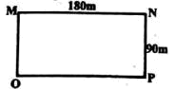
- Below is a representation of a school field

Kingi walked from point M to N through O and P and back to M through the same route. What distance did he cover altogether?
  - 540 m

  - 360 m

  - 720 m

  - 1080 m

- The diagram below represents Machogu's home bank.
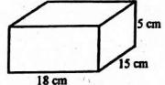

What is its volume?

  - 270 cm³

  - 75 cm³

  - 1350 cm³

  - 90 cm³

- A table weighs 33 kg and a stool weighs 29 kg. How heavier is the table than the stool?

  - 62 g

  - 62000 g

  - 4 g

  - 4000 g

- The square below represents the top of Rajab's table.
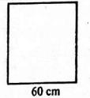

What is its area?

  - 3600 cm²

  - 360 cm²

  - 240 cm²

  - 2400 cm²

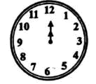
- A bullfight started at the time shown on the clockface below.

If the bullfight lasted for 2700 seconds, which of the following clock faces shows the time it ended?

  - A

  - B

  - C

  - D

- A cartoon program lasted for 45 minutes, news took 50 minutes and a religious show lasted for 1 hour. What was the total time consumed by the three programs?
  - 2 hours 35 minutes

  - 1 hour 35 minutes

  - 2 hours 45 minutes

  - 1 hour 45 minutes

- Which of the following services provided by banks in our country?

  - Printing notes for circulation

  - Issuing visas to the workers

  - Lending loans to citizens

  - Ensuring national security

- Which of the following boxes contains a vertical line?

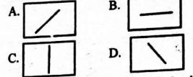

  - A

  - B

  - C

  - D

- Kandawala saw railway lines during his visit to his friend. Which of the following represents what he saw?

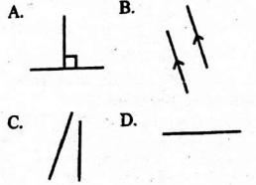
A. A

  - B

  - C

  - D

- Which of the following angles measures 35⁰?
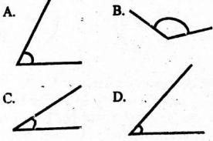

  - A

  - B

  - C

  - D

- Simplify the algebraic equation below.

16 n + 9 r- 5n + r

  - 10 n + 11 r

  - 10 n + 11 r

  - 11 n - 10 r

  - 11 n + 10 r

- Maua and his brother had 4 oranges each. They gave Sally w oranges. Which of the following expressions represents this information?
  - 4 - w

  - 4 - 2 w

  - (4 + 4) - w

  - 8 - 4 w

- In a class of 25 learners, each learner was given m packets of milk. If seven packets remained, after sharing 57 packets, what is m?
  - 32

  - 7

  - 5

  - 2

- The piled matchboxes below represent the number of seedlings planted by Grade six learners in their school compound for a period of four days. One matchbox represents two seedlings.
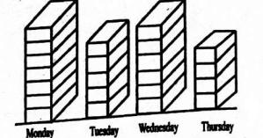
How many seedlings were planted on last two days?

  - 10

  - 20

  - 30

  - 15

- Which two days had a total of 22 seedlings?

  - Tuesday and Wednesday

  - Monday and Tuesday

  - Wednesday and Thursday

  - Tuesday and Friday

- Which two days had the least number of seedlings?

  - Wednesday and Thursday

  - Tuesday and Monday

  - Monday and Wednesday

  - Thursday and Tuesday

- How many seedlings were planted in the four days altogether?

  - 22

  - 88

  - 44

  - 11

Answers

- Forty three thousand and sixty eight

- 3000

- 1089

- 34

- 9¹³/₁₅

- ¹⁹/₂₀

- 40%

- Tenths

- 816.87 kg

- 244

11. 41km 21m

- 688 km 752 m

- 15

- 720 m

- 1350 cm³

- 4000 g

- 3600 cm²
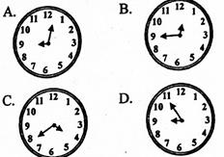

18.

- 2 hours 35 minutes

- Lending loans to citizens

- C

- B

- C

- 11 n - 10 r

- (4 + 4) - w

- 2

- 20

- Tuesday and Wednesday

- Thursday and Tuesday

- 44

