GRADE 6 - 2025

CBC ASSESSMENT
THIRD TRIAL

ENDTERM

PRIMARY SCHOOL EDUCATION ASSESSMENT

ENGLISH LANGUAGE

TIME: 1 HOUR

INSTRUCTIONS TO LEARNER’S (Please read these instructions carefully)

- You have been given this question booklet and a separate answer sheet. The question booklet contains 30 questions. Answer all the questions.

- Do any necessary rough work in this booklet.

- When you have chosen your answer, mark it on the ANSWER SHEET, not in this question booklet.

HOW TO USE THE ANSWER SHEET

- Use ordinary pencil.

- Confirm that the answer sheet that you have been provided with has the following:

YOUR ASSESSMENT NUMBER YOURNAME

NAME OFYOUR SCHOOL NAMEOF SUBJECT
- Do not make any marks outside the boxes.

- Keep the sheet as clean as possible and do not fold it.

- For each of the question 1 - 30, four answers are given. The choices are lettered A, B, C, D. In each case only ONE of the four choices is correct. Choose the correct answer.

- On the answer sheet, show the correct answer by drawing a dark line inside the box in which the letter you have chosen is written.

Example:

In the question booklet:

11. Complete with the correct determiner. We have _______ food to last us several days.

- little

- a few

- enough

- a lot

The correct answer is C (enough)

On the answer sheet:

In the set of boxes numbered 11, draw a dark line inside the box with letter C printed as indicated below.


  - [A] [B] [C] [D]

- Your dark line MUST be within the box.

- For each question, ONLY ONE box is to be marked in each set of four boxes.

This paper consists of 4 printed pages. Turn over

G6

CBC ASSESSMENT 1 /Eng/GR.6

Read the following conversation and answer questions 1 to 5.

Tortoise: Hey Mr. Hyena, did you hear what the King said would be happening soon in this jungle?

Hyena: No. I didn’t, what did the king say?

Tortoise: Mr. Lion sent word all round the jungle that there would be a dancing competition amongst us.

Hyena: How comes I did not see him?

Tortoise: He did not come round personally. He sent his messenger, miss Jackal

Hyena: When did this information go round?

Tortoise: Last wednesday during the better part of the afternoon.

Hyena: I guess I did not get the infomation because on that day I was away looking for some herbs.

Tortoise: Well, now you know, prepare for the same.

Hyena: Thank you so much for this information.


Questions.

- According to this conversation, who was the king?

A. Hyena B. Tortoise

C. Lion D. Jackal.

- How many animals have been mentioned in the dialogue?

A. Two B. Four

C. Five D. Three.

- Which one of the following statements is not true according to this dialogue?
  - Tortoise was well infomed about the event of the big day.

  - Hyena neither saw nor heard the messenger pass the news.

  - Lion did not go round the jungle passing the information.

  - Hyena was not willing to take part in the competition.

- The hyena did not get the information because

  - he was away looking for herbs

  - the messenger did not know where he was

  - miss Jackal did not pass his place

  - he came home before the message was passed across.

- The phrase ‘during the better part of the afternoon’ has been underlined. What does it imply?

  - For a long time in the afternoon.

  - In the afternoon when every animal was present.

  - From two to three in the afternoon.

  - When the weather was condusive for the passing of the information.

Read the passage below and answer questions 6 to 10.

Donkeys are referred to as beasts of burden. People use them to carry heavy loads. Camels are also beasts of burden. Camels are very interesting animals. They are not like any other animal in the world. Some people say that camels are ugly and clumsy but I think the camel is a very beautiful animal. Daudi takes his donkey to the river to get water. He also owns a camel.

If you watched Daudi’s donkey, you would certainly laugh. The donkey is old but it jumps and runs like a youngster. Daudi cannot control it. It runs to the river very fast because its load is light. It also wants to drink water. Daudi runs after it shouting and complaining. However, it is a different story on the way back. The donkey plods very slowly and Daudi cannot make it go faster. Every time it passes our school it sings to us and we all say, ‘There goes Daudi and his donkey.’

CBC ASSESSMENT 2 /Eng/GR.6

Questions.

- What is a beast of burden?

  - An animal that is a burden to the owner.

  - An animal that helps carry things.

  - A domestic animal.

  - Most donkeys but not camels.

- What makes one laugh at Daudi’s donkey?

  - It’s old.

  - The way it behaves.

  - It runs as it drinks water.

  - It behaves like Daudi.

- Name two acts that the old donkey can perform

  - Rise and fall.

  - Run and sleep.

C. Jump and run.
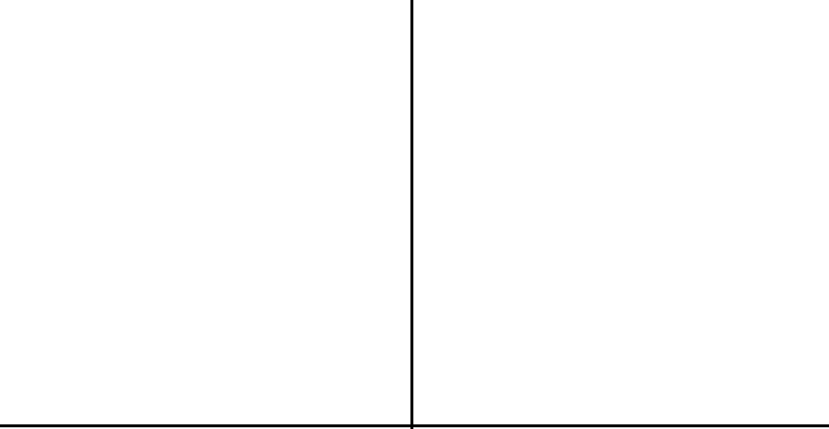

D. Kick and jump.

- Which word in the passage means the opposite of ugly?

  - Clumsy

  - Burden

  - Interesting

  - Beautiful.

- Why does the donkey run to the river?

  - It is normally thirsty

  - It wants to enjoy Daudi

  - Because it is playing

  - Because it has a light burden.

Use the following information to answer questions 11 to 13.

Four boys; Mwangi, Ngetich, Farah and Nandwa sat for exams last year. Mwangi scored higher marks than Ngetich, but not as high as Nandwa. Farah did better than Nandwa. Ngetich didn’t do as well as Nandwa.


Questions

- Which boy got the highest marks?

  - Nandwa

  - Mwangi

  - Farah

  - Ngetich.

- Which boy had the lowest marks?

  - Ngetich

  - Mwangi

Read the passage below and answer questions 14-15.

  - Nandwa

  - Farah.

- Which boy held the third position?

  - Ngetich

  - Farah

  - Mwangi

  - Nandwa.

Gedi is an important historical site off the Mombasa- Malindi road. It consists of the ruins of 18th centruy Arab town. It is about 114km from Mombasa and 16km from Malindi. The town of Gedi was built in the late 1200AD. By 1450AD, it had grown into a very big town but it was abandoned in the 1600s.


14. How far is Gedi ruins from Mombasa? | 15. The town of Gedi was left behind in the
A. 104 km | A. 1450
B. 130km | B. 1200
C. 114km | C. 1600
D. 16km | D. 18th century

CBC ASSESSMENT 3 /Eng/GR.6

Read the passage below. It contains blank spaces numbered 16 to 20. For each blank space, select the best alternative from the choices given

June and May were _____16_____ friends. ____17______ had _____18_____ the school ___19_____ at

the same time ____20______ they came from different backgrounds.

16. | A. great | B. greet
17. | A. She | B. They
18. | A. left | B. come
19. | A. almost | B. after
20. | A. although | B. since

For questions 21 - 22, fill in the correct preposition.

21. | They went home ________ foot.
 | A. by | B. on
 | C. with | D. onto
22. | He was so touched that he wept _______ them.
 | A. about | B. for
 | C. in | D. to

For questions 23 - 25, choose the correct question tag in each of the sentences.

- You are travelling to Kisumu on Saturday, _____?

  - are you

  - don’t you

  - do you

  - aren’t you

- You should not make noise in class, ____?

  - shouldn’t you

  - should you

  - will you

  - shall you

- The stone is quite heavy for me to lift, _______?

  - isn’t it

  - was it

  - is it

  - wasn’t it

C. better D. bolt

C. One D. All

C. joined D. been

C. even D. later

C. when D. because


For questions 26 - 27, choose the correct order of adjectives.

- The chef used a _____________ pan.

  - round, large, old

  - large, round, old

  - large, old, round

  - old, large, round

- The feast was to be held in the ______ house.

  - big, new, rectangular

  - big, rectangular, new

  - rectangular, big, new

  - new, big, rectangular.

From questions 28 - 30, choose the correct possessive pronoun from the choices given.

- The dog started wagging ______ tail when the owner arrived.

A. it is B. it’s

C. its D. it

- We cheered when ______________ team scored a goal.

A. we B. my

C. our D. us

30. They carried ____________ bags into the hotel.

A. there B. they’re

C. them D. their

CBC ASSESSMENT 4 /Eng/GR.6

