GRADE 6 - 2025
^{COMPETENCE BASED CURRICULUM}

CBC ASSESSMENT
FIRST TRIAL

001

PRIMARY SCHOOL EDUCATION ASSESSMENT

CREATIVE ARTS

TIME: 2 HOURS

INSTRUCTIONS TO LEARNER’S (Please read these instructions carefully)

- You have been given this question booklet and a separate answer sheet. The question booklet contains 30 questions. Answer all the questions.

- Do any necessary rough work in this booklet.

- When you have chosen your answer, mark it on the ANSWER SHEET, not in this question booklet.

HOW TO USE THE ANSWER SHEET

- Use ordinary pencil.

- Confirm that the answer sheet that you have been provided with has the following:

YOUR ASSESSMENT NUMBER YOURNAME

NAME OFYOUR SCHOOL NAMEOF SUBJECT
- Do not make any marks outside the boxes.

- Keep the sheet as clean as possible and do not fold it.

- For each of the question 1 - 30, four answers are given. The choices are lettered A, B, C, D. In each case only ONE of the four choices is correct. Choose the correct answer.

- On the answer sheet, show the correct answer by drawing a dark line inside the box in which the letter you have chosen is written.

Example:

In the question booklet:

11. The art of making containers using clay is known as

- puppetry

- thonging

- pottery

- coil technique.

The correct answer is C (pottery)


On the answer sheet: 11. [A] [B] [C] [D]

In the set of boxes numbered 11, draw a dark line inside the box with letter C printed as indicated below.

- Your dark line MUST be within the box.

- For each question, ONLY ONE box is to be marked in each set of four boxes.

This paper consists of 4 printed pages. Turn over

- The following are reasons why we sing patriotic songs. Which one is not?
  - To praise our country.

  - To praise our creator.

  - Show love for our country.

  - Express our pride as a nation.

- The following verse was taken from a certain type of a song.

“Umoja wetu ni nguzo yetu” From which song was it taken?
  - National anthem

  - The East African Community anthem

  - Folk song

  - Sacred song.

- Which one of the following is not an example of a voice in a choir?
  - Solo

  - Alto

  - Saprano

  - Tenor.

- The following are occasions when folk songs are sung. Which one is not?
  - Marriages

  - Worshipping

  - Working

  - Child naming.

- In which community does the instrument below belong to?
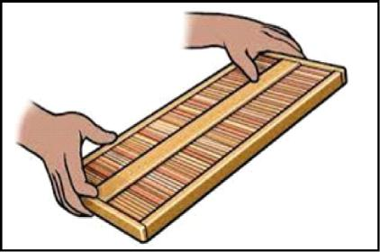

- Agikuyu

- Mijikenda

- Gusii

- Luhyia.

- I am a musical instrument. I belong to wind instruments. I have seven small holes with end openings. Which musical instrument am I?

  - Adet

  - Mulele

  - Coro

  - Chivoti.

- The following are reasons why we take care of instruments. Which one is not?
  - To save money.

  - Save on resources.

  - Dispose the old ones.

  - Have a collection of instruments.

- Who among the following is not a participant in a dance?
  - Soloist

  - Referee

  - Dancers

  - Instrumentalists.

- Which of the following is a role of adornments and ornaments in a dance?
  - Making the dance beautiful.

  - Make noise during dance.

  - Reduce confidence during presentation.

  - Segregation of communities.

- A learner wants to make a dance skirt. She collected all the following materials. Which one is not useful?
  - Sisal ropes

  - Sisal fibres

  - Water based paints

  - Sticks.

_{CBC ASSESSMENT} 2 CRTARTS/GR.6

- What technique was used to decorate the tool below?
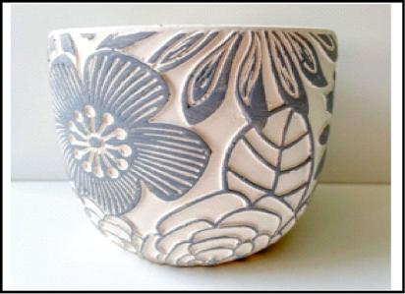

A. Stamping B. Embossing

C. Coiling D. Embedding

- In order to display your 3D and 2D artwork in an attractive manner, what factors should you consider?
  - Color contrast of the background.

  - View point.

  - Center of interest.

  - Focus quality.

- What technique of shading has been used in the picture below?
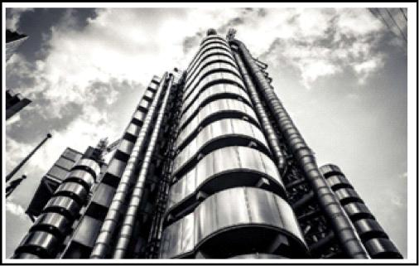

A. Smudge technique.

B. Cross hatching technique.

C. Crayon etching technique.

D. Shading technique.

- A cooking stick can be decorated using the following techniques except
  - polishing

  - smoking

  - painting

  - texturing.
- Ronnie wants to curve an elephant from wood. The following are the tools he will require except
  - chisel

  - axe

  - knife

  - hammer.

- The art of making pictures using lines and shades is called

  - painting

  - smearing

  - drawing

  - modelling.

- Which of the following is not a factor to consider when mounting artworks for exhibition?

  - Placement of artwork.

  - Proper use of space.

  - Color contrast of the background.

  - The price range of the artwork.

- The technique of sticking more than one type of material on a surface to create a picture is called
  - montage

  - collage

  - pictorial

  - overlapping.

- When preparing flexible fibres for weaving, we use the following methods
except

A. cutting B. stripping

C. splitting D. kneading.

20. The following are primary colours except

A. Red B. Green

C. Blue D. Yellow

_{CBC ASSESSMENT} 3 CRTARTS/GR.6

- Five action sequence involves the use of five gymnastic skills. The following list shows the skills used in a five action sequence. Which is not?
  - T-balance

  - Cartwheel

  - Handspring

  - Forward roll.

- What kind of balance is shown in the picture below?
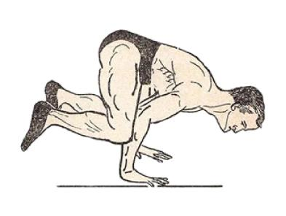

A. Hand balance

  - Headstand

  - Hand walk

  - T - balance.

- In the game of Rounders, when a player hits the ball in the direction desired, the process is called
  - fielding

  - gripping

  - bowling

  - batting.

- The process by which a fielder touches the post using the hand with the ball is called
  - batting

  - stamping

  - fielding

  - catching.

- The picture below shows a facility for an activity. Which activity is performed in it?
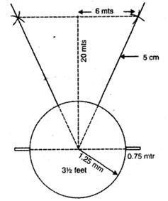

A. Discus B. Sprint race

C. Long jump D. Soccer.

26. The following are symptoms of a sprain

except

A. swelling B. pain

C. nausea D. bruising.

- How many players are needed in each team in the game of softball?
A. Twelve B. Fourteen

C. Nine D. Eighteen.

- The picture below shows an equipment used in softball.
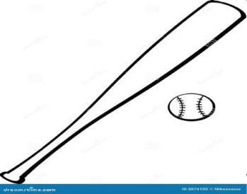

What is it called?

A. Bat B. Fielding glove

C. Hand gear D. Catcher’s mitt.

29. The following are techniques used in

rounders. Which one is not?

A. Fielding B. Throwing

C. Batting D. Hitting.

- A technique in the game of volleyball in which the ball being passed is kept high in the air by the fingers using both hands is
called

A. the dig B. the volley

C. the catch D. the serve.

_{CBC ASSESSMENT} 4 CRTARTS/GR.6

