COMPETENCE BASED CURRICULUM
HOMEWORK ENGAGEMENT PROGRAM
GRADE 6 2024 AUGUST
CREATIVE ARTS

- Which one of the pictures below shows a drawing with balanced objects?
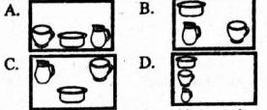

  - A

  - B

  - C

  - D

- The surface quality of an object can be called

  - tone

  - texture

  - variation

  - smoothness

- In picture making, we can use _____________ to show the surface quality of a drawing.

  - paint

  - cotton wool

  - water

  - dots

- Observe the pictures below.
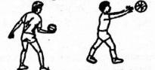

The type of composition shown above is called ______________ composition.

  - sports

  - throwing

  - imaginative

  - ball game

- Samoei collected the following materials:
- Picture cut outs

- Adhesive

- Manila paper

Which picture making technique did he want to practise?

  - Montage

  - Stippling

  - Sticking

  - Collage

- A group of Grade six learners made a wristband like the one shown below.

Which of the following pairs of material were they Ikely to have used?

  - Wax and glue

  - Leather and beads

  - Beads and plastic

  - Hard paper and leather

- A floor mat and basket can both be made using

  - pasting method.

  - modelling technique.

  - coil and stitch technique.

  - cutting and pasting technique.

- Use of closely drawn lines on a drawing to show the effects of light and darkness is called

  - stippling

  - shading

  - smudging

  - cross hatching

- Which of the following forms is not in a 3D form?

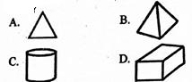

  - A

  - B

  - C

  - D

- Which of the following can be decorated using applique?

  - Clay materials

  - Finished woodwork items

  - Book jackets

  - Plastic items

Sing the song written below.

"Ninaipenda nchi yangu, naitambua Kenya yangu, Ooh viongozi wetu wa bidii,

Ee wao hufanya kazi bila ubaguzi, lelele!" The type of song written above is a

  - lullaby

  - gospel song

  - sacred song

  - patriotic song

- All the following are social-economic importance of songs except that they

  - are used to shape morals.

  - can be used to encourage bad behaviour.

  - help in promoting unity.

  - can be used to promote peace.

- Which one of the following types of folk songs can be sung in a burial ceremony?

  - Marriage folk song.

  - Funeral folk songs.

  - Initiation folk songs.

  - Worship folk songs.

- Which part of a fiddle is normally bowed to produce sound?

  - String

  - Bow

  - Membrane

  - Bridge

- Which of the following is not a string instrument?
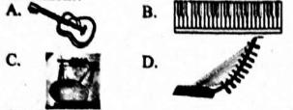

  - A

  - B

  - C

  - D

- When three people sing a three part song, we say they are singing in a

  - pair

  - duet

  - solo

  - trio

- All the following are messages found in the Kenya National Anthem. Which one is not?

  - The importance of maintaining peace among East African countries.

  - We expect blessings from God.

  - The importance of hard work.

  - The need to have peace within our nation.

- Which of the following musical instruments is played differently?

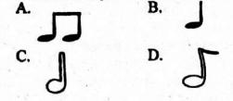

  - A

  - B

  - C

  - D

- Which of the following symbols represents the French rhythm name taa - aa?

  - A

  - B

  - C

  - D

- What is the role of a soloist in a folk dance?

  - Playing the instruments.

  - Leading other performers.

  - Receiving the message.

  - Decorating the bodies of folk dancers.
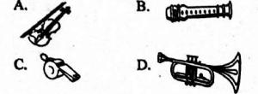
Answers

- C

- texture

- dots

- imaginative

5. Montage

- Leather and beads

- coil and stitch technique.

- cross hatching

- A

- Book jackets

- patriotic song

- can be used to encourage bad behaviour.

- Funeral folk songs.

- String

- B

- trio

- The importance of maintaining peace among East African countries.

- A

- C

- Leading other performers.

