GRADE 6 - 2025
G6

ENDTERM
CBC ASSESSMENT
THIRD TRIAL

PRIMARY SCHOOL EDUCATION ASSESSMENT

CREATIVE ARTS

TIME: 1 HOUR

INSTRUCTIONS TO LEARNER’S (Please read these instructions carefully)

- You have been given this question booklet and a separate answer sheet. The question booklet contains 30 questions. Answer all the questions.

- Do any necessary rough work in this booklet.

- When you have chosen your answer, mark it on the ANSWER SHEET, not in this question booklet.

HOW TO USE THE ANSWER SHEET

- Use ordinary pencil.

- Confirm that the answer sheet that you have been provided with has the following:

YOUR ASSESSMENT NUMBER YOURNAME

NAME OFYOUR SCHOOL NAMEOF SUBJECT
- Do not make any marks outside the boxes.

- Keep the sheet as clean as possible and do not fold it.

- For each of the question 1 - 30, four answers are given. The choices are lettered A, B, C, D. In each case only ONE of the four choices is correct. Choose the correct answer.

- On the answer sheet, show the correct answer by drawing a dark line inside the box in which the letter you have chosen is written.

Example:

In the question booklet:

11. The art of making containers using clay is known as

- puppetry

- thonging

- pottery

- coil technique.

The correct answer is C (pottery)


On the answer sheet: 11. [A] [B] [C] [D]

In the set of boxes numbered 11, draw a dark line inside the box with letter C printed as indicated below.

- Your dark line MUST be within the box.

- For each question, ONLY ONE box is to be marked in each set of four boxes.

This paper consists of 4 printed pages. Turn over

- The following are ways to critique each other’s artwork in class. Which one is not?
  - Giving helpful suggestions.

  - Keeping your opinions to yourself.

  - Giving honest and positive comments.

  - Respecting each other’s opinion.

- Which type of song is sung to show love for one’s country?

  - Action song

  - Sacred song

  - Patriotic song

  - Topical song.

- The main role of a soloist in a folk song is to

  - play musical instruments

  - train the choir

  - lead the performance

  - entertain the audience.

- Which of the following statements about the descant recorder is false? It
  - is a wind instrument

  - should be cleaned before and after playing

  - is played by blowing

  - should be properly assembled.

- In folk dances the participants decorate their bodies using paint to make patterns. This is
known as ______

A. ornaments B. costumes

C. body adornment D. decoration.

- Write French rhythm for the following note symbols. Taa tate taa-aa


A. B. 
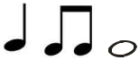



C. D.
- During a group work activity grade six learners paired indigenous instruments with the community that plays it as as shown below. Which one was wrongly matched?
  - Abu - Luhya

  - Adet - Turkana

  - Coro - Agikuyu

  - Chovoti - Mijikenda.

- Name the following technique of weaving.

  - Twinning technique

  - Plaiting technique

  - Stripping technique

  - Coiling technique.

- Which the following groups consists of factors considered when drawing forms?
  - Texture, balance and space.

  - Space, rhythm and texture.

  - Balance, proportion and space.

  - Space, value and proportion.

- The darkness and lightness of the colour of an object is known as

A. shading B. rubbing

C. tonal value D. overlapping.

- A plastic paper or metallic material with cut out designs for making prints is called a _______
A. motif B. media

C. stencil D. print

- Pressing kneaded clay to remove air trapped in the clay is called ______

A. scoring B. embedding

C. piercing D. wedging.

_{CBC ASSESSMENT} 2

13. Which one of the following is not a painting tool?

A. Spatula B. Paint brush

C. Pencil D. Palette.

- A grade six pupil drew the picture below. Identify the aspect that was not put into consideration?
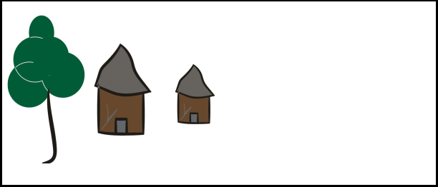

A. Proportion B. Balance

C. Space D. Colour

- The picture below shows a pot made and decorated through;

  - coiling and incising

  - coiling and embedding

  - coiling and stamping

  - coiling and thonging.

- How many players form a team in volleyball?

  - 5

  - 11

  - 6

  - 12

- Which is the most important value in the game of soccer?

  - Hard work

  - Teamwork

  - Self - centered

  - Co-operation.
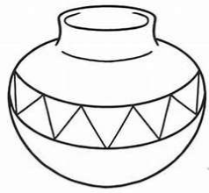
- Which of the following pairs consists of track events only?
  - Long jump and Javelin.

  - Relays and hurdles.

  - High jump and short races.

  - Hurdles and javelin.

- Which of the following items is not used in a

rounders game?

A. Bat B. Ball

C. Post D. Net.

- Identify the third stage in hurdles.

  - Hurdle clearance

  - Flight

  - Approach

  - Take off.

- Which of the following is not a part of the foot that is used to pass the ball in a game of football?
  - Instep

  - Inside of the foot

  - Outside of the foot

  - Arm pass.

- A grade six teacher guided learners in performing the following activities.

(i) Crab walk. (ii) Hand walk. (iii) Head stand.

Which component of physical fitness was developed?

  - Reaction time

  - Speed

  - Balance

  - Strength.

- Loop pass in a game of netball is also called

  - overhead pass

  - lob pass

  - shoulder pass

  - skypass.

_{CBC ASSESSMENT} 3

- A teacher asked grade four learners to explain how one scores a point in a game of netball.
They gave the following responses.

David : Any player successfully shoots the

ball from anywhere on the court.

Daniel: The wing attacker successfully shoots

the ball within the shooting circle

Damaris: The goal shooter successfully

shoots the ball from within the opposing team’s goal third.

Danilla: Either the goal shooter or goal

attacker successfully shoots the ball within the shooting circle.

Who among them gave the correct response?

A. Danilla B. David

C. Damaris D. Daniel.

- Which one of the following is not a ropework skill?

  - Skier

  - Down sweep

  - Wounded duck

  - Heel taps.

- Which of the following can be used to improvise a relay baton?

  - Broken glasses

  - Maize stalks

  - Old clothes

  - Thread.
- A group of learners were seen practising single hand dig pass. Which game were they preparing for?

  - Handball

  - Football

  - Volleyball

  - Netball.

- Which is the swimming style where a swimmer lies on one side in the water for live saving and leisure?

  - Back stroke

  - Side stroke

  - Breast stroke

  - Inverted back stroke.

- Which of the following games activities can be played by children of 6 to 12 years?
  - Skipping games

  - Volleyball

  - Hockey

  - Table tennis.

- When starting a race in athletics, competitors are given commands. Which of the following is the first command?
  - Go

  - Set

  - On your marks

  - Be ready.

_{CBC ASSESSMENT} 4

