COMPETENCE BASED ASSESSMENT

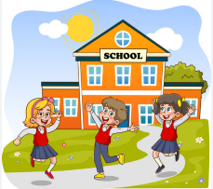
KENYA PRIMARY SCHOOL EDUCATION ASSESSMENT
GRADE 6
AGRICULTURE AND NUTRITION
ENDTERM 2 2024
LEARNER’S NAME:_________________________________________________________________________________ SIGN:_______________.
ASSESSMENT NUMBER: _____________________________________________________________DATE________________________________.
FOR EXAMINERS USE ONLY.
OUT OF | 50 MARKS
Learners Score.
Learners %
Score Range | Performance Level | Tick
80-100 | Exceeding Expectation
60-79 | Meeting Expectations
40-59 | Approaching Expectations
Below 40 | Below Expectations
Instructions to Learners.
Answer all the Questions.

LEARNERS INSTRUCTIONS

- Write your name and assessment number in the spaces provided above

- Answer all the questions in this paper.

- All your answers must be written in the spaces provided in the question paper.

- Learners should check the question paper to ascertain that all the pages are printed as indicated and that no questions are missing.

- Learners must answer the questions in English
(1 Marks)
- The following are changes that take place during adolescence:

  - Production of sex cells.

  - Broadening of hips.

  - Deepening of voice.

  - Increase in weight and height

  - Menstruation.

Which of the changes above take place in both adolescent boys and girls?

A. ii, v

B. i, iv

C. iii, iv

D. ii, iv

2. Which of the following statements is true about the soil with particles of medium size? (2 Marks)

A. It retains the highest amount of water.

B. It retains the least amount of water.

C. Most crops can be grown on it.

D. It supports farming of rice.

(1 Marks)
- The causes of obesity are listed below. Which one is not?

  - Excess intake of fat

  - Lack of regular exercises

  - Maintaining a healthy body weight

  - Eating junk foods

- Mwahangila noticed that seedlings on his nursery bed were congested. Which practice would (2 Marks) you advice him to carry out?

    - Pruning

    - Thinning

    - Shading

    - Weeding

5. The best way for controlling gulley erosion is by (2 Marks)

A. building gabbions.

B. making terraces.

C. planting cover crops.

D. contour farming.

6. The following are healthy eating habits. Which one is not? (1 Marks)

A. Eating a balanced diet.

B. Observing time for meals.

C. Eating any amount of food.

D. Correct choice of snacks.

7. Which of the following describes sheet erosion? (2 Marks)

A. Running water carries soil leading to the formation of small channels.

B. Raindrops hit the ground leaving small holes.

C. Top soil is uniformly washed away by flowing rain water.

D. Running water carries the soil away leaving V – shaped trenches.
(2 Marks)
8. The needlework tool shown below is used for
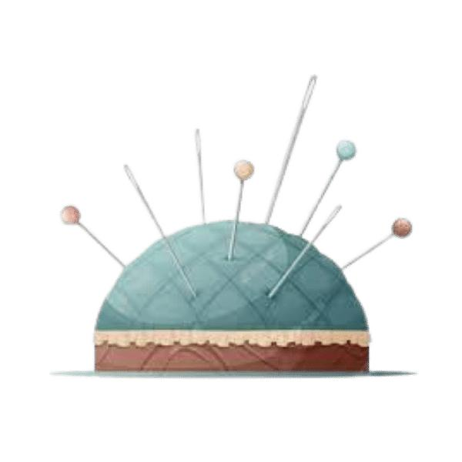

A. storing the sewing kit

B. protecting the tailor

C. holding thread

D. storing pins and needles

- Grade five learners were told to apply dry leaves and grass at the base around the seedling. (2 Marks) This method is referred to as

  - Mulching

  - Drying

  - Watering

  - Composting

10. Grade 6 learners from Kaloleni Preparatory school were asked to name ways of managing, (1 Marks) controlling and avoiding non-communicable diseases. All the learners gave correct answers

except;

A. AKINYI: eating a healthy diet

B. ALFA: exercising regulary

C. ALMASI: using sugar, salt and fats moderately

D. ASMIN: staying in a well aerated room

- Grade 6 learners were discussing about the importance of maintaining an appropriate number (2 Marks) of small domestic animals. Which among them is not correct?

  - To avoid overcrowding

  - To reduce the resources used to take care of them

  - To reduce the chances of spreading diseases

  - To get more rich

12. Anderi constructed an electric fence around her farm. Which of the following wild animals (2 Marks) cannot be dettered by the fence?

A. Weaver birds

- Gazelles

- Elephants
 | D. Wildbeast
13. | The following are ways of conserving water in farming. Which one is not? | (2 Marks)
 | A. Using sunken beds.
 | B. Mulching
 | C. Shading
 | D. Practicing irrigation
14. | The following method can be used to cook an egg. Which is it? | (2 Marks)
 | A. Roasting
 | B. Dry fat cooking
 | C. Deep frying
 | D. Steaming
15. | Which one of the following is not a reason for laundry work? To | (2 Marks)
 | A. improve creases.
 | B. make the garments neat.
 | C. remove dirt and stains.
 | D. kill germs.
16. | One of the following is an effect of misusing accessories. Which one is it? | (1 Marks)
 | A. Skin rashes or diseases.
 | B. Enhancement of beauty.
 | C. Removal of wrinkles.
 | D. Taking away bad smell.
17. | What is the meaning of organic gardening? | (2 Marks)
 | A. Growing crops without use of soil.
 | B. Growing crops without use of agro-chemicals.
 | C. Growing crops using vertical or horizontal containers.
 | D. Growing crops that do not have strong stems.
 |  | (2 Marks)
- Mr. Lee listed the following signs and symptoms of a certain nutritional deficiency disease.

  - Brownish thin hair.

  - Swollen body parts like arms, feet and face.

  - Sores at the corners of the mouth.

  - Protruding belly.

Which disease was he talking about?

- Kwashiorkor

- Obesity

- Rickets

- Marasmus.

19. Perfumes and make-ups are examples of (2 Marks)

- needs.

- lotions.

- accessories.

- cosmetics.

20. Nekesa was asked by her Agriculture teacher to mention the best way of controlling splash (2 Marks) erosion. If she was correct, what did she say?

A. Cultivating across the slope.
B. Making terraces across the slopes.

C. Planting covercrops.

D. Building porous dams.

21. A process by which top soil is gradually removed from one place to the other by water, | (2 Marks)
animals or wind is called soil
A. deposition
B. rescue
C. erosion
D. cleaning
22. Lucy had the following signs and symptoms. | (2 Marks)
i. Skin rash that was very itchy.
ii. Fever
iii. Feeling tired
iv. Bumps filled with a liquid that looked like milky water.
Which of the following diseases was she likely to have?
A. Chicken pox
B. Cholera
C. HIV/AIDS
D. Covid
23. Which farm equipment is drawn below? | (2 Marks)
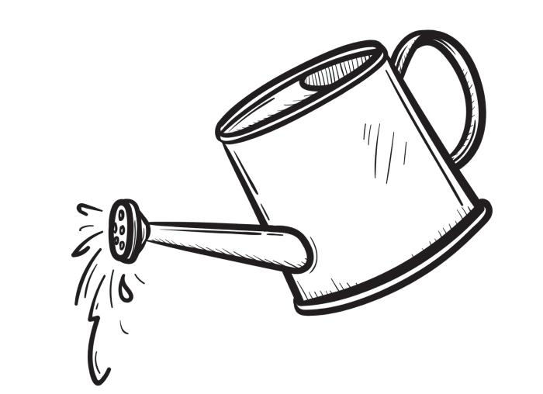

- Jug

- Rake

- Watering can

- Sprayer

(2 Marks)
- Grade six learners of Gori school constructed a feature as shown below. The learners were demonstrating how to make a:
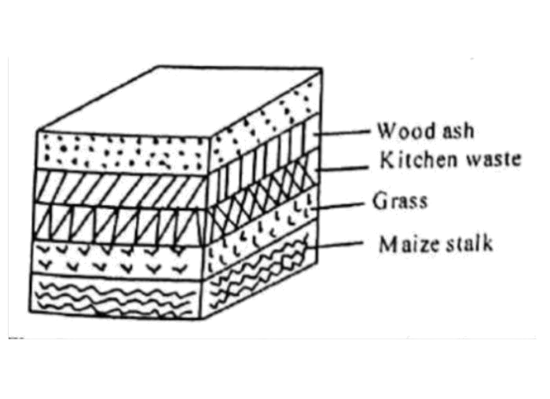

A. Farmyard manure

B. Organic mulches

C. Compost manure

D. Green manure

(2 Marks)
- The steps below are taken when offering first aid to an epilepsy patient. Arrange them in the correct order.

  - Remove anything around the person that may cause injury

  - Loosen anything around the neck

  - Put a folded sweater under the head

  - Let the person lie on the ground

    - (i), (ii), (iii), (iv)

    - (ii), (iv), (iii), (I)

    - (iii), (I), (iv), (ii)

    - (iv), (I), (iii), (ii)

26. The process of planning how to spend money that you have is known as (2 Marks)

A. Shopping list

- Advertisement

- Planning

- Budgeting

27. To protect my fingers as I sew I can use a (2 Marks)

A.rope

- gloves C.thimble D. cushion

28. Birds kept for laying eggs are called (2 Marks)

A. broilers.

B. dairy.

C. layers.

D. beef.

29. Grade 5 learners from Little Angels Academy made a sack garden during an Agriculture lesson. They were guided by their teacher to arrange some stones in the middle of the sack. Why were the stones put in the middle of the sack?

(2 Marks)

B. To allow water to flow to the lower level of the sack.

C. To make the sack to be very firm.

D. For the sack not to grow old easily.

30. Which one of the following is an expense? (2 Marks)

A. Buying cosmetics and accessories

B. Selling masks

C. Selling sanitizers

D. Selling farm produce

31. When preparing a vegetable nursery bed, grade 5 learners placed some mulch after planting (2 Marks) the seeds. Why do you think they did so?

A. To reduce water loss from the soil, to keep the seeds and the soil from being eroded.

B. To reduce water loss from the soil to keep the seedlings from drying.

C. To increase the fertility of the soil, to prevent soil erosion.

D. To increase the rate of growth of the seeds, to keep the seedlings from drying.

32. Three of the following crops are grown in a sunked seedbed except (2 Marks)

  - kale.

  - spinach

  - tomatoes

  - Sugarcane

- The following are some of the steps of preparing seeds for planting. Which of the steps is the (1 Marks) second one?

  - Drying

  - Extracting

  - Washing

  - Selecting

(2 Marks)
- A grade 5 pupil was writing down notes on water conservation for plants in nurseries. He wrote down the following points.

  - Building of gabions

  - Terracing

  - Weeding

  - Shading

Which one of the above was a correct point for the water conservation?

A. Building of gabions

- Terracing

- Weeding

- Shading

(1 Marks)
- Which of the following can be used for mulching?

  - Polythene papers.

  - Old rags.

  - Pieces of iron sheets.

  - Dry leaves or grass.

36. Building gabions is the best way of controlling (2 Marks)

A. Gulley erosion.
B. Splash erosion.

C. Sheet erosion.

D. Rill erosion.

37. When we eat foods rich in calcium like milk and yoghurt, we are not likely to suffer from; (2 Marks)

- Goiter

- Scurvy

- Anaemia

- Rickets

38. Which of the following choices contains a cosmetic and an accessory respectively? (2 Marks)

A. Headband, bracelet.

B. Deodorant, skin moisturizer.

C. Nail polish, necklace.

D. Handbag, facial make up.

39. | Which of the following is not a method of controlling soil erosion? | (2 Marks)
 | A. Contour farming
 | B. Controlled grazing
 | C. Building gabions
 | D. Terracing
40. | Which of the following crops shows a creeper and a climber respectively? | (2 Marks)
 | A. Strawberries and passion fruit.
 | B. Pumpkins and melons.
 | C. Grape vine and calabash plant.
 | D. Grape vine and passion fruit.
41. | Good grooming helps us to look | (2 Marks)
 | A. neat.
 | B. rough.
 | C. naughty.
 | D. desperate.
42. | Kiptoo was experiencing changes in his body. Which one of the following is not a change | (2 Marks)
 | that occurs in boys?

A. Growth of an acne.

B. Growth of beards.

C. Broadening of shoulders.

D. Broadening of the hips.

(2 Marks)
43. The following are changes that take place during adolescence:

i. Production of sex cells.

ii. Broadening of hips.

iii. Deepening of voice.

iv. Increase in weight and height

v. Menstruation.

Which of the changes above take place in both adolescent boys and girls?

A. ii, v

B. i, iv

C. iii, iv
D. ii, iv

44. The use of cover crop for the conservation of soil will work the same way as (2 Marks)

- shading

- gabions

- mulching

- planting

(1 Marks)
- Which of the following can be used for mulching?

  - Polythene papers.

  - Old rags.

  - Pieces of iron sheets.

  - Dry leaves or grass.

- Grade 5 pupils from Heshima Academy grouped food in groups below. Which group consists(1 Marks) of food that provide our bodies with fats and oil?

    - Beans, groundnuts, lentils.

    - Samosa, mandazi, pancakes.

    - Butter, cheese, red meat.

    - Chicken, ice cream, oily spinach.

47. Why is drip irrigation method better than the use of an overhead irrigation? (2 Marks)

A. Uses water sparingly

B. A lot of water is used

C. The rate of evaporation is high

D. Used water can be re-used

48. The following are common non-communicable disease except (2 Marks)

- Diabetes

- Hypertension

- Heart disease

- Tuberculosis

49. The following are ways of controlling soil erosion. Which one is not? (1 Marks)

A. Building gabions

B. Contour ploughing

- Deforestation

- Planting cover crops

50. The following animals can be controlled by the use of a fence except a (2 Marks)

- squirrel.

- Mongoose

- hare.

- bird
(Confidential)

Marking Scheme

1. | B | (1 Marks)
2. | C | (2 Marks)
3. | D | (1 Marks)
4. | B | (2 Marks)
5. | A | (2 Marks)
6. | C | (1 Marks)
7. | C | (2 Marks)
8. | D | (2 Marks)
9. | A | (2 Marks)
10. | D | (1 Marks)
11. | D | (2 Marks)
12. | A | (2 Marks)
13. | D | (2 Marks)
14. | C | (2 Marks)
15. | A | (2 Marks)
16. | A | (1 Marks)
17. | B | (2 Marks)
18. | A | (2 Marks)
19. | D | (2 Marks)
20. | C | (2 Marks)
21. | C | (2 Marks)
22. | A | (2 Marks)
23. | C | (2 Marks)

24. | C | (2 Marks)
25. | D | (2 Marks)
26. | D | (2 Marks)
27. | C | (2 Marks)
28. | C | (2 Marks)
29. | B | (2 Marks)
30. | A | (2 Marks)
31. | A | (2 Marks)
32. | D | (2 Marks)
33. | C | (1 Marks)
34. | D | (2 Marks)
35. | D | (1 Marks)
36. | A | (2 Marks)
37. | D | (2 Marks)
38. | C | (2 Marks)
39. | C | (2 Marks)
40. | A | (2 Marks)
41. | A | (2 Marks)
42. | D | (2 Marks)
43. | B | (2 Marks)
44. | C | (2 Marks)
45. | D | (1 Marks)
46. | C | (1 Marks)
47. | A | (2 Marks)
48. | D | (2 Marks)
49. | C | (1 Marks)
50. | D | (2 Marks)

