COMPETECE BASED CURRICULUM
HOMEWORKK ENGAGEMENT ACTIVITY
DECEMBER HOLIDAY
GRADE 5
MATHEMATICS HOMEWORK

- What is the place value of digit 5 in the number 749519?(2 marks)

- What is 60339 in words? ( 2 marks)

- Work out ( 2 marks) a. 749

    - 69

____

  - 18√936

- A cyclist covered 624km from his home to town. Convert the distance into metres ( 2 marks)

- Find the width of the figure below ( 2 marks)
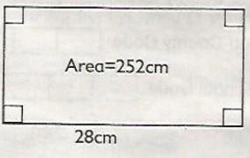

- Work out 23.652m + 72.12m ( 2 marks)

- Fill in the table below ( 4 marks)
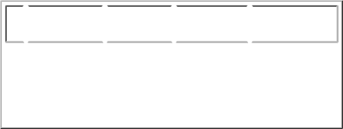

LengthWidthHeightVolume

a |  | 7cm |  | 6cm |  |  |  | 210cm³
b |  | 9cm |  | 4cm |  | 3cm

- Work out ( 4 marks) a. L ml
  - 605 -12 532

________

- L ml

  - 554 x 5

_______

- A meeting took 960 seconds. How many minutes did the meeting take? ( 2 marks)

- Mwikali bought 25000 grams of ripe bananas. How many kilograms did she buy? ( 2 marks)

- How many cubes are in the stack below? ( 2 marks)
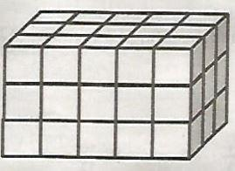

- If I want to measure a distance of 39m using a 1m rode, how many strokes will I make?( 2 marks)

- What is the difference between 27 minutes 16 seconds and 21 minutes 43 seconds? ( 2 marks)

- Work out ( 2 marks)

a. minutes seconds

      - 57

    - 1844

________________

  - 9√58 mins 39 seconds

- How many 100g sachets of downy can balance a 1kg mass? ( 2 marks)

- Arrange the numbers on the card from the largest to the smallest ( 2 marks)

- Jesse measured different items and recorded them down. Which of the following were units of masses by Jesse?

0.45, 1m, 51, 45g, 50kg, 30km

- A square tile has a length of 30cm. What is the area of 3 such tiles? ( 2 marks)

- Work out the following ( 3 marks)

  - ³/₄ - ⁷/₁₂
  - ¹¹/₁₂ - ¹/₃
  - ¹⁰/₁₂ - ¹/₄

- Fill in the missing number ( 4 marks)

  - ¹/₂ = ?/₄ = ³/?
  - ³/? = ?/₁₆ = ⁹/₁₂

MATH TASK 2

1. Write 87954 in words (1mk)

2.Write down the place value of digits 7 and 3 in the figure 742309 (2mks)

  - 7

  - 3

3. | List the common multiples of 3 and 6 that are less than 20 (3mks)
 | a.
 | b.
 | c.
4. | Work out 403 + 689 − 507 | (2mks)
5. | Estimate the product of 194 and 14 by rounding off each number to the nearest 10 (3mks)
- Complete the pattern below. (2mks) 2505, 3005, 3505, __________, ___________

- Simplify the following fractions (2mks)

  - 15

25

  - 6

12

8. Work out (2mks)

38.545

  - 10.234

- A shopkeeper had 10kg of sugar. He packed the sugar in ½ kg packets. How many packets did he get? (2mks)

- Convert the following metres into kilometres (3mks)

    - 1250m

    - 25640m

    - 318500m

- Find the area of the figure below (3mks)

- Work out (2mks)
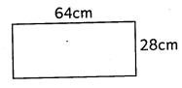

km m

    - 150

  - 4

- A fruit vendor bought 16 litres of fruit juice. He then put the juice in 500ml containers. How many containers

did he get? ____________________ (2mks)

14. What is the time? (1mk)
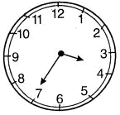

______________________________

- Work out (2mks)

- Amos paid sh. 4580 for three shirts that cost a total of sh. 4200. How much tax did he pay?

______________________ (2mks)

- Draw a horizontal line (1mk)

- The capacity of a tank is 750litres and 500ml. The tank has 250litres and 200ml. How much water is needed to fill the tank?

____________________________________ (3mks)

- Mary takes 30minutes 45 seconds to go to school from home. How much time will she use to go to school and back home?______________________________ (2mks)
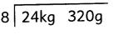
20. Draw a reflex angle (2mks)

- Work out (2mks) sh cts 480 50

+ 130 75

- Children went for a break for 45 minutes. How much was this time in seconds ______________________________

(2mks)

23. Find the volume of the box below (2mks)
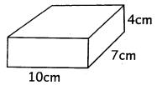

24. Name the figure below. (1mk)
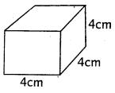

25. What is the approximate height of your Mathematics teacher? _________________________ (1mk)

Marking Scheme TASK 1

- Hundreds

- Sixty thousand, three hundred and thirty nine.

  - 51681

  - 52

- 624000m

- Width 9cm

- 95.772

7.

- 5 cm

- 108 cm

8.

  - 13 L 73ml

  - 202l 770 ml

- 16 minutes

- 25 kg
- 45 cubes

- 39 strokes

- 5 min 33 sec

  - 56 min 41 sec

  - 6 mins 31 sec

- 10 sockets

- 0.702, 0.542, 0.452, 0.352, 0.152

- 45g 50kg

- 2700cm³

- ¹/₆
- ⁷/₁₂
- ⁹/₁₂

20.
- ¹/₂ = ²/₄ = ³/₆
- ³/₄ = ¹²/₁₆= ⁹/₁₂

MARKING SCHEME TASK 2

- Eighty seven thousand, nine hundred and fifty four

  - 7 - hundreds of thousands

  - 3 - hundreds

- 6, 12, 18

- 585

- 1900

- 4005, 4505

- a. ³/₅,

  - ½

- 28.311

- 20 packets

  - 1.25km

  - 25.64km

  - 318.5km

- 1792cm²
- 200km 600m

- 32 containers

- 25 minutes to 4

- 3km 40g

- Sh. 380

- ____________________

- 500litres 300ml

- 61minutes 30seconds

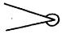

- Sh. 611 25cts

- 2700secs

- 280cm³
- cube

- mark accordingly

