GRADE 5 - 2025
^{COMPETENCE BASED CURRICULUM}

CBC ASSESSMENT
FIRST TRIAL

CODE 001

PRIMARY SCHOOL EDUCATION ASSESSMENT

MATHEMATICS | TIME: 2 HOURS

INSTRUCTIONS TO LEARNER’S (Please read these instructions carefully)

- You have been given this question booklet and a separate answer sheet. The question booklet contains 30 questions. Answer all the questions.

- Do any necessary rough work in this booklet.

- When you have chosen your answer, mark it on the ANSWER SHEET, not in this question booklet.

HOW TO USE THE ANSWER SHEET

- Use ordinary pencil.

- Confirm that the answer sheet that you have been provided with has the following:

YOURASSESSMENT NUMBER YOURNAME

NAME OFYOURSCHOOL NAMEOFSUBJECT
- Do not make any marks outside the boxes.

- Keep the sheet as clean as possible and do not fold it.

- For each of the question 1 - 30, four answers are given. The choices are lettered A, B, C, D. In each case only ONE of the four choices is correct. Choose the correct answer.

- On the answer sheet, show the correct answer by drawing a dark line inside the box in which the letter you have chosen is written.

Example:

In the question booklet:

11. Work out : 335 x 24

- 8004

- 8400

- 8040

- 80040

The correct answer is C (8040)

On the answer sheet:

In the set of boxes numbered 11, draw a dark line inside the box with letter C printed as indicated below.


  - [A] [B] [C] [D]

- Your dark line MUST be within the box.

- For each question, ONLY ONE box is to be marked in each set of four boxes.

This paper consists of 4 printed pages. Turn over

CBC ASSESSMENT 1 MATHS/GR. 5

- The number of animals vaccinated in a county were 62734. What is the total value of digit 6?
  - 60000

  - Ten thousands

  - Thousands

  - 1000

- A school received thirty six thousand four hundred and ten desks. What is the number of the desks in symbols?

  - 36401

  - 360410

  - 36410

  - 360401

- A farmer planted 623 cypress seedlings, 737 eucalyptus seedlings and 106 avacado seedlings. How many tree seedlings did the farmer plant together?
  - 1560

  - 1466

  - 1456

  - 943

- A guard recorded animals in four parks as 7284, 6391, 1007, 2998. Arrange the number of animals in ascending order.
  - 2998, 6391, 1007, 7284

  - 7284, 6391, 1007, 2998

  - 2998, 1007, 6391, 7284

  - 1007, 2998, 6391, 7284

- A milling firm produced 9267kg of maize flour in a certain month. Round off to the nearest thousands.
  - 9200

  - 9000

  - 9260

  - 10000

- Which one of the following numbers is divisible by 5?

  - 2001

  - 1996

  - 1800

  - 1999

- A lorry carried 97841kg of salt. It off loaded 7830kg of salt. How many kilograms remained in the lorry?

  - 90011kg

  - 90071kg

  - 104011kg

  - 105671kg

- Akinyi sells eggs in groups of four. Which of the numbers below can be arranged in groups of 4?
  - 26

  - 36

  - 49

  - 71

- What is the sum of all even numbers between 131 and 141?

  - 681

  - 680

  - 675

  - 816

- A book has ix pages. What is the number of pages in Hindu Arabic numerals?
  - 6

  - 8

  - 10

  - 9

- Kilonzi had 371 cows and 114 sheep. How many animals did he have altogether written in words?
  - Three hundred and seventy one.

  - One hundred and fourteen.

  - Four hundred and eighty five.

  - Five hundred and ten.

- The number of people who went to visit a governor in June were 698. In July, they were 974. How many more people visited the governor in July than in June?
  - 276

  - 1662

  - 1672

  - 124

CBC ASSESSMENT 2 MATHS/GR. 5

- A meeting was attended by 3014 people. There were 726 women in the meeting and the rest were men. How many men were in the meeting?
  - 3740

  - 3730

  - 2288

  - 2298

- There were 621 pens in a box. A teacher gave 324 pens to his learners . He later added 200 pens to the same box. How many pens did he have in the box finally?
  - 945

  - 1145

  - 297

  - 497

- What is the next number in the pattern below? 7940,7440, 6940, _______
  - 6440

  - 6400

  - 6340

  - 5940

- A box holds 21 candles. Maggy bought 11 boxes. How many candles did she have in total?
  - 32

  - 231

  - 321

  - 212

- A learner multiplied a number by 6 and got 72. Which number did she use to multiply?
  - 8

  - 7

  - 12

  - 21
- A famer collected 216 eggs from a store. If the store had 16 chicken that laid the eggs how many eggs did each chicken lay?
  - 36

  - 27

  - 18

  - 14

- Nine hundred and eighteen coconuts were packed in groups of 6. How many groups were formed?
  - 126

  - 251

  - 153

  - 118

- Four learners had a clothing material which they

measured and recorded. Which of the materials was the smallest?

  - ¹₂ m

  - ¹₄ m

  - ³₄ m

2
  - ₃ m

- Kipruno weighed 17.63kg of maize. Which digit is in the hundredths position?
  - 1

  - 7

  - 6

  - 3

- Grade 5 leaners measured heights of different items and recorded them as follows. Which item is the tallest?

  - Pen: 0.14m

  - Pencil: 0.23m

  - Ruler: 0.31m

  - Spoon: 0.19m

CBC ASSESSMENT 3 MATHS/GR. 5

23. Using a ruler, measure the following line ________

  - 13cm

  - 6cm

  - 9cm

  - 11cm

- A string measured 17m. What is the size of the string in centimetres?

  - 1700cm

  - 17000cm

  - 170cm

  - 0.17cm

- Kirima’s land is in the shape below. What is the perimeter of the land?
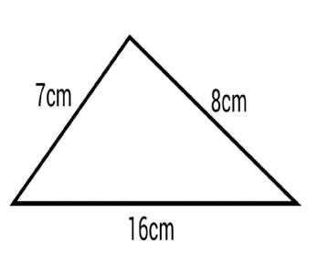

  - 15cm

  - 13cm

  - 24cm

  - 31cm

- What is the area of the figure below?
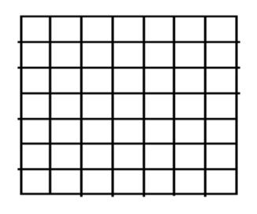

A. 14square units

- 21square units

- 49square units

- 64square units

- Angela had 7 half kilograms of milk powder. How many kilograms did he have?

  - 1 ⁵₂ kg

  - 8kg

  - 3 ¹₂ kg

  - ¹₂ kg

- What is the volume of the figure below?


  - 96cm³

  - 112cm³

  - 208cm³

  - 1344cm³

- A tank had 171litres of water. After raining, the amount of water was 264 litres. How many litres of water was gotten from rain?
  - 435L

  - 113L

  - 93L

  - 121L

- What is the time on the clock below?

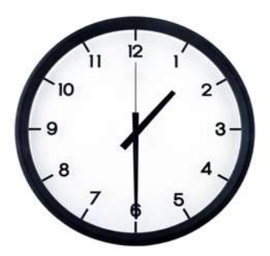

A. Half past twelve o’clock

- Half past one o’clock

- Half past two o’clock

- A quarter past six o’clock

CBC ASSESSMENT 4 MATHS/GR. 5

