G5
GRADE 5 - 2025

CBC ASSESSMENT
THIRD TRIAL

ENDTERM

PRIMARY SCHOOL EDUCATION ASSESSMENT

CREATIVE ARTS

TIME: 1 HOUR

INSTRUCTIONS TO LEARNER’S (Please read these instructions carefully)

- You have been given this question booklet and a separate answer sheet. The question booklet contains 30 questions. Answer all the questions.

- Do any necessary rough work in this booklet.

- When you have chosen your answer, mark it on the ANSWER SHEET, not in this question booklet.

HOW TO USE THE ANSWER SHEET

- Use ordinary pencil.

- Confirm that the answer sheet that you have been provided with has the following:

YOUR ASSESSMENT NUMBER YOURNAME

NAME OFYOUR SCHOOL NAMEOF SUBJECT
- Do not make any marks outside the boxes.

- Keep the sheet as clean as possible and do not fold it.

- For each of the question 1 - 30, four answers are given. The choices are lettered A, B, C, D. In each case only ONE of the four choices is correct. Choose the correct answer.

- On the answer sheet, show the correct answer by drawing a dark line inside the box in which the letter you have chosen is written.

Example:

In the question booklet:

11. The art of making containers using clay is known as

- puppetry

- thonging

- pottery

- coil technique.

The correct answer is C (pottery)

On the answer sheet:

In the set of boxes numbered 11, draw a dark line inside the box with letter C printed as indicated below.


  - [A] [B] [C] [D]

- Your dark line MUST be within the box.

- For each question, ONLY ONE box is to be marked in each set of four boxes.

CBC ASSESSMENT 1 CRT/ARTS/GR. 5

- A flute is played by

  - bowing

  - shaking

  - blowing

  - hitting.

- Which one of the following is a way of creating rhythm? By

  - crying

  - waiting

  - walking

  - clapping.

- The arrangement of notes of different pitches and directions sung is called

  - rhythm

  - tempo

  - melody

  - mood.

- Songs sung to soothe babies are classified as

A. sacred songs B. lullaby songs

C. folk songs D. action songs.

- What is the name given to the part marked Q in the musical instrument below?
Q
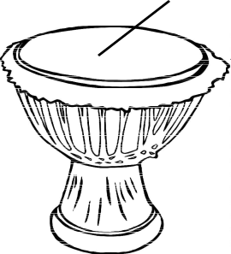

- Membrane

- Sound box

- Sling

- Resonator.

- The following are main parts of the musical instrument shown below. Which one is not?
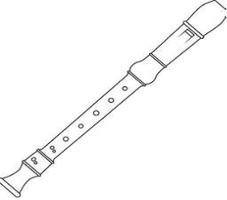

A. Head joint B. Window

C. Foot joint D. Middle joint.

- The French rhythm name given to a minim is

A. Ta-te B. Taa-aa-aa-aa

C. Taa-aa D. Taa-aa-ta-te

- Grade 5 learners were discussing indigenous wind instruments. Which one of the following is an example of an indigenous wind instrument?
  - Kayamba

  - Shaker

  - Nzumari

  - A drum.

- Grade five learners wanted to draw a still life composition based on wind instrument using crayon etching technique. Which of the following materials cannot be used to make improvised crayons?
  - Candle wax

  - Bee wax

  - Pigment

  - Paper.

- Which one of the following aspects is not important to observe when mounting pictures using mat technique?
  - Balance

  - Pasting

  - Correct dimensions

  - Material.

CBC ASSESSMENT 2 CRT/ARTS/GR. 5

- Grade four learners cut pictures and pasted them on a manila paper. This is called
  - mosaic

  - montage

  - pasting

  - crayon etching.

- ____ is a drawing of an arrangement of non- moving objects.
  - Still-life composition

  - Smudge

  - Painting

  - Etching.

- Which of the following groups consists of only primary colours?

  - Blue, green, red

  - Red, yellow, blue

  - Green, Indigo, purple

  - Orange, red, green.

- The technique shown below is known as

  - value gradation

  - mudging

  - shading

  - painting.

- Which one of the following is not a factor to consider when drawing forms?
  - Colour of paint

  - Proportion

  - Space

  - Balance.

- Which of the following cards is used in managing soccer games?

  - Blue card

  - Yellow cards

  - Square cards

  - Pinpoint cards.
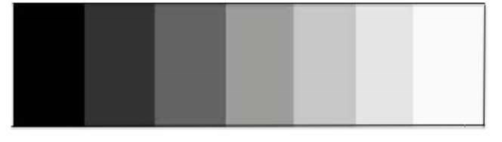

- Below is a rounder’s bat. Name the part labelled K K

  - grip

  - knob

  - end cap

  - barrel.

- Which game is played using the equipment below?
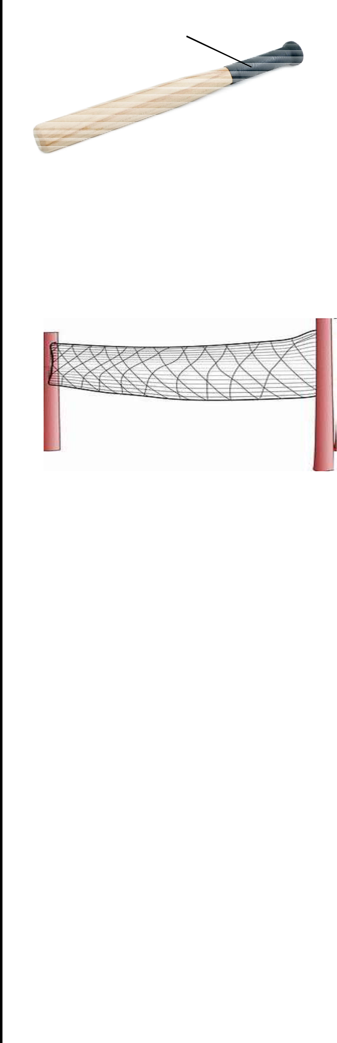

  - Netball

  - Volleyball

  - Football

  - Rounders.

- Warm up activities are important because they

  - relax muscles without being sore

  - help muscles stretch without being injured

  - help muscles to exercise without fatigue

  - help the heartbeat go back to normal gradually.

- The following equipment is commonly used during games and sports. It is called a

  - bib

  - baton

  - scarf

  - whistle.

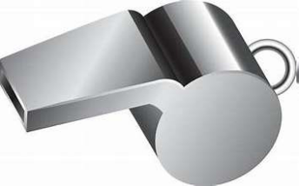

CBC ASSESSMENT 3 CRT/ARTS/GR. 5

21.A team of players in the game of football should be made of ____ players at the start of the game.
  - 22

  - 9

  - 11

  - 7

- _______ is the act of receiving and controlling the ball in the game of football.
  - Trapping

  - Passing

  - Kicking

  - Bouncing.

- What is the name of playing technique drawn below in the game of volleyball?

  - Volley

  - Underarm service

  - Dig

  - Overarm

- When do you score a full rounder in a game of rounders? When the batter reaches
  - 4th post in one hit

  - 3rd post in one hit

  - 2nd post in one hit

  - 2nd or 3rd post in one hit.

- Which game is played using the facility drawn below?
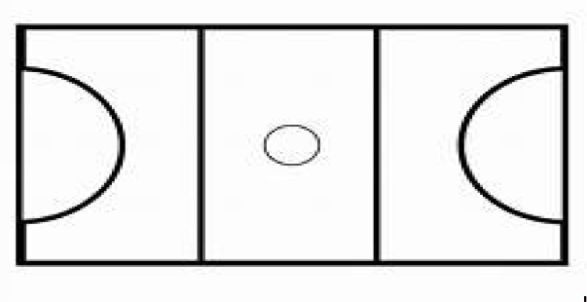
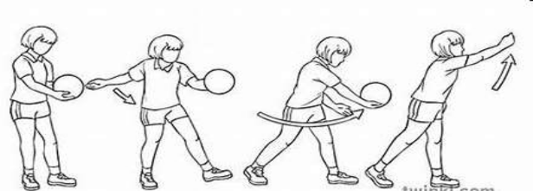

 | Centre
Goal | circle
Goal | 15.25m
circle | 15.25m
 | 30.5m

- Football

- Netball

- Volley ball

- Rounders.

- Net ball is played by a team of _______ players in one team.

A. 7 | B. 14
C. 12 | D. 9

- Which of the following types of passes is found in the game of football?

  - Head pass

  - Bounce pass

  - Under arm

  - Overhead pass.

- How many shooting rings are there in the game of Netball?

  - Four

  - Three

  - Two

  - One.

- A teacher was seen telling his pupils to skip a rope before they begin playing. What is the importance of it?

  - To strengthen the body parts.

  - For the pupils to be happy.

  - To start off.

  - To cool down the pupils.

- Mueni discovered her teammate was bleeding in the field. What should Mueni do?
  - Ignore and continue playing.

  - Call the coach.

  - Stop the match.

  - Carry out first aid.

CBC ASSESSMENT 4 CRT/ARTS/GR. 5

