^{COMPETENCE BASED CURRICULUM}
GRADE 5 - 2025

CBC ASSESSMENT
FIRST TRIAL

CODE 001

PRIMARY SCHOOL EDUCATION ASSESSMENT

CREATIVE ARTS

TIME: 2 HOURS

INSTRUCTIONS TO LEARNER’S (Please read these instructions carefully)

- You have been given this question booklet and a separate answer sheet. The question booklet contains 30 questions. Answer all the questions.

- Do any necessary rough work in this booklet.

- When you have chosen your answer, mark it on the ANSWER SHEET, not in this question booklet.

HOW TO USE THE ANSWER SHEET

- Use ordinary pencil.

- Confirm that the answer sheet that you have been provided with has the following:

YOUR ASSESSMENT NUMBER YOURNAME

NAME OFYOUR SCHOOL NAMEOF SUBJECT
- Do not make any marks outside the boxes.

- Keep the sheet as clean as possible and do not fold it.

- For each of the question 1 - 30, four answers are given. The choices are lettered A, B, C, D. In each case only ONE of the four choices is correct. Choose the correct answer.

- On the answer sheet, show the correct answer by drawing a dark line inside the box in which the letter you have chosen is written.

Example:

In the question booklet:

11. The art of making containers using clay is known as

- puppetry

- thonging

- pottery

- coil technique.

The correct answer is C (pottery)

On the answer sheet:

In the set of boxes numbered 11, draw a dark line inside the box with letter C printed as indicated below.


  - [A] [B] [C] [D]

- Your dark line MUST be within the box.

- For each question, ONLY ONE box is to be marked in each set of four boxes.

This paper consists of 4 printed pages. Turn over

CBC ASSESSMENT 1 CRT/ARTS/GR. 5

- Most of traditional drums were made of the

following materials. Which one?

A. Cotton wool

B. Animal skins

  - Fibres

  - Wires.

- A learner brought the instrument below during a group discussion. How is the instrument played?
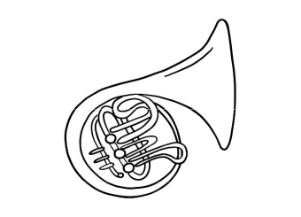

  - Shaking

  - Biting

  - Plucking

  - Blowing.

- The following are items used when presenting a dance. Which one is a prop?
  - Skirts

  - Necklaces

  - Sticks

  - Hats.

- Dance formations can be done in the following ways, except

  - circles

  - lines

  - triangles

  - congested groups.

- Which of the following is equal to ta-te?

  - taa

  - taa -te

  - te -ta

  - ta-ta.

- Which part of the body is used to show a rhythm being used?

  - Knees

  - Waist

  - Hands

  - Nose.

- A grade 5 learner wants to record an audio. Which device will she use?

  - Radio

  - Smart phone

  - A wall clock

  - Television.

- Which of these melodies is correctly arranged?

  - dmrf

  - fdmr

  - drmf

  - rmfd.

- A trainer showed the hand sign below. Which solfa sound does it show?
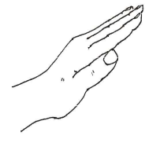

  - doh

  - re

  - mi

  - fa

- Topical songs talk about different titles. Which one of the following is not a theme used in topical songs?

  - Healthy living.

  - Child care and protection.

  - Praise of our nation.

  - Good leaders.

- The image which is created when light falls on a sensitive material inside the camera is called
  - image

  - photograph

  - picture

  - painting.

CBC ASSESSMENT 2 CRT/ARTS/GR. 5

- What kind of puppet theatre show is shown in the picture?
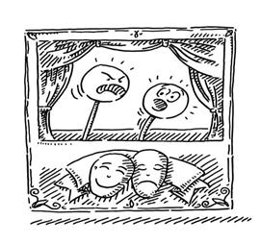

17. What kind of lettering has been used below?


A. Window theatre.

B. Doorway theatre.

C. Closed curtain theatre.

D. Open theatre.

- William is a person who manipulates puppets. What name do we call him?

  - Puppet master

  - Puppeteer

  - Puppet manipulator

  - Puppetry .

- Which of the following is not made using the basketry technique?

  - Granary

  - Fish trap

  - Winnowing tray

  - Rolling board.

- Overlapping is an important technique in arranging still life pictures because it

  - helps the artist to create texture in drawing

  - makes the drawings look 3 dimensional

  - helps to create balance

  - helps the artist to create tone.

- The picture below shows a tie die technique of decorating. Which type is it?
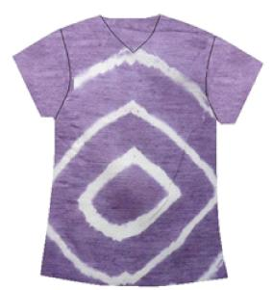

- Pleating

- Knotting

- Circular pattern

- Putting objects

A. Block lettering.

B. Uppercase lettering.

C. Lower case lettering.

D. Freehand lettering.

- Which of the following is not a process used in weaving?

  - Coiling

  - Plaiting

  - Twining

  - Kneading.

- The modelling technique in which containers are made by pressing on the walls using thumb and forefinger is called
  - pinch technique

  - press technique

  - stamping technique

  - scratch technique.

- What is the name of the thin piece of leather used to join pieces of leather?

  - Leather strip

  - Thong

  - Leather string

  - Resonator.

- The type of start in which the legs are close together with the knee of the back leg placed opposite the front leg is called
  - elongated sprint start

  - medium sprint start

  - standing start

  - crouch start.

- Recreational facilities are a community resource. How can we take good care of them?
  - Throwing litter everywhere.

  - Spray painting messages on them.

  - Planting trees and grass on or around them.

  - Burning plastics in or near them.

CBC ASSESSMENT 3 CRT/ARTS/GR. 5

- Leisure activities are categorized as either passive or active. Which of the following is a passive activity?

  - Playing board games.

  - Playing football.

  - Skipping rope.

  - Running races.

- There are different injuries we get from sport.
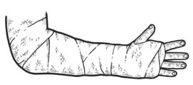

Which injury is shown below?

  - Fracture

  - Bruise

  - Cut

  - Sprain.

- When engaging in physical activity, we are required to eat a healthy diet. Which of the following is not a healthy diet?

  - Rice, beans, cabbage and apple.

  - Tea, bread, cake and lollipop.

  - Ugali, fish, spinach and milk.

  - Rice, chicken and cabbage.

- The following are importance of muscular endur-ance. Which one is not?
  - It helps increase stamina.

  - It helps prevent injuries.

  - It helps us compete better in competitions.

  - It helps us never to get tired.

- The following body parts are part of the cardiores-piratory system.

Which is the exception?

  - Heart

  - Lungs

  - kidney

  - Blood vessels.

- What kind of throw is shown in the

picture?
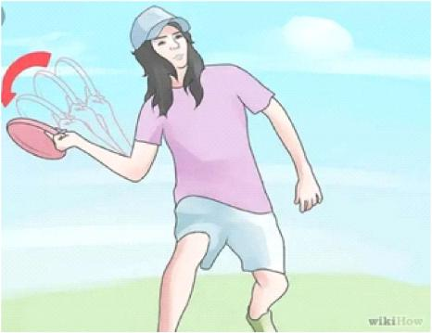

A. Forehand throw

B. Backhand throw

C. Overhead throw

D. Underarm throw.

- Gymnastics involves the use of different skills. Which of the following skills is part of the two-action sequence?
  - Headstand

  - T-balance

  - Rolling

  - Single-leg balance.

- The following are techniques used in rope skipping

except

A. single bounce

B. double bounce

C. triple bounce

D. one foot bounce.

CBC ASSESSMENT 4 CRT/ARTS/GR. 5

