COMPETECE BASED CURRICULUM
HOMEWORKK ENGAGEMENT ACTIVITY
DECEMBER HOLIDAY
GRADE 5
CREATIVE ARTS AND SPORTS
- Draw and colour two runners exchanging a relay baton (1mk)

- Use the diagram below to answer questions that folllow

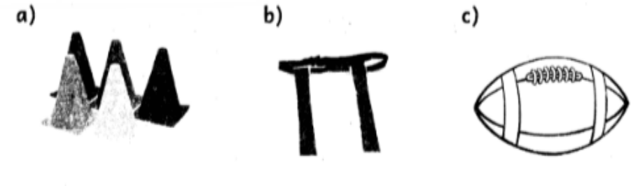

  - The above facility is used when playing a __________________________________ event called

______________________ (2 marks)

  - Name the parts labelled (3mks)

    - ______________________________________

    - ______________________________________

    - ______________________________________

- List two rope skippikg skill (2 marks)

  - ___________________________________________

  - ___________________________________________

4. Write down two importance of sliding when playing softball (2mks)

  - _________________________________________________

  - _________________________________________________

- What do you call the players that play the game of rounders? (2mks) _______________________ and

_____________________

- List three basic equipment that are used in volleyball. (3mks)

  - __________________________________________________

  - ___________________________________________________

  - ___________________________________________________

- Each team in the game of Kabaddi has _______ players at the start of the game (1mk)
8. Name the following equipment used in tag rugby game (3mks)
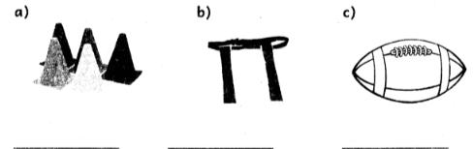

- There are ____________________________ _______phases used when performing standing discus technique. (3, 4, 6) (1mk)

- Name two types of songs. (2marks)
- ________________________________
- _________________________________

- A song sung during worship is called .___________________ (2marks)

- When singing the national anthem every one should________________________________________ (2marks)

- One uses facial expressions while singing to express ____________ and _____________ (2marks)

- What is a trio? (2marks)

________________________________________________________________________________________________________________________

- Draw one indigenous instrument. (2marks)

- Make a wind instrument using locally available materials such as hollowed out wood, bamboo stem, straight or coiled animal horns and guards. (l,marks)
- Make a folk song costume using locally available materials such a', old newspapers, sisal fibres, old blankets and clothes. (4marks)

- What is structure in music? (2marks)

______________________________________________________________________________________________________________________________

- Draw a semi-breve and write its French Rythm name. (3ma rks)

- A three-dimension figure has __________________________(2marks)

- What is a book jacket?

________________________________________________________________________________________________________________ (2marks)

- What is a still-life drawing? (2marks)
________________________________________________________________________________________________________________________

- Draw two tools used in carving. (4marks)

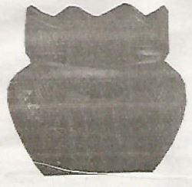
- Name the technique used in decorating the indigenous pot below. (2marks)

- _______________________________________________________
- ________________________________________________________
- ________________________________________________________

- Skins are used to make items such as (2marks)

- _______________________________________
- _______________________________________

- State two materials that can be used for weaving. (2marks)
- _________________________________________________
- _________________________________________________

- Name the weaving tool in the picture below. (2marks)
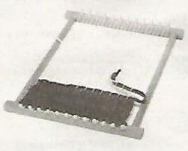

- Draw the National Flag and colour it appropriately. (4marks)


- Write name of your school in 3D and colour it. (3marks)

- List three categories of colour (3mks)

  - _________________________________

  - _________________________________

  - _________________________________

- What are the two techniques used in weaving? (2mks)

  - __________________________________

  - __________________________________

- When making a drawing composition you either make a vertical or horizontal layouts. The vertical layout is also called ______________________ while the horizontal layout is also called _________________________ (2mks)

- What do you call the type of drawing that involves drawing arrangement of man-made or natural things?

________________(1mk)

- List two techniques that are used to show value on drawn objects (2mks)

  - ___________________________________

  - ___________________________________

- In crayon etching technique, crayons can be made using _____________________ wax or

____________________wax. (2mrks)

- List three materials that can be carved in sculpture to make sculptural forms (3mks)

  - ______________________________________

  - ______________________________________

  - ______________________________________

- Name two techniques used when modelling items 2mks)

  - ______________________________________

  - ______________________________________

- Draw and colour a cooking stick (1mk)
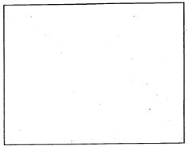

- A _____________________________ is a simple type of loom that is made by tying four sticks hat four corners to make a frame and is used in weaving (1mk)
- _____________________________________ is the surface appearance of objects in the presence of light. (Shape, Colour) (1mks)

(Total 20 mks)

- Name the following wind instruments. (2mks) a.
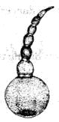

_____________________________________

b.
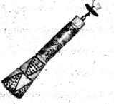

______________________________________

- The musical instruments shown above are played by ____________________________ them to produce sound.(1mk)

- List four types of songs. (4mks).

  - _________________________________________

  - _________________________________________

  - _________________________________________

  - _________________________________________

- Write down the roles of the following participants in a folk song. (3mks) a

  - Instrumentalists ____________________________________

  - Soloist ___________________________________________

  - Singers ___________________________________________

- When two voices are in agreement while singing together they create ____________________________ in a song. (Imk)

- What do you call a song that is sung as a symbol of the unity among the member states of the East African Community?

_______________________________________ (1mk)

- Fill in the gaps using the words in the box (3mks)

costumes, ornaments, body adornment

  - The beads, necklaces, bracelets and anklets worn by dancers during the performance are called

____________________

  - The paint decorations made on the body of dancers during performance are known as

__________________________

  - In folk dances the attire worn by dancers that are specially designed are known as

____________________________

- Name four participants in a folk dance (4mks)

  - ___________________________________________

  - ___________________________________________

  - ___________________________________________

  - ___________________________________________

- Draw the note symbol of a crotchet (1mk)

MARKING SCHEME

- Picture of children exchanging a relay button

  - field, long jump

  - A-runway

B - take off board C - Landing pit

- Straddle, straddle cross, skier, heel, taps

- prevent injury, avoid a tag, make a diversion, because it is the quickest way to the base

- fielders and battlers

- net, ball, posts

- 7

8.

- training cones

- tag belt

- rugby ball

9. 4

- Patriotic, folk, action, topical, sacred

- Sacred song

- Attention/alert

- Emotions and feelings

- A musical composition for three voice parts

- nzumari, coro, drum

- Assess

- Assess

- Assess
- Assess

- Length, width and height

- Assess

- Assess

- Assess

- Knife, stone etc

- handbags, drums, shoes, sheaths

- banana fibres, raffia, grass, sisal

- a peg loom

- Assess

- Assess

- Primary colours

- Secondary colours

- Tertiary colours

29.

  - Plain weave/ check weave

  - twine weave

- potrait layout, landscape layout

- Still life drawing

  - Smudge technique

  - Cross-hatching

- paraffin, bee

- wood, plastic, clay, stone, stabs, rubber

  - pinch

  - coil

- Coloured picture of a cooking stick

- Dowel loom

- Colour

- .

  - Abu

  - Nzumari

- Blowing

- Lullaby, patriotic, scared, action, topical, popular, folk

  - play the instruments

  - leads the singers in a performance

  - respond to the soloist

- harmony

- East African Community Anthem

  - ornaments

  - body adonment

  - costumes

48.

- soloist

- response group

- instrumentalists

- dancers

49.

