COMPETECE BASED CURRICULUM
HOMEWORKK ENGAGEMENT ACTIVITY
DECEMBER HOLIDAY
GRADE 5
AGRICULTURE AND NUTRITION HOMEWORK
1. Write down two emotional changes that take place in pre-adolescents (2mks)
a. ______________________________________
b. ______________________________________
2. Fill in the table below using examples of common communicable diseases that affect people. (8mks)

Skin diseases | Respiratory diseases | Insect transmitted diseases | Immunisable diseases
3. Write down three aspects of good grooming (3mks)
a. ______________________________
b. ______________________________
c. ______________________________
4. What is an advertisement?(1mk) __________________________________________________________
5. List two types of media that can be used in the advertisement of new product. (2mks)
a. _________________________________
b. _________________________________
c. _________________________________
6. Identify the materials the following surfaces are made of (4mks)
a.

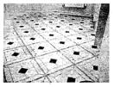

________________________________________________



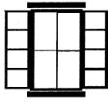
___________________________________________

_________________________________________

- Chebet a pre-adolescent girl has been given money by her parents to buy christmas clothes and shoes. What factors do you think she is supposed to consider when choosing her shoes and clothes? (4mks)
  - _______________________________________

  - _______________________________________

  - _______________________________________

  - _______________________________________

- _____________________________ involves making a buying decision in the right manner. (1mk)

- Use the words in the box to fill in the gaps (4mks)

expiry date, impulse buying, shopping list, compare prices

  - It is always important to check the _____________________________ of the items you are buying.

  - Planning for items to buy helps to avoid ____________________________________

  - Use your _________________________________ when buying items that you need.

  - You save money when you _____________________________________ and buy a similar item at a cheaper price.

- ______________________ is a nutritional deficiency disease and disorder that is caused by lack of enough proteins in the diet (1mk)

(Total marks 30)

- Grade five learners at Jikaze primary school started a club of planting climbing fruit trees. Imagine you are asked to advise them on ways of managing those climbing fruit trees to ensure they grow strong and heathy, give them five activities they can undertake to manage their climbing fruit trees (5mks)

  - _____________________________________

  - _____________________________________

  - _____________________________________

  - _____________________________________

  - _____________________________________

- List three climbing fruit trees grade five learners are likely to plant in question 1 above (3mks)

  - ______________________________________

  - ______________________________________

  - ______________________________________

- Write two planting materials for climbing fruits the grade five learners can use to plant their climbing fruit trees in question 1 above. (2mks)

  - ______________________________________

  - ______________________________________

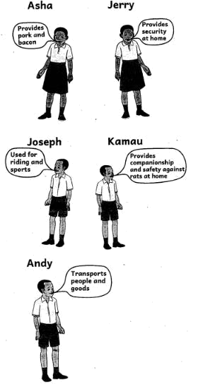
- Five grade tive learners made placards of various domestic animals

Identify the domestic animals mentioned by the five learners. (5mks)

a. Joseph ___________________________

  - Andy _____________________________

  - Asha ._____________________________

  - Jerry ______________________________

  - Kamau _____________________________

- Name the following gardening tools and equipment (5mks)

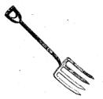

__________________________________
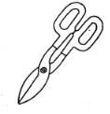

b.

____________________________________

c.
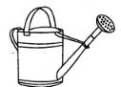___________________________________
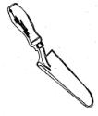

d.

_____________________________________
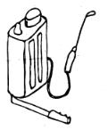

e.

_______________________________________

- Define the following terms (8mks)

  - Run off ___________________________________________________

  - Soil recovery ________________________________________________________

  - Soil conservation __________________________________________________________________

  - Soil erosion _____________________________________________________________

- Draw and colour a diagram showing mulching in plants. (2mks)


- What is the meaning of soil recovery? (1 mark)
_____________________________________________________________________________________________________________

_____________________________________________________________________________________________________________

- Name two areas where eroded soil may be deposited. (1 mark)
  - ______________________________________________________________
  - ______________________________________________________________

- Why is it important to recover eroded soil? (1 mark)
_________________________________________________________________________________________________________________________________________________________________________________________________________________________

- Use YES or NO.(3 marks)

  - Climbing fruit plants have a strong stem.________________________________

  - Eroded soil has nutrients.____________________________________________

  - Fruits of climbing fruit plants are all harvested at once_________________________

- Learners from Kileleshwa Academy were advised to use organic materials only in their waste pit. What is the meaning of 'organic materials'? (1 mark)
__________________________________________________________________________________________________________________________________________________________________________________________________________________________

- What is the meaning of water conservation' on the farm?(1 mark)
__________________________________________________________________________________________________________________________________________________________________________________________________________________________

- Give two reasons why we conserve water on the farm. (2 marks)
  - _____________________________________________________________________________
  - _____________________________________________________________________________

- Use the diagrams bellow to answer the following questions.
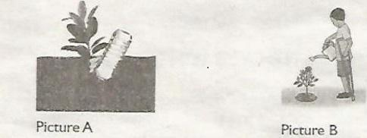

  - Identify what you can see in picture A and B. (2 marks)
Picture A___________________________________
Picture B______________________________________

  - Which of the above methods conserves water when used for irrigation? (1 mark)
__________________________________________________________________________________________________________________________________________________________________________________________________________________________

- Mzee Ojwang has planted many fruit climbing plants on his farm.

  - Write two benefits that Mzee Ojwang can get from climbing fruit plants. (2 marks)
__________________________________________________________________________________________________________________________________________________________________________________________________________________________

  - State two ways that Mzee Ojwang can use to know mature fruits before harvesting them. (1 mark)
__________________________________________________________________________________________________________________________________________________________________________________________________________________________

- Write two practices that can be carried out when taking care of climbing plants. (2 marks)
__________________________________________________________________________________________________________________________________________________________________________________________________________________________

- What is the colour of blackberries that are ready for harvesting?__________________________ (1 mark)

- A shade preserves water by reducing________________. (irrigation, evaporation) (1 mark)

- How can the following animals be controlled from damaging crops? (3 marks)

  - A mole__________________-_____________________________________________

  - Birds____________________________________________________________________

  - Mongoose________________________________________________________________

- Write two safety precautions to be considered when handling small wild animals. (2 marks)
  - _____________________________________________________________________________
  - _____________________________________________________________________________

- Write the names of two domestic animals that are kept in your locality. (2 marks)
  - ________________________________________________
  - ________________________________________________

- Fill in the following table correctly. (3 marks)

Domestic animal | use
Horse
 | Honey
Cat

- State any cultural use of domestic animals. (1 mark)
  - ______________________________________________________________
  - ______________________________________________________________

- Identify the domestic animal described below. (1 mark)

  - Can be used to provide meat.____________________________________________--

  - They are used for ploughing.____________________________________________
_
  - They provide hides when slaughtered._____________________________________

- What is the meaning of indigenous food crops? (1 mark)
_______________________________________________________________________________________________________________________________________________________________________________________________________________________________________________________________________________________________________________________________________

- Name two examples of indigenous foods crops that you know. (2 marks)
  - __________________________________________
  - __________________________________________

MARKING SCHEME

1.

- shyness

- mood swings

2.

Skin diseases - ringworms, scabies

Respiratory - coughs, colds, corona virus, T.B,

Insect transmitted - malaria

Immunisable - measles, chicken pox.

- Exercises, personal hygiene, dressing, care of clothes, etiquette ( any 3)

- It is a public notice that promotes a product or a service.

- Notice board, posters, billboards, word of mouth, phones, newspapers, radio, television (any 2)

  - wood

  - tile
  - cement

  - glass

- shape and size, comfort, weather, age, colour, occasion, price (any 4)

- Wise buying

9.

  - expiry date

  - Impulse buying

  - Shopping list

  - Compare prices

- Kwashiorkor

- watering, mulching, applying manure, weeding, training.

- passion fruits, raspberry, fruits, gooseberry fruits, grapes, kiwi fruits (any 3)

- seeds, stem cuttings.

14.

- horse

- donkey

- pig

- dog

- cat

15.

- garden fork

- pruning shears

- watering can

- garden trowel

- garden insecticide sprayer

16.

  - The excess water that flows on the ground surface after heavy rainfall

  - The process of collecting soil from the depostition sites and using it to replace the lost top soil.

  - Process of preventing the loss of the top layer of soil from erosion or contamination

  - It is the carrying away of the top soil from one place to another

- Picture of mulched plant.

- Soil recovery is making of the soil useful again after erosion or destruction

- Along river banks, valleys etc

- To make it useful again

4.

  - no

  - Yes

  - no

- Materials that can decompose/ decay

- Using farming methods and practices that help in saving/ conserving water.

- To avoid wastage, to enable plants have water for a long time

- picture A- drip irrigation

picture B - watering using a watering can

- method in picture A

  - He can use the fruits from the climbing plants as food, the climbing plants act as soil cover hence prevent erosion, he can sell the fruits to get income

  - Observing their colour, observing the size of the fruits, etc

- Watering , weediung etc

- Dark, black

- Evaporation

  - Setting safe traps

  - Using deflectors that make noise

  - Using repellants

- Wearing protective clothing to avoid contracting pests and diseases from them, Being careful not to get injured and bites from them etc

- Assess

- Used in racing , Bees, Used as a pet

- Cows as used in payment of dowry etc,

- Cows

- Crops that grow on their own in some places and are considered the main source of food in that area

- Sweet potatoes, cassava etc

