G4
GRADE 4 - 2025

CBC ASSESSMENT
THIRD TRIAL

ENDTERM

PRIMARY SCHOOL EDUCATION ASSESSMENT

SOCIAL STUDIES /RELIGIOUS EDUCATION TIME: 1 HOUR

INSTRUCTIONS TO LEARNER’S (Please read these instructions carefully)

- You have been given this question booklet and a separate answer sheet. The question booklet contains 30 questions. Answer all the questions.

- Do any necessary rough work in this booklet.

- When you have chosen your answer, mark it on the ANSWER SHEET, not in this question booklet.

HOW TO USE THE ANSWER SHEET

- Use ordinary pencil.

- Confirm that the answer sheet that you have been provided with has the following:

YOUR ASSESSMENT NUMBER YOURNAME

NAME OFYOUR SCHOOL NAMEOF SUBJECT
- Do not make any marks outside the boxes.

- Keep the sheet as clean as possible and do not fold it.

- For each of the question 1 - 30, four answers are given. The choices are lettered A, B, C, D. In each case only ONE of the four choices is correct. Choose the correct answer.

- On the answer sheet, show the correct answer by drawing a dark line inside the box in which the letter you have chosen is written.

Example:

In the question booklet:

11. Which one of the following was not a method of learning in Traditional African Society?

A. Story telling

B. Songs and wise sayings

C. Reading story books

- Riddles.

The correct answer is C (Reading story books)

On the answer sheet:

In the set of boxes numbered 11, draw a dark line inside the box with letter C printed as indicated below.


  - [A] [B] [C] [D]

- Your dark line MUST be within the box.

- For each question, ONLY ONE box is to be marked in each set of four boxes.

This paper consists of 4 printed pages. Turn over

CBC ASSESSMENT 1 SOCIAL/RE/GR. 4

PART 1: SOCIAL STUDIES. (Answer all questions in this section)

KERA AREA
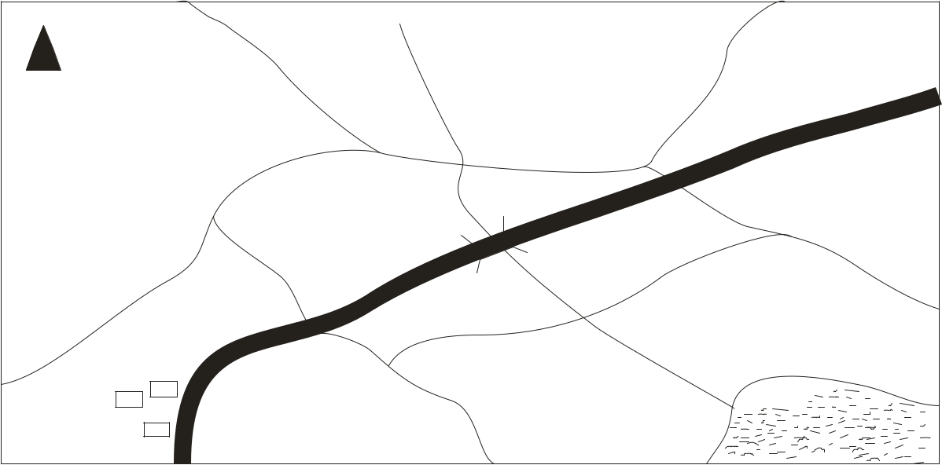

N


Kera hill | Wima Subcounty | Nuru Subcounty
Poa sub county
 | Nana Subcounty

 | R |  | Zoa County
 | i
 | v
 |  | e
 |  | r
 |  | K
 |  | e
 |  | r
 |  | a | Lake
Kera Town | Lema Subcounty |  | Lake


Use the map of Kera area to answer questions 1- 4.

- Which subcounty borders Nana subcounty to the North

  - Poa subcounty

  - Lema subcounty

  - Wima subcounty

  - Zoa subcounty.

- People of Kera county get their water from

A. River Kera B. Kera Hill

C. Kera town D. Nuru subcounty.

- Which physical feature is found in the North Eastern

part of Kera county?

A. Kera town B. River Kera

C. Kera Hill D. Lake.

- Kera county is headed by a

  - Senator

  - Chief

  - Ward administrator

  - Governor.

- People usually cross a river using a

A. stick B. tree

C. rope D. bridge.

- Which one of the following is not a physical feature?

  - Hills

  - Mountain

  - Railway line

  - Plateau.

- The following are importance of physical features. Which one is not?

  - Some gives us water for use.

  - Acts as tourists attraction.

  - Make land look beautiful.

  - Provide good leaders.

- There are ____ seasons in a year.

A. 2 | B. 4
C. 3 | D. 6

- When there is too much rainfall it can lead to

A. hunger B. drought

C. erosion D. floods.

- The act of depending on each is called

  - population

  - dependency

  - interdependence

  - distribution.

- Which one is not a cardinal point of a compass?

A. South B. North

C. East D. North East.

- ______ refers to the number of people living in a particular area.

A. people B. densely

C. population D. total

13. Places with ____ people are sparsely populated.

A. many B. too many

C. strong D. few

CBC ASSESSMENT 2 SOCIAL/RE/GR. 4

- People’s way of life is called

  - population

  - culture

  - interdependence

  - standards.

- There are _______ counties in Kenya.

  - 12

  - 20

  - 47

  - 17

CHRISTIAN RELIGIOUS EDUCATION

- God created us in his _____ and _____.

  - Image, thought

  - Image, likeness

  - mind, physical body

  - colour, image.

- Which of the following is the last book in the old testament?

  - Genesis

  - Revelation

  - Mathew

  - Malachi.

- “God with us” is the meaning of the name

  - Messiah

  - Christ

  - Emmanuel

  - Jesus.

- Jesus grew up in

  - Bethlehem

  - Bethany

  - Nazareth

  - Jerusalem.

- Samuel was called by God ________ times.

A. four B. three

C. five D. two

- Jesus taught us that we should forgive inorder to

  - go to heaven

  - love God

  - pray

  - be forgiven.

- Elijah proved to all Israelites that God was the only true God on Mount

  - Sinai

  - Carmel

  - Horeb

  - Moriah.

23. Who among the following prophets was called by God even before he was born?
A. Jeremiah B. Samuel

C. Micah D. Isaiah.

- Which one of the following days do Christians celebrate the resurrection of Jesus?
  - Christmas

  - Easter Sunday

  - Good Friday

  - Good Monday.

- When God said “I am who I am” He was speaking to

  - Aaron

  - Moses

  - David

  - Abraham.

- The three wisemen who visited Jesus gave Him all the following gifts except

  - Gold

  - Myrr

  - Silver

  - Frankinsence.

- God helped ______ to interprete pharaoh’s dreams.

  - Joseph

  - Daniel

  - Moses

  - Balak

- Who among the following was not a disciple of Jesus

  - Amos

  - James

  - Peter

  - John.

- Which of the following is a Chistian value?

  - Dishonesty

  - Hatred

  - Selfishness

  - Justice.

- Jesus was laid in a ________ after He was born.

  - house

  - cot

  - manger

  - basket

CBC ASSESSMENT 3 SOCIAL/RE/GR. 4

ISLAMIC RELIGIOUS EDUCATION

- Grade four learners were asked to name a day in which Muslims pray together. Which day was it?
  - Sunday

  - Tuesday

  - Monday

  - Friday.

- Amar and Ali are Muslim boys. They greet each other by saying

  - Jambo

  - Bismillah

  - Assalam aleikum

  - Shikamoo.

- A teacher wrote the verse below. Complete it.

‘tarmiyhim bihijaaratim ............’

  - Maakul.

  - minsij-jiyl

  - Alhamdullillah

  - fajaalahum

- Complete the Hadith, swalah is the ____ of religion

  - sunnah

  - pillar

  - guide

  - belief

- Ali was walking home and he saw an old woman carrying firewood. He should
  - run away

  - push the woman

  - spit on the woman

  - assist the woman.

- How many prophets are mentioned in the Quran?

A. 99 | B. 24
C. 5 | D. 25

- Which of the following statements is true?

  - An-Naas means mankind.

  - Al-falaq and An-Naas are recited before we sleep.

  - Surah fatiha means protection.

  - Kafirun are the believers.

- On the day of judgement people will stand for a long time. Which term is used to refer to that day of standing?

  - Yaumul hisaab

  - Yaumul qiyaama

  - Yaumul a akhir

  - Yaumul hisaab.

- At an early age the prophet worked as a

  - Shepherd

  - Merchant

  - Farmer

  - Butcher.

- Grade 4 learners were discussing about ihsaan. How did they define ihsaan?
  - To worship Allah as if he is with us.

  - To worship Allah as if he is in the heavens.

  - To worship Allah as if we see him.

  - To worship Allah with fear.

- Complete the hadith, “Speak the truth even if it is...........”

  - better

  - bad

  - good

  - bitter.

- Which one of the following is a quality of a good leader?

  - Role model

  - Rude

  - Pride

  - Corrupt.

- Which pillar of Islam is only performed in the month of Ramadhan?

  - Swalah

  - Zakah

  - Saum

  - Hajj.

- Which prayer has the least number of rakaa?

  - Fajr

  - Dhuhr

  - Asr

  - Magharib.

- What does a Muslim say in i’tidal?

  - Subhanalla rabbiyaal adheem

  - Rabbana lakal hamdi

  - Allahu akbar

  - Rabbighfrilii.

CBC ASSESSMENT 4 SOCIAL/RE/GR. 4

