COMPETECE BASED CURRICULUM
HOMEWORKK ENGAGEMENT ACTIVITY
DECEMBER HOLIDAY\
GRADE 4

QUESTIONS

SOCIAL STUDIES

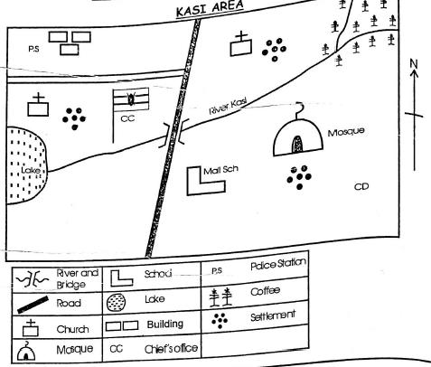

- People of Kasi area get water from a___

- The main cash crop in the area is___

- The main means of transport is Kasi area is___

- River Kasi starts from which direction?

- What is the name of the school in Kasi Area.

- There are___counties in Kenya

- ___ is an instrument used to show direction of one place from another.

- Densely populated areas have___

- Name any 3 physical features (3mks)

- The best time for harvesting is during the___season

- Name three counties that are neighbouring your county.

- Draw and name two artefacts from your community. (4mks)

- List two economic activities carried out in your county (2mks)

- Name two religious leaders in your community (2mks)

- Crops grown mainly for sale are known as___

- The raw material used in making shoes is___

RELIGIOUS ACTIVITIES

- Write three good thoughts (3mks

- Name three members of the extended family.
- Write three attributes of God property. (3mks)

  - YLHO

  - GNIVLO

  - TOTAERC

- ___climbed a sycamore tree. (1mk)

- Which animal spoke to Baalam?(1mk)

- Samson and his parents were going to the vineyards at___when he killed a lion. (1mk)

- Who interpreted pharaoh's dream?(1mk)

- List the four gospel books. (4mks)

- Where was Abram living when God called him?

- The Birth of Jesus was announced by Angel___

- The parents of John the Baptist were ___and___ (2mks)

- Blind Bartimaeus was the son of___

- A leper is a person suffering from a disease called___(1mk)

- The widow whose son was raised by Jesus was from the town of___(1mk)

- How many lepers went back to give thanks to Jesus?(1mk)

MARKING SCHEME

  SOCIAL STUDIES |  | RELIGIOUS ACTIVITIES

- lake

- coffee

- road

- north east

- mall

- 47

- a compass

- many

9.

- river valley

- mountain

- hill

- dry

- (a-c mark relevant answer)

- (a-b mark relevant answer)

- (a-b mark relevant answer)

  - pastors Bishop

  - priest

sheikh

- cash crops

- leather

- Mark relevant answer

  - uncles nieces

  - cousins nephews

  - aunts

grandparents

3.

  - HOLY

  - LOVING

  - CREATOR

- Zacchaeus

- donkey

- Timnah

- Joseph

8.

  - Matthew

  - Mark

  - Luke

  - John

- Haran

- Gabriel

- Zechariah, Elizabeth

- Timaeus

- Leprosy

- Nain

- One

